**Drone Parts**

|  |  |  |  |
| --- | --- | --- | --- |
| Components | | | |
| Item | Part | Quantity | Cost |
| 1 | Frame | 1 | £17.30 |
| 2 | Motors | 4 | £20.80 |
| 3 | Electronic speed controllers | 6 | £19.39 |
| 4 | Battery | 1 | £18.05 |
| 5 | Battery Charger | 1 | £15.99 |
| 6 | Propeller | 10 | £2.06 |
| 7 | Diode Pack | 1 | £5.81 |
| 8 | Inertial measurement unit | 1 | £3.39 |
| 9 | WIFI Connector | 1 | £6.99 |
| 10 | Resistors Pack | 1 | £12.99 |
| 11 | Arduino Uno | 1 | £9.99 |
| 12 | Silicone Cable | 2 | £7.59 |
| 13 | Heat Shrink Tubing Pack | 1 | £5.99 |
| Total | | | £146.34 |

**1.Frame**

Quadcopter F330 33cm Frame

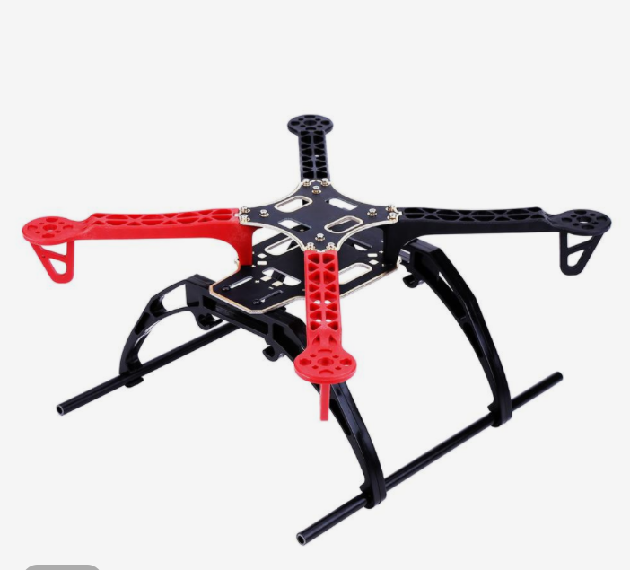

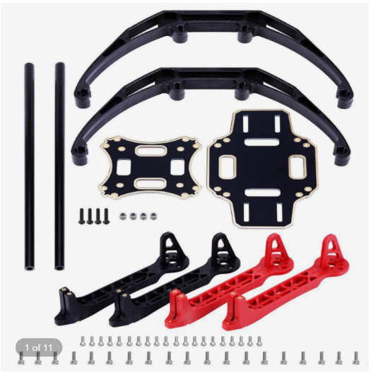

**2.Motors**

Racerstar BR2212 2200KV 2-3S Brushless Motor for Quadcopter

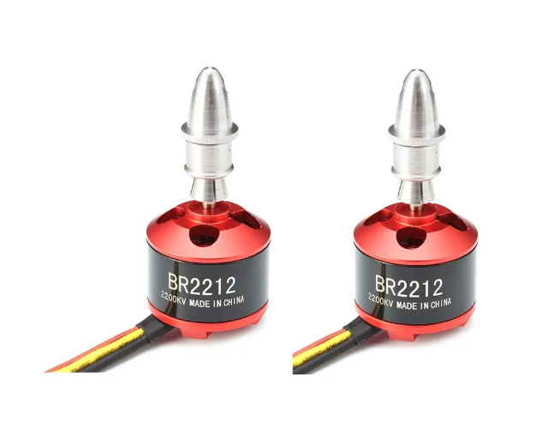

**3.Electronic speed controllers [ESC]**

6PCS XXD HW30A 30A Brushless ESC for Quadcopter

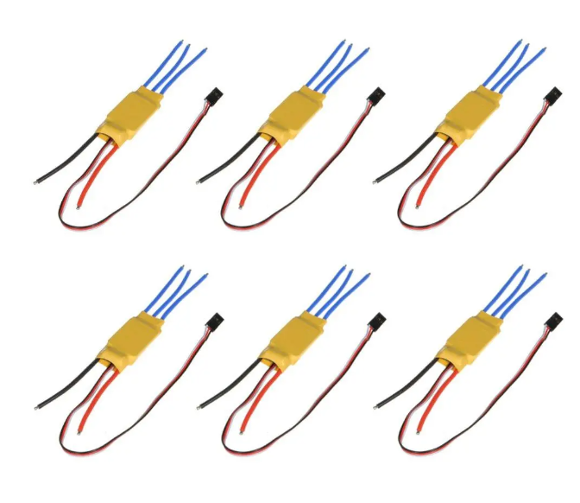

**4.Battery**

Makerfire 1500mAh 11.1V 3S Lipo Battery 45C

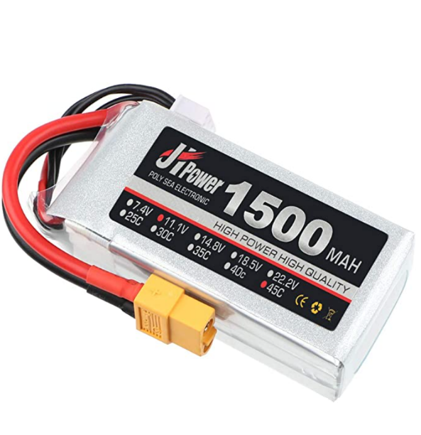

**5.Battery Charger**

SKYRC e3 Lipo Balance Charger 15W 100-240V for 2-3s LiPo Battery

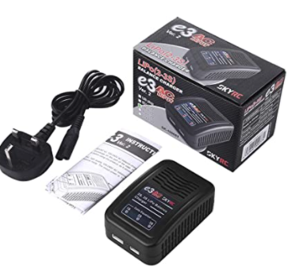

**6.Propellers**

10pcs 6030 ABS Direct Drive Orange Propeller Blade

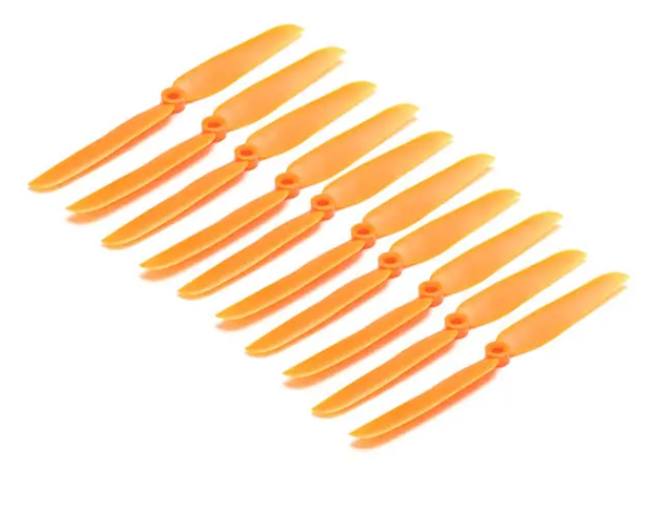

**7.Diode Pack**

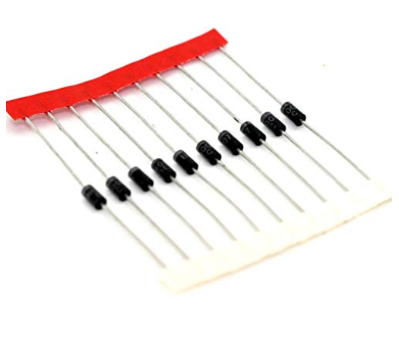E-Projects - 1N4001 Diode

**8. Inertial measurement unit [IMU]**

MPU-6050 Module: 3-axis Gyroscope and 3-axis Accelerometer

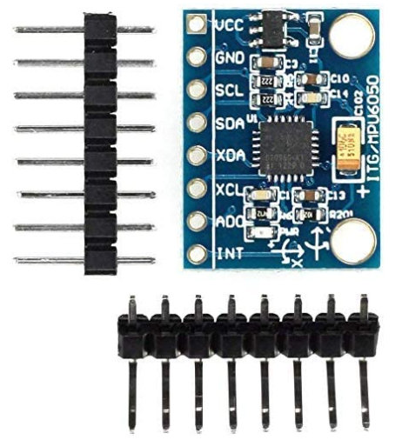

**9.WIFI Connector**

ESP8266 ESP-01S Serial Wireless WLAN WIFi Connector

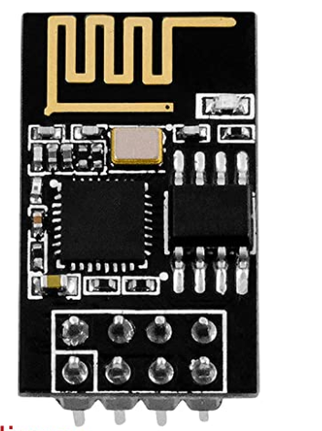**10.Resistor Pack**

1480 Pieces Resistor Kit 0 Ohm-1M Ohm

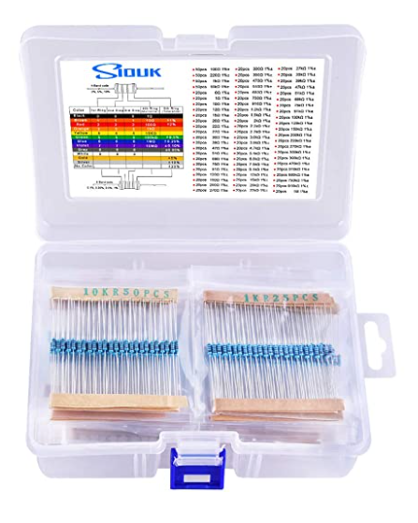

**11.Arduino Uno**

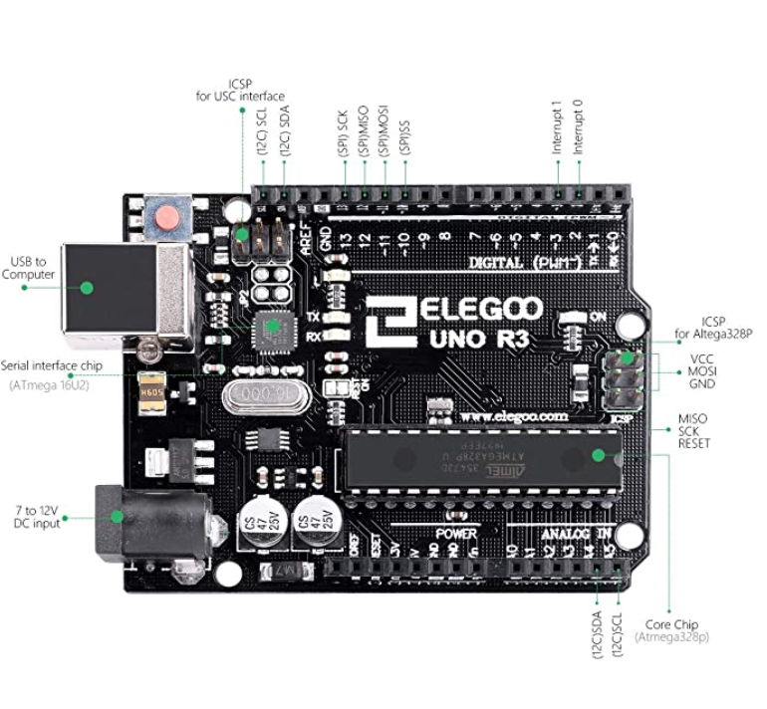ELEGOO UNO R3 Board ATmega328P ATMEGA16U2

**12.Silicone Cable**

Dilwe 2 Set XT60 Female Male Cable, Connector Adapter 14AWG Silicone Cable

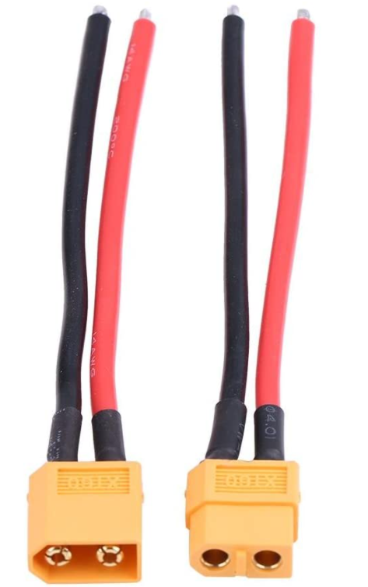

**13.Heat Shrink Tubing Pack**

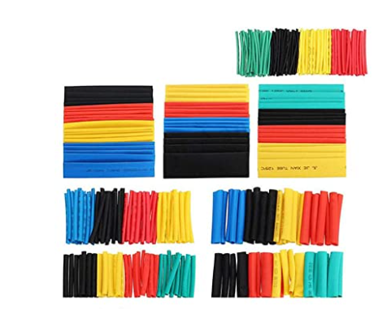164 Pcs Heat Shrink Tubing