ANALYSTLAB AFRICA — DATA SCIENCE INTERNSHIP
FinTrust Digital Bank Project | Batch E
Week 3 Submission - Model Development, Refinement & Validation
Data Science Track: FinTrust Risk Review Predictive Model - Model Development & Validation
Takudzwa Jeffrey Gumbo
Data Science Track | AnalystLab Africa Experience Lab Internship Programme
Project: FinTrust Financial Intelligence & Digital Banking Support Solution
Document control | Detail
Week | Week 3 - Model Development, Refinement & Validation
Track | Data Science
Intern | Takudzwa Jeffrey Gumbo
Project | FinTrust Financial Intelligence & Digital Banking Support Solution
Version | Final submission
Date of Submission | 4 October 2026
Deadline | 4 October 2026, 11:59 PM WAT
Repository | github.com/tgumbo07-ctrl/fintrust-risk-intelligence
Headline result | Refined logistic regression retained: validation ROC-AUC 0.683; recall 0.703 at threshold 0.4869
Data status | Entirely synthetic; test set untouched

Responsible-use notice
This project uses entirely synthetic educational data. Risk_Review_Flag is a synthetic review-prioritisation label and must not be interpreted as real fraud detection, a fraud probability, or an automated basis for adverse customer action.

Contents
1. Executive Summary
2. Applying the Week 2 Plan
3. Resources and Tools Used
4. Part A — Baseline Model Review
5. Part B — Additional Model Development
6. Part C — Feature Refinement
7. Part D — Model Comparison
8. Part E — Error Analysis
9. Part F — Model Interpretation
10. Part G — Candidate Final Model
11. Mandatory Validation Chain
12. Testing and Quality Assurance
13. Decision Log
14. Assumptions, Limitations and Risks — Week 2 Review
15. Week 3 Project Summary
16. Appendices

1. Executive Summary
Week 3 continues the same FinTrust modelling project rather than starting a new analysis. The central question was whether the performance ceiling observed in Weeks 1 and 2 was primarily a limitation of the Week 2 model specification or a limitation of the information available in the supplied synthetic data. The work therefore combined feature refinement, additional nonlinear model families, hyperparameter search, threshold evaluation, error analysis and model interpretation while preserving the original split and success criteria.
The headline finding is that greater model complexity did not materially improve discrimination. Feature refinement reduced the model from 24 to 16 raw inputs while preserving cross-validated performance and correcting the Week 2 coefficient-sign problem. Gradient Boosting, HistGradientBoosting and a tuned Random Forest were then evaluated as challengers. None met the pre-registered replacement rule, so the refined logistic regression is retained as the candidate final model for Week 4.
Result | Value | Against project criterion
Refined logistic regression ROC-AUC (5-fold CV) | 0.663 ± 0.021 | Below the ≥ 0.75 target
Validation ROC-AUC | 0.683 | Highest Week 3 validation AUC
Recall at tuned threshold 0.4869 | 0.703 | Meets the ≥ 0.70 binding constraint
Precision at that threshold | 0.286 | Explicit review-workload trade-off
Feature-set reduction | 24 → 16 raw inputs | Interpretability improved with negligible CV change
Best new-model validation AUC | 0.672 — Gradient Boosting | Does not replace incumbent
Candidate for Week 4 | Refined Logistic Regression | Frozen before final test scoring

Five findings shape the Week 4 handoff:
• The Week 2 performance ceiling persists. The strongest nonlinear challenger, Gradient Boosting, reached validation ROC-AUC 0.672, below the refined logistic regression at 0.683.
• Feature refinement solved a genuine interpretability defect without buying performance through leakage or post-hoc target chasing. CV ROC-AUC moved only from 0.6650 ± 0.0174 to 0.6630 ± 0.0208, while Amount_Band_Q5 changed to the directionally coherent +0.407 coefficient.
• The binding recall constraint remains achievable. At threshold 0.4869, validation recall is 0.703 and precision is 0.286.
• The error pattern remains uneven by transaction type. Transfer recall is 0.950 while Bill Payment recall is 0.269, so aggregate recall cannot be treated as uniform performance.
• The untouched test set remains reserved for the single Week 4 score. Week 3 therefore ends with a frozen candidate rather than another round of validation-driven model changes.
Responsible-use notice: Risk_Review_Flag is synthetic and is not a real fraud label. All results are educational evidence for review prioritisation only.

2. Applying the Week 2 Plan
This section mirrors the Week 2 report’s “Applying the previous week’s plan” structure. Each Week 2 action is traced to what was implemented, what changed and why.

2.1 Planned versus implemented
Week 2 plan | Status | Week 3 implementation / evidence
Reduce redundant amount encodings | Complete | Kept Amount_Band; removed Amount_Log and Is_High_Value. CV changed by only -0.0020 and Q5 coefficient became +0.407.
Test whether Amount_vs_Cust_Mean adds independent value | Complete | Removed after Week 2 permutation importance of only 0.003 and evidence of confounding with absolute amount.
Remove weak temporal/activity features | Complete | Transaction_DayOfWeek, Is_Weekend and Cust_Txn_Count removed.
Review weak fairness-sensitive candidates | Complete | Age and Monthly_Income_Band removed; Gender remains excluded.
Test stronger nonlinear algorithms | Complete | Gradient Boosting and HistGradientBoosting added; tuned Random Forest also evaluated.
Hyperparameter tuning | Complete | RandomizedSearchCV used on training folds; validation reserved for comparison/threshold selection.
Deepen error analysis | Complete | False positives/false negatives and transaction-type patterns quantified.
Prepare a Week 4 candidate | Complete | Refined Logistic Regression frozen; test set remains untouched.

2.2 What changed from the Week 2 approach, and why
Change | Week 2 position | Week 3 position | Reason
Amount representation | Amount_Log, Amount_Band and Is_High_Value all present | Amount_Band retained alone | Three overlapping encodings destabilised coefficients; Amount_Band had the strongest Week 2 amount importance.
Customer-relative amount | Amount_vs_Cust_Mean retained | Removed | Week 2 importance only 0.003; support for H1 did not translate into independent model value.
Model families | LR, Decision Tree, Random Forest | Adds tuned RF, Gradient Boosting and HistGradientBoosting | Tests whether the ceiling is algorithmic rather than data-driven.
XGBoost | Planned candidate | Not used | Unavailable in the execution environment; sklearn histogram boosting supplied a justified tree-boosting alternative.
Candidate interpretation | Permutation importance required because coefficients conflicted | Permutation importance retained; coefficients again usable as a secondary check | Feature reduction corrected the multicollinearity-driven sign problem.

No change was made to the target definition, the 70/15/15 stratified split, seed 42, primary metric, recall constraint, replacement rule or test-set policy. Keeping these commitments fixed is essential to making Week 3 a genuine validation exercise rather than a moving-target optimisation exercise.

3. Resources and Tools Used

3.1 Resources
Resource | How it was used in Week 3 | What it provided | Limitations encountered
FinTrust_Transaction_Data.csv | Primary transaction-level source and synthetic target | Amount, time, transaction type, channel, location, international status and Risk_Review_Flag | Synthetic target definition remains undocumented; no velocity, counterparty, device-fingerprint or network signals.
FinTrust_Customer_Data.csv | Customer attributes joined by Customer_ID | Segment, account, tenure and engagement context | Customer-level attributes remain weak predictors.
Week 2 notebook and modelling outputs | Exact methodological continuation | Split logic, baseline specification, feature evidence, permutation importance and risk register | Week 2 feature redundancy had to be corrected before coefficients could be interpreted safely.
Week 2 prepared modelling dataset | Reproducibility/reference check | Confirmed previous engineered-feature definitions and dimensions | Not used as a shortcut around training-only fitting; Week 3 reconstruction preserves the original split logic.
FinTrust project brief / roadmap | Business framing and scope control | Review-prioritisation framing and four-week sequence | No quantified business cost ratio for false positives versus false negatives.

3.2 Tools
Tool | What it was used for | Why appropriate
Python 3 / Jupyter / Colab | End-to-end reproducible Week 3 analysis | Keeps code, outputs and reasoning together; notebook verified to run end-to-end.
pandas / NumPy | Data preparation, feature transformations, result tables | Consistent with Week 2 and sufficient for tabular synthetic data.
scikit-learn Pipeline / ColumnTransformer | Preprocessing, fitting and fold-safe transformation | Refits preprocessing inside each CV fold, enforcing leakage control mechanically.
RandomizedSearchCV | Bounded tuning of tree/boosting candidates | Tests useful parameter combinations without an excessive exhaustive grid.
GradientBoostingClassifier | First additional model family | Tests sequential nonlinear boosting using standard sklearn.
HistGradientBoostingClassifier | Second additional model family | Efficient histogram-based nonlinear boosting; justified substitute when XGBoost was unavailable.
Permutation importance | Validation-set model interpretation | Model-agnostic and directly comparable with Week 2 interpretation.
Git / GitHub | Version control and portfolio submission | Preserves the Week 1 → Week 2 → Week 3 progression in one repository.

4. Part A — Baseline Model Review
Week 3 begins from the selected Week 2 logistic-regression baseline, not from a new specification. The review covers performance, features, preprocessing, metrics, error behaviour and limitations, as required by Part A.

4.1 Performance carried forward from Week 2
Measure | Week 2 evidence | Week 3 implication
5-fold CV ROC-AUC | 0.665 ± 0.017 | Below the ≥0.75 target; meaningful challenger must clear the replacement rule.
Validation ROC-AUC | 0.674 | Modest discrimination; room for improvement.
Recall at default 0.5 | 0.671 | Below binding ≥0.70 constraint.
Recall at tuned threshold | 0.703 | Constraint achievable through threshold selection.
Precision at tuned threshold | 0.283 | High review workload must be reported explicitly.
Top-decile lift | 1.96× | Some prioritisation value despite modest AUC.

4.2 Feature-set review
Week 2 interpretation identified a clear hierarchy: Transaction_Type and Is_Overnight dominated; amount and international status added secondary signal; customer-level attributes contributed almost nothing. The major defect was not leakage but redundancy: Amount_Log, Amount_Band and Is_High_Value encoded the same underlying quantity, while Amount_vs_Cust_Mean added little once absolute amount was present.

4.3 Preprocessing review
The preprocessing design itself was retained. Numeric scaling and categorical one-hot encoding remain inside a ColumnTransformer embedded in each scikit-learn Pipeline. This is important because cross-validation refits preprocessing inside every training fold. The Week 3 improvement therefore targets feature content and model family, not the leakage-safe architecture.

4.4 Areas requiring improvement
• Remove redundant and near-zero-value features so the candidate can be interpreted directly.
• Test at least two additional nonlinear classifiers beyond the Week 2 LR/DT/RF set.
• Tune tree-based candidates without using the test set.
• Re-run threshold selection against the binding recall constraint for every candidate.
• Go beyond aggregate recall and quantify false-negative/false-positive patterns by transaction type.
• Freeze the selected candidate after Week 3 to reduce validation overfitting before Week 4.

5. Part B — Additional Model Development
Three challengers were evaluated on the refined Week 3 feature set: a tuned Random Forest and two additional model families, Gradient Boosting and HistGradientBoosting. The two boosting models satisfy the assignment requirement for at least two classifiers beyond the three Week 2 models.

5.1 Search discipline
Hyperparameter search used training-fold ROC-AUC. Validation was not used to fit preprocessing or search parameters; it was used only after fitting for model comparison and threshold selection. The test split remained untouched.
Model | Best CV ROC-AUC | Validation ROC-AUC | Role / finding
Tuned Random Forest | 0.662 | 0.668 | Checks whether tuning rescues the Week 2 ensemble; it does not.
Gradient Boosting | 0.664 | 0.672 | Best new nonlinear challenger, but below the refined LR on validation.
HistGradientBoosting | 0.658 | 0.667 | Second required new family; no material gain.

5.2 Why XGBoost was not used
XGBoost was planned as a possible Week 3 candidate but was unavailable in the execution environment and could not be installed there. The substitution is documented rather than hidden: scikit-learn’s GradientBoostingClassifier and HistGradientBoostingClassifier provide two legitimate gradient-boosting approaches without adding an unverified external dependency.

5.3 Result of the algorithmic-ceiling test
The best new challenger reached validation ROC-AUC 0.672. The refined logistic regression reached 0.683. More importantly, no challenger exceeded the incumbent by more than the incumbent’s own cross-fold standard deviation. The pre-registered replacement rule therefore does not trigger. The result supports the Week 2 narrative that the main constraint is the feature information available, not simply the absence of a more sophisticated classifier.

6. Part C — Feature Refinement
Feature refinement was evidence-led. No feature was removed because it was inconvenient to the result; each decision traces to Week 2 importance, hypothesis evidence, fairness scrutiny or the multicollinearity defect.
Feature decision | Reason | Expected effect | Observed result
Keep Amount_Band; drop Amount_Log and Is_High_Value | Three encodings represented the same signal and destabilised coefficients | Reduce multicollinearity without material information loss | Q5 coefficient becomes +0.407; CV change negligible.
Drop Amount_vs_Cust_Mean | Week 2 permutation importance only 0.003; confounded with absolute amount | Simpler amount interpretation | No material performance loss.
Drop Transaction_DayOfWeek and Is_Weekend | No useful Week 2 signal | Reduce noise/dimensionality | Refined model remains within baseline CV noise.
Drop Cust_Txn_Count | Near-zero importance and weak behavioural meaning | Remove weak feature | No material loss.
Drop Age and Monthly_Income_Band | Negligible signal under fairness scrutiny | Avoid weak demographic/proxy candidates | Candidate uses fewer fairness-sensitive inputs.
Continue excluding Gender | Protected attribute; prior fairness commitment | Prevent direct protected-attribute use | Exclusion maintained.

6.1 Re-test after refinement
Specification | Raw inputs | 5-fold CV ROC-AUC | Interpretability
Week 2 logistic regression | 24 | 0.6650 ± 0.0174 | Amount-band coefficient signs unstable
Week 3 refined logistic regression | 16 | 0.6630 ± 0.0208 | Amount_Band_Q5 +0.407; direction coherent

The -0.0020 change in mean CV ROC-AUC is negligible relative to cross-fold variability. The refinement therefore succeeds on its intended objective: remove redundant/weak inputs and restore direct interpretability without sacrificing meaningful predictive information.

7. Part D — Model Comparison
Every model is compared at a validation threshold selected to satisfy recall ≥0.70. Accuracy is shown because the assignment asks for it, but it remains excluded from selection for the same reason established in Week 1: with a 19.6% positive class, accuracy can reward models that simply avoid predicting the minority class.
Model | Accuracy | Precision | Recall | F1 | ROC-AUC | Threshold
Logistic Regression | 0.599 | 0.286 | 0.703 | 0.407 | 0.683 | 0.4869
Decision Tree | 0.551 | 0.262 | 0.708 | 0.382 | 0.633 | 0.5063
Random Forest | 0.569 | 0.270 | 0.703 | 0.390 | 0.658 | 0.3689
Tuned Random Forest | 0.574 | 0.273 | 0.703 | 0.393 | 0.668 | 0.4692
Gradient Boosting | 0.565 | 0.269 | 0.708 | 0.389 | 0.672 | 0.1913
HistGradientBoosting | 0.582 | 0.277 | 0.703 | 0.397 | 0.667 | 0.2072

7.1 Trade-off discussion
• Logistic regression has the highest validation ROC-AUC (0.683) and the highest F1 (0.407) among the compared recall-constrained operating points.
• Decision Tree and Gradient Boosting obtain slightly higher recall (0.708), but that small gain is accompanied by lower precision and substantially lower ROC-AUC.
• HistGradientBoosting produces the highest accuracy among the challengers (0.582) and precision 0.277, but neither changes the candidate decision because accuracy is not a selection metric and its ROC-AUC is only 0.667.
• The tuned Random Forest improves on the untuned forest’s validation ROC-AUC from 0.658 to 0.668, but the improvement is insufficient to replace logistic regression.
• No model reaches the project ROC-AUC target of 0.75. That shortfall remains a reported result, not a criterion to tune away.
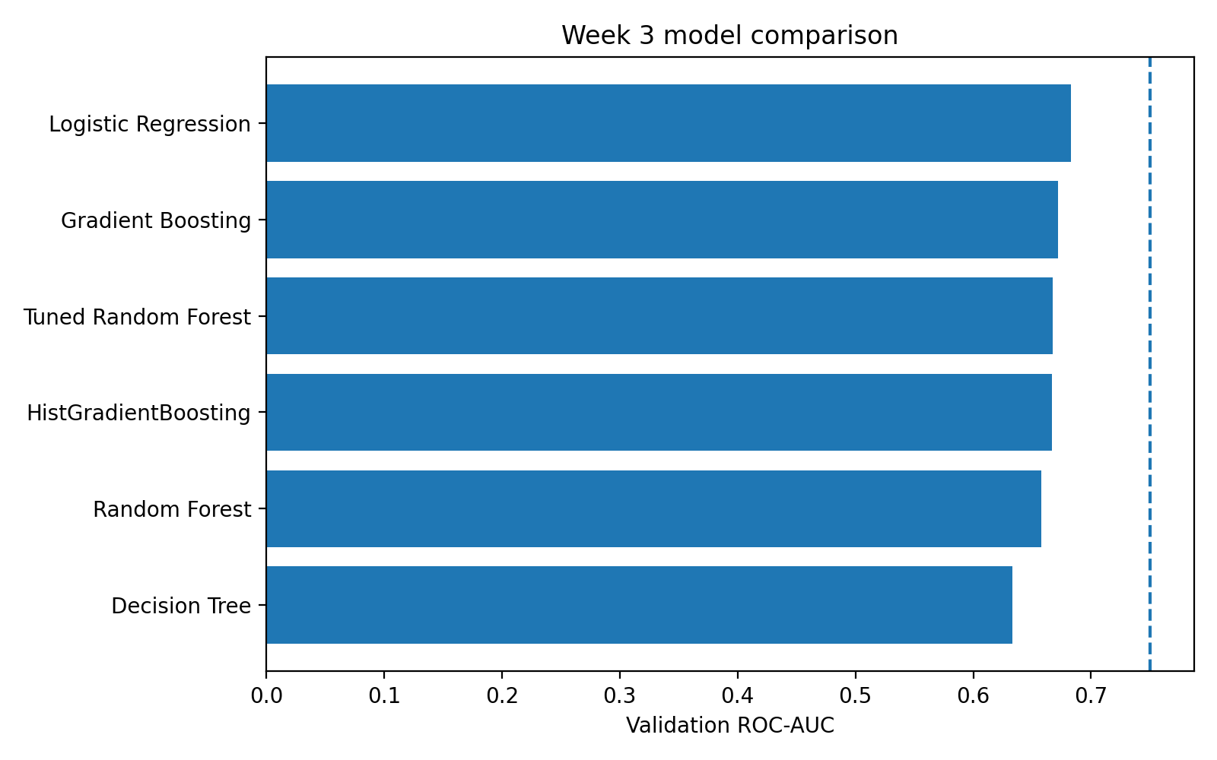
Figure 15 — Week 3 validation ROC-AUC comparison.

8. Part E — Error Analysis
At the candidate threshold of 0.4869, the refined logistic regression produces TN=830, FP=618, FN=105 and TP=248 on validation. The 105 false negatives are synthetic review cases that would not be prioritised; the 618 false positives represent additional analyst workload. The model therefore meets recall by accepting low precision rather than by creating an impression of uniformly strong classification.
Outcome | Count | Operational reading
True negatives | 830 | Transactions correctly left outside the prioritised review queue.
False positives | 618 | Unflagged synthetic cases sent to review; main workload cost.
False negatives | 105 | Flagged synthetic cases missed by the queue; binding risk controlled through recall threshold.
True positives | 248 | Flagged synthetic cases correctly prioritised.

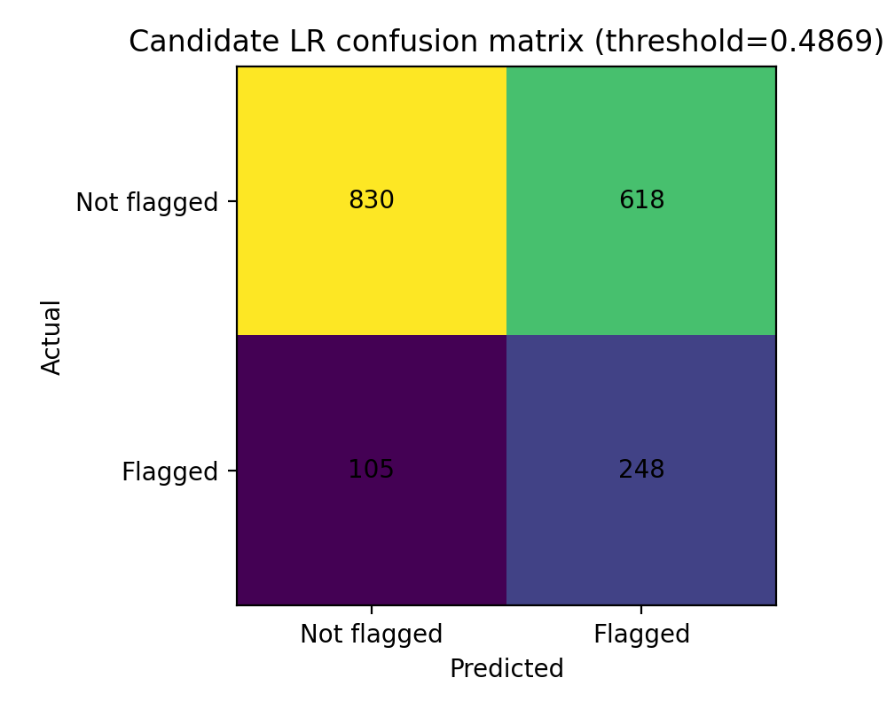
Figure 16 — Candidate logistic-regression confusion matrix at the recall-constrained validation threshold.

8.1 Error patterns by transaction type
Transaction type | n | Recall | Precision | FP | FN
Airtime/Data | 166 | 0.476 | 0.200 | 40 | 11
Bill Payment | 209 | 0.269 | 0.259 | 20 | 19
Card Purchase | 470 | 0.311 | 0.271 | 51 | 42
Cash Withdrawal | 193 | 0.885 | 0.289 | 113 | 6
Deposit | 202 | 0.424 | 0.250 | 42 | 19
Transfer | 561 | 0.950 | 0.302 | 352 | 8

8.2 What the errors mean
The failure mode is systematic. Transfer recall is 0.950 and Cash Withdrawal recall is 0.885, while Bill Payment is only 0.269 and Card Purchase 0.311. This means the model is effective where the supplied features strongly identify high-base-rate transaction categories, but it has little information for distinguishing flagged from unflagged cases inside low-signal categories. The error analysis therefore reinforces, rather than contradicts, the performance-ceiling conclusion.
The model should not be described as uniformly detecting risky transactions. A more accurate statement is that it prioritises the synthetic review label unevenly, with strong coverage in transfers/cash withdrawals and weak coverage in bill payments/card purchases.

9. Part F — Model Interpretation
Permutation importance remains the primary interpretation method so that Week 3 is directly comparable with Week 2. Logistic-regression coefficients are now added as a secondary directional check because feature refinement removed the amount multicollinearity defect.
Feature | Permutation AUC drop | Interpretation
Transaction_Type | 0.084 | Dominant signal; transaction category drives much of the ranking.
Is_Overnight | 0.052 | Strong time-of-day signal consistent with Week 2.
Amount_Band | 0.018 | Upper-tail amount effect remains useful after redundant encodings are removed.
Is_International | 0.011 | Strong per-case effect but limited by low prevalence.
Channel | 0.004 | Weak incremental contribution.
Account_Type | 0.004 | Weak customer-level contribution.
Tenure_Band | 0.004 | Weak; consistent with rejected tenure hypothesis.
Engagement_Band | 0.003 | Weak customer-level contribution.
Location | 0.002 | Near-noise contribution.
Tenure_Months | 0.001 | Near-noise contribution.

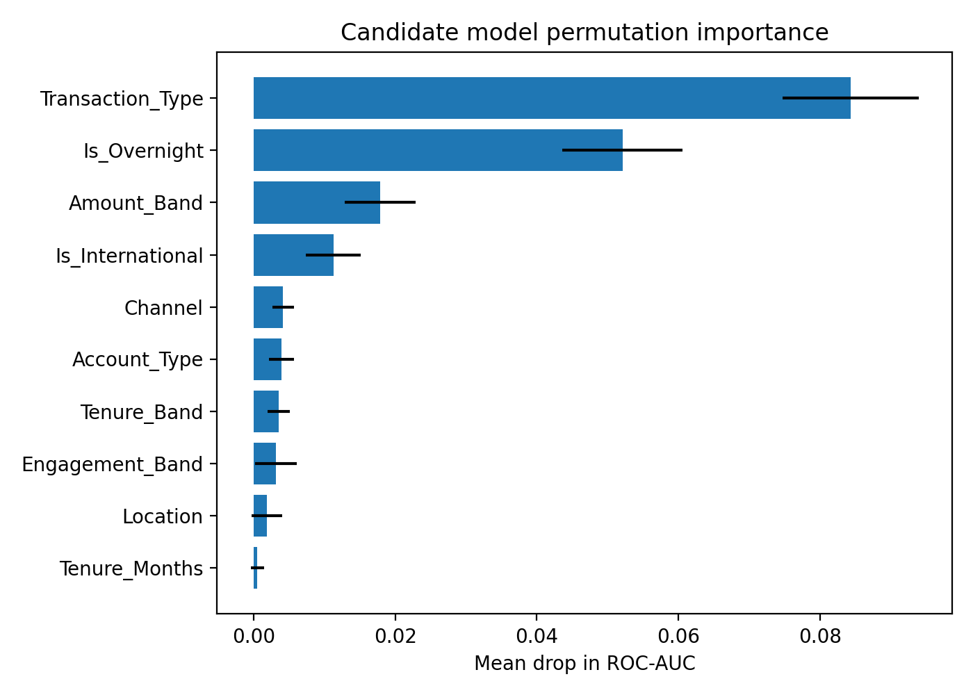
Figure 17 — Candidate model permutation importance on validation data.

9.1 Coefficient sanity check
Term | Coefficient | Reading
Is_International | +0.942 | International transactions receive higher model scores, consistent with training evidence.
Is_Overnight | +0.830 | Overnight activity increases the model score.
Transaction_Type_Transfer | +0.672 | Transfers are associated with higher review priority.
Transaction_Type_Cash Withdrawal | +0.596 | Cash withdrawals are associated with higher review priority.
Amount_Band_Q5 | +0.407 | Top amount band now has the expected positive direction.

The key validation result is Amount_Band_Q5. In Week 2 its sign contradicted the descriptive evidence because three amount encodings competed inside the same linear model. After refinement it is +0.407, matching the observed high-value pattern. This closes the Week 2 interpretation defect rather than merely working around it.

10. Part G — Candidate Final Model
The candidate final model is frozen at the end of Week 3 so that Week 4 can perform one final untouched test evaluation rather than continuing to optimise against validation.
Item | Decision / evidence
Model | Refined Logistic Regression
Features used | 16 raw inputs after Week 3 refinement
Preprocessing | StandardScaler for numeric inputs and OneHotEncoder for categoricals inside ColumnTransformer/Pipeline
Training/validation design | Original seed-42 stratified 70/15/15 split; training-only fitting; validation for Week 3 comparison
5-fold CV ROC-AUC | 0.663 ± 0.021
Validation ROC-AUC | 0.683
Operating threshold | 0.4869
Recall / precision | 0.703 / 0.286
Why selected | Highest validation AUC, interpretable, meets recall constraint, and no challenger cleared replacement rule
Known limitation | ROC-AUC target 0.75 remains unmet; low precision and missing behavioural feature categories
Week 4 status | Candidate frozen; test set not yet scored

10.1 Why the simpler model wins
The selection is not a preference for simplicity in the abstract. It follows the pre-registered evidence rule. A more complex model would replace the incumbent only if its improvement exceeded the incumbent’s own cross-fold standard deviation. None did. Retaining logistic regression therefore applies the same rule that prevented the Week 2 Random Forest from replacing it on a marginal raw AUC difference.

10.2 What would be needed to move beyond the ceiling
The evidence increasingly points toward missing feature categories rather than missing algorithm complexity. Useful future categories would include transaction velocity, device fingerprint consistency, counterparty/network relationships and richer geolocation behaviour. Those variables are not present in the supplied synthetic dataset, so Week 3 does not invent proxies for them or claim they were tested.

11. Mandatory Validation Chain
The assignment requires the explicit chain Initial Output → Test → Finding → Refinement → Re-test → Result. Week 3 contains two linked chains: one addressing interpretability and one addressing the performance ceiling.
Initial Output | Test | Finding | Refinement | Re-test | Result
Week 2 LR: CV AUC 0.665; contradictory amount coefficient | Feature redundancy review | Three overlapping amount encodings caused unstable interpretation | Keep Amount_Band; remove redundant/weak inputs | 5-fold CV + coefficient inspection | CV AUC 0.663 ± 0.021; Q5 coefficient +0.407
Week 2 performance ceiling | Tuned RF + GB + HGB | No challenger produced material CV gain | Retain simpler candidate | Validation AUC + replacement rule | LR validation AUC 0.683; ceiling persists

11.1 Improvement demonstrated
The meaningful improvement is not an inflated AUC claim. It is a model-design improvement: the refined specification removes eight weak/redundant raw inputs, restores directionally coherent coefficients and preserves performance within cross-fold noise. The re-test demonstrates that the Week 2 interpretability problem was caused by feature redundancy rather than by information that had to be retained for discrimination.

12. Testing and Quality Assurance
This section follows the same prescribed Week 2 structure: Work Completed → Test/Evaluation → Finding → Action/Improvement → Result.
# | Work Completed | Test / Evaluation | Finding | Action / Improvement | Result
T1 | Exact split reconstruction | Checked row counts and class rates | 8,399 / 1,801 / 1,800 structure preserved | Reuse seed-42 split logic | Week 2–3 evidence remains comparable
T2 | Feature refinement | 5-fold stratified CV | Mean AUC changed by only -0.0020 | Retain reduced set | Interpretability improved without material loss
T3 | Coefficient interpretation | Compared refined signs with descriptive evidence | Amount_Band_Q5 now +0.407 | Use coefficients as secondary check | Week 2 sign bug resolved
T4 | Additional model development | RandomizedSearchCV + validation comparison | No challenger materially replaces LR | Keep incumbent | Replacement rule applied literally
T5 | Recall constraint | Validation threshold search | Default operating point insufficient for binding rule | Tune threshold to 0.4869 | Recall 0.703
T6 | Error analysis | Confusion matrix + transaction-type breakdown | Recall highly uneven by type | Carry limitation into candidate decision | Aggregate recall not overstated
T7 | Interpretation | Permutation importance + coefficients | Transaction-level features dominate | Report both model-agnostic and directional evidence | Week 1–2 signal hierarchy confirmed
T8 | Test-set protection | Checked Week 3 workflow for test scoring | No Week 3 test evaluation performed | Freeze candidate | Single Week 4 scoring remains valid

13. Decision Log
Week 3 continues the Week 2 decision numbering rather than restarting it.
Decision | Reason | Evidence | Impact
D9 — Reduce feature set | Remove redundancy and weak inputs | CV -0.0020 only; Q5 sign fixed | Simpler, more interpretable candidate
D10 — Use sklearn GB/HGB | XGBoost unavailable in execution environment | No install/network access; sklearn alternatives available | Two legitimate additional model families delivered
D11 — Retain Logistic Regression | Replacement rule not met | Best new validation AUC 0.672 vs LR 0.683; no material CV gain | Candidate frozen for Week 4
D12 — Tune operating threshold | Recall ≥0.70 is binding | Threshold 0.4869 gives recall 0.703 | Accept precision 0.286 as explicit workload trade-off
D13 — Freeze after Week 3 | Repeated validation comparison creates overfitting risk | Multiple models already compared on validation | No further candidate changes before test scoring
D14 — Keep permutation importance as primary interpretation | Maintains continuity and is model-agnostic | Week 2 and Week 3 importance rankings directly comparable | Coefficients used only as secondary directional check

14. Assumptions, Limitations and Risks — Week 2 Review
The Week 2 risk register is carried forward rather than rewritten. Status changes are evidence-based and new Week 3 risks are added separately.

14.1 Prior risk register review
Risk | Week 2 status | Week 3 status | Evidence / action
R1 — Undocumented synthetic target | Materialised | Active | Target provenance still unavailable; non-fraud disclaimer remains mandatory.
R2 — Transaction_Status leakage | Resolved | Resolved | Field remains excluded.
R3 — Class imbalance | Controlled | Controlled | Threshold tuning continues to enforce recall constraint; accuracy excluded from selection.
R4 — Repeated-customer dependence | Resolved | Resolved | Week 2 grouped sensitivity was negligible; no contrary Week 3 evidence.
R5 — Performance ceiling | Materialised / managed | Materialised | Boosting did not materially improve ROC-AUC.
R6 — Final-test overfitting | Not yet active | Controlled / not yet active | Test set remains untouched; candidate frozen.
R7 — Synthetic-data generalisability | Active | Active | No real-world validation; all claims remain educational.
R8 — Review-cost assumptions | Active | Active | No supplied FP/FN cost ratio; recall-weighted threshold remains an assumption.
R10 — Temporal realism | Active | Active | Synthetic temporal generation limits behavioural/seasonality inference.
R11 — Governance / target provenance | Active | Active | Human oversight and documented provenance would be required operationally.
R12 — Feature redundancy | Active | Resolved | Redundant amount encodings removed; coefficient direction corrected.
R13 — Uneven segment recall | Active | Active | Week 3 error analysis confirms recall from 0.269 to 0.950 across types.
R14 — International coefficient stability | Active | Active | Important signal but limited prevalence; no new data added.

14.2 New Week 3 risks
New risk | Status | Why it matters | Mitigation
R15 — Validation overfitting from repeated model comparison | Active | Week 3 compares several candidates on the same validation split | Freeze candidate now; score test once in Week 4.
R16 — Low precision at recall-constrained threshold | Active | Precision 0.286 implies substantial review workload | Report workload explicitly; do not claim automated decisioning.
R17 — Missing behavioural feature categories | Materialised limitation | Model complexity did not close the AUC gap | Document absent velocity/device/network/geolocation signals; do not fabricate them.

14.3 Model and data limitations
• Validation ROC-AUC 0.683 remains below the pre-set 0.75 target.
• Precision 0.286 at the recall-constrained threshold means many reviewed cases would not carry the synthetic flag.
• Recall varies materially by transaction type; the model is not uniformly effective across products.
• Risk_Review_Flag is synthetic and undocumented; it cannot be interpreted as fraud truth.
• The available data omit behavioural categories that could plausibly improve within-category discrimination.
• No Week 3 result establishes real-world generalisability, fairness or operational suitability.

15. Week 3 Project Summary
The table below answers the Week 3 assignment points directly and leaves a clear Week 4 handoff.
Assignment point | Week 3 answer | Evidence location
Review baseline model | Week 2 LR reviewed for performance, preprocessing, feature weaknesses, errors and limitations | §4
Train ≥2 additional classifiers | Gradient Boosting and HistGradientBoosting added; tuned RF also evaluated | §5
Feature refinement | 24 raw inputs reduced to 16; redundant/weak/fairness-sensitive candidates removed | §6
Model comparison | All six models compared on accuracy, precision, recall, F1 and ROC-AUC | §7
Error analysis | 618 FP, 105 FN, 248 TP at candidate threshold; type-level patterns quantified | §8
Model interpretation | Permutation importance plus corrected LR coefficients | §9
Candidate final model | Refined Logistic Regression, threshold 0.4869, validation AUC 0.683 | §10
Validation chain | Feature-redundancy fix and algorithmic-ceiling test both re-tested | §11
Testing / QA | Eight explicit tests documented in required structure | §12
Limitations / risks | Prior register updated; R15–R17 added | §14
Week 4 readiness | Candidate frozen; test set untouched for one final score | §10, §14

15.1 Week 4 entry point
• Restart and run the final notebook in a clean environment to confirm reproducibility.
• Load the frozen refined logistic-regression specification without further validation-driven tuning.
• Score the untouched test split once and report ROC-AUC plus the pre-defined supporting metrics.
• Perform final fairness/segment review and document any gap between validation and test performance.
• Prepare final documentation and presentation without reframing Risk_Review_Flag as real fraud detection.

16. Appendices

Appendix A — File manifest
Artifact | Purpose
notebooks/03_week3_model_development_and_validation.ipynb | Self-contained Week 3 analysis; Google Drive data loading; model development, validation and interpretation.
reports/week3/FinTrust_Week3_DataScience_Submission_TJGumbo.docx | Editable Week 3 report.
reports/week3/FinTrust_Week3_DataScience_Submission_TJGumbo.pdf | Submission-ready Week 3 report.
reports/figures/fig15–fig17 | Week 3 model comparison, confusion matrix and permutation-importance figures.
README.md | Current project results, weekly progress and limitations.
WEEK3_SUBMISSION_CHECKLIST.md | Assignment-to-evidence mapping and submission checks.
social_posts_week3.md | LinkedIn and optional X copy for Week 3.

Appendix B — Reproducibility statement
The analysis uses seed 42 and the original stratified 70/15/15 split created before exploratory analysis or feature fitting. All fitted statistics are learned from training data only. Preprocessing is embedded inside scikit-learn Pipeline/ColumnTransformer objects so cross-validation refits transformations per fold. Validation is used for Week 3 model comparison, threshold selection and interpretation. The test set is not scored in Week 3 and is reserved for one final Week 4 evaluation.

Appendix C — Methodological commitments retained
• Train/validation/test split fixed before EDA or feature engineering: 70/15/15, stratified, seed 42.
• All EDA and fitted statistics use the training split only.
• Test set remains untouched until Week 4.
• Preprocessing remains inside Pipeline/ColumnTransformer objects.
• Primary metric remains ROC-AUC with recall ≥0.70 as the binding constraint.
• Accuracy is reported but excluded from model selection.
• Replacement rule remains literal: a challenger must beat the incumbent by more than the incumbent cross-fold standard deviation.
• Rejected hypotheses remain reported as results.
• Gender remains excluded; weak demographic candidates were removed under fairness scrutiny.
• No result is claimed unless produced by executed code.

Appendix D — Responsible-use statement
This project uses entirely synthetic educational data. Risk_Review_Flag is a synthetic review-prioritisation label and must not be interpreted as real fraud detection, a fraud probability, or an automated basis for adverse customer action. Model outputs are suitable only for educational demonstration of a review-prioritisation workflow. Human oversight, documented target provenance, representative real-world validation, fairness testing and governance would be required before any operational use.

