ANALYSTLAB AFRICA — DATA SCIENCE INTERNSHIP
FinTrust Digital Bank Project | Batch E
Week 2 Submission - Analyse & Prepare
Data Science Track: FinTrust Risk Review Predictive Model - Initial Development

Takudzwa Jeffrey Gumbo
Data Science Track | AnalystLab Africa Experience Lab Internship Programme
Project: FinTrust Financial Intelligence & Digital Banking Support Solution
Document control | Detail
Week | Week 2 - Analyse & Prepare
Track | Data Science
Intern | Takudzwa Jeffrey Gumbo
Date of Submission | 21 September 2026
Headline result | Logistic regression baseline: ROC-AUC 0.665 (5-fold CV, ±0.017); 0.674 on validation. Below the 0.75 target set in Week 1 - reported as a finding, not tuned away.

Contents
1. Executive Summary
2. Applying the Week 1 Plan
3. Resources and Tools Used
4. Part A — Data Preparation
5. Part B — Exploratory Data Analysis
6. Part B (continued) — Hypothesis Testing
7. Part C — Feature Engineering
8. Part D — Baseline Model Development
9. Part E — Model Evaluation
10. Part F — Model Interpretation
11. Testing and Quality Assurance
12. Decision Log
13. Assumptions, Limitations and Risks — Week 1 Review
14. Week 2 Project Summary
15. Appendices

1. Executive Summary
Week 1 defined the predictive problem and committed, in advance, to how success would be measured. Week 2 executed that plan: the datasets were joined and prepared, the split was created before any exploratory analysis, thirteen features were engineered using training data only, all five Week 1 hypotheses were formally tested, and three classification models were trained and evaluated.
The headline result is that the baseline does not reach the Week 1 target, and that this was anticipated.
Result | Value | Against Week 1 target
Logistic regression ROC-AUC (5-fold CV) | 0.665 ± 0.017 | Below the ≥ 0.75 target
Random forest ROC-AUC (5-fold CV) | 0.670 ± 0.016 | Below target; +0.005 over baseline, inside one standard deviation
Recall at tuned threshold (0.488) | 0.703 | Meets the ≥ 0.70 constraint
Precision at that threshold | 0.283 | Roughly 2.5 unnecessary reviews per genuine one
Top-decile lift over random allocation | 1.96× | Operationally meaningful despite modest AUC
Hypotheses supported | H1, H4, H5 | H2 and H3 rejected — both predicted to fail in Week 1
Four findings shape the Week 3 plan:
- The performance ceiling is real and was predicted. Week 1 recorded, before any modelling, that customer-level attributes showed almost no variation in flag rate and that a modest ceiling should be expected. Permutation importance now confirms it: every customer-level feature contributes less than 0.004 ROC-AUC, while Transaction_Type alone contributes 0.071.
- Two of five hypotheses were rejected, exactly as anticipated. Tenure (H2, p = 0.12) and channel (H3, p = 0.29) show no meaningful association. Reporting these as results rather than dropping them is what justifies not spending Week 3 capacity on tenure- or channel-derived features.
- The Transaction_Status leakage risk is resolved. Including the field adds only +0.007 ROC-AUC. Since the gain is negligible and the leakage risk is genuine, the field is excluded — a field that might leak and barely helps is not worth the methodological exposure.
- Risk R4 from the Week 1 register is resolved. The grouped split by Customer_ID returns 0.676 against 0.674 for the random split. Non-independence was a legitimate concern in principle but is immaterial here, precisely because customer attributes carry so little signal.
Week 3 will focus on hyperparameter tuning, gradient boosting, removal of redundant amount encodings, interaction terms and a full threshold and cost analysis.

2. Applying the Week 1 Plan
This section addresses General Requirement A: what was planned, what is now implemented, what changed and why.

2.1 Planned versus implemented
Week 1 plan (Stage) | Status | Where it appears
Stage 1 — Data preparation: explicit dtypes, validated join, target encoding, missing-value treatment, stratified 70/15/15 split before EDA | Complete | Notebook Part A; report §4
Stage 2 — Exploratory data analysis on the training split only | Complete — 13 figures | Notebook Part B; report §5
Stage 3 — Formal testing of H1 to H5 with effect sizes | Complete | Notebook Part B; report §6
Stage 4 — Feature engineering fitted on training data only | Complete — 13 features | Notebook Part C; report §7
Stage 5 — Logistic regression baseline with class_weight='balanced' | Complete | Notebook Part D; report §8
Stage 6 — Candidate algorithms | Partially complete — logistic regression, decision tree and random forest trained; XGBoost deferred to Week 3 as planned | Notebook Part D; report §8
Stage 7 — Class imbalance handling | Complete — class weighting applied; SMOTE assessed and deferred (see §12, Decision D6) | Report §8.3, §12
Stage 8 — Evaluation and validation, including the grouped-split sensitivity check | Complete | Notebook Part E; report §9
Stage 9 — Error analysis and limitations | Complete | Notebook Part F; report §10

2.2 What changed from the Week 1 approach, and why
Change | Week 1 position | Week 2 position | Reason
Transaction_Status excluded from the baseline | Train with and without, compare, report the difference | Excluded from the baseline model specification | The comparison was run as planned. The field adds only +0.007 ROC-AUC on validation. A negligible gain does not justify carrying a live leakage risk, so the conservative specification was adopted.
Amount encoded three ways, then flagged for reduction | Log transformation for linear models, raw for tree models | Amount_Log, Amount_Band and Is_High_Value all included, and now identified as redundant | Including all three produced unstable coefficient signs through multicollinearity. This was not anticipated in Week 1. Permutation importance is used for interpretation instead, and the redundancy is scheduled for removal in Week 3.
Txn_Count_7d replaced by Cust_Txn_Count | A strictly backward-looking 7-day rolling transaction count | Total transaction count per customer, fitted on training data | With a mean of 8 transactions per customer over 90 days, 7-day windows were almost always empty, making the feature near-constant. Week 1 flagged this sparsity risk; the data confirmed it.
Hypothesis H4 split into two tests | A single hypothesis covering international status and amount | H4a (two-proportion z-test on international status) and H4b (chi-square across amount bands) | The two components need different tests and have very different effect sizes. Splitting them makes the evidence clearer.
XGBoost deferred | Listed as a Week 3 candidate | Confirmed for Week 3 | Unchanged. Week 2 requires a baseline; adding gradient boosting before the baseline is understood would invert the intended sequence.
No change was made to the target definition, the evaluation metrics, the success thresholds or the split strategy. Fixing those in Week 1 and leaving them untouched is what makes the underperformance reportable as a finding rather than a moving target.

3. Resources and Tools Used

3.1 Resources (General Requirement B)
Resource | How it was used in Week 2 | What it provided | Limitations encountered
FinTrust_Transaction_Data.csv | Primary modelling table; source of the target and of all time-, amount- and channel-derived features | 12,000 transactions; the Risk_Review_Flag target; timestamps for the overnight feature that proved to be the second strongest predictor | 96 missing Device_Type and 96 missing Location values, treated as an explicit Unknown category. Uniform temporal generation means no seasonality analysis is credible.
FinTrust_Customer_Data.csv | Joined on Customer_ID to supply segment, account, tenure and engagement attributes | 1,500 customer records; clean one-to-many join with full referential integrity | Every customer-level feature proved to contribute less than 0.004 ROC-AUC. The file is complete and well formed; the limitation is in the signal it carries, not its quality.
FinTrust Data Dictionary | Reference for field meaning; used to justify excluding Customer_Name from modelling | Field definitions and the Modelling_Use indicator for the 12 customer fields | Covers the customer dataset only. No definition exists for Risk_Review_Flag, so the target's meaning remains inferred — carried forward from Week 1 as an unresolved limitation.
FinTrust Project Brief | Anchored the framing of the model as a review-triage tool rather than a fraud detector | Business problem, scope and governance principles | Contains no cost information for false positives versus false negatives, so the recall-weighted threshold remains an assumption.
FinTrust 4-Week Master Roadmap | Used to confirm the Week 2 scope boundary: analysis, preparation and initial development | Week-by-week track focus | Indicative only; no effect on the technical work.

3.2 Tools (General Requirement C)
Tool | What it was used for | Why it was the appropriate choice
Python 3 / Jupyter Notebook | The full analysis, from loading to interpretation | Required tool for the Data Science track; the notebook format keeps code, output and reasoning together for the assessor
pandas | Loading, joining, the missing-value treatment and all feature engineering | The validate='many_to_one' argument on the merge is what made the join assertion possible
NumPy | Log transformation, quantile cut points and threshold arrays | Underpins the quantile logic used for amount banding
Matplotlib and seaborn | All 13 figures | Matplotlib for fine control of the dual-axis and annotated charts; seaborn for the correlation heatmap and confusion matrices
scikit-learn | Pipelines, splitting, cross-validation, the three classifiers, all metrics and permutation importance | The Pipeline and ColumnTransformer objects are what enforce the no-leakage commitment mechanically rather than by discipline alone
SciPy | Chi-square tests, two-proportion z-tests and Cramér's V | Needed for the formal hypothesis testing promised in Week 1
Git / GitHub | Version control and submission of the repository | Required for portfolio evidence; commit history documents the progression from Week 1 to Week 2
XGBoost was not used in Week 2. Week 2 asks for a baseline, and the baseline has to be understood before a gradient-boosted model can be judged against it. XGBoost is scheduled for Week 3 as planned in Week 1.

4. Part A — Data Preparation
Ten preparation steps were completed. Each decision below records what was decided, why, the evidence that supported it and the effect it had on the work, as required by General Requirement F.

4.1 Load, join and validate
Both files were loaded with an explicit datetime format so that a change in the source would fail loudly rather than silently produce wrong dates. The merge used validate='many_to_one', which raises an error if Customer_ID is not unique in the customer file, and an assertion confirmed the row count was unchanged at 12,000. The merged table is 12,000 rows by 22 columns.

4.2 Inspection results
Check | Result | Action taken
Missing values | Device_Type 96 (0.80%), Location 96 (0.80%); 4 records missing both | Imputed as an explicit 'Unknown' category
Duplicate Transaction_ID | 0 | None required
Duplicate full rows | 0 | None required
Data types | 17 object/string, 2 float, 2 integer, 1 datetime after parsing | Timestamp parsed; target encoded to integer
Zero or negative amounts | 0 | None required
Ages outside 18–100 | 0 | None required
Implausible tenure (> (Age − 18) × 12) | 145 customers | Retained — see Decision D3
Duplicated customer names | 1,320 of 1,500 | Customer_Name excluded from modelling
Target distribution | 2,352 Yes (19.6%) / 9,648 No (80.4%) | Encoded 1/0; class weighting applied

4.3 Variables excluded from modelling
Variable | Reason for exclusion
Customer_Name | Display field; 1,320 of 1,500 names are non-unique. The data dictionary marks it as not for modelling.
Customer_ID | Identifier. Including it would let the model memorise individual customers instead of learning transferable patterns.
Transaction_ID | Unique per row; carries no generalisable signal.
Gender | Protected attribute. Using it to prioritise transactions for human review is not defensible, and profiling showed no material variation across its levels in any case.
Transaction_DateTime | Raw timestamp replaced by derived hour, day-of-week and overnight features.
Transaction_Status | Leakage risk — may be set as a consequence of review rather than before it. Tested explicitly in §9.3 and excluded.
Risk_Review_Flag | The target itself.

4.4 The split, created before any analysis
A stratified 70/15/15 split was created immediately after preparation and before a single exploratory chart was drawn. This ordering is the most consequential methodological decision in the notebook: it means no pattern observed during exploration could influence a feature definition, and every derived statistic could be computed on training data alone.
Split | Rows | Positive rate | Use
Train | 8,399 | 0.1960 | All EDA, hypothesis testing, feature fitting and model training
Validation | 1,801 | 0.1960 | Model comparison, threshold selection, permutation importance
Test | 1,800 | 0.1961 | Untouched in Week 2 — scored once in Week 4

5. Part B — Exploratory Data Analysis
Thirteen figures were produced, all on the training split. The most informative are reproduced below; the full set is in the notebook and in reports/figures/.

5.1 Transaction type is the strongest single driver
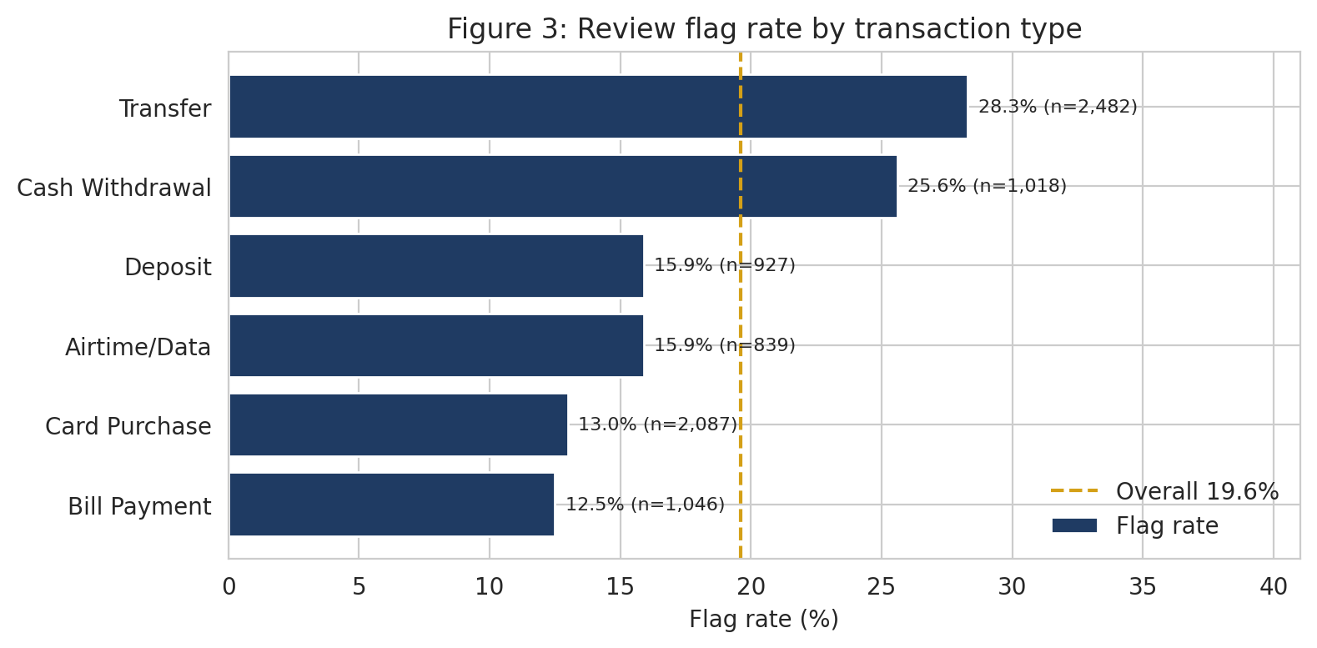
Figure 3 — Review flag rate by transaction type (training split). Dashed line is the overall 19.6% rate.
What it shows: flag rates range from 12.4% for bill payments to 28.5% for transfers, with cash withdrawals at 26.9%. Why it matters: this is the widest spread of any single variable examined, and it survives into the model as the largest permutation importance. Business insight: transfers and cash withdrawals account for a disproportionate share of review volume, so any capacity planning should be built around those two product types rather than around total transaction volume.

5.2 The overnight window
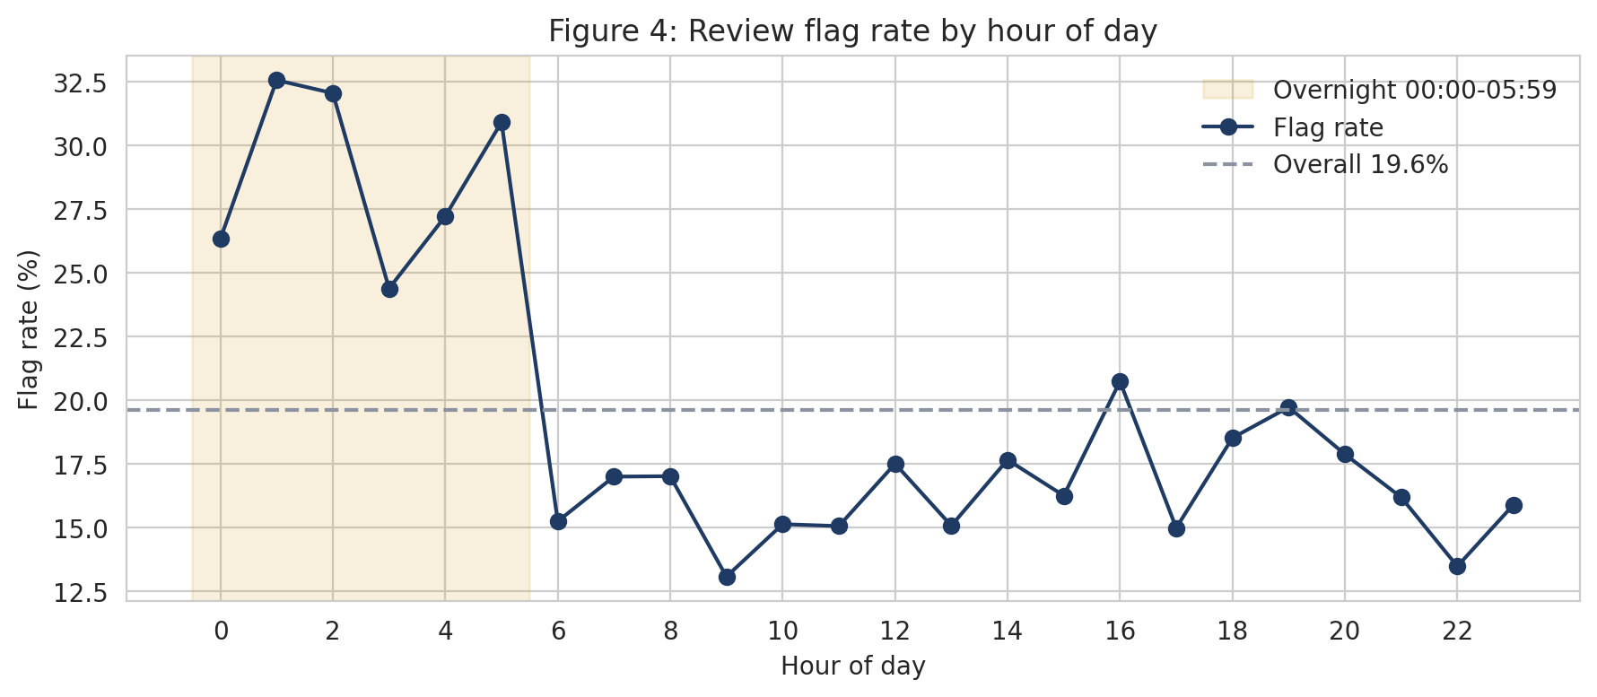
Figure 4 — Review flag rate by hour of day, with the 00:00–05:59 window shaded.
What it shows: the flag rate sits near 28–31% for every hour between midnight and 05:59, then drops sharply from 06:00 and stays between 15% and 20% for the rest of the day. Why it matters: this confirms the hypothesis revision made in Week 1, where the originally assumed window (before 07:00 or after 22:00) was corrected to 00:00–05:59 after profiling showed late evening sitting below the daytime rate. Business insight: overnight transactions warrant a different review posture from daytime transactions, and the boundary is sharp enough at 06:00 to be operationally usable.

5.3 Customer attributes are close to inert
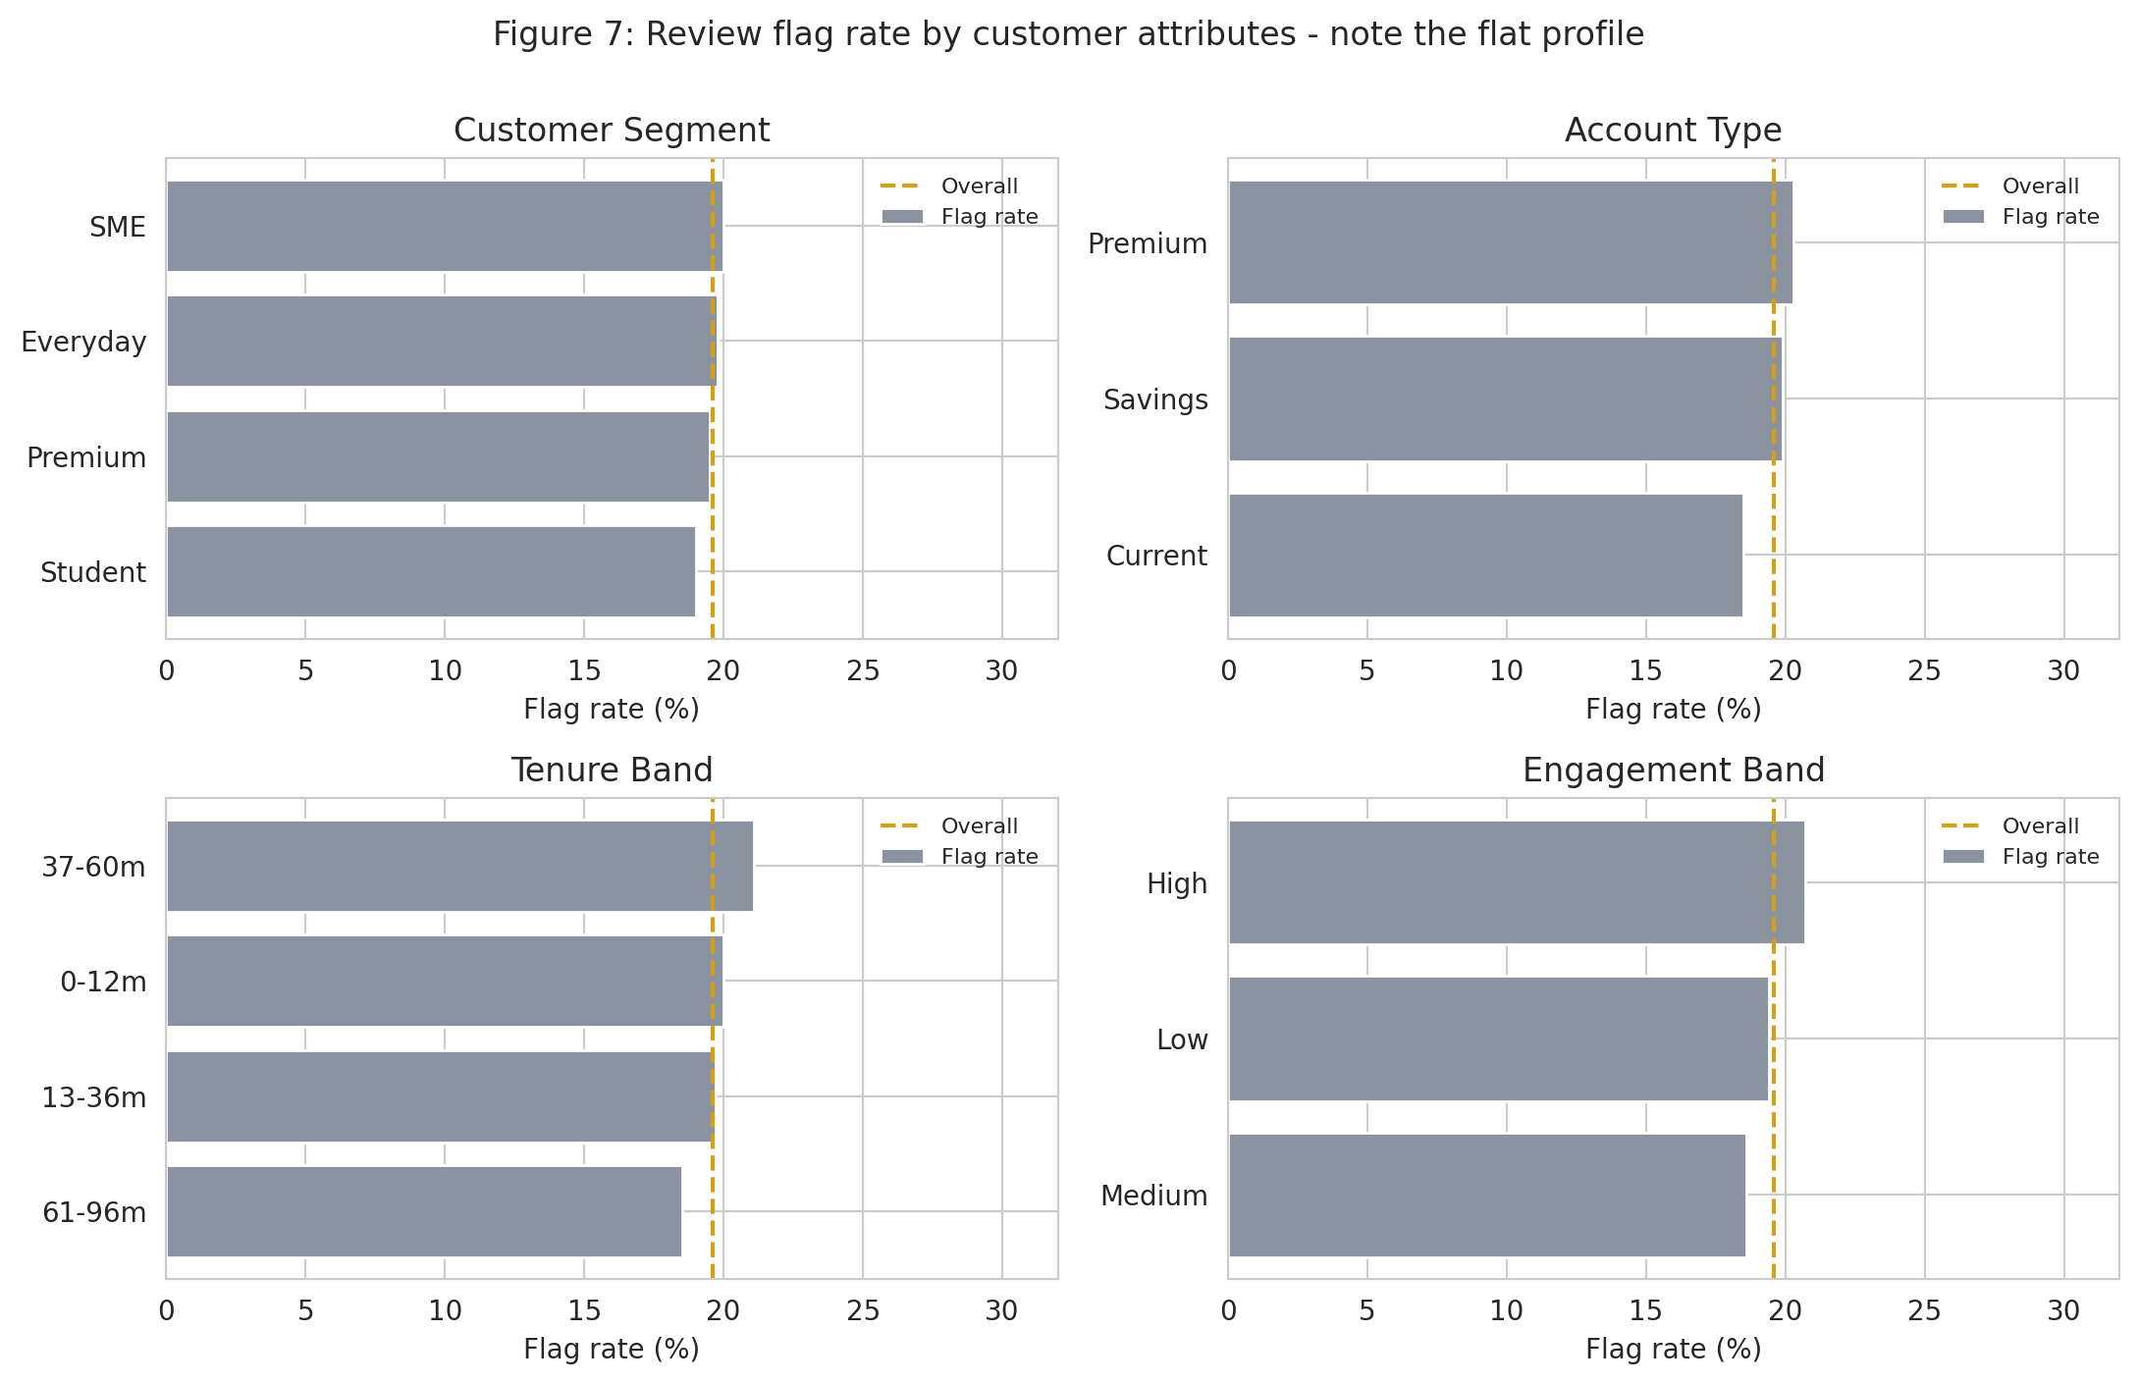
Figure 7 — Review flag rate by customer segment, account type, tenure band and engagement band.
What it shows: every level of every customer attribute sits within roughly two percentage points of the overall rate. Why it matters: this is the single most consequential EDA finding of Week 2. It confirms the expectation recorded in Week 1 and explains, in advance of the modelling results, why the ROC-AUC target was not met. Business insight: on this synthetic data, who the customer is tells you almost nothing about whether a transaction is reviewed; what the transaction is tells you a great deal. Any future FinTrust risk model should be built primarily on transaction behaviour.

5.4 International status and transaction status
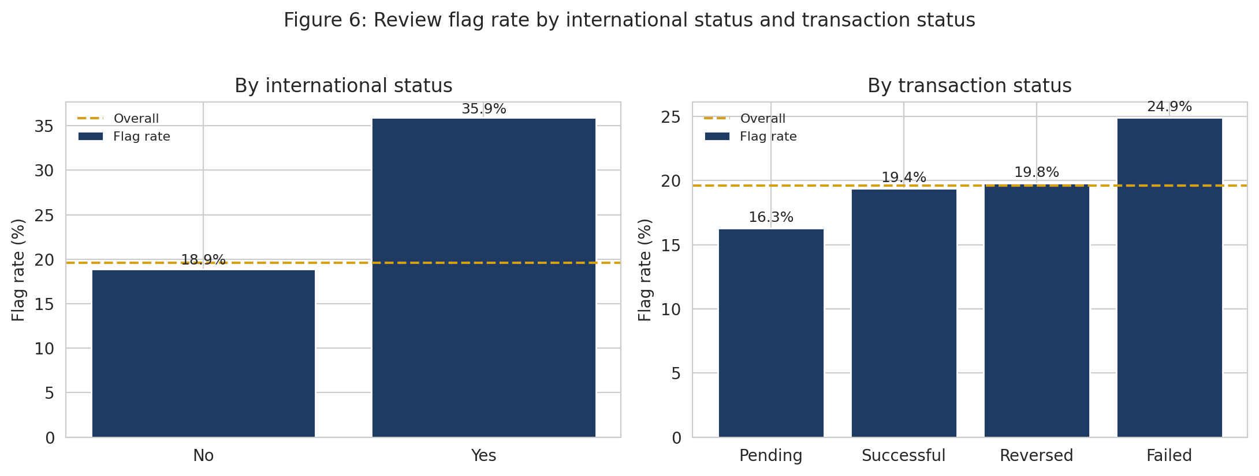
Figure 6 — Review flag rate by international status and by transaction status.
What it shows: international transactions carry a 35.9% flag rate against 18.9% for domestic, the largest single-variable gap in the data. Transaction status shows a smaller spread, with failed transactions elevated. Why it matters: the international effect is large per transaction but applies to only 4% of records, which is why it produces the largest model coefficient yet a modest permutation importance. Business insight: cross-border activity is a high-yield review filter, but it cannot carry a review programme on its own because the volume is small.

5.5 Amount behaves non-linearly
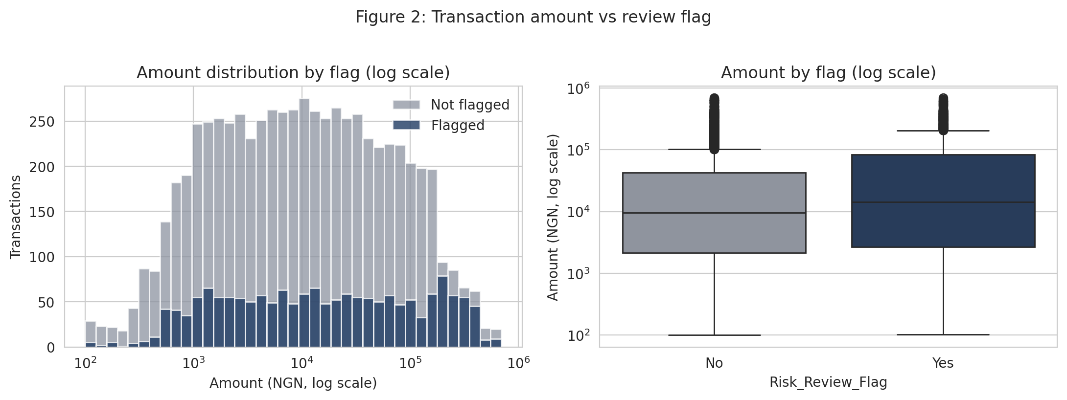
Figure 2 — Transaction amount distribution and boxplot by review flag, logarithmic scale.
What it shows: the flagged and unflagged distributions overlap heavily across most of the range and separate only in the upper tail. Median amount is ₦14,311 for flagged transactions against ₦9,631 for unflagged, while the means are ₦69,322 and ₦41,146 respectively. Why it matters: the gap between the median and mean differences confirms the effect is concentrated in large transactions rather than spread across the distribution. Business insight: a simple amount threshold would capture part of the pattern, but it would miss the majority of flagged transactions, which sit in ordinary amount ranges.

5.6 Feature redundancy
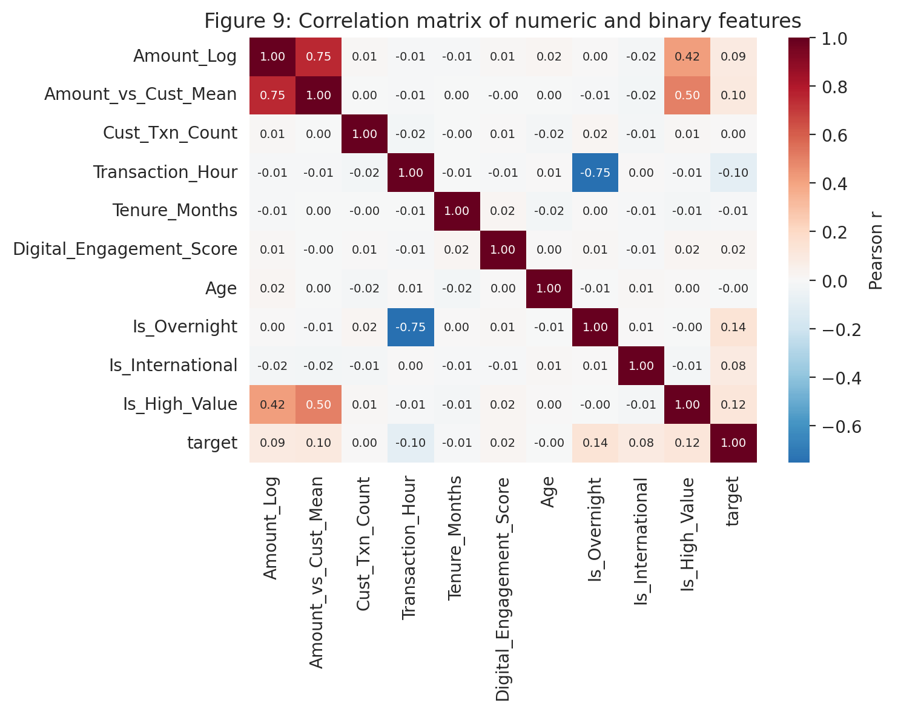
Figure 9 — Correlation matrix of numeric and binary features against the target.
What it shows: no single numeric feature correlates strongly with the target; the strongest is the overnight indicator. It also shows the amount features correlating with each other. Why it matters: this is the first visible sign of the multicollinearity that later destabilised the coefficient signs, and it is the evidence behind the Week 3 action to reduce the amount encodings to one.

6. Part B (continued) — Hypothesis Testing
All five Week 1 hypotheses were tested on the training split at α = 0.05, with Cramér's V reported alongside each p-value. With 8,399 records, statistical significance is easy to obtain; effect size is what determines whether a variable is worth modelling.
ID | Hypothesis | Test | Statistic | p-value | Effect | Verdict
H1 | Transactions deviating from the customer's own typical amount are flagged at a different rate | Chi-square across quintiles of Amount / customer mean | χ² = 71.43, dof = 4 | 1.13 × 10⁻¹⁴ | Cramér's V = 0.092 (small). Top quintile 26.8% vs 16.7–18.6% elsewhere | Supported
H2 | Customers with shorter tenure have a different flag rate | Chi-square across tenure bands | χ² = 5.77, dof = 3 | 0.123 | Cramér's V = 0.026 (negligible). Range 18.5%–21.1%, no gradient | Not supported
H3 | Digital self-service channels are flagged at a different rate from physical channels | Chi-square across five channels | χ² = 5.02, dof = 4 | 0.285 | Cramér's V = 0.024 (negligible). Range 18.5%–21.3% | Not supported
H4a | International transactions are flagged at a higher rate | Two-proportion z-test | z = 7.72 | 1.13 × 10⁻¹⁴ | 35.9% vs 18.9% — a 17.0 percentage point difference | Supported
H4b | High-value transactions are flagged at a higher rate | Chi-square across amount quintiles | χ² = 74.04, dof = 4 | 3.19 × 10⁻¹⁵ | Cramér's V = 0.094. Top quintile 27.0% vs 17.2–18.8% elsewhere | Supported
H5 | Overnight transactions (00:00–05:59) are flagged at a higher rate | Two-proportion z-test | z = 12.47 | < 10⁻¹⁵ | 28.9% vs 16.4% — a 12.4 percentage point difference | Supported

6.1 Interpreting the rejections
H2 and H3 were both predicted to fail in Week 1, on the basis of descriptive profiling that showed almost no variation across tenure bands or channels. Both failed. Two points follow.
- The rejections are results, not gaps. They are the evidence for not spending Week 3 capacity engineering tenure-derived or channel-derived features, and they corroborate the broader finding that the synthetic label is generated from transaction attributes.
- Predicting them in advance is what makes them credible. Had the profiling been done after the tests, the same observation would read as rationalising a null result.

6.2 A caveat on H1
H1 is supported, but the effect is very likely confounded with absolute transaction size: a transaction in the top quintile of a customer's own distribution is usually also large in absolute terms, and H4b shows absolute size is itself associated with the flag. The permutation importance of Amount_vs_Cust_Mean is 0.003, close to noise, which is consistent with the customer-relative framing adding little once raw amount is in the model. Disentangling the two is a Week 3 task and is recorded as such in §14.
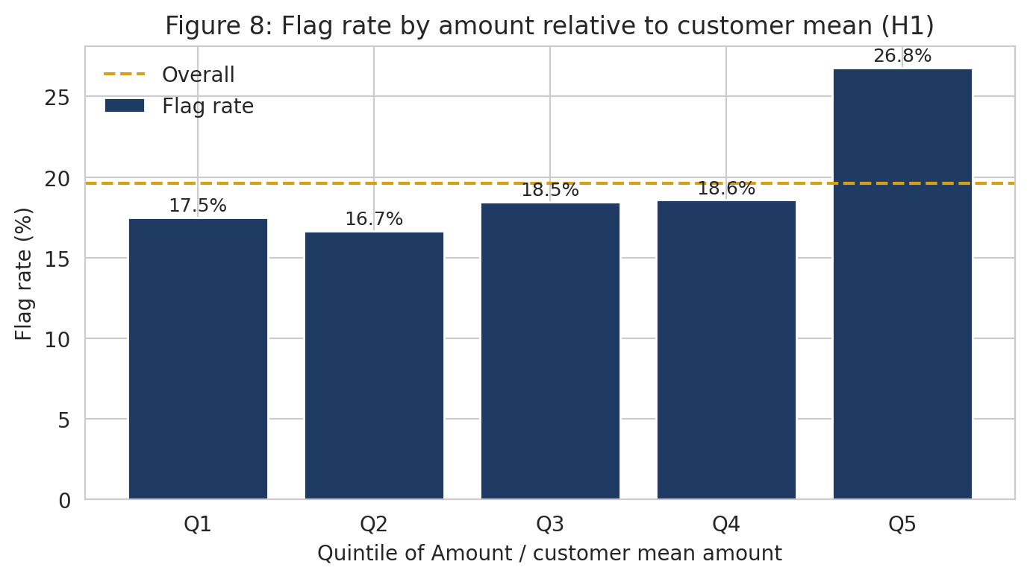
Figure 8 — Flag rate by quintile of amount relative to the customer's own mean (H1).

7. Part C — Feature Engineering
Thirteen features were engineered, exceeding the required minimum of eight. Every statistic used in the transformations — customer mean amounts, quantile cut points, customer transaction counts — was computed on the training split only and then applied unchanged to validation and test, so that applying the function to held-out data cannot leak information back into the features.
# | Feature | How it was created | Why it may matter | Outcome
1 | Transaction_Hour | Hour component extracted from the parsed Transaction_DateTime | Time of day was the clearest pattern in Week 1 profiling | Retained; permutation importance 0.001 as a raw integer — the binary form below carries the signal
2 | Is_Overnight | Binary indicator for hours 00:00–05:59, using the window corrected in Week 1 | The overnight window shows a materially elevated flag rate | Second strongest feature; permutation importance 0.049
3 | Transaction_DayOfWeek | Day name extracted from the timestamp | Tests whether weekend activity behaves differently | Negligible contribution; candidate for removal in Week 3
4 | Is_Weekend | Binary indicator for Saturday and Sunday | Compact form of the weekday hypothesis | Negligible contribution
5 | Amount_Log | log(1 + Amount_NGN) | Amount is right-skewed with the mean 4.5× the median; linear models need the transformation | Permutation importance 0.018, but redundant with features 6 and 7
6 | Amount_Band | Quintile bands cut at the training-split 20th, 40th, 60th and 80th percentiles | The relationship with the target is non-linear, concentrated in the top quintile | Permutation importance 0.020 — the strongest amount encoding
7 | Is_High_Value | Binary indicator for amounts above the training-split 95th percentile (₦225,482) | Tests whether a hard threshold captures the upper-tail effect | Permutation importance 0.006; redundant with features 5 and 6
8 | Cust_Mean_Amount | Mean transaction amount per customer, computed on training rows only; unseen customers receive the training global mean | Provides the denominator for the customer-relative feature | Intermediate feature, not used directly in the model
9 | Amount_vs_Cust_Mean | Amount_NGN divided by Cust_Mean_Amount | Tests H1 — a deviation of 5× is meaningful for one customer and routine for another | Permutation importance 0.003, close to noise; likely confounded with raw amount
10 | Cust_Txn_Count | Count of transactions per customer on the training split; unseen customers receive 0 | Frequency of activity may distinguish habitual from occasional customers. Replaced the planned 7-day rolling count, which was too sparse to be usable | Negligible contribution
11 | Is_International | Binary encoding of International_Transaction | Cross-border activity is a standard escalation trigger | Largest model coefficient (+0.95); permutation importance 0.008, limited by the 4% base
12 | Tenure_Band | Tenure_Months cut into 0–12, 13–36, 37–60 and 61–96 month bands | Tests H2 — whether newer relationships behave differently | H2 rejected; permutation importance 0.003
13 | Engagement_Band | Digital_Engagement_Score cut into Low (≤40), Medium (41–70) and High (>70) | Tests whether digital behaviour intensity relates to review | Permutation importance 0.004; among the strongest of a weak customer-feature set
Three of the thirteen — Amount_Log, Amount_Band and Is_High_Value — encode the same underlying quantity. Including all three was a deliberate test of which encoding captures the non-linearity best; it succeeded in identifying Amount_Band as the strongest, but at the cost of destabilising the coefficient signs. That trade-off and its resolution are documented in §10.1 and §12 (Decision D5).

8. Part D — Baseline Model Development

8.1 Modelling data preparation
Model inputs comprise 7 numeric features, 4 binary indicators and 13 categorical features, expanded by one-hot encoding with the first level dropped. Numeric features are standardised. Both transformations sit inside a scikit-learn ColumnTransformer within a Pipeline, which means that under cross-validation they are refitted on each training fold and never see the held-out fold. This enforces the no-leakage commitment mechanically rather than relying on discipline.

8.2 Models trained
Model | Configuration | Role
Logistic Regression | max_iter = 2000, class_weight = 'balanced' | Baseline. Chosen because its coefficients are directly interpretable and it exposes the direction of every effect.
Decision Tree | max_depth = 6, class_weight = 'balanced' | Interpretable non-linear reference. Depth capped at 6 to keep the tree readable and limit overfitting.
Random Forest | n_estimators = 300, min_samples_leaf = 5, class_weight = 'balanced' | Primary non-linear candidate. Handles interactions without manual specification.

8.3 Class imbalance handling
class_weight='balanced' was applied to all three models, which reweights the loss function in inverse proportion to class frequency without fabricating records. SMOTE was assessed and deferred: at 19.6% positive the imbalance is moderate rather than severe, class weighting already achieves recall above the 0.70 constraint, and synthetic oversampling of transaction records risks generating implausible combinations such as an international airtime purchase at an ATM. If Week 3 tuning fails to lift performance, SMOTE will be tested inside cross-validation folds as a comparison.

8.4 Results
Model | CV ROC-AUC | Val ROC-AUC | Val PR-AUC | Precision | Recall | F1 | Accuracy
Logistic Regression (baseline) | 0.665 ± 0.017 | 0.674 | 0.337 | 0.290 | 0.671 | 0.405 | 0.613
Decision Tree | 0.652 ± 0.023 | 0.625 | 0.297 | 0.276 | 0.640 | 0.385 | 0.601
Random Forest | 0.670 ± 0.016 | 0.677 | 0.342 | 0.432 | 0.252 | 0.318 | 0.799
Metrics other than the cross-validated ROC-AUC are measured on the validation set at the default 0.5 threshold. Three observations follow.
- The random forest leads on ROC-AUC by 0.005, which is smaller than the baseline's own cross-fold standard deviation of 0.017. Under the Week 1 rule that any additional model must beat the baseline by more than that standard deviation, the random forest does not yet justify replacing logistic regression. The baseline is retained for Week 2.
- The random forest's apparently strong accuracy of 0.799 is the clearest illustration of why accuracy was excluded as a selection metric in Week 1: it is achieved by predicting the negative class far more often, which drives recall down to 0.252 — the model finds only a quarter of the transactions that were actually flagged.
- The decision tree underperforms both, which is expected for a single depth-limited tree against an ensemble and a regularised linear model.
All three sit well below the 0.75 ROC-AUC target set in Week 1. This is the expected consequence of the signal ceiling documented in §5.3, and it is reported as the result.

9. Part E — Model Evaluation

9.1 Why these metrics are appropriate
Metric | Why it is appropriate for this problem
ROC-AUC (primary) | Threshold-independent. The operating point will move as review capacity changes, so the primary metric should not depend on one fixed threshold.
PR-AUC | With a 19.6% positive class, PR-AUC is more informative than ROC-AUC about performance on the minority class, which is the class of interest.
Recall | A missed review is the costlier error in a triage setting. This is the binding operational constraint, set at ≥ 0.70 in Week 1.
Precision | Determines how much analyst time is consumed by transactions that did not need review. Traded off explicitly against recall rather than optimised.
F1 | Single balanced summary for comparing models at a fixed threshold.
Confusion matrix | Converts rates into case counts, which is what a reviewer actually experiences.
Accuracy | Reported for completeness but explicitly not used for model selection — predicting 'No' for every transaction scores 80.4% while detecting nothing.
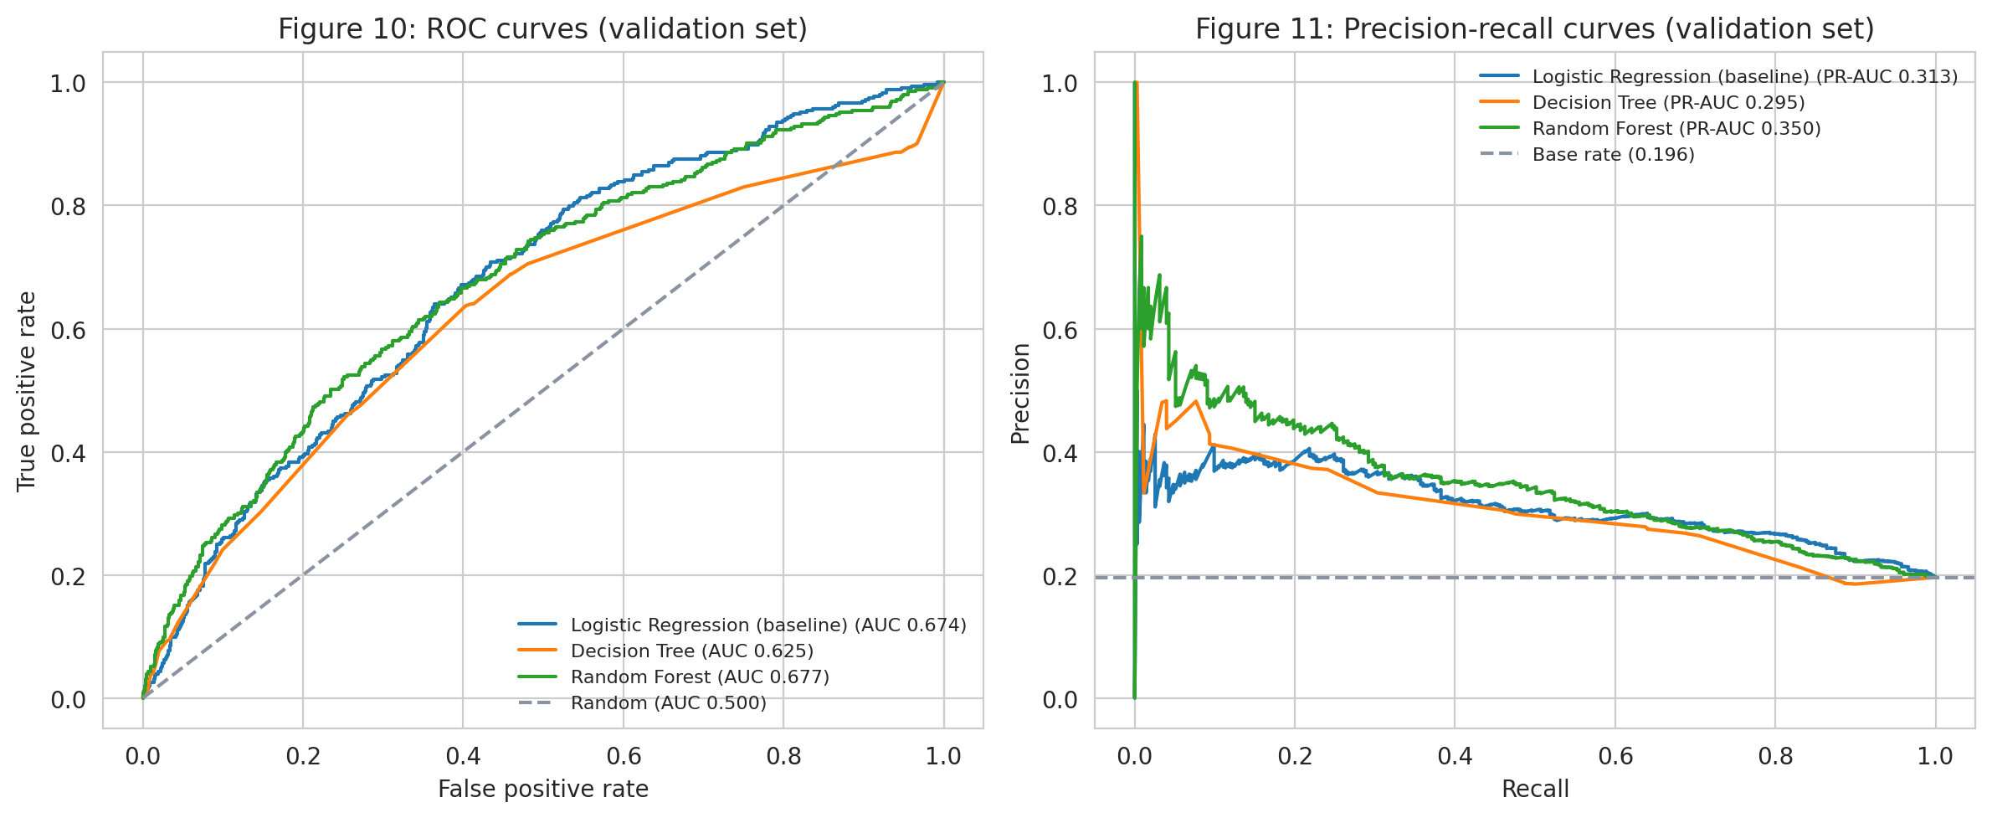
Figures 10 and 11 — ROC and precision-recall curves for all three candidates on the validation set.

9.2 Threshold selection
The Week 1 commitment was to choose the operating threshold to satisfy recall ≥ 0.70 and to state the precision cost of that choice explicitly. On the validation set the threshold that achieves this is 0.4875.
Threshold | Recall | Precision | F1 | Accuracy | TN | FP | FN | TP
Default 0.500 | 0.671 | 0.290 | 0.405 | 0.613 | 867 | 581 | 116 | 237
Tuned 0.488 | 0.703 | 0.283 | 0.404 | 0.594 | 821 | 627 | 105 | 248
The tuned threshold recovers 11 additional flagged transactions at the cost of 46 additional unnecessary reviews. At this operating point the model presents 875 transactions for review out of 1,801, of which 248 were actually flagged — a precision of 28.3%, or roughly 2.5 unnecessary reviews for every genuine one. Whether that trade is acceptable depends on the relative cost of a missed review versus an unnecessary one, which the Project Brief does not supply; the recall-weighted choice remains a documented assumption.
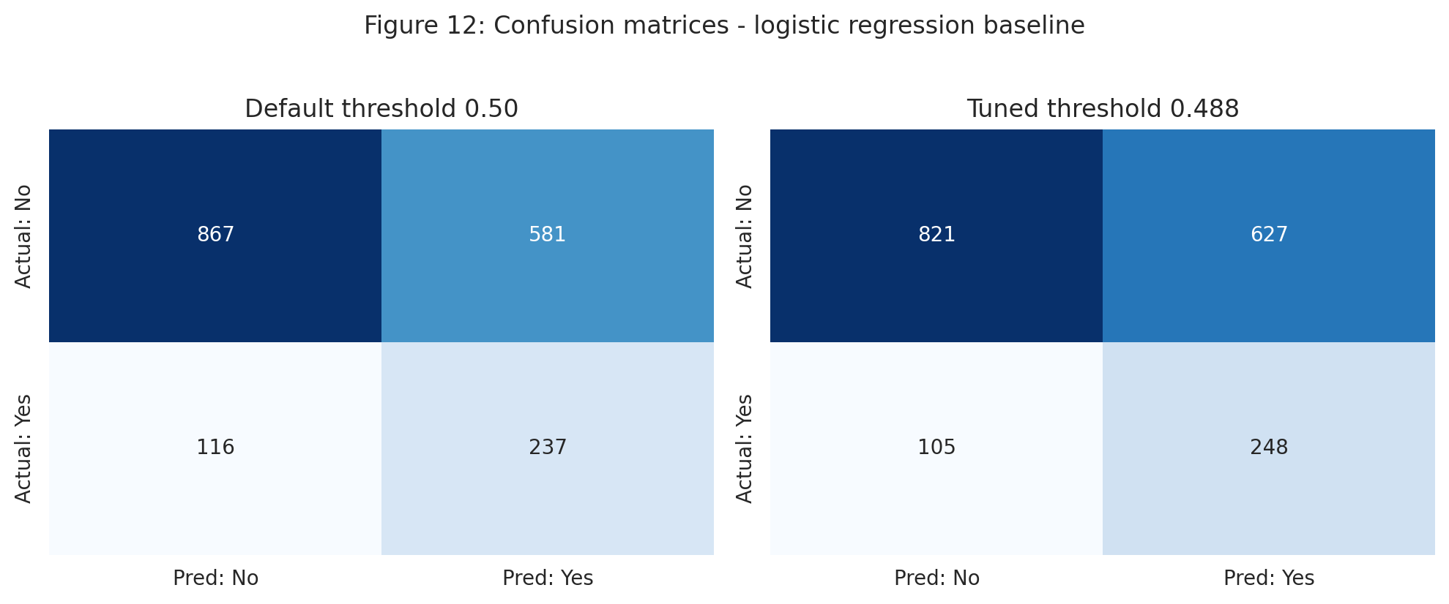
Figure 12 — Confusion matrices at the default and tuned thresholds.

9.3 Operational value despite modest discrimination
ROC-AUC of 0.67 is modest, but the operational question is whether the model allocates review capacity better than the status quo. Ranking the validation set by predicted probability and taking the top decile gives a flag rate of 38.3% against a base rate of 19.6% — a lift of 1.96×. A reviewer working the top decile of this queue encounters roughly twice as many genuinely flagged transactions as one working an unordered list. That is a meaningful improvement even though the model falls short of the discrimination target, and it is the more honest way to describe what the model currently offers.

9.4 Leakage test — Transaction_Status
Week 1 identified Transaction_Status as a leakage risk because a status such as Failed or Reversed may be set as a consequence of review rather than before it. The Week 1 commitment was to train paired models and report the difference rather than assume either way.
Specification | CV ROC-AUC | Validation ROC-AUC
Without Transaction_Status (baseline) | 0.6650 | 0.6742
With Transaction_Status | 0.6685 | 0.6812
Difference | +0.0035 | +0.0070
The field adds +0.007 ROC-AUC on validation, well inside the cross-fold standard deviation of 0.017. Decision: exclude it. A field that carries a genuine leakage risk and delivers a gain indistinguishable from noise is not worth the methodological exposure. Had the gain been large, the correct response would have been to investigate the field's timing with the data owner rather than to accept the uplift.

9.5 Grouped-split sensitivity — resolving risk R4
Week 1 recorded as risk R4 that transactions from the same customer share customer attributes, so rows are not independent and a random split could place the same customer on both sides. A GroupShuffleSplit by Customer_ID was run as the planned sensitivity check.
Split strategy | Validation ROC-AUC | Difference
Random stratified split | 0.6742 | —
Grouped split by Customer_ID | 0.6759 | +0.0017
The two are effectively identical, which resolves R4. The reason is instructive: because customer attributes carry almost no signal, sharing customers between training and validation gives the model nothing to memorise. The concern was legitimate in principle and is immaterial in this dataset — a conclusion that could only be reached by running the check rather than asserting it.

10. Part F — Model Interpretation

10.1 Feature → Evidence → Interpretation
Feature | Evidence | Interpretation
Transaction_Type | Largest permutation importance at 0.071 ROC-AUC drop (± 0.009). Flag rates from 12.4% (bill payment) to 28.5% (transfer). Coefficients: Transfer +0.60, Cash Withdrawal +0.58, Bill Payment −0.33 | The dominant driver. Transfers and cash withdrawals carry roughly double the review rate of bill payments and card purchases. Any operational deployment should segment by product type first.
Is_Overnight | Second largest permutation importance at 0.049 (± 0.008). Flag rate 28.9% vs 16.4%. Coefficient +0.85 | The strongest single binary indicator. The 06:00 boundary is sharp and stable, making it directly usable as an operational rule.
Amount_Band | Permutation importance 0.020 (± 0.003); top quintile 27.0% vs 17.2–18.8% elsewhere | Amount matters through its upper tail, not linearly. The banded encoding outperforms both the log transformation and the hard threshold.
Amount_Log | Permutation importance 0.018 (± 0.005); coefficient +0.28 | Captures the same effect as Amount_Band. Its positive coefficient alongside negative band coefficients is a multicollinearity artefact, not a finding.
Is_International | Permutation importance 0.008 (± 0.003); largest coefficient at +0.95; flag rate 35.9% vs 18.9% | The largest per-transaction effect in the model, but only 4% of transactions are international, so its contribution to overall discrimination is limited by volume rather than by strength.
Is_High_Value | Permutation importance 0.006 (± 0.001); coefficient +0.61 | Redundant with the other two amount encodings. Scheduled for removal in Week 3.
All customer-level features | Account_Type 0.004, Engagement_Band 0.004, Tenure_Band 0.003, Customer_Segment below 0.002 | Collectively negligible. Consistent with the EDA in §5.3 and with the rejection of H2. The synthetic label appears not to depend on who the customer is.
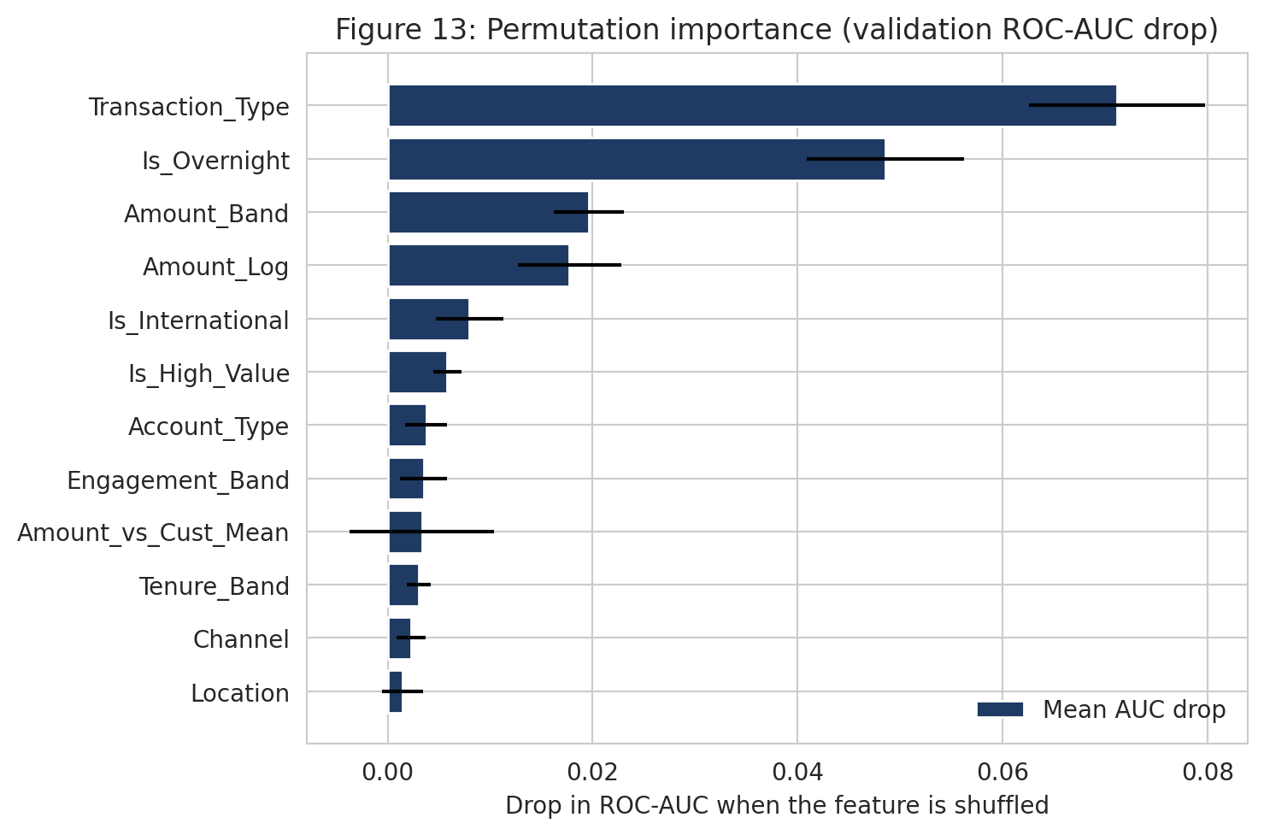
Figure 13 — Permutation importance measured as the drop in validation ROC-AUC when each column is shuffled.

10.2 Why permutation importance is trusted over the coefficients
The coefficient table shows Amount_Band_Q5 with a negative sign while Amount_Log is positive, which would read as larger amounts reducing review risk — the opposite of what every descriptive figure shows. This is a multicollinearity artefact: Amount_Log, Amount_Band and Is_High_Value all encode the same underlying quantity, so the fitting procedure distributes the effect across them in a way that is mathematically valid but individually uninterpretable.
Permutation importance measures each column's actual contribution to predictive performance by shuffling it and observing the degradation, and is not distorted by this. It is therefore the basis for the interpretation above. The underlying redundancy is a genuine design flaw in the Week 2 feature set, not merely a presentational issue, and reducing the three encodings to one is the first item on the Week 3 list.

10.3 Error analysis — where the model succeeds and fails
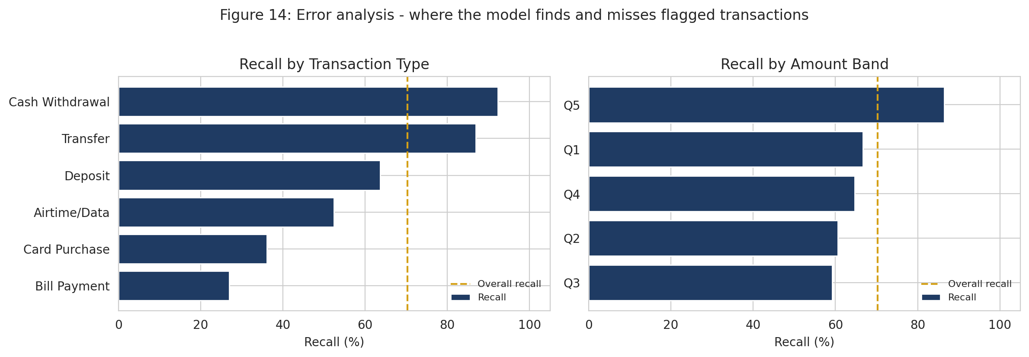
Figure 14 — Recall by transaction type and by amount band at the tuned threshold.
Segment | n | Actual flag rate | Recall | Reading
Cash Withdrawal | 193 | 26.9% | 92.3% | Strong — the model finds almost all flagged cash withdrawals
Transfer | 561 | 28.5% | 86.9% | Strong, and this is the highest-volume flagged segment
Deposit | 202 | 16.3% | 63.6% | Moderate
Airtime/Data | 166 | 12.7% | 52.4% | Weak
Card Purchase | 470 | 13.0% | 36.1% | Weak — high volume, low recall
Bill Payment | 209 | 12.4% | 26.9% | Weakest segment in the model
Overnight transactions | 440 | 28.9% | 89.8% | Strong
Daytime transactions | 1,361 | 16.6% | 59.3% | Moderate
International | 65 | 32.3% | 95.2% | Strong, but a very small base
The failure mode is systematic rather than random: the model performs well precisely where the base rate is high and poorly where it is low. It has learned the strong categorical signals — transfer, cash withdrawal, overnight, international — and has essentially nothing to distinguish a flagged bill payment from an unflagged one. Recall of 26.9% on bill payments means roughly three in four flagged bill payments are missed. If the FinTrust use case required uniform coverage across product types, this model would not be fit for that purpose, and that limitation should be stated to any stakeholder before the aggregate metrics are discussed.

10.4 Limitations

Model limitations
- Cross-validated ROC-AUC of 0.665 falls short of the 0.75 target set in Week 1. The shortfall is reported rather than addressed by tuning towards the number.
- Precision at the tuned threshold is 0.283, meaning roughly 2.5 unnecessary reviews per genuine one.
- Recall varies from 26.9% to 92.3% across transaction types, so aggregate performance conceals substantial segment-level variation.
- No hyperparameter tuning has been performed; all three models use sensible defaults. Week 3 work.
- Three redundant amount encodings destabilise the coefficient signs, so the linear model is currently not safely interpretable at the coefficient level.

Data limitations
- The label is synthetic and no definition was supplied for it, so its generating rule remains inferred.
- Transaction volume is uniform by construction — exactly 500 per hour — so no seasonality or burst analysis is credible.
- Customer attributes are point-in-time rather than as-at-transaction-date, introducing mild look-ahead in tenure and account status.
- Channel and Device_Type are internally inconsistent, so they cannot be interpreted as corroborating each other.
- Only 4% of transactions are international, so that coefficient rests on 340 training cases.

Possible sources of bias
- The label records a review decision, not a confirmed outcome. Any selection bias present in the original review process is learned and reproduced by the model.
- Gender is excluded by design. Age and Monthly_Income_Band were retained as candidates but show negligible importance and are candidates for removal in Week 3 on the same fairness reasoning — a feature that cannot earn its place should not be carried when it is demographically sensitive.
- The model's uneven recall across transaction types means review effort would concentrate on transfer and cash-withdrawal customers, which is a distributional consequence worth stating even on synthetic data.

Areas requiring further investigation
- Whether Amount_vs_Cust_Mean adds anything once absolute amount is in the model, or whether H1's support is entirely a reflection of H4b.
- Whether interaction terms — international × high value, overnight × transfer — lift performance above the additive ceiling.
- Whether gradient boosting finds non-linear structure that the linear baseline and the shallow forest miss.
- Whether the poor recall on bill payments and card purchases reflects genuinely absent signal or a feature set that does not describe those products well.

11. Testing and Quality Assurance
This section addresses the Week 2 testing requirement using the prescribed structure: Work Completed → Test/Evaluation → Finding → Action/Improvement → Result. Seven tests were performed.
# | Work completed | Test / evaluation | Finding | Action / improvement | Result
T1 | Join of the customer and transaction datasets | Merge executed with validate='many_to_one' and an assertion on row count | Join preserved exactly 12,000 rows; no fan-out and no loss | No change required; assertion retained in the notebook so any future data change fails loudly | Join integrity verified and permanently guarded
T2 | Feature engineering pipeline | Applied the training-fitted function to validation and test; checked for unseen customers | 7 of 1,500 customers appear only outside the training split and have no fitted mean | Added a fallback to the training global mean and a zero transaction count for unseen customers | Pipeline runs on all three splits without error or silent nulls
T3 | Baseline model specification | Trained paired models with and without Transaction_Status | Including the field adds only +0.007 validation ROC-AUC, inside the cross-fold standard deviation | Excluded the field from the baseline specification | Leakage risk R2 from the Week 1 register closed; the baseline carries no known leakage path
T4 | Independence of observations | GroupShuffleSplit by Customer_ID compared against the random stratified split | Grouped 0.6759 vs random 0.6742 — a difference of 0.0017 | No change to the split strategy; documented the reasoning | Risk R4 from the Week 1 register closed
T5 | Coefficient interpretation | Compared logistic regression coefficient signs against the descriptive flag rates | Amount_Band_Q5 has a negative coefficient while every descriptive figure shows the top quintile elevated — a contradiction | Diagnosed multicollinearity across the three amount encodings; switched interpretation to permutation importance and scheduled removal of the redundant encodings | Interpretation is now based on a metric that is robust to the redundancy; the underlying flaw is documented and scheduled
T6 | Threshold selection | Swept the precision-recall curve to find the threshold meeting recall ≥ 0.70 | Default 0.5 gives recall 0.671, just below the Week 1 constraint | Lowered the threshold to 0.4875 | Recall 0.703, constraint met; precision cost of 0.007 documented rather than hidden
T7 | Notebook reproducibility | Executed the full notebook from a clean kernel, top to bottom, with no manual intervention | Ran to completion with no errors; all 13 figures regenerated | None required; random seed fixed at 42 throughout | Every figure and number in this report is reproducible from the submitted notebook

12. Decision Log
This section addresses General Requirement F. Each decision records what was decided, why, the evidence and the effect on the work.
ID | Decision | Reason | Evidence | Impact on the work
D1 | Impute Device_Type and Location as an explicit 'Unknown' category rather than dropping records | Dropping would discard 192 otherwise-usable transactions for no analytical gain | 0.80% missingness in each field, overlapping in only 4 records; flag rate similar whether present or missing | Full 12,000 records retained. Device_Type_Unknown appears among the larger coefficients, suggesting the missingness pattern itself carries weak signal
D2 | Create the train/validation/test split before any exploratory analysis | Prevents any pattern observed during exploration from influencing a feature definition | Methodological commitment made in Week 1 §5.2 | All EDA and all fitted statistics are confined to the training split; the test set remains untouched for Week 4
D3 | Retain the 145 customers with implausible tenure | Tenure shows no meaningful association with the target, so excluding them would cost data for no benefit | H2 rejected at p = 0.123 with Cramér's V of 0.026 | No records lost. Documented as a data-quality limitation rather than treated
D4 | Exclude Gender from the feature set | Using a protected attribute to prioritise transactions for human review is not defensible | Week 1 fairness commitment; profiling showed no material variation across levels | Removed before modelling. Age and Monthly_Income_Band retained as candidates but flagged for the same treatment in Week 3 given their negligible importance
D5 | Interpret the model using permutation importance rather than coefficients | The coefficient signs are distorted by multicollinearity across three amount encodings | Amount_Band_Q5 coefficient −0.71 while Amount_Log is +0.28, contradicting every descriptive figure | Section 10 is built on permutation importance. Reducing the amount encodings to one is the first Week 3 action
D6 | Use class_weight='balanced' and defer SMOTE | The imbalance is moderate, class weighting already meets the recall constraint, and synthetic transaction records risk implausible combinations | 19.6% positive class; recall 0.703 achieved with weighting alone | No synthetic records generated. SMOTE held as a Week 3 comparison if tuning fails to lift performance
D7 | Retain logistic regression as the selected model despite the random forest's marginally higher ROC-AUC | The Week 1 rule requires any replacement to beat the baseline by more than the cross-fold standard deviation | Random forest +0.005 against a baseline standard deviation of 0.017 | The interpretable model is retained for Week 2. The rule is applied as written rather than relaxed to favour the newer result
D8 | Replace the planned 7-day rolling transaction count with a total customer transaction count | The 7-day windows were almost always empty, making the feature near-constant | Mean of 8 transactions per customer across a 90-day window | A usable frequency feature was retained, though it proved to contribute little. The sparsity risk was anticipated in Week 1

13. Assumptions, Limitations and Risks — Week 1 Review
This section addresses Week 2 requirement 10: which Week 1 items remain relevant, which are resolved, which have changed, and what is new.

13.1 Risk register update
ID | Risk from Week 1 | Status | Evidence and action
R1 | Model fails to reach ROC-AUC ≥ 0.75 because the synthetic label carries limited signal | Materialised | Confirmed at 0.665 CV. Reported as a finding with its cross-fold standard deviation, as committed in Week 1. Week 3 will test whether tuning and gradient boosting lift it, but the ceiling is expected to hold
R2 | Target leakage through Transaction_Status | Resolved | Paired models showed only +0.007 ROC-AUC. Field excluded from the baseline
R3 | Leakage through engineered features computed on the full dataset | Controlled | All statistics fitted on the training split; transformations enclosed in Pipeline objects so cross-validation refits them per fold. No further action needed
R4 | Non-independence of rows, since transactions share customer attributes | Resolved | Grouped split matched the random split within 0.002 ROC-AUC
R5 | Over-reliance on customer features that carry little signal | Materialised and managed | Every customer feature scored below 0.004 permutation importance. They are retained for now but are candidates for removal in Week 3
R6 | Overfitting during hyperparameter tuning | Not yet active | No tuning performed in Week 2. Becomes live in Week 3
R7 | Findings misinterpreted as real fraud detection | Active — mitigated | Synthetic-label statement repeated in the report, the notebook, the README and both professional posts
R8 | Data-quality issues distort results | Active — monitored | 145 implausible-tenure customers retained. Since tenure carries no signal, the sensitivity check planned in Week 1 is no longer informative and has been deprioritised
R9 | Reproducibility failure | Controlled | Notebook verified to run from a clean kernel; seed fixed at 42; dependencies pinned
R10 | Schedule pressure across concurrent weekly deliverables | Active | Week 2 front-loaded the pipeline work as planned, leaving Week 3 for tuning and analysis rather than construction
R11 | Cross-track hand-offs arrive late or unusable | Active — not yet triggered | No formal collaboration required in Week 2. The prepared modelling dataset and feature specification are now available for the ML Engineering track when integration begins

13.2 New risks identified in Week 2
ID | New risk | Prob. | Impact | Mitigation
R12 | Feature redundancy across the three amount encodings makes the linear model uninterpretable at the coefficient level and may mask the true contribution of each | High | Medium | Reduce to a single amount encoding in Week 3 and re-estimate; continue using permutation importance for interpretation in the interim
R13 | Severely uneven recall across transaction types (26.9% to 92.3%) means aggregate metrics overstate usefulness for low-base-rate products | High | Medium | Report segment-level recall alongside every aggregate metric; state the limitation before discussing headline performance with any stakeholder
R14 | The international coefficient rests on only 340 training cases, so it may not be stable across resampling | Medium | Low | Check coefficient stability across cross-validation folds in Week 3 and report the spread

13.3 Assumptions
Assumption | Status after Week 2
Risk_Review_Flag indicates a transaction selected for risk review | Unchanged and still inferred. No transaction-level dictionary was supplied
A missed review is more costly than an unnecessary one | Unchanged. Still the basis for weighting recall above precision, and still an assumption rather than sourced guidance
Customer attributes are stable enough over 90 days for point-in-time values to be acceptable | Unchanged, and now lower-impact: since customer attributes contribute almost nothing, any anachronism in them has correspondingly little effect on results
Amount_NGN is denominated in Nigerian Naira | Unchanged. No currency field exists to confirm it
Each row is one distinct transaction | Verified — zero duplicate transaction IDs and zero duplicate rows

14. Week 2 Project Summary
This section addresses Week 2 requirement 11.
# | Item | Summary
1 | What I planned to accomplish | Execute Stages 1 to 9 of the Week 1 modelling plan: prepare and join the data, run EDA on a training split created beforehand, test all five hypotheses, engineer features without leakage, fit a logistic regression baseline, evaluate it against the pre-committed metrics, and interpret the result
2 | What I actually completed | All nine stages. 13 features engineered, 13 figures produced, 5 hypotheses tested, 3 models trained and compared, threshold tuned to the recall constraint, leakage test and grouped-split check completed, permutation importance and segment-level error analysis produced
3 | Tools used | Python 3, pandas, NumPy, SciPy, Matplotlib, seaborn, scikit-learn, Jupyter Notebook, Git and GitHub
4 | Key findings | Baseline ROC-AUC 0.665 (CV), below the 0.75 target. H1, H4 and H5 supported; H2 and H3 rejected. Transaction_Type and the overnight indicator dominate; every customer-level feature contributes under 0.004. Top-decile lift of 1.96× over random allocation. Leakage and non-independence risks both resolved
5 | Major challenges | Three: the coefficient signs contradicted the descriptive evidence, which required diagnosing multicollinearity and changing the interpretation method; the planned 7-day rolling count proved too sparse to use and had to be replaced; and reconciling a below-target headline metric with a model that nonetheless doubles review efficiency required careful framing rather than either overclaiming or dismissing the result
6 | Important decisions and why | Eight decisions logged in §12. The most consequential were excluding Transaction_Status on a leakage-versus-benefit judgement, retaining logistic regression under the Week 1 improvement rule despite the random forest's marginally higher AUC, and switching interpretation from coefficients to permutation importance
7 | Changes to the Week 1 approach | Five changes, all documented in §2.2 with reasons. No change was made to the target, the metrics, the success thresholds or the split strategy
8 | Testing performed | Seven tests documented in §11 using the prescribed Work → Test → Finding → Action → Result structure, covering join integrity, pipeline robustness, leakage, independence, interpretation validity, threshold selection and reproducibility
9 | Key limitations | Performance below target; precision of 0.283 at the tuned threshold; recall varying from 26.9% to 92.3% across product types; redundant amount encodings; the synthetic and undefined label; uniform temporal structure
10 | Remaining work | Hyperparameter tuning; gradient boosting; removal of redundant amount encodings; interaction terms; disentangling H1 from absolute amount; coefficient stability checks; the single test-set scoring in Week 4
11 | Proposed focus for Week 3 | Establish whether the 0.67 ceiling is a property of the data or of the model. Tune the random forest and fit XGBoost; if neither moves performance materially, that becomes the finding and Week 4 documents the ceiling with evidence rather than treating it as a failure

15. Appendices

Appendix A — Submission file manifest
File | Purpose
reports/week2/FinTrust_Week2_DataScience_Submission_TJGumbo.pdf | This document — the main Week 2 submission
notebooks/02_week2_eda_and_baseline_model.ipynb | Complete Week 2 analysis; runs top to bottom from a clean kernel
data/processed/fintrust_modelling_dataset.csv | Prepared modelling dataset — 12,000 rows × 36 columns including all 13 engineered features
reports/figures/fig01–fig14 | All 13 figures, saved with descriptive filenames
README.md | Repository overview, updated with Week 2 results
requirements.txt | Pinned dependencies for reproducibility

Appendix B — Reproducibility
- Random seed fixed at 42 for every split, model fit and permutation importance calculation.
- All preprocessing enclosed in scikit-learn Pipeline objects, so cross-validation refits transformations per fold.
- The notebook was executed from a clean kernel, top to bottom, with no manual intervention, before submission.
- Every figure in this report was generated by the submitted notebook and saved to reports/figures/.
- Every numeric result quoted in this document comes from that notebook run. No figure has been estimated or carried over from a previous version.

Appendix C — Responsible-use statement
Risk_Review_Flag is a synthetic educational label created for the AnalystLab Africa Experience Lab. It is not a fraud determination. The model described in this document must not be presented as a fraud detection system, must not be used to make real financial decisions, and says nothing about real customers or real financial crime. Every customer, transaction and amount referenced here is fictional. This statement is repeated in the notebook, the repository README and any public post describing this work.
End of Week 2 submission — Data Science Track — Takudzwa Jeffrey Gumbo

