ANALYSTLAB AFRICA — DATA SCIENCE INTERNSHIP
FinTrust Digital Bank Project | Batch E
Week 1 Submission - Understand & Plan
Data Science Track: FinTrust Predictive Intelligence Problem Definition

Takudzwa Jeffrey Gumbo
Data Science Track | AnalystLab Africa Data Science Internship Programme
Project: FinTrust Financial Intelligence & Digital Banking Support Solution
Document control | Detail
Week | Week 1 - Understand & Plan
Track | Data Science
Intern | Takudzwa Jeffrey Gumbo
Project | FinTrust Financial Intelligence & Digital Banking Support Solution
Date of submission | 20 September 2026

Contents
1. Executive Summary
2. Business Understanding
3. Resource Review
4. Data Science Track Objectives
5. Success Criteria
6. Part A — Predictive Problem Statement
7. Part B — Target Variable Assessment: Risk_Review_Flag
8. Data Understanding and Data-Quality Observations
9. Part C — Candidate Feature Table
10. Part D — Research Hypotheses
11. Part E — Initial Modelling Plan
12. Week 2–4 Implementation Plan
13. Risk Register
14. Future Cross-Track Dependencies
15. Assumptions, Limitations and Responsible-Use Statement
16. Appendices

1. Executive Summary
This document is my Week 1 submission for the Data Science track of the FinTrust Digital Bank Experience Lab. Week 1 is a foundation week: the objective is to define the predictive problem precisely, assess whether the proposed target variable can actually support a model, profile the supplied data, state testable hypotheses, and set out a modelling plan for Weeks 2 to 4. No model is trained in Week 1 and no analytical conclusions are claimed.
I profiled both supplied datasets in Python before writing this plan, so that every figure quoted here comes from the data itself rather than from assumption. The headline observations are:
- The two datasets join cleanly. FinTrust_Customer_Data.csv holds 1,500 customers across 12 fields and FinTrust_Transaction_Data.csv holds 12,000 transactions across 11 fields, covering 1 January to 31 March 2026. Every transaction resolves to a customer and every customer has at least one transaction, giving a clean one-to-many relationship on Customer_ID (mean 8 transactions per customer, range 1 to 20).
- Risk_Review_Flag is usable as a supervised target. It is binary (Yes/No), fully populated, and moderately imbalanced at 2,352 flagged transactions (19.6%) against 9,648 unflagged (80.4%) — roughly a 1:4.1 ratio. This is imbalanced enough to rule out accuracy as a metric, but not so extreme that resampling is automatically required.
- Data quality is good but not perfect. There are no duplicate keys and no missing values in the customer file; the transaction file has 96 missing Device_Type values (0.80%) and 96 missing Location values (0.80%), overlapping in only 4 records. Several internal-consistency and plausibility issues are documented in Section 8 and will shape the cleaning strategy in Week 2.
- Preliminary profiling suggests the label is associated with transaction-level attributes rather than customer-level attributes. Flag rates vary materially across transaction amount, hour of day, international status and transaction type, but are almost flat across customer segment, account type, tenure band and income band. This is an observation about the supplied synthetic data, not a finding about banking risk, and it is the single most important input to my feature strategy.
The plan that follows commits to a binary classification model predicting Risk_Review_Flag, evaluated primarily on ROC-AUC (target ≥ 0.75) with recall on the flagged class (target ≥ 0.70) as the key operational metric, validated using stratified five-fold cross-validation against a held-out test set. Throughout, Risk_Review_Flag is treated as a synthetic educational label and never as a real determination of fraud.

2. Business Understanding

2.1 What problem is FinTrust trying to solve?
FinTrust Digital Bank serves a growing customer base through mobile, web, USSD, POS and ATM channels, and is accumulating customer and transaction data faster than it can convert that data into decisions. The Project Brief describes an organisation that holds the raw material for insight but lacks an integrated capability to act on it: it cannot see customer and transaction behaviour clearly, it cannot systematically identify unusual or higher-risk transaction patterns, it has no predictive input into risk decisions, and it has no reliable way to operationalise analytical output or to give customers grounded digital support.
Stated as a single business problem: FinTrust reviews transaction risk reactively and manually, which does not scale with transaction volume, and it has no quantified, repeatable way to decide which transactions deserve human attention first.

2.2 Why is the problem important?
- Cost of review capacity. Manual review is finite. On the supplied data, roughly one transaction in five carries a review flag. If review effort is allocated arbitrarily, analyst time is spent disproportionately on low-concern transactions while genuinely unusual activity waits in the queue.
- Customer experience. Every unnecessary hold, decline or query imposes friction on a customer who has done nothing wrong. Better prioritisation is as much a customer-experience objective as a risk objective.
- Operational consistency. A model applies the same criteria to every transaction. Human reviewers, working under time pressure across shifts, cannot guarantee that consistency.
- Scalability. Transaction volume grows with the customer base; review headcount does not grow proportionally. A predictive triage layer is how the gap is absorbed.
- Evidence for governance. A documented model, with measured performance and stated limitations, is auditable in a way that individual judgement is not.

2.3 How can the Data Science track contribute?
The Data Science track is responsible for the predictive layer in the FinTrust solution flow: Customer & Transaction Data → Analytics & KPIs → Predictive Risk Intelligence → ML Workflow/Service → Knowledge-Based GenAI Support. My contribution is to establish whether historical transaction and customer attributes carry enough signal to anticipate the review flag, to quantify how well that can be done, to explain which factors drive the prediction, and to state honestly where the approach breaks down.
Specifically, the track converts a descriptive question ("which transactions were reviewed?") into a forward-looking one ("which transactions are likely to require review, and how confident are we?"), and supplies both the scored output and the interpretation that makes the output usable by a non-technical reviewer.

2.4 What output could the Data Science track provide?
Output | Description | Primary consumer
Trained classification model | A validated model that returns a risk-review probability for each transaction, with a documented decision threshold | ML Engineering track; FinTrust risk operations
Feature importance and interpretation | Ranked drivers of the prediction, with direction of effect, supported by permutation importance and coefficient analysis | Risk management; Data Analytics track
Engineered feature specification | A documented, reproducible transformation pipeline from raw fields to model inputs | ML Engineering track
Model evaluation report | ROC-AUC, precision-recall, confusion matrix, threshold analysis and error analysis by segment | Project Management; risk governance
Scored transaction extract | A sample of transactions with predicted probabilities and risk bands, suitable for dashboarding | Data Analytics track
Limitations statement | Explicit documentation of what the model cannot be used for, given the synthetic label | All tracks; final presentation

3. Resource Review
The table below records what each approved resource contains, how I expect to use it, and the limitations I identified while reviewing it. Limitations listed here are resource limitations; data-quality observations within the datasets are treated separately in Section 8.
Resource | What it contains | How I will use it | Limitations identified
FinTrust_Transaction_Data.csv | 12,000 transactions × 11 fields: Transaction_ID, Customer_ID, Transaction_DateTime, Transaction_Type, Amount_NGN, Channel, Device_Type, Location, International_Transaction, Transaction_Status, Risk_Review_Flag. Period: 1 Jan – 31 Mar 2026. | Primary modelling table. Supplies the target and most predictive features; basis for time-derived and customer-relative engineered features. | 96 missing Device_Type and 96 missing Location values. Transaction volume is exactly uniform by hour (500 per hour) and near-uniform by day, which is not realistic banking behaviour and limits any volume-based seasonality analysis. Transaction_Status may be partly concurrent with, rather than prior to, the review decision.
FinTrust_Customer_Data.csv | 1,500 customers × 12 fields: Customer_ID, Customer_Name, Age, Gender, City, Customer_Segment, Account_Type, Tenure_Months, Digital_Engagement_Score, Monthly_Income_Band, Preferred_Channel, Account_Status. No missing values. | Joined to transactions on Customer_ID to add demographic, tenure and engagement context, and to build customer-relative behavioural features. | Point-in-time only: fields such as Tenure_Months and Account_Status describe the customer as at extraction, not as at each transaction date, which introduces a mild look-ahead risk. 1,320 of 1,500 names are non-unique, so Customer_Name must never be used as an identifier. 145 records show tenure exceeding what the customer's age plausibly allows.
FinTrust Data Dictionary | Field-level definitions, data types, business use and a modelling-use indicator. The supplied file covers the 12 customer fields. | Authoritative reference for field meaning and intended modelling use; used to justify inclusion and exclusion of variables. | Supplied as a CSV covering the Customer dataset only; the brief refers to an Excel dictionary. No definitions are provided for the transaction fields, including Risk_Review_Flag itself. The meaning of the target therefore has to be inferred from the brief and from profiling, which is a material limitation recorded in Section 7.
FinTrust Project Brief | Business scenario, business problem, objectives, key business questions, scope, team structure, success criteria and governance principles. | Anchors the problem framing, the definition of success and the responsible-use constraints applied throughout this document. | Business-level only; contains no field definitions, no target definition and no risk-appetite guidance, so the cost balance between false positives and false negatives has to be assumed rather than sourced.
FinTrust 4-Week Master Roadmap | Week-by-week focus for each track, integration principles and final presentation requirement. | Used to sequence my Week 2–4 plan and to time the cross-track dependencies in Section 14. | Indicative rather than prescriptive; exact hand-off formats between tracks are not specified and will need to be agreed from Week 2.
FinTrust_Financial_Knowledge_Base.docx | Approved customer-support knowledge base for the GenAI track: scope, account access, transaction issues, transfers, cards, fees and limits, escalation rules and evaluation rules. | Not a Data Science resource. Reviewed for awareness only, so that model outputs are described in language consistent with the approved support scope. | Out of scope for predictive modelling; contains no data relevant to the target.

4. Data Science Track Objectives
The following five objectives define my contribution for the four-week project. Each is specific, testable and within the scope of the supplied synthetic data.
- Objective 1 — Establish a validated supervised baseline. Build and document a logistic regression baseline that predicts Risk_Review_Flag, evaluated under stratified five-fold cross-validation, to provide a defensible reference point against which every later model must justify its additional complexity.
- Objective 2 — Quantify the achievable signal. Determine how much of the variation in Risk_Review_Flag can be explained by the supplied features, reported as ROC-AUC with confidence intervals across folds, and state clearly where the ceiling lies and why.
- Objective 3 — Engineer and document behaviour-relative features. Produce a reproducible feature pipeline that captures transaction timing, customer-relative amount behaviour and short-window transaction frequency, and measure the incremental contribution of each engineered feature.
- Objective 4 — Explain the model, not just score it. Deliver ranked feature importance with direction of effect and a per-segment error analysis, so that a non-technical reviewer can understand why a transaction was prioritised.
- Objective 5 — Deliver a reproducible, portfolio-grade artefact. Produce a clean notebook, a documented repository and a written evaluation that another analyst could rerun end to end and obtain the same results.

5. Success Criteria
Success is assessed at three levels: technical performance, methodological quality and business usefulness. Thresholds are set in advance so that the evaluation in Weeks 3 and 4 cannot be rationalised after the fact.

5.1 Technical success criteria
Criterion | Metric | Target | Rationale
Discrimination | ROC-AUC (mean across 5 stratified folds) | ≥ 0.75 | Threshold-independent measure of separation between flagged and unflagged transactions; the primary metric because operating thresholds may change.
Detection of flagged transactions | Recall on the positive class | ≥ 0.70 | A missed review case is the more costly error in a triage setting; recall is the operationally binding constraint.
Efficiency of review effort | Precision on the positive class | Reported and traded off explicitly against recall via the precision-recall curve | Precision determines how much analyst time is spent on transactions that did not need review.
Balanced performance | F1 and PR-AUC | Reported for every candidate model | With a 19.6% positive class, PR-AUC is more informative than ROC-AUC alone about performance on the minority class.
Improvement over baseline | ROC-AUC uplift versus logistic regression | Any additional model must beat the baseline by a margin exceeding the cross-fold standard deviation | Prevents complexity being adopted for its own sake.
Stability | Standard deviation of fold scores | ≤ 0.03 on ROC-AUC | Wide fold variance indicates the model is fitting noise rather than structure.
Generalisation | Test-set performance versus cross-validated performance | Degradation ≤ 0.05 ROC-AUC | Confirms the model has not been tuned into the validation data.

5.2 Methodological success criteria
- The train/validation/test split is created before any exploratory analysis influences feature choice, and the test set is scored once.
- Every engineered feature is computed inside a pipeline fitted on training data only, so that no target or future information leaks into the features.
- Class imbalance is addressed explicitly and the chosen approach is justified against at least one alternative.
- Every result reported in Weeks 2 to 4 is reproducible from the supplied notebook with a fixed random seed.
- Limitations are documented as findings in their own right, not as caveats added at the end.

5.3 Business success criteria
- The model produces a ranked review queue that is measurably better than random allocation of review effort, demonstrated using lift in the top decile of predicted probability.
- Model drivers can be explained to a non-technical stakeholder in plain language, with direction of effect.
- The output is in a form the ML Engineering track can consume without rework, and the Data Analytics track can visualise without re-deriving features.
- The submission states unambiguously that Risk_Review_Flag is a synthetic educational label and that the model must not be represented as a fraud detection system.

6. Part A — Predictive Problem Statement

6.1 What I want to predict
I will build a binary classification model that estimates, for an individual transaction, the probability that the transaction carries a risk-review flag (Risk_Review_Flag = Yes), using attributes of the transaction itself together with attributes of the customer who initiated it.
Formal statement: given a feature vector describing a transaction and its originating customer, predict P(Risk_Review_Flag = Yes). The output is a continuous probability in [0, 1], converted to a review/no-review decision by a threshold chosen to satisfy the recall constraint defined in Section 5.

6.2 Why prediction could be useful
A probability attached to every transaction converts an unordered review backlog into a ranked queue. The practical value is not in labelling transactions as risky or safe — it is in ordering them, so that finite review capacity is spent where the model considers concern most likely. Three specific uses follow:
- Triage. Reviewers work a queue sorted by predicted probability rather than by arrival time.
- Threshold control. Because the output is a probability rather than a hard label, the bank can move the operating point as review capacity changes, without retraining.
- Pattern articulation. Feature importance makes explicit which attribute combinations are associated with the review flag, which is useful even where the model itself is not deployed.

6.3 Who could use the prediction
User | Use of the prediction
Risk review analysts | Work a probability-ranked queue rather than an unordered list; see the top contributing factors for each transaction
Risk and compliance management | Monitor flag-rate patterns, set and review the operating threshold, evidence a consistent and documented review process
Operations management | Forecast review workload from the distribution of predicted probabilities and plan capacity accordingly
ML Engineering track | Consume the trained model and feature pipeline as the core of the operational workflow or scoring service
Data Analytics track | Incorporate predicted risk bands into dashboards alongside descriptive KPIs
Customer support (GenAI track) | Understand, at a general level, why a transaction may be under review, within the limits of the approved knowledge base

6.4 What a successful model would need to achieve
A successful model must discriminate meaningfully between flagged and unflagged transactions (ROC-AUC ≥ 0.75), recover at least 70% of flagged transactions at the chosen operating threshold, hold its performance on unseen data, and be explainable well enough that a reviewer can be told in one sentence why a transaction was ranked highly. A model that meets the statistical thresholds but cannot be explained does not meet the objective of this track.

7. Part B — Target Variable Assessment: Risk_Review_Flag

7.1 What the field represents
Risk_Review_Flag is a field in the transaction dataset that records whether a transaction was marked as warranting risk review. Because the supplied data dictionary covers only the customer dataset, no formal definition of this field was provided; its meaning is therefore inferred from the Project Brief, which describes the risk-related objective as predicting "whether a transaction requires risk review", and from profiling the field itself.
This distinction matters and is carried through the whole submission: the label records a review decision, not a confirmed outcome. It does not indicate that a transaction was fraudulent, disputed or reversed, and the brief states explicitly that it must not be treated as a real fraud determination.

7.2 Possible values and distribution
The field is a two-level categorical variable taking the values Yes and No. It is fully populated across all 12,000 transactions, with no nulls, blanks or unexpected categories, and will be encoded as 1 = Yes (flagged) and 0 = No for modelling.
Value | Count | Proportion | Modelling encoding
No — not flagged for review | 9,648 | 80.4% | 0 (negative class)
Yes — flagged for review | 2,352 | 19.6% | 1 (positive class)
Missing / other | 0 | 0.0% | Not applicable
Total | 12,000 | 100.0%
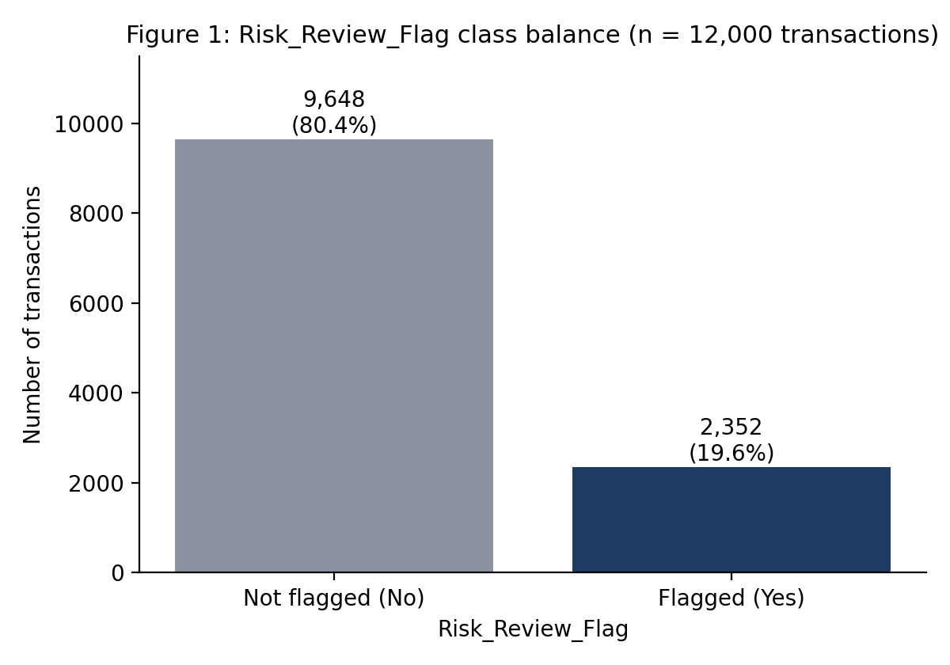
Figure 1 — Class distribution of Risk_Review_Flag across 12,000 transactions.

7.3 Can it serve as a modelling target?
Yes. The field satisfies each of the conditions a supervised target must meet:
Requirement | Assessment
Well defined and consistently recorded | Met — exactly two values, no free text, no ambiguous categories
Fully populated | Met — zero missing values across 12,000 records, so no rows are lost and no target imputation is required
Sufficient positive cases | Met — 2,352 positive cases is ample for the candidate algorithms; even a 20% test split retains roughly 470 positives
Aligned to a real decision | Met — the flag corresponds to a review action that consumes finite operational capacity
Knowable at prediction time | Partially met — the flag is the outcome to be predicted, but Transaction_Status requires scrutiny for leakage (see 7.5)
Non-degenerate class balance | Met — at 19.6% positive, the minority class is large enough to model directly with class weighting

7.4 Balanced or imbalanced?
The target is moderately imbalanced at approximately 1:4.1 (19.6% positive). Two consequences follow, and both are built into the modelling plan.
- Accuracy is unusable as a headline metric. A model that predicts "No" for every transaction achieves 80.4% accuracy while detecting nothing, so accuracy is excluded from the primary metric set and ROC-AUC, PR-AUC, recall and precision are used instead.
- The imbalance is moderate rather than severe. At roughly one positive in five, class_weight='balanced' is the proportionate first response; synthetic oversampling such as SMOTE carries a real risk of manufacturing implausible transaction records and will only be evaluated as a comparison, applied inside cross-validation folds and never before the split.

7.5 Limitations of using this target
- It is a synthetic educational label. The flag was generated for a learning exercise. Model performance measured on it says nothing about performance on real banking data, and no finding in this project may be presented as fraud detection.
- No definition was supplied. Without a dictionary entry, the precise rule behind the flag is unknown. Preliminary profiling is consistent with a rule-based generation process involving transaction amount, hour of day and international status, which would cap how much a model can learn beyond those drivers.
- Review is not confirmation. A flagged transaction is one selected for review; the review's outcome is not recorded. The model therefore learns to reproduce a selection decision, including any bias inside that decision, which is the classic selection-bias problem in risk modelling.
- Possible leakage through Transaction_Status. Failed transactions carry a 27.0% flag rate against 19.2% for successful ones. If a status such as Failed or Reversed is set as a consequence of review rather than before it, including that field would leak outcome information. I will model with and without Transaction_Status in Week 2 and report the difference rather than assume either way.
- Point-in-time customer attributes. Customer fields describe the customer at extraction, not at transaction time, so a feature such as Tenure_Months is mildly anachronistic for older transactions. The effect is small over a 90-day window but is documented.
- No cost information. The brief gives no relative cost for a missed review versus an unnecessary one, so the recall-weighted threshold is my assumption and is stated as such.
8. Data Understanding and Data-Quality Observations
Both files were profiled in Python. In line with the Week 1 instruction, no cleaning has been applied; the purpose here is to document what exists and to identify what will need treatment in Week 2.

8.1 Dataset overview
Attribute | FinTrust_Customer_Data.csv | FinTrust_Transaction_Data.csv
Records | 1,500 | 12,000
Columns | 12 | 11
Primary key | Customer_ID (unique, no duplicates) | Transaction_ID (unique, no duplicates)
Foreign key | — | Customer_ID → Customer_Data.Customer_ID
Numerical fields | Age, Tenure_Months, Digital_Engagement_Score | Amount_NGN
Categorical fields | Gender, City, Customer_Segment, Account_Type, Monthly_Income_Band, Preferred_Channel, Account_Status | Transaction_Type, Channel, Device_Type, Location, International_Transaction, Transaction_Status, Risk_Review_Flag
Date/time fields | None (Tenure_Months is a derived duration) | Transaction_DateTime (1 Jan – 31 Mar 2026)
Identifier/text fields | Customer_ID, Customer_Name | Transaction_ID, Customer_ID
Missing values | None in any field | Device_Type 96 (0.80%); Location 96 (0.80%); all other fields complete
Duplicate rows | None | None

8.2 Relationship between the datasets
The datasets form a clean one-to-many relationship: one customer record to many transaction records, joined on Customer_ID. Referential integrity is complete in both directions — every one of the 12,000 transactions resolves to a customer in the customer file, and all 1,500 customers appear in the transaction file, so an inner join loses no rows. Transaction counts per customer range from 1 to 20 with a mean of 8.0 and a median of 8.
The merged analytical table is therefore 12,000 rows by 22 modelling-relevant columns, with customer attributes repeated across that customer's transactions. That repetition has an important methodological consequence: rows are not independent, because transactions from the same customer share customer attributes. This is recorded as a modelling risk in Section 13 and is the reason grouped validation is listed as a sensitivity check in the modelling plan.

8.3 Numerical field profile
Field | Min | Median | Mean | Max | Std dev | Observation
Amount_NGN | 100.17 | 10,305.94 | 46,706.45 | 693,454.45 | 86,028.72 | Strongly right-skewed; mean is 4.5× the median. Log transformation indicated for linear models.
Age | 18 | 42 | 41.59 | 65 | 13.73 | Plausible adult range; no under-18 or implausible values
Tenure_Months | 1 | 51 | 49.86 | 96 | 27.91 | Up to 8 years; broadly uniform rather than concentrated
Digital_Engagement_Score | 16.70 | 68.00 | 67.95 | 100.00 | 17.56 | Matches the 10–100 synthetic range described in the dictionary

8.4 Data-quality observations
Ten observations are recorded below. Each is stated with its evidence, its likely impact on modelling and the treatment planned for Week 2.
# | Observation | Evidence | Impact | Planned treatment
1 | Missing Device_Type | 96 records (0.80%) | Low volume; complete-case deletion would still discard usable transactions | Impute as an explicit 'Unknown' category rather than dropping; test whether missingness itself is predictive
2 | Missing Location | 96 records (0.80%), overlapping with the Device_Type gaps in only 4 records | Independent missingness patterns, consistent with random omission | Same treatment: explicit 'Unknown' category
3 | Transaction volume is perfectly uniform in time | Exactly 500 transactions in every hour of the day; 133–134 per day across all 90 days | Real banking volume is never uniform. No volume-based seasonality or burst-detection analysis is credible on this data | Exclude volume-based temporal features; restrict time features to the flag-rate dimension and state the limitation
4 | Channel and Device_Type are internally inconsistent | ATM-channel transactions recorded with Android and iOS devices; Mobile App transactions recorded with POS Terminal and ATM Terminal devices | The two fields are close to independent, so Device_Type cannot be read as corroborating Channel | Treat as independent categoricals; do not construct a combined channel-device feature; document as a synthetic-data artefact
5 | Transaction Location is unrelated to customer City | 86.5% of transactions occur in a city other than the customer's recorded home city | Location cannot be interpreted as a home location, and a naive 'away from home' feature would be meaningless here | Retain Location as a plain categorical; do not build distance or home-mismatch features
6 | Implausible tenure relative to age | 145 customers have Tenure_Months exceeding (Age − 18) × 12 | Affects roughly 10% of customers; a banking relationship predating adulthood is questionable | Flag and retain; test sensitivity by excluding these customers and report whether results change
7 | Customer_Name is not unique | 1,320 of 1,500 names are duplicated | Name is not an identifier and must never be joined on | Exclude from modelling entirely, in line with the dictionary's 'Modelling_Use: No'
8 | Semantically unusual international transactions | International_Transaction = Yes appears against Deposit, Airtime/Data and Cash Withdrawal types | Some combinations are not realistic products | Retain — the flag is still informative — but do not interpret these categories as real product behaviour
9 | Possible target leakage via Transaction_Status | Flag rate 27.0% for Failed versus 19.2% for Successful | If status is set after review, inclusion inflates performance artificially | Train with and without the field, compare, and report the difference explicitly
10 | No transaction-level data dictionary | Supplied dictionary covers the 12 customer fields only | Field semantics, units and the target definition must be inferred | Document all inferred definitions as assumptions in the notebook and in this report

8.5 Preliminary target profiling
The figures in this sub-section are descriptive profiling only. They are reported to justify the feature and hypothesis choices that follow. No statistical test has been performed, no association has been established as significant, and none of these observations should be read as a conclusion. Formal testing is Week 2 work.
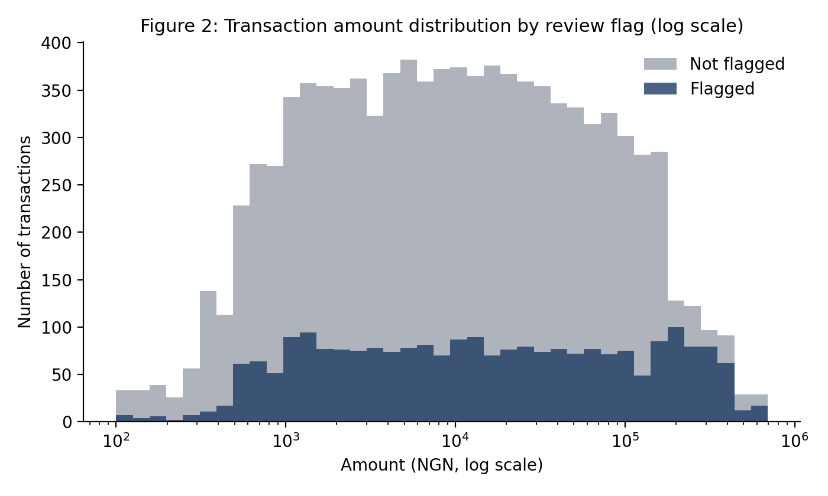
Figure 2 — Distribution of transaction amount by review flag, plotted on a logarithmic scale.
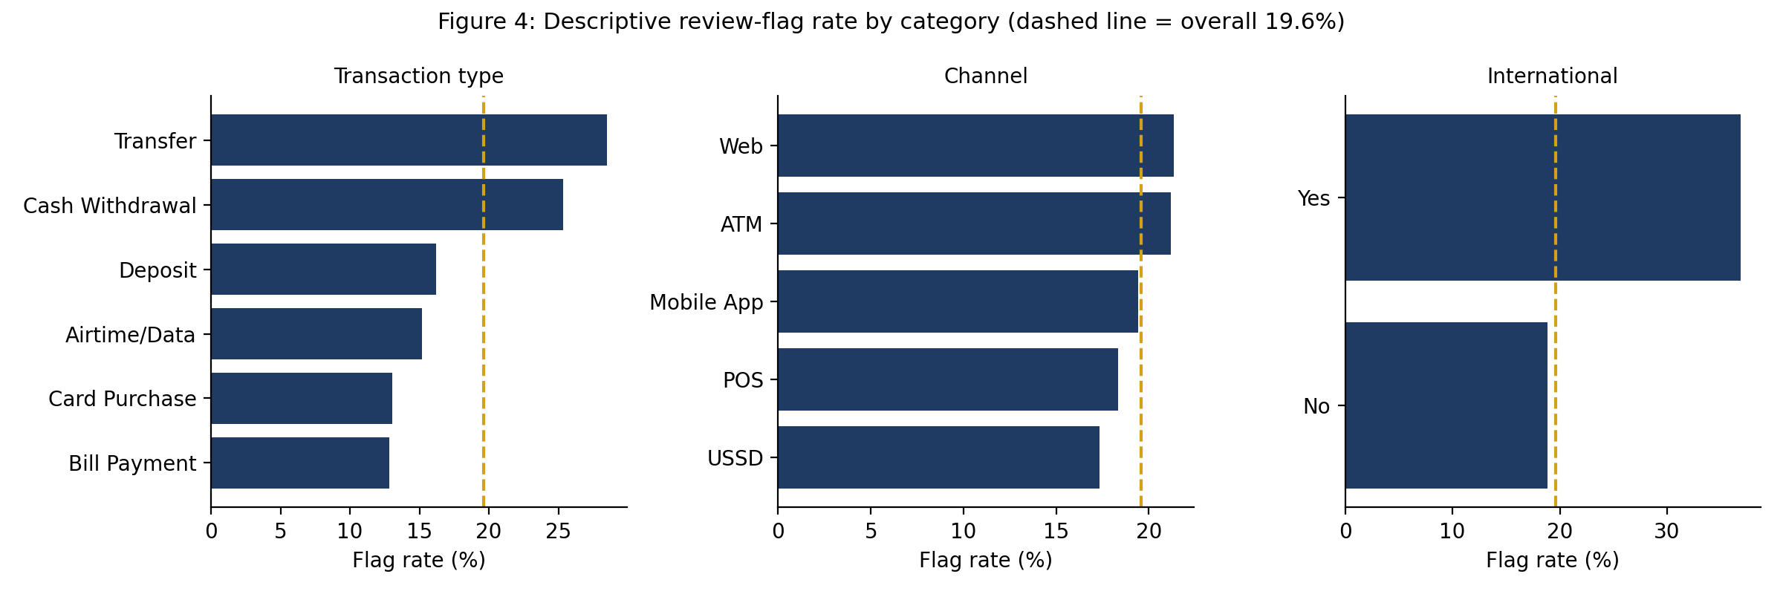
Figure 4 — Descriptive review-flag rate by transaction type, channel and international status. The dashed reference line is the overall rate of 19.6%.
Three patterns in this profiling shape the plan that follows.
- Transaction-level attributes vary; customer-level attributes barely do. Flag rates range from 12.8% to 28.5% across transaction type, from 18.9% to 36.9% across international status, and from 16.9% to 28.4% across time of day. Across customer segment (19.3%–20.3%), account type (18.0%–20.1%), tenure band (18.7%–20.6%) and income band (18.4%–20.2%) the variation is negligible.
- Amount matters in the upper tail rather than linearly. The flag rate sits between 17.4% and 18.4% across the lowest four quintiles of amount, then rises to 26.8% in the top quintile and to 40.5% above ₦200,000. A monotonic linear term will not capture this; binning or a tree-based model will.
- The elevated overnight window is narrower than the one I assumed in my original hypothesis. Hours 00:00–05:59 carry a 28.4% flag rate against 16.9% for 06:00–21:59, but 22:00–23:59 sits at 15.3% — below the daytime rate. The hypothesis in Section 10 has been restated accordingly, and Figure 3 shows the pattern.
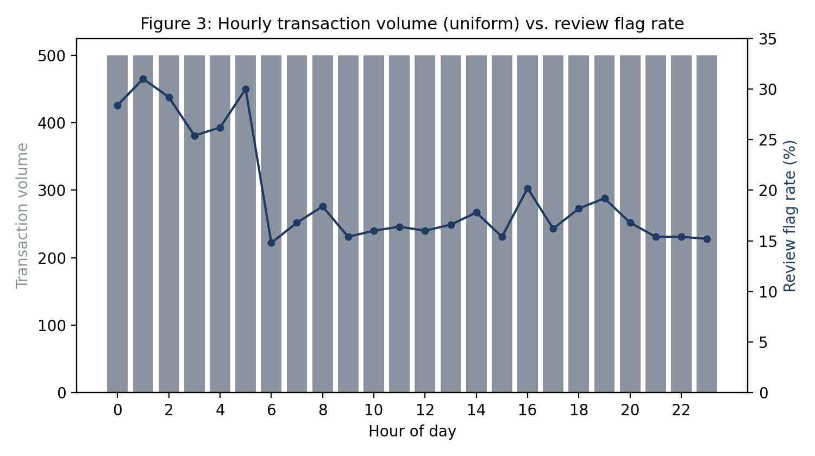
Figure 3 — Hourly transaction volume (bars, uniform by construction) against review flag rate (line).
The near-flat customer-level rates are the most consequential observation for this project. They suggest that the supplied label is driven principally by transaction attributes, and that customer features may contribute little. This is a property of synthetic data rather than a statement about banking risk. I will still test the customer features properly in Week 2 — a weak marginal association can still matter in interaction with others — but I am recording now, in advance of the results, that I expect a modest performance ceiling and that I will report it honestly rather than tuning towards a target number.

9. Part C — Candidate Feature Table
Twelve candidate features are proposed: nine drawn directly from the supplied fields and three engineered. Inclusion here is a candidate decision, not a final one; each will be assessed for predictive contribution, leakage risk and stability in Week 2.
# | Feature | Source | Why it may matter | Data type | Potential concern
1 | Amount_NGN | Transaction | Transaction value is the most commonly used single indicator in transaction monitoring; profiling shows the flag rate rising sharply in the upper tail | Numerical (continuous) | Strongly right-skewed (mean 4.5× median); relationship with the target is non-linear, so log transformation or binning is required for linear models
2 | Transaction_Type | Transaction | Product types carry different risk characteristics; observed flag rates range from 12.8% to 28.5% | Categorical (6 levels) | Correlated with amount and channel; one-hot encoding adds five columns
3 | Channel | Transaction | Channel controls the authentication path available for a transaction | Categorical (5 levels) | Observed variation is narrow (17.3%–21.3%), so the marginal contribution may be small
4 | International_Transaction | Transaction | Cross-border activity is a standard escalation trigger; the observed rate is roughly double the domestic rate | Binary | Only 480 international transactions (4.0%), so estimates for this level are supported by relatively few cases
5 | Transaction_Status | Transaction | Failed transactions show an elevated flag rate (27.0% versus 19.2%) | Categorical (4 levels) | Leakage risk — status may be set after the review decision. Will be modelled both with and without
6 | Transaction_Hour (derived) | Transaction | Derived from Transaction_DateTime; the 00:00–05:59 window shows a materially higher flag rate | Numerical (0–23), also binned | Cyclical: hour 23 is adjacent to hour 0. Will be encoded as a binned category or via sine/cosine transformation, not as a raw integer
7 | Transaction_DayOfWeek (derived) | Transaction | Tests whether weekend activity behaves differently from weekday activity | Categorical (7 levels) | Profiling shows minimal variation (18.4%–21.0%); likely to be dropped after formal testing
8 | Device_Type | Transaction | Device class may carry residual signal independent of channel | Categorical (5 levels + Unknown) | 96 missing values; internally inconsistent with Channel, so it cannot be interpreted as corroborating evidence
9 | Account_Status | Customer | Dormant and restricted accounts show a marginally higher flag rate (20.4% and 22.3% against 19.5%) | Categorical (3 levels) | Point-in-time field: status at extraction, not at transaction date. Restricted covers only 26 customers
10 | Tenure_Months | Customer | Standard lifecycle indicator; tests whether newer relationships behave differently | Numerical (integer) | Profiling shows almost no gradient (18.7%–20.6%); 145 customers hold implausible values relative to age
11 | Amount_vs_Customer_Mean (engineered) | Derived | Captures behaviour relative to the customer's own history rather than an absolute threshold — a deviation of 5× is meaningful for one customer and routine for another | Numerical (ratio) | Must be computed using training-fold data only to avoid leakage; unstable for customers with few transactions (minimum is 1)
12 | Txn_Count_7d (engineered) | Derived | Short-window transaction frequency captures bursts of activity that single-transaction features cannot see | Numerical (count) | Requires a strictly backward-looking window to avoid using future transactions; with a mean of 8 transactions per customer over 90 days, most windows will be sparse
Two supplied fields are excluded from modelling by design. Customer_Name is a display field with no predictive content and is explicitly marked as not for modelling in the data dictionary. Gender is excluded on fairness grounds: using a protected attribute to prioritise transactions for review is not defensible, and the profiling shows no material variation across its levels in any case. Age and Monthly_Income_Band are retained as candidates for the moment but will be assessed with the same fairness question in mind before any final model is proposed.

10. Part D — Research Hypotheses
These are hypotheses to be tested, not findings. Each is stated with a null and alternative form, a planned test and a falsifiable prediction. The descriptive rates quoted in Section 8 informed which hypotheses are worth testing; they do not constitute evidence for them. Each hypothesis will be tested in Week 2 at α = 0.05 with effect sizes reported alongside p-values, since with 12,000 records statistical significance is easy to obtain and practical significance is what matters.
ID | Hypothesis | Null / alternative | Planned test | Falsifiable prediction
H1 | Transactions whose value deviates substantially from the customer's own typical transaction value are flagged at a different rate from transactions near that customer's norm | H₀: flag rate is independent of the amount-to-customer-mean ratio. H₁: it is not | Chi-square test across quintiles of the ratio; logistic regression coefficient on the continuous ratio | If H₁ holds, the highest-deviation quintile shows a materially higher flag rate than the middle quintiles and the coefficient is positive and significant
H2 | Customers with shorter account tenure experience a different flag rate from longer-tenured customers | H₀: flag rate is independent of tenure band. H₁: it is not | Chi-square test across tenure bands; point-biserial correlation of tenure with the flag | If H₁ holds, the shortest tenure band shows a materially higher rate. Descriptive profiling suggests this hypothesis is likely to be rejected, which would itself be a reportable result
H3 | Transactions originating on digital self-service channels are flagged at a different rate from those on physical channels | H₀: flag rate is independent of channel. H₁: it is not | Chi-square test across the five channel levels; Cramér's V for effect size | If H₁ holds, digital channels separate clearly from ATM and POS. The observed spread is narrow, so a statistically significant but practically negligible result is a plausible outcome and will be reported as such
H4 | International transfers and high-value transactions are flagged at a higher rate than domestic and lower-value transactions | H₀: flag rate is independent of international status and amount band. H₁: it is higher for international and high-value transactions | Two-proportion z-test for international status; chi-square across amount quintiles; interaction term in logistic regression | If H₁ holds, both main effects are positive and significant and the interaction is examined for whether the combination compounds
H5 | Transactions occurring in the overnight window of 00:00–05:59 are flagged at a higher rate than daytime transactions | H₀: flag rate is independent of the overnight window. H₁: it is higher overnight | Two-proportion z-test comparing 00:00–05:59 against 06:00–23:59; hour-level chi-square | If H₁ holds, the overnight window shows a materially higher rate. Note the revision: my original hypothesis defined off-hours as before 07:00 or after 22:00, but profiling showed the 22:00–23:59 window is below the daytime rate, so the window has been narrowed before testing rather than after

11. Part E — Initial Modelling Plan
The plan runs in nine stages, each with a defined input, output and completion test.

Stage 1 — Data preparation
- Load both CSV files with explicit dtypes; parse Transaction_DateTime with an explicit format string rather than relying on inference.
- Inner join transaction to customer records on Customer_ID and assert that the row count remains 12,000, confirming no fan-out or loss.
- Encode the target as 1 = Yes, 0 = No and verify the positive rate is 19.6%.
- Apply the missing-value treatments in Section 8.4: explicit 'Unknown' levels for Device_Type and Location.
- Create a stratified 70/15/15 train/validation/test split with a fixed random seed, before any exploratory analysis informs feature decisions. The test set is not examined again until Week 4.

Stage 2 — Exploratory data analysis
- Univariate distributions for every field, with amount examined on both linear and logarithmic scales.
- Bivariate analysis of every candidate feature against the target, using flag rate for categoricals and distribution comparison for numericals.
- Correlation matrix across numerical features to identify redundancy before modelling.
- All exploratory work performed on the training split only.

Stage 3 — Hypothesis testing
- Formally test H1 to H5 as specified in Section 10, reporting the test statistic, p-value and an effect size for each.
- Report rejected hypotheses as results in their own right; a hypothesis that fails is a finding about the data, not a failure of the analysis.

Stage 4 — Feature engineering
- Derive Transaction_Hour, Transaction_DayOfWeek and an overnight indicator from the timestamp.
- Compute Amount_vs_Customer_Mean and Txn_Count_7d using strictly backward-looking windows, fitted on training data only.
- Apply a log transformation to amount for the linear baseline; retain the raw value for tree-based models.
- Encode categoricals by one-hot encoding, fitted on the training split and applied to validation and test through the same pipeline object.

Stage 5 — Baseline model
- Fit logistic regression with class_weight='balanced' as the reference model, chosen because its coefficients are directly interpretable and it exposes the direction of every effect.
- Record baseline ROC-AUC, PR-AUC, precision, recall and F1 under stratified five-fold cross-validation.
- Every subsequent model must beat this baseline by more than the cross-fold standard deviation to justify its complexity.

Stage 6 — Candidate algorithms
Model | Role | Why included
Logistic regression | Baseline | Interpretable coefficients; exposes direction of effect; fast to iterate
Decision tree | Interpretable non-linear reference | Makes threshold effects visible, which matters given the tail behaviour observed in the amount distribution
Random forest | Primary non-linear candidate | Handles interactions and non-linearity without manual specification; robust to feature scaling
XGBoost | Performance candidate | Typically strongest on tabular data of this size; supports scale_pos_weight for imbalance

Stage 7 — Class imbalance handling
- Primary approach: class_weight='balanced' for scikit-learn models and scale_pos_weight for XGBoost, which reweights without fabricating records.
- Comparison approach: SMOTE, applied inside cross-validation folds only. Resampling before splitting is a common and serious error and will be avoided explicitly.
- Both approaches compared on PR-AUC and recall; the simpler approach retained unless the more complex one produces a material gain.

Stage 8 — Evaluation and validation
Element | Approach
Validation strategy | Stratified five-fold cross-validation on the training split; a grouped split by Customer_ID run as a sensitivity check, because transactions from the same customer are not independent
Primary metric | ROC-AUC, reported as a mean with standard deviation across folds
Secondary metrics | PR-AUC, recall, precision, F1, and the full confusion matrix at the chosen threshold
Threshold selection | Chosen on the validation set to meet the recall ≥ 0.70 constraint, with the precision cost of that choice stated explicitly
Curves | ROC and precision-recall curves for every candidate model, plotted on shared axes
Hyperparameter tuning | Randomised search with cross-validation on the training split only; the search space and the selected values documented
Final evaluation | The held-out test set is scored exactly once, in Week 4, after the final model is selected

Stage 9 — Error analysis and limitations
- Segment errors by transaction type, channel, amount band and hour to identify where the model underperforms.
- Inspect the highest-confidence false positives and false negatives individually to characterise systematic failure modes.
- Compare performance across customer segments as a fairness check, even though protected attributes are excluded from the feature set.
- Document all limitations — synthetic label, inferred target definition, uniform temporal structure, point-in-time customer attributes, absent cost information — as part of the result rather than as an afterthought.

12. Week 2–4 Implementation Plan
Week | Theme | Planned activities | Deliverables | Completion test
Week 2 | Explore & Prepare | Merge datasets; full EDA on the training split; formally test H1–H5; build the feature engineering pipeline; fit the logistic regression baseline; compare imbalance handling approaches; run the leakage test on Transaction_Status | EDA notebook with saved figures; hypothesis test results table; baseline cross-validated metrics; documented feature pipeline | Baseline ROC-AUC recorded with fold-level variance; all five hypotheses tested with effect sizes reported
Week 3 | Model & Evaluate | Train decision tree, random forest and XGBoost; cross-validated comparison; hyperparameter tuning; ROC and precision-recall analysis; threshold selection; error analysis by segment; permutation feature importance | Model comparison table; tuned final candidate; confusion matrices and curves; feature importance analysis; error analysis write-up | A model selected on validation performance with the selection reasoning documented; test set still untouched
Week 4 | Refine & Present | Single scoring of the held-out test set; final documentation; notebook cleaning and reproducibility check from a fresh kernel; repository housekeeping; recorded presentation; professional posts | Final technical report; clean reproducible notebook; completed GitHub repository with README; 5–10 minute recorded presentation | A third party can clone the repository and reproduce every reported figure

13. Risk Register
Probability and impact are assessed on a three-point scale (Low / Medium / High) over the remaining three weeks of the project.
# | Risk | Prob. | Impact | Mitigation
R1 | Model fails to reach the ROC-AUC ≥ 0.75 target because the synthetic label carries limited learnable signal | Medium | Medium | Report the achieved performance honestly with its confidence interval rather than tuning towards the target; treat a modest ceiling as a finding about the data and evidence it through the feature-contribution analysis
R2 | Target leakage through Transaction_Status inflates apparent performance | Medium | High | Train paired models with and without the field, quantify the difference, and select the conservative specification unless the field can be justified as pre-review
R3 | Leakage through engineered features computed on the full dataset | Medium | High | Compute all customer-relative and rolling features inside scikit-learn pipeline objects fitted on training folds only; assert no post-split refitting
R4 | Non-independence of rows, since transactions from the same customer share customer attributes | High | Medium | Run a grouped split by Customer_ID as a sensitivity check and report both results; do not claim per-customer generalisation from a random split
R5 | Over-reliance on customer features that profiling suggests carry little signal | Medium | Low | Test each feature's incremental contribution explicitly; drop features that do not earn their place rather than retaining them for completeness
R6 | Overfitting during hyperparameter tuning | Medium | Medium | Tune on the training split with cross-validation only; hold the test set for a single scoring in Week 4; monitor the gap between cross-validated and test performance
R7 | Findings misinterpreted as real fraud detection | Medium | High | State the synthetic-label limitation in the report, the notebook, the README, the presentation and both professional posts
R8 | Data-quality issues (implausible tenure, inconsistent channel-device pairings) distort results | Medium | Medium | Document all issues in Section 8; run the sensitivity check excluding the 145 implausible-tenure customers and report whether conclusions change
R9 | Reproducibility failure — results cannot be regenerated from the notebook | Low | High | Fix random seeds throughout; pin package versions in requirements.txt; rerun the notebook from a clean kernel before each weekly submission
R10 | Schedule pressure across four concurrent weekly deliverables | Medium | Medium | Front-load the pipeline work in Week 2 so that Weeks 3 and 4 are analysis and documentation rather than construction; keep the notebook submission-ready at all times
R11 | Cross-track integration hand-offs arrive late or in an unusable format | Medium | Low | Define and publish my output format (scored extract schema and feature specification) in Week 2 so that dependent tracks are not blocked by me

14. Future Cross-Track Dependencies
No collaboration is required in Week 1. The dependencies below are identified in advance so that they can be managed from Week 2 onward, in line with the roadmap.
From | To | Dependency | Why it matters | Expected week
Data Analytics | Data Science | Segment definitions, KPI logic and descriptive transaction patterns | Aligning my feature definitions with the analytics team's segment logic prevents the two tracks reporting different numbers for the same concept | Week 2
Data Science | Data Analytics | Scored transaction extract with predicted probabilities and risk bands | Allows predicted risk to be visualised in the dashboard alongside descriptive KPIs | Week 3
Data Science | ML Engineering | Trained model artefact, feature pipeline specification and input schema | The ML Engineering track cannot build the scoring workflow until the input contract is fixed | Week 3
ML Engineering | Data Science | Validation of the pipeline in a reproducible environment; feedback on input assumptions | Surfaces environment and schema problems while there is still time to correct them | Week 3
Data Science | Generative AI | Plain-language description of the model's drivers and its limitations | Keeps any support-facing explanation of review status consistent with what the model actually does and within the approved knowledge scope | Week 3–4
Data Science | Project Management | Weekly progress, metrics achieved and risk updates | Feeds the project-level risk register and delivery tracking | Weekly from Week 2
Project Management | Data Science | Integration schedule, hand-off formats and deadline confirmations | Determines when my outputs must be frozen for downstream use | Week 2

15. Assumptions, Limitations and Responsible-Use Statement

15.1 Assumptions
- Risk_Review_Flag indicates that a transaction was selected for risk review, as inferred from the Project Brief in the absence of a dictionary definition for the field.
- Each row in the transaction dataset represents one distinct transaction, and Transaction_ID is unique — verified during profiling.
- Customer attributes are stable enough over the 90-day observation window that point-in-time values are acceptable for modelling, subject to the limitation recorded below.
- A missed review (false negative) is more costly than an unnecessary review (false positive), which is why recall is weighted above precision. No cost information was supplied; this is my assumption and the threshold can be moved if the assumption changes.
- Amount_NGN is denominated in Nigerian Naira, as indicated by the field name; no currency field is supplied to confirm this.

15.2 Limitations
- All data is synthetic. Performance measured here does not transfer to real banking data, and the uniform temporal structure confirms the data was generated rather than observed.
- The target definition is inferred rather than documented, because no transaction-level dictionary was supplied.
- The observation window is 90 days, which is too short to observe annual seasonality or long-run behavioural change.
- Customer attributes are point-in-time, introducing mild look-ahead in tenure and account status.
- The label records a review decision, not a confirmed outcome, so any bias present in the original selection process is learned by the model.
- Transactions from the same customer are not independent observations, which a random split does not fully respect.

15.3 Responsible-use statement
Risk_Review_Flag is a synthetic educational label created for the AnalystLab Africa Experience Lab. It is not a fraud determination. No model, figure or statement produced in this project may be presented as evidence about real customers, real transactions or real financial crime, and no output of this work constitutes personalised financial, investment or legal advice. Every customer name, transaction and balance referenced in this submission is fictional. This statement is repeated in the notebook, the repository README and the final presentation.

16. Appendices

Appendix A — Profiling summary
Check | Result
Customer records / columns | 1,500 / 12
Transaction records / columns | 12,000 / 11
Duplicate Customer_ID / Transaction_ID | 0 / 0
Duplicate full rows (either file) | 0
Missing values — customer file | 0 across all 12 fields
Missing values — transaction file | Device_Type 96 (0.80%); Location 96 (0.80%); 4 records missing both
Referential integrity | 0 orphan transactions; 0 customers without transactions
Transactions per customer | Min 1, median 8, mean 8.0, max 20
Date range / parsing failures | 1 Jan 2026 – 31 Mar 2026 (90 days) / 0
Transactions per hour / per day | Exactly 500 per hour; 133–134 per day
Amount range | ₦100.17 – ₦693,454.45; no zero or negative values
Target distribution | Yes 2,352 (19.6%) / No 9,648 (80.4%)
Categorical cardinality (transaction) | Transaction_Type 6, Channel 5, Device_Type 5, Location 8, Transaction_Status 4, International_Transaction 2
Categorical cardinality (customer) | Gender 3, City 8, Customer_Segment 4, Account_Type 3, Monthly_Income_Band 5, Preferred_Channel 3, Account_Status 3

Appendix B — Repository structure
The GitHub repository accompanying this submission is organised as follows:
Path | Purpose
data/raw/ | Supplied CSV files, unmodified (git-tracked only if licence permits; otherwise documented)
data/processed/ | Merged and cleaned analytical table generated by the notebook; not committed
notebooks/01_week1_data_profiling.ipynb | Week 1 profiling notebook producing every figure and table in this report
src/ | Reusable functions: data loading, feature engineering, evaluation helpers
reports/week1/ | This submission document and its exported PDF
reports/figures/ | All saved figures with descriptive filenames
models/ | Serialised model artefacts (from Week 3)
README.md | Project overview, structure, setup instructions, weekly progress and the synthetic-data disclaimer
requirements.txt | Pinned package versions for reproducibility

Appendix C — Reproducibility
- Environment: Python 3.11 with pandas, NumPy, Matplotlib, seaborn and scikit-learn; versions pinned in requirements.txt.
- Random seed fixed at 42 for every split, resampling and model fit.
- The notebook is rerun from a clean kernel before each weekly submission and must execute top to bottom without manual intervention.
- Every figure in this report is generated by the accompanying notebook and saved to reports/figures/ with a descriptive filename.
End of Week 1 submission — Data Science Track — Takudzwa Jeffrey Gumbo

