ANALYSTLAB AFRICA
Week 6 Data Quality Report
HealthConnect Rwanda - Healthcare Predictive Analytics and Population Health Intelligence
Takudzwa Jeffrey Gumbo (TJ) | Data Science Track
Synthetic educational healthcare data. Analytical outputs are not clinical advice or diagnosis.
1. Executive finding
The supplied package contains 25 CSV files plus a six-sheet Clinical Transactions workbook. The detailed appointment sheet contains 5,000 appointments, while full diagnosis and billing tables extend to 60,000 AppointmentIDs. The enterprise revenue summary reports 60,809 annual appointments. This means the 5,000 detailed appointments are treated as an analytical sample for appointment-level modelling, while enterprise forecasting uses the monthly summary.
2. Dataset quality profile
Dataset | Rows | Cols | Missing | Duplicates
Clinical_Admissions | 5,000 | 3 | 0 | 0
Clinical_Appointments | 5,000 | 7 | 0 | 0
Clinical_Diagnoses | 5,000 | 4 | 0 | 0
Clinical_Laboratory_Tests | 5,000 | 4 | 0 | 0
Clinical_Prescriptions | 5,000 | 4 | 0 | 0
Clinical_Referrals | 4,708 | 3 | 0 | 0
HCCountries | 1 | 6 | 0 | 0
HC_Administrative_Staff | 80 | 10 | 0 | 0
HC_Beds | 2,000 | 3 | 0 | 0
HC_Billing | 60,000 | 4 | 0 | 0
HC_Departments | 200 | 3 | 0 | 0
HC_Diagnoses | 60,000 | 4 | 0 | 0
HC_Districts | 30 | 3 | 0 | 0
HC_Doctor | 350 | 10 | 0 | 0
HC_Medical_Equipment | 200 | 4 | 0 | 0
HC_Medical_Specialties | 200 | 3 | 0 | 0
HC_Nurse | 700 | 10 | 0 | 0
HC_Ownership_Types | 4 | 2 | 0 | 0
HC_Patient_Feedback | 21,064 | 4 | 0 | 0
HC_Patients | 20,000 | 19 | 5,071 | 0
HC_Payments | 60,000 | 4 | 0 | 0
HC_Provinces | 5 | 3 | 0 | 0
HC_Radiographer | 30 | 10 | 0 | 0
HC_Revenue_Summary | 12 | 3 | 0 | 0
HC_Rooms | 400 | 4 | 0 | 0
HC_Sectors | 120 | 3 | 0 | 0
HC_Services | 400 | 3 | 0 | 0
HC_Villages | 480 | 3 | 0 | 0
Insurance_Claims | 42,036 | 5 | 0 | 0
Laboratory_Scientist | 40 | 10 | 0 | 0
Pharmacist | 50 | 10 | 0 | 0
3. Relationship validation
Relationship | Unmatched | Match rate
Patients.VillageID -> Villages.VillageID | 0 | 100.0%
Appointments.PatientID -> Patients.PatientID | 0 | 100.0%
Appointments.DoctorID -> Doctors.StaffID | 0 | 100.0%
Appointments.DepartmentID -> Departments.DepartmentID | 0 | 100.0%
Diagnoses.AppointmentID -> detailed Appointments | 55,000 | 8.3%
Billing.AppointmentID -> detailed Appointments | 55,000 | 8.3%
Feedback.AppointmentID -> detailed Appointments | 19,308 | 8.3%
Beds.RoomID -> Rooms.RoomID | 0 | 100.0%
Rooms.DepartmentID -> Departments.DepartmentID | 0 | 100.0%
Equipment.DepartmentID -> Departments.DepartmentID | 0 | 100.0%
4. Material data limitations
Health Facilities master missing: FacilityID values HF001-HF020 are used throughout the data, but no supplied table defines facility names, types, ownership or geographic links. Facility reporting therefore remains anonymised by FacilityID.
Department-Facility hierarchy inconsistency: only 5.1% of appointment DepartmentID-FacilityID pairs match the Department master; doctors and nurses show similarly low consistency, while Rooms and Medical Equipment are fully consistent. DepartmentID is therefore used for department labels, but the Department master is not treated as a reliable cross-facility hierarchy for appointments/staff.
Insurance coverage comparison requested in the brief cannot be performed as insured vs uninsured because every patient record contains an InsuranceID. Alternative supported statistical comparisons are used instead.
All 2,000 supplied beds are marked Available. This variable therefore has no variation and cannot support meaningful bed-occupancy prediction or facility capacity ranking.
5. Responsible-use decision
No missing facility names, ownerships or geographic facility mappings are fabricated. The HighRiskPatientIndicator is a transparent educational heuristic for feature-engineering demonstration only; it must not be used for clinical triage or care decisions.
6. Analytical relationship map
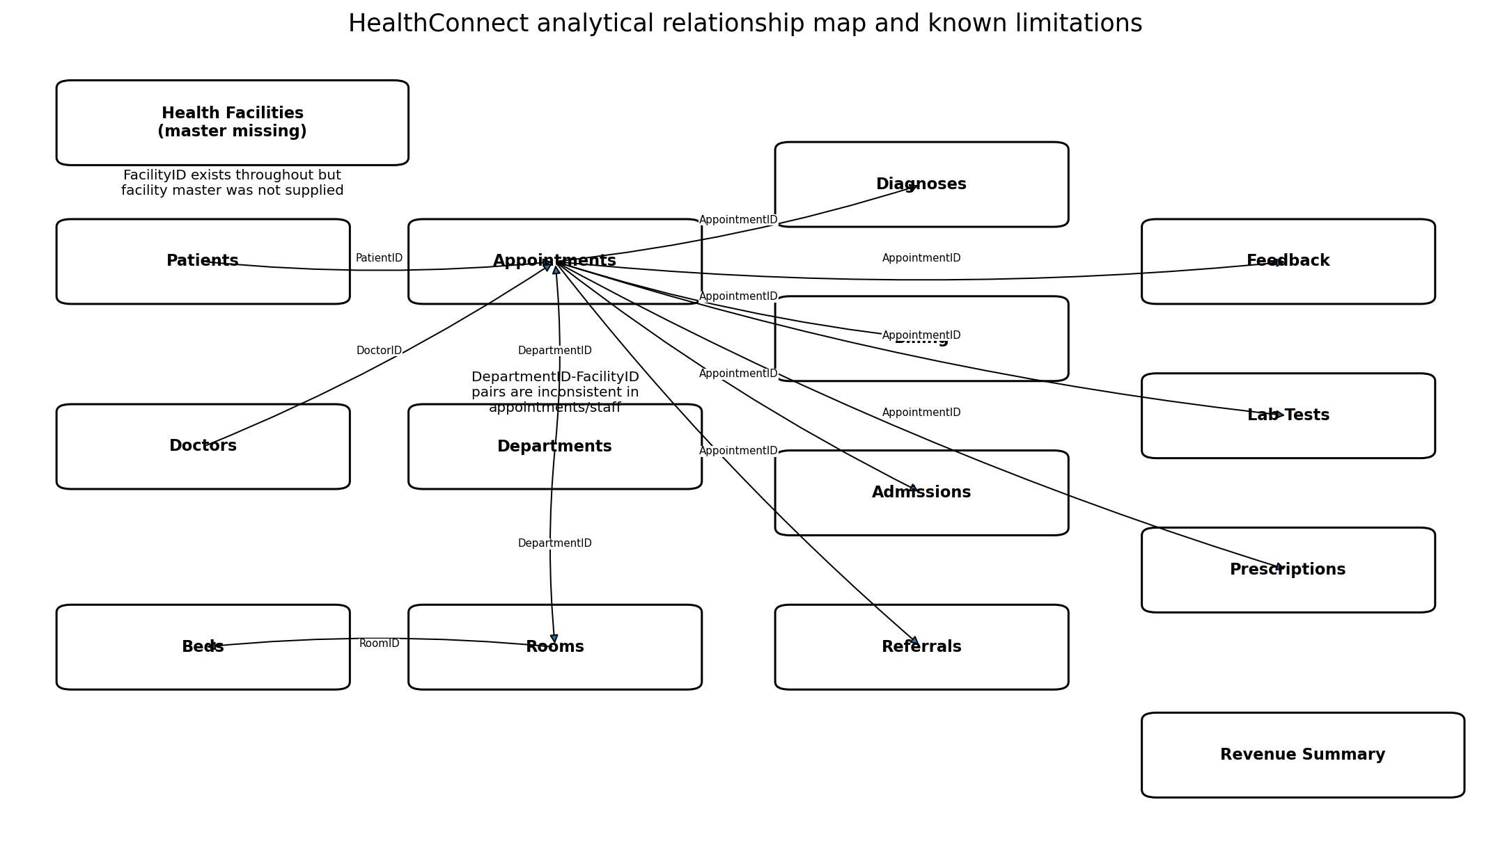
Figure 1. Validated analytical relationships and known master-data limitations.

