ANALYSTLAB AFRICA
Week 6 Exploratory Data Analysis Report
HealthConnect Rwanda - Data Science Track
Takudzwa Jeffrey Gumbo (TJ) | Data Science Track
Synthetic educational healthcare data. Analytical outputs are not clinical advice or diagnosis.
1. Executive summary
The patient master contains 20,000 synthetic patients with mean age 45.0 years. A recorded chronic condition is present for 74.6% of patient records. The full feedback table contains 21,064 records with mean rating 2.99/5. The billing table contains 60,000 bills totaling RWF 9,309,401,961.
2. Patient population
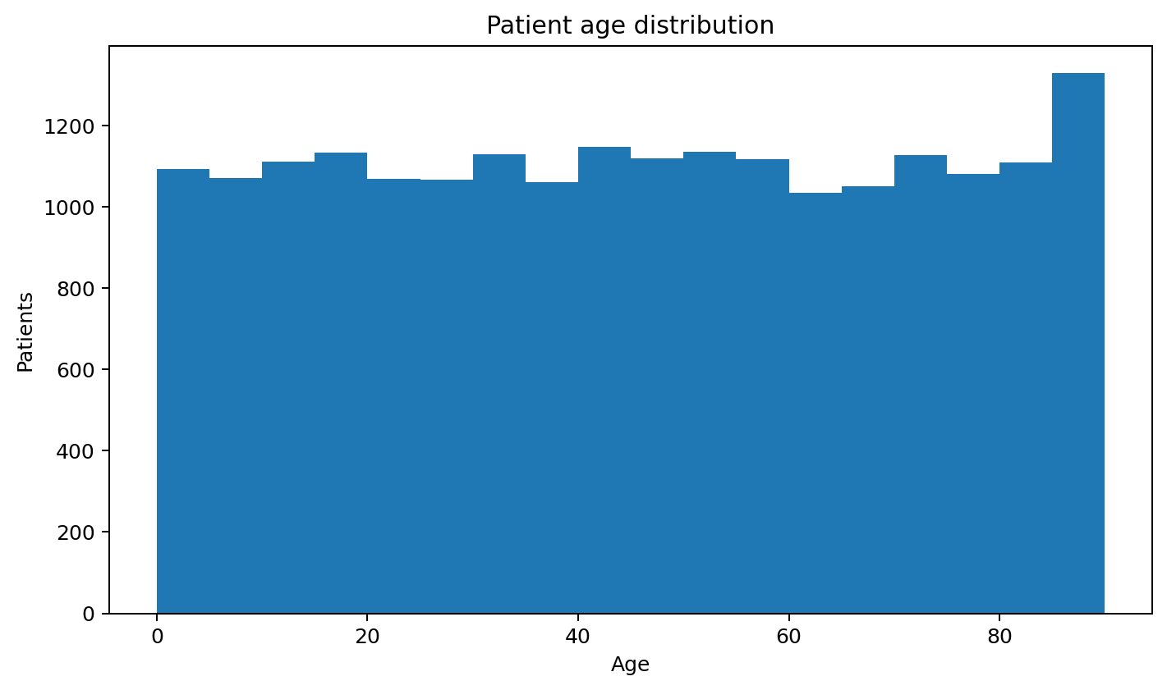
Figure 1. Patient age distribution.
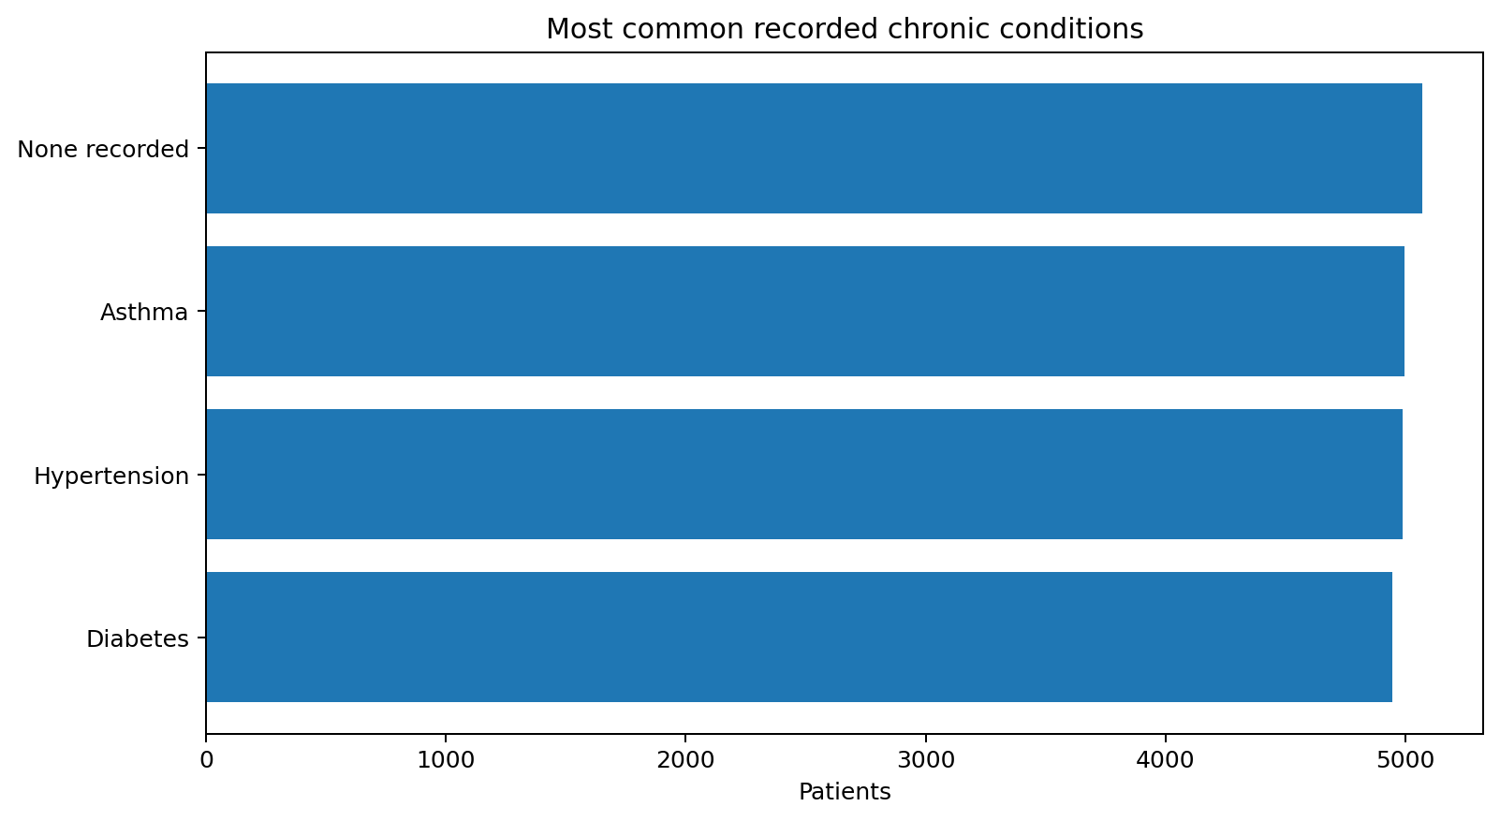
Figure 2. Most common recorded chronic conditions.
3. Clinical activity
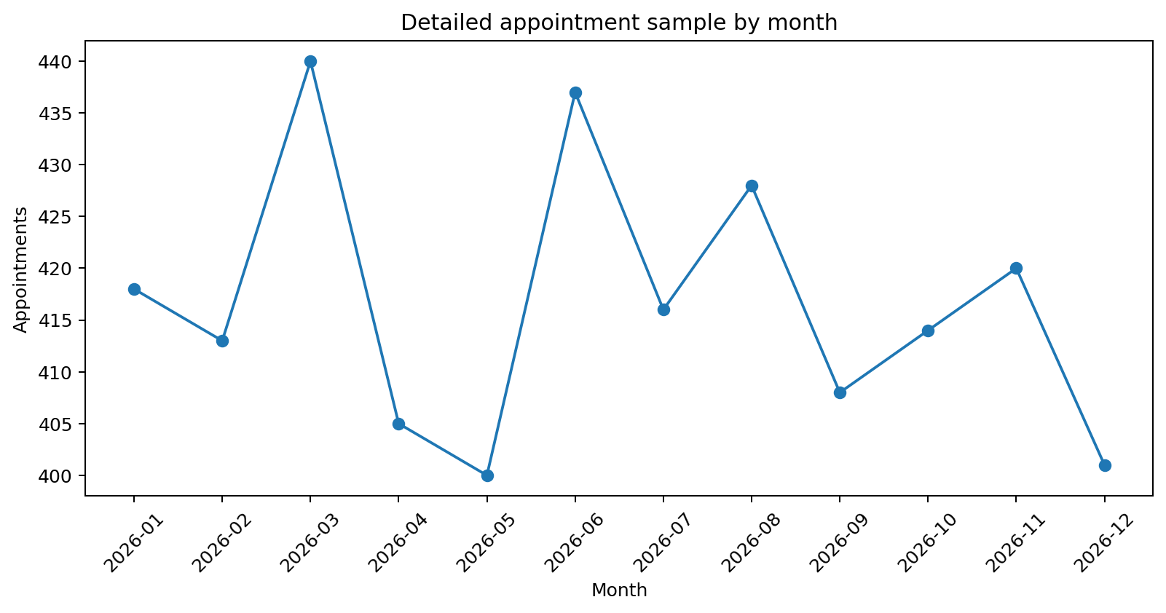
Figure 3. Monthly pattern in the 5,000 detailed appointments.
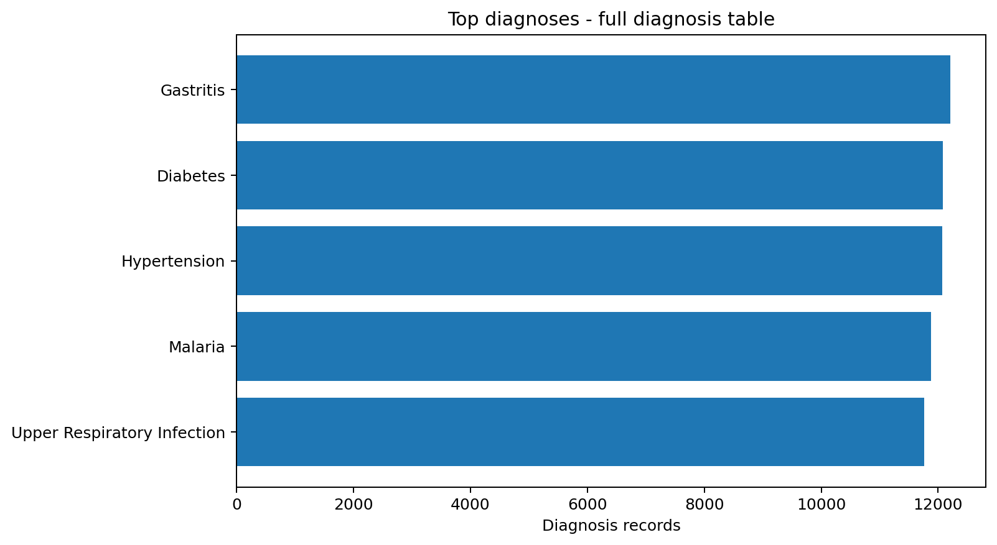
Figure 4. Top diagnoses in the 60,000-record diagnosis table.
4. Financial activity
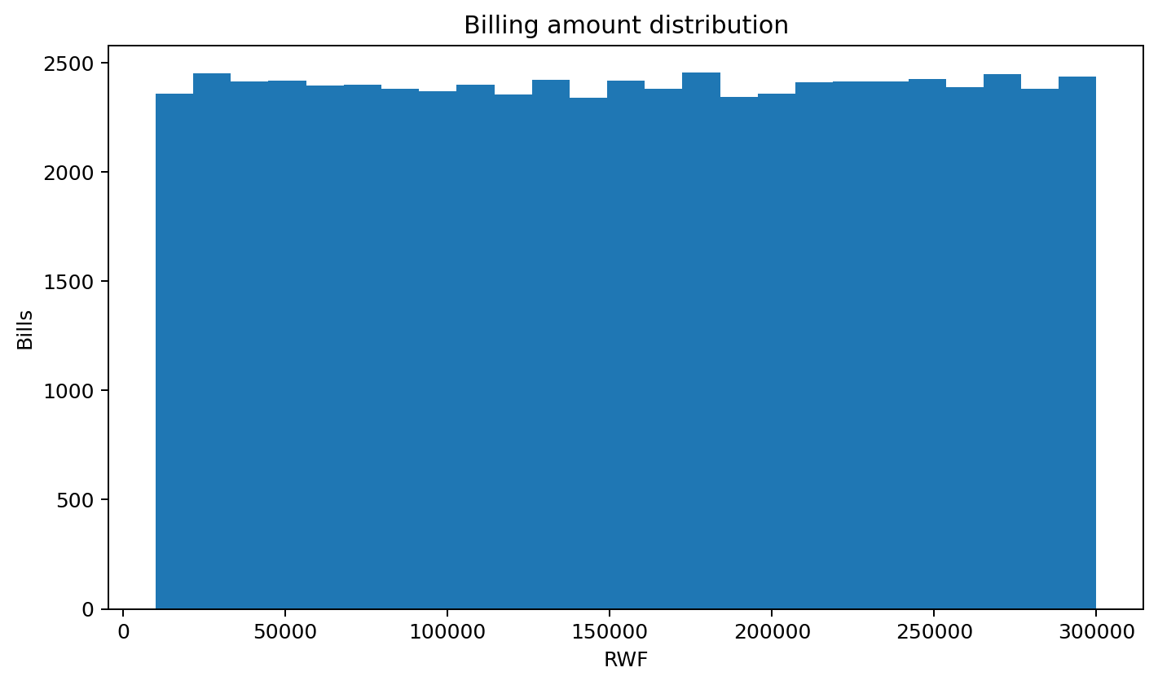
Figure 5. Billing amount distribution.
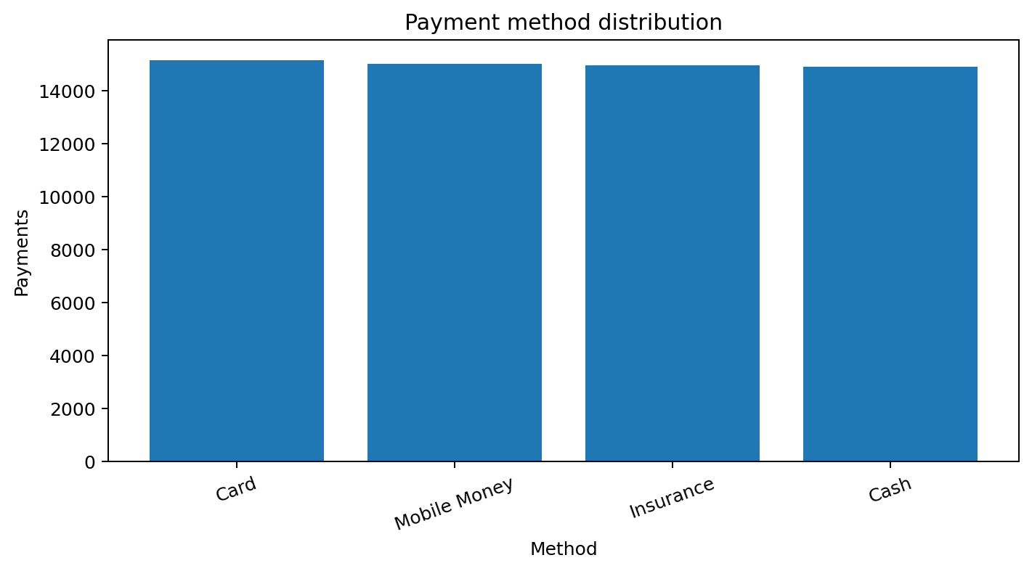
Figure 6. Payment method distribution.
5. Patient experience
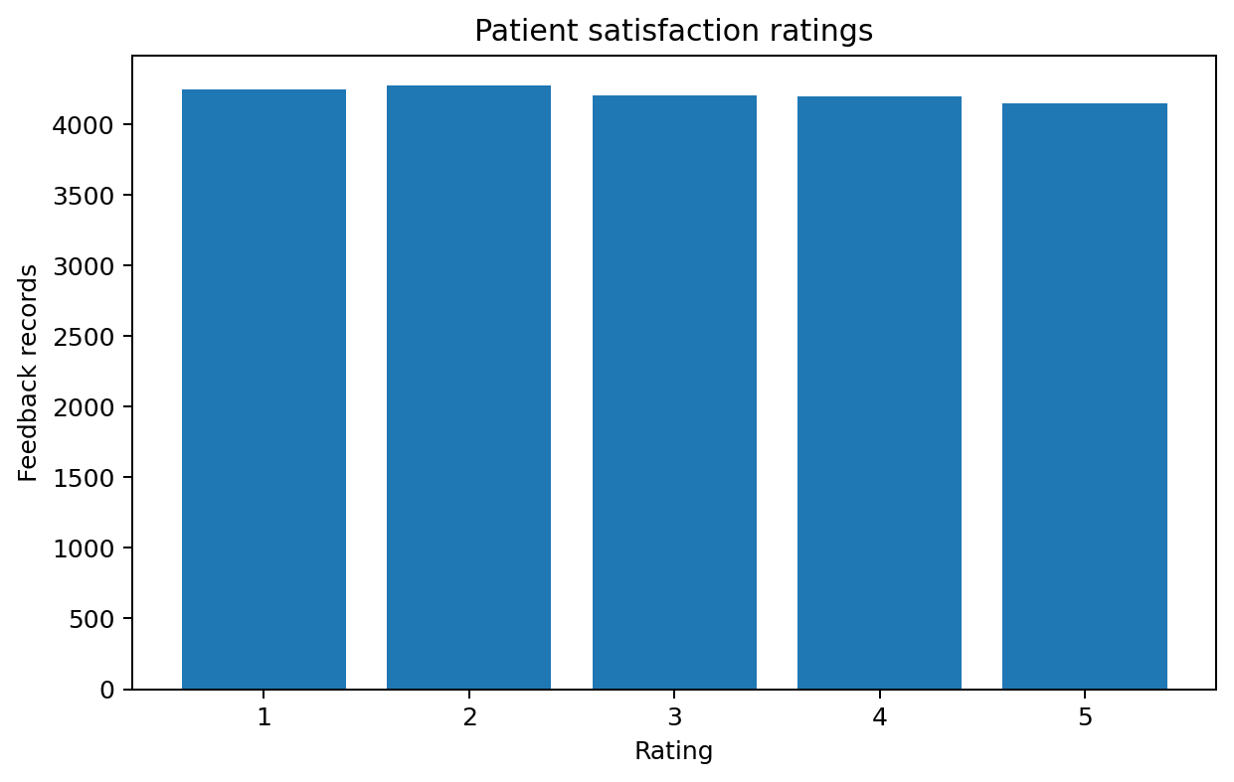
Figure 7. Satisfaction rating distribution.
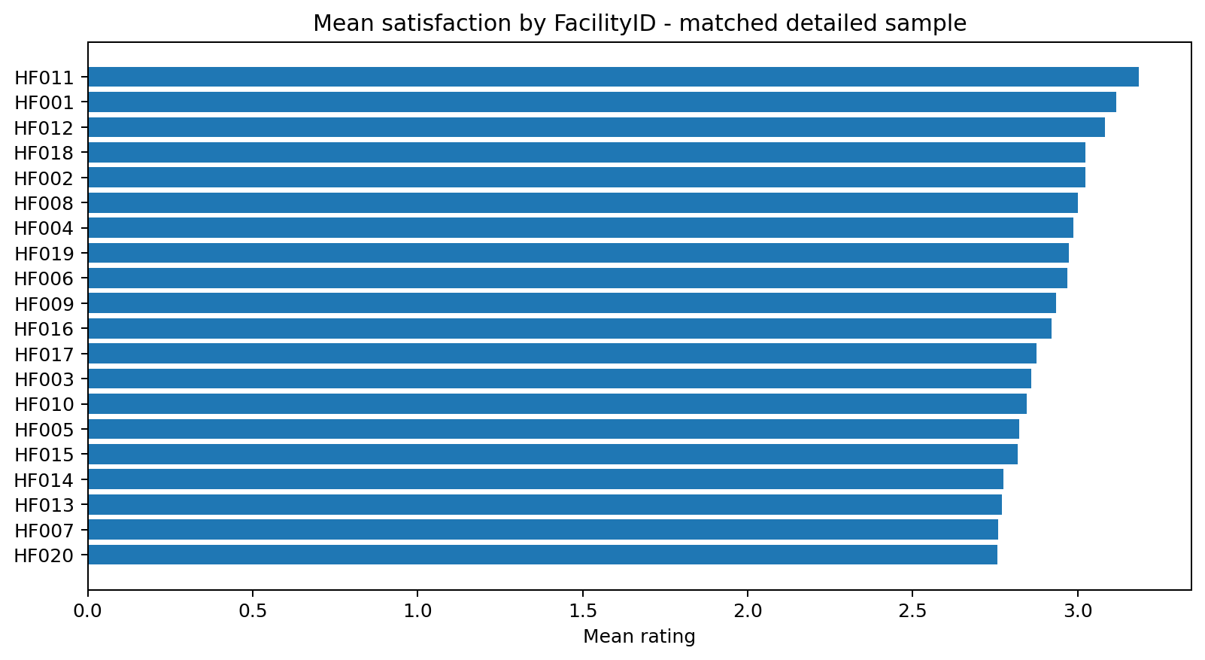
Figure 8. Mean satisfaction by anonymised FacilityID in the matched sample.
6. Operations
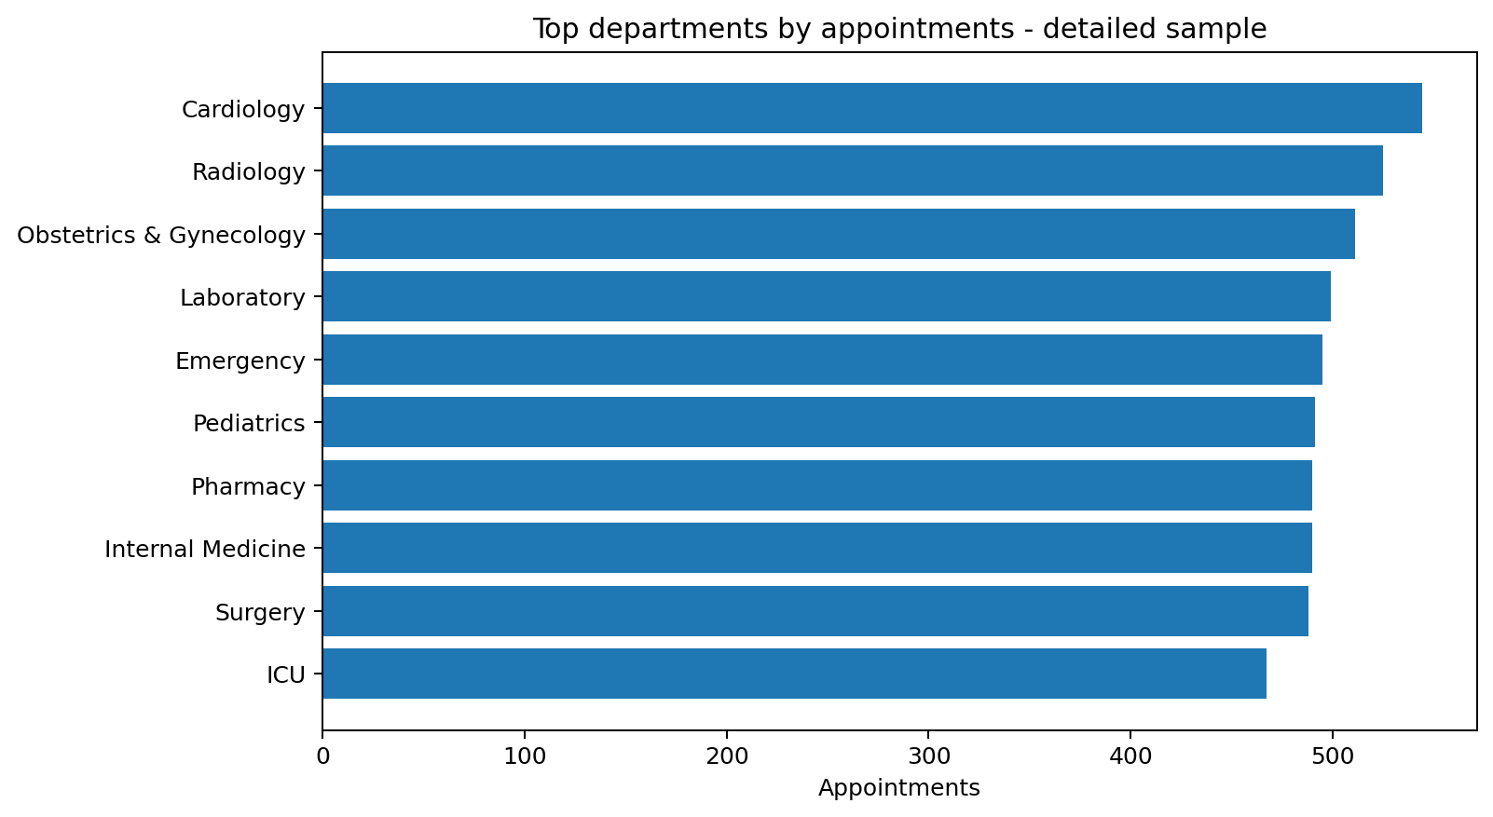
Figure 9. Top department categories by appointment count in the detailed sample.
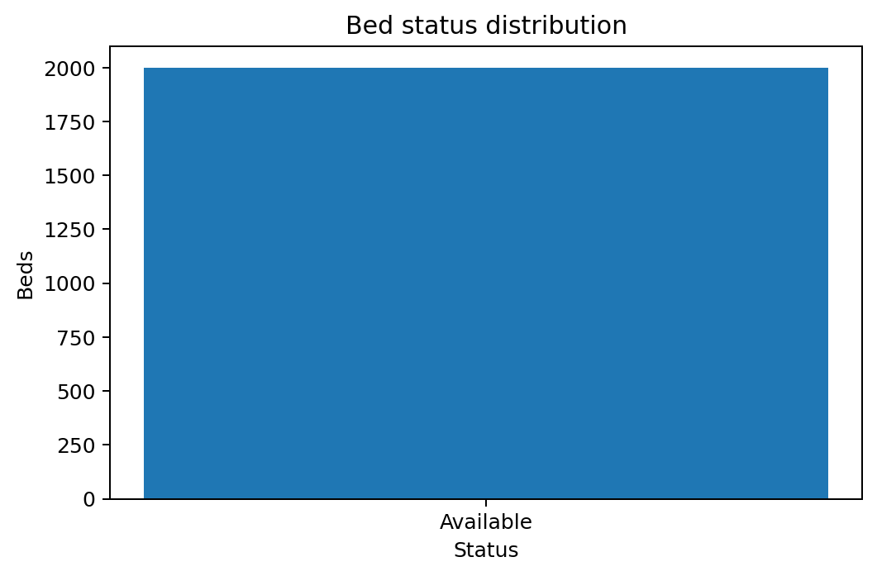
Figure 10. Bed status distribution; all supplied beds are Available.
7. Business interpretation
The synthetic data provides broad coverage across clinical, financial and patient-experience domains, but important structural limitations constrain causal and facility-level conclusions. The detailed appointment sample is sufficient for educational predictive modelling, while enterprise-level time series are best sourced from the monthly Revenue Summary. Facility names and geographic/ownership attributes cannot be joined reliably because the Health Facilities master was not supplied.

