ANALYSTLAB AFRICA
Week 6 Executive Summary
HealthConnect Rwanda - Healthcare Predictive Analytics and Population Health Intelligence
Takudzwa Jeffrey Gumbo (TJ) | Data Science Track
Synthetic educational healthcare data. Analytical outputs are not clinical advice or diagnosis.
Executive overview
This Data Science project integrates HealthConnect Rwanda synthetic patient, clinical, operational, financial and experience data to support population-health intelligence, forecasting and predictive analytics. The available package contains 20,000 patient records, 60,000 billing records, 60,000 diagnosis records and a 5,000-record detailed appointment sample. Enterprise monthly summaries report 60,809 appointments and RWF 1,132,677,500 revenue across 2026.
Key findings
Measure | Result
Recorded chronic-condition prevalence | 74.6%
Mean patient age | 45.0 years
Mean satisfaction | 2.99/5
Detailed-sample admission rate | 11.7%
Claims approved | 50.0%
Best admission ROC-AUC | 0.497
Best satisfaction R2 | -0.022
What the statistics show
Patient satisfaction did not differ significantly across anonymised FacilityIDs (p=0.7952), while admission status showed a statistically significant association with age group (p=0.0308). Billing distributions did not differ significantly by recorded chronic-condition status (p=0.5438). These are synthetic-data associations and should not be treated as clinical causal evidence.
Predictive and forecasting conclusion
The strongest admission model achieved ROC-AUC 0.497, indicating weak discrimination. Satisfaction models also performed poorly, with best R-squared -0.022. These results are important: the available variables do not support reliable clinical-risk or satisfaction prediction. Twelve-month appointment and revenue forecasts are therefore presented only as planning illustrations based on 12 monthly observations.
Data-quality constraints
The Health Facilities master table was not supplied, so FacilityIDs cannot be mapped to names, ownership, or geography. DepartmentID-FacilityID combinations are also inconsistent in appointments and staff relative to the Department master, preventing a trustworthy facility-department hierarchy. All supplied beds are marked Available, so bed-utilization modelling is not possible from the supplied bed status field.
Recommendations
1. Collect a complete Health Facilities master with stable FacilityID, name, type, ownership and geographic keys.
2. Enforce referential integrity between FacilityID and DepartmentID across appointments and staff systems.
3. Capture true bed occupancy events and timestamps rather than static Available status only.
4. Preserve complete longitudinal appointment histories with consistent patient, facility, department and clinician keys.
5. Capture waiting time, triage acuity and discharge outcome fields for operational and admission modelling.
6. Use the current admission and satisfaction models only as educational baselines; do not deploy them clinically.
7. Retain forecast uncertainty in capacity planning because only 12 monthly enterprise observations are available.
8. Use patient clustering only for descriptive service-planning exploration, with fairness and clinical review before any intervention.
9. Implement data-quality monitoring for invalid cross-table relationships before expanding AI use.
10. Require human oversight, privacy controls, bias assessment and prospective validation for any future healthcare AI.

Evidence snapshot
Enterprise demand and revenue planning
The enterprise Revenue Summary provides 12 monthly observations for 2026. Forecasts therefore use a transparent damped-trend method and are presented as planning illustrations. The limited history means uncertainty is material; the forecasts should not be used as binding staffing or investment commitments without additional monthly history and external validation.
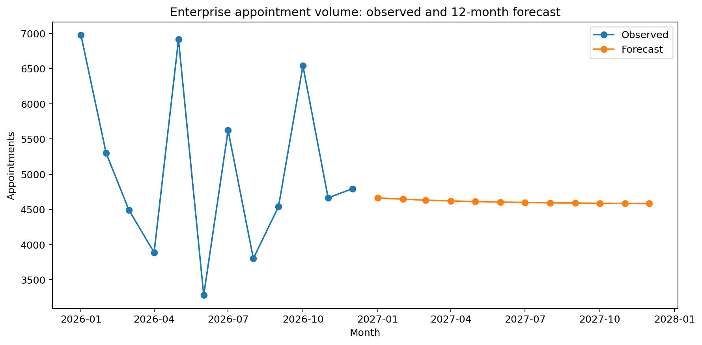
Figure 1. Enterprise appointment volume: observed 2026 summary and 12-month forecast.
Predictive model evidence
Admission models did not demonstrate useful discrimination: the highest observed ROC-AUC was approximately 0.497, which is effectively random ranking. Patient-satisfaction models also failed to explain ratings beyond a simple baseline. These null/weak results are retained as valid findings and indicate that stronger longitudinal and operational features are required before predictive deployment.

Executive action priorities
Priority | Why it matters | Recommended action
1. Master data integrity | Facility names/geography/ownership are unavailable and FacilityID-DepartmentID relationships are inconsistent. | Create and govern a Health Facilities master; enforce referential integrity across departments, staff and appointments.
2. Operational capacity data | All supplied beds are marked Available, preventing meaningful occupancy analysis. | Capture bed occupancy episodes, timestamps, ward transfers, capacity and discharge events.
3. Longitudinal patient journey | Only 5,000 appointments contain full patient/doctor/facility details while other transaction tables extend to 60,000 AppointmentIDs. | Provide a complete appointment fact table covering the same AppointmentID universe as diagnosis, billing, feedback and admissions.
4. Predictive feature quality | Current variables do not support reliable admission or satisfaction prediction. | Capture waiting times, triage acuity, prior admissions, medication/lab history and outcome timestamps.
5. Responsible AI governance | Healthcare predictions can affect high-stakes decisions. | Require human oversight, privacy controls, bias testing, explainability and prospective clinical/operational validation.

Closing position
The project demonstrates a complete healthcare data-science workflow while preserving uncertainty and data limitations. The strongest management recommendation is to improve data architecture and longitudinal operational capture before expanding predictive AI. This is a synthetic educational analysis; no output should be interpreted as diagnosis, treatment guidance or clinical risk scoring.

