ANALYSTLAB AFRICA
Week 6 Predictive Analytics Report
HealthConnect Rwanda - Data Science Track
Takudzwa Jeffrey Gumbo (TJ) | Data Science Track
Synthetic educational healthcare data. Analytical outputs are not clinical advice or diagnosis.
1. Scope and safeguards
Predictive modelling is restricted to relationships supported by the supplied synthetic data. The 5,000 detailed appointment records form the modelling universe for admission prediction and matched satisfaction modelling. No predictions are presented as clinical advice.
2. Patient volume and revenue forecasting
The monthly summary contains only 12 historical observations. A damped Holt trend model is therefore used as a transparent planning demonstration rather than a production forecast. Last-three-month backtest MAE is 1,299 appointments and RWF 23,126,582 for revenue, indicating substantial uncertainty.
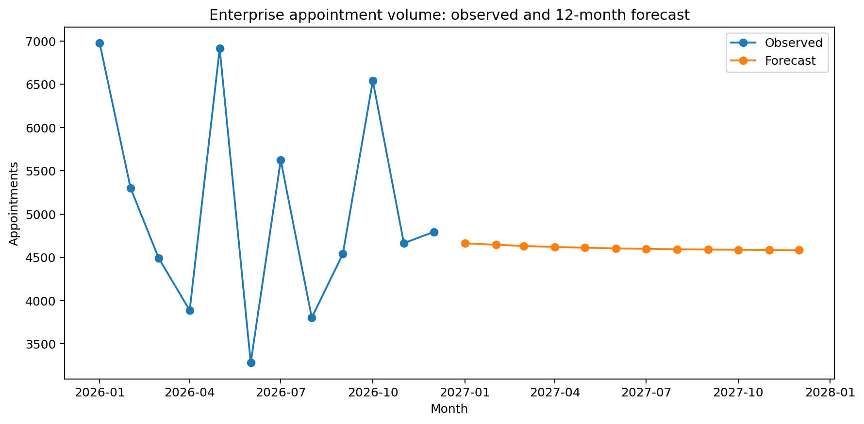
Figure 1. Observed monthly appointments and 12-month forecast.
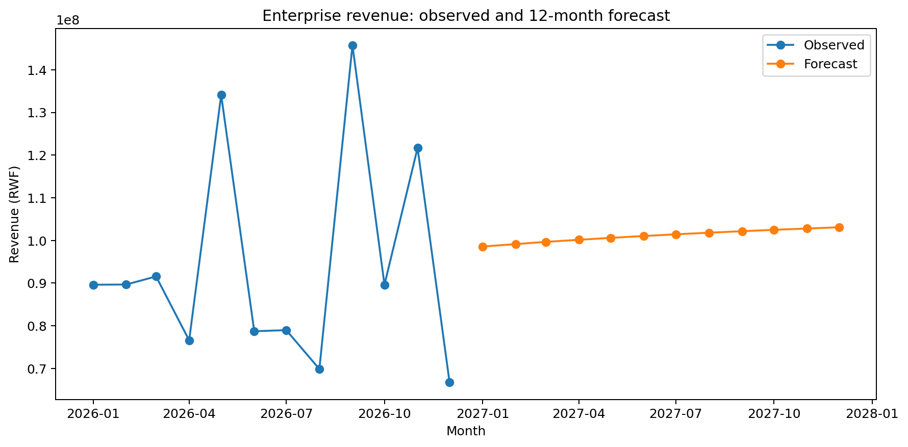
Figure 2. Observed monthly revenue and 12-month forecast.
3. Hospital admission prediction
Model | ROC-AUC | Accuracy | Precision | Recall | F1
Gradient Boosting | 0.497 | 0.881 | 0.000 | 0.000 | 0.000
Logistic Regression | 0.496 | 0.532 | 0.109 | 0.419 | 0.173
Random Forest | 0.483 | 0.728 | 0.103 | 0.171 | 0.128
The strongest admission model by ROC-AUC is Gradient Boosting at 0.497. This is only slightly above random ranking, so the data does not support a strong admission-risk model. The weak result is retained rather than overstated.
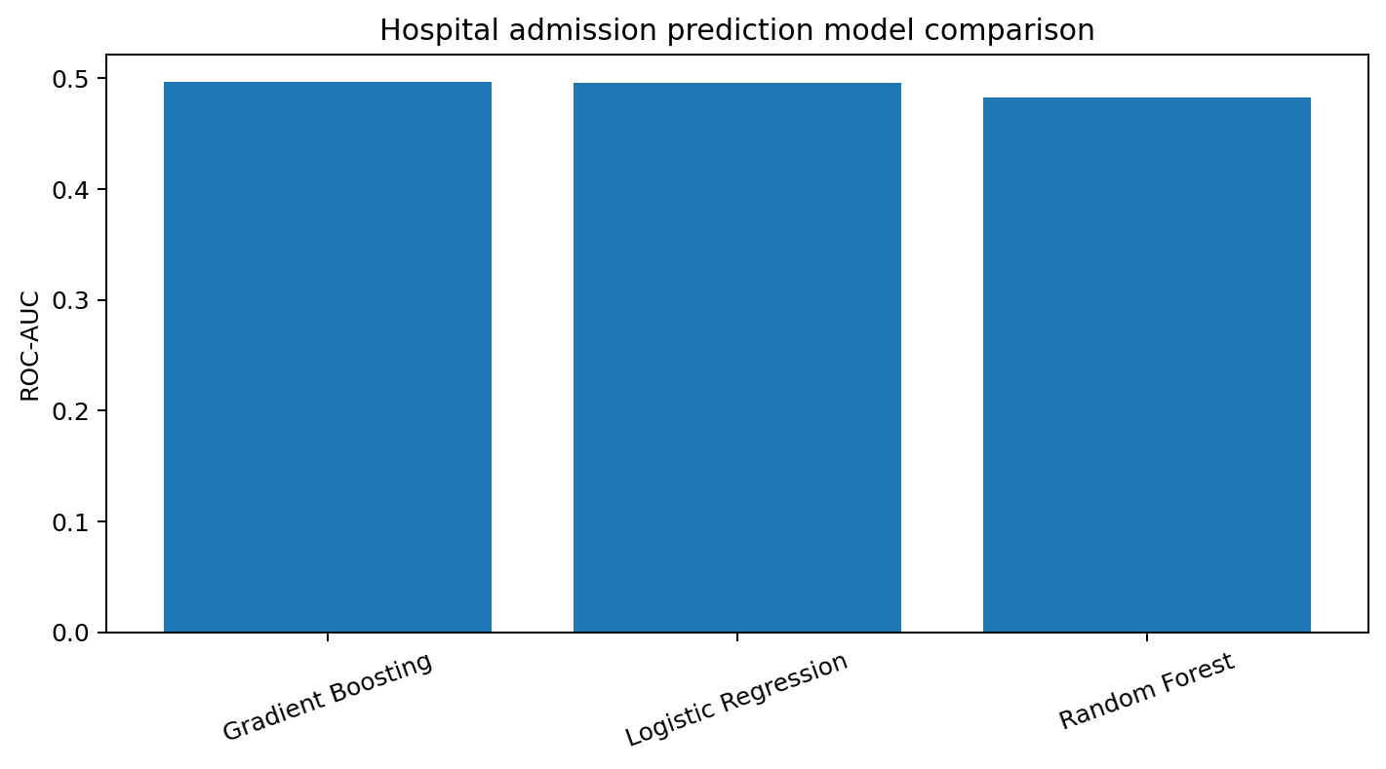
Figure 3. Admission model ROC-AUC comparison.
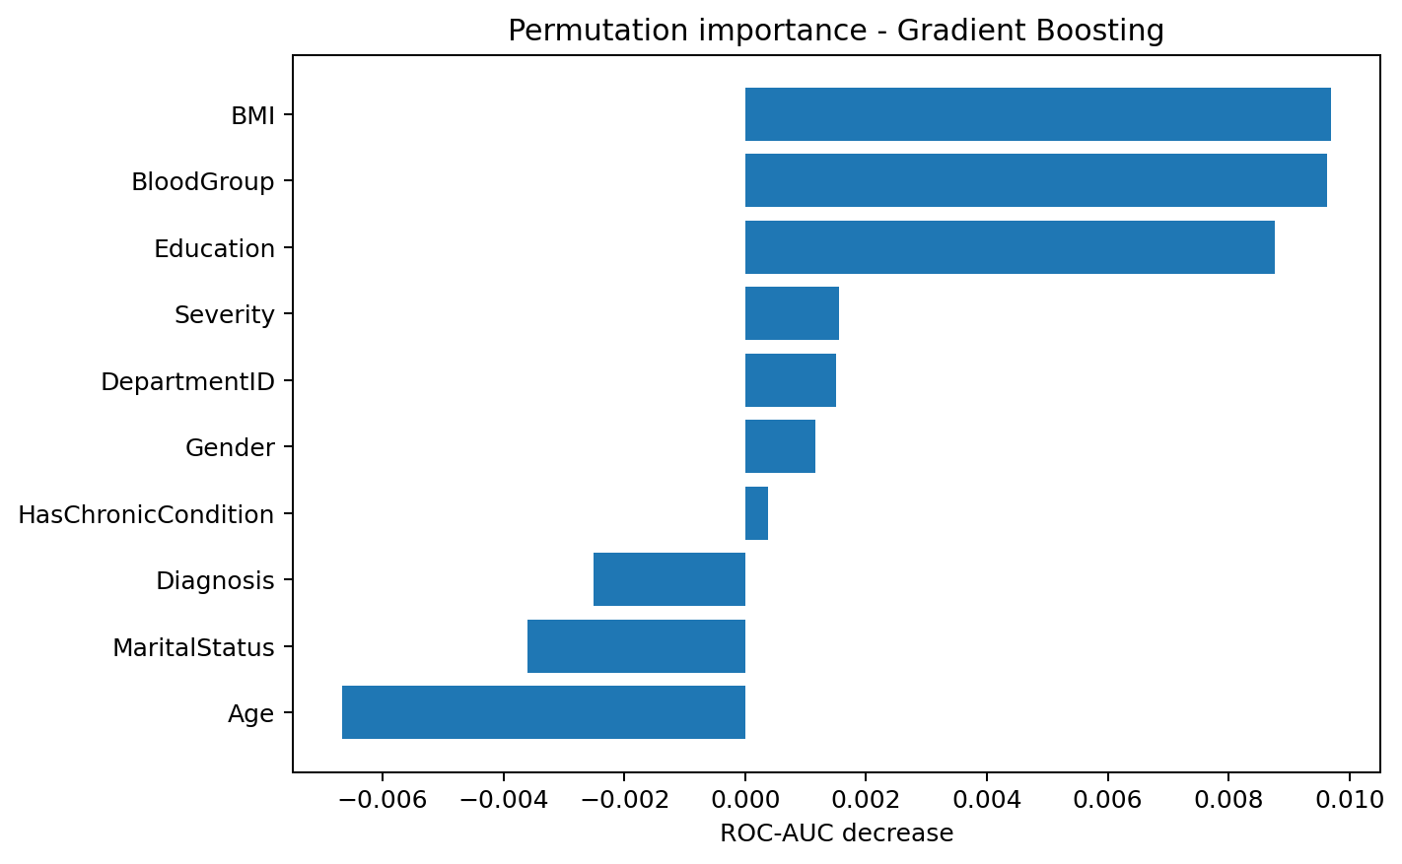
Figure 4. Permutation importance for the selected admission model.
4. Patient satisfaction prediction
Model | MAE | RMSE | R2
Random Forest Regressor | 1.212 | 1.409 | -0.022
Gradient Boosting Regressor | 1.222 | 1.418 | -0.035
Linear Regression | 1.277 | 1.498 | -0.155
The best satisfaction model by RMSE is Random Forest Regressor with RMSE 1.409 and R-squared -0.022. The negative/near-zero R-squared indicates that the supplied operational/clinical variables do not explain satisfaction ratings well in the matched sample.
5. Patient segmentation
K-Means clustering selected k=3 using the best silhouette score among k=3, 4 and 5 (0.439). The segments are descriptive analytical groupings, not clinical phenotypes.
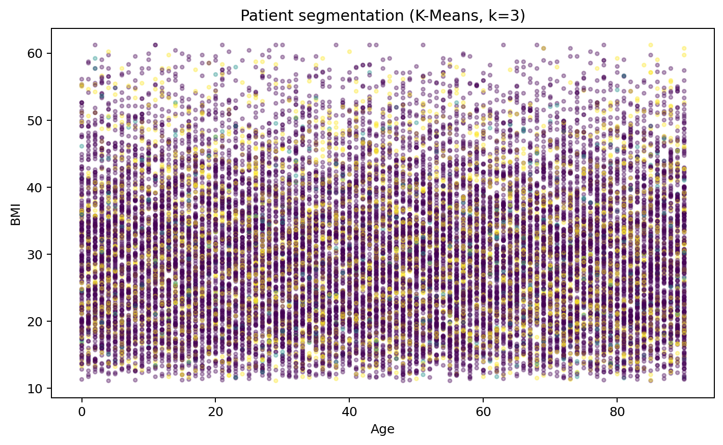
Figure 5. Patient segmentation by age and BMI, coloured by cluster.
6. Department workload forecasting
Department-level 12-month workload projections are generated for the ten most frequently observed department categories using simple linear trends over the 12 monthly detailed-sample counts. Because the detailed appointment table is only a 5,000-record sample, these forecasts should be used as directional workload illustrations rather than staffing commitments.
7. Final predictive conclusion
Forecasting and clustering are useful as planning demonstrations, but the admission and satisfaction models show limited predictive signal. Future data collection should prioritize complete longitudinal appointment histories, consistent facility-department relationships, validated operational capacity measures, waiting times, actual bed occupancy, and clearly time-stamped patient outcomes.

