ANALYSTLAB AFRICA
Week 6 Statistical Analysis Report
HealthConnect Rwanda - Data Science Track
Takudzwa Jeffrey Gumbo (TJ) | Data Science Track
Synthetic educational healthcare data. Analytical outputs are not clinical advice or diagnosis.
1. Methods
Significance level alpha = 0.05. Non-parametric tests are used where rating/billing distributions are not assumed normal, and a chi-square test is used for categorical admission status by age group.
2. Hypothesis tests
Test | Method | Statistic | p-value | Decision
H1 | Kruskal-Wallis | 13.800 | 0.7952 | Fail to reject H0
H2 | Chi-square independence | 10.653 | 0.0308 | Reject H0
H3 | Mann-Whitney U | 2332992.500 | 0.5438 | Fail to reject H0
3. Interpretation
H1 - Satisfaction across facilities: p=0.7952. There is no statistically significant evidence of different satisfaction distributions across FacilityIDs in the matched detailed sample.
H2 - Admission by age group: p=0.0308. The null of independence is rejected at 5%, indicating that admission occurrence varies across the defined age groups in this synthetic detailed sample. This is an association, not a clinical causal conclusion.
H3 - Billing by recorded chronic-condition status: p=0.5438. There is no statistically significant evidence that billing distributions differ between records with and without a recorded chronic condition in the matched sample.
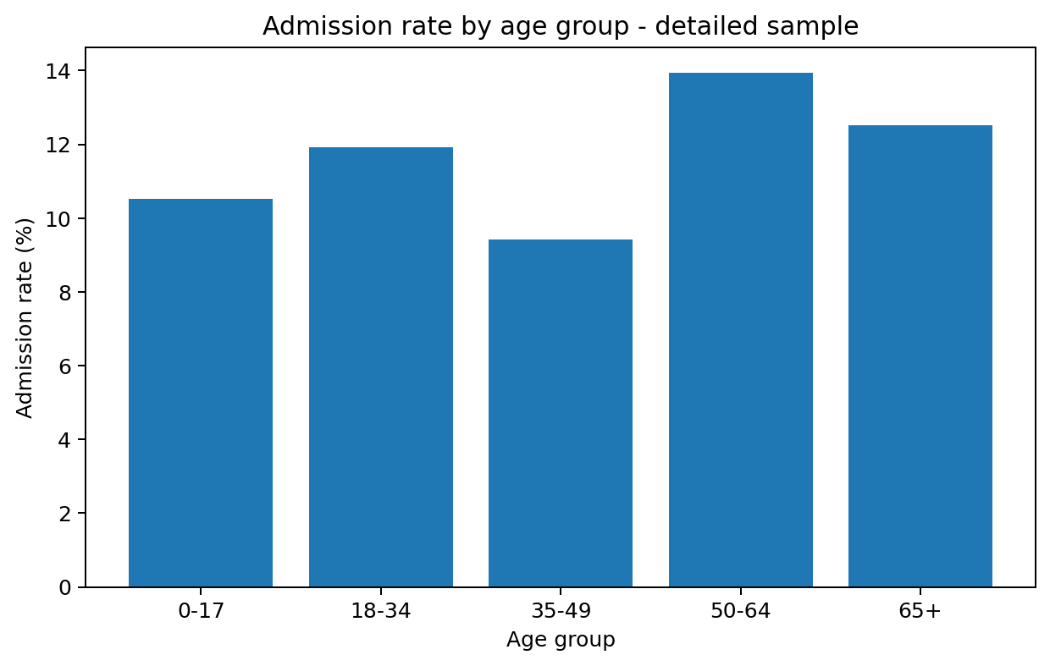
Figure 1. Admission rates by age group in the detailed sample.
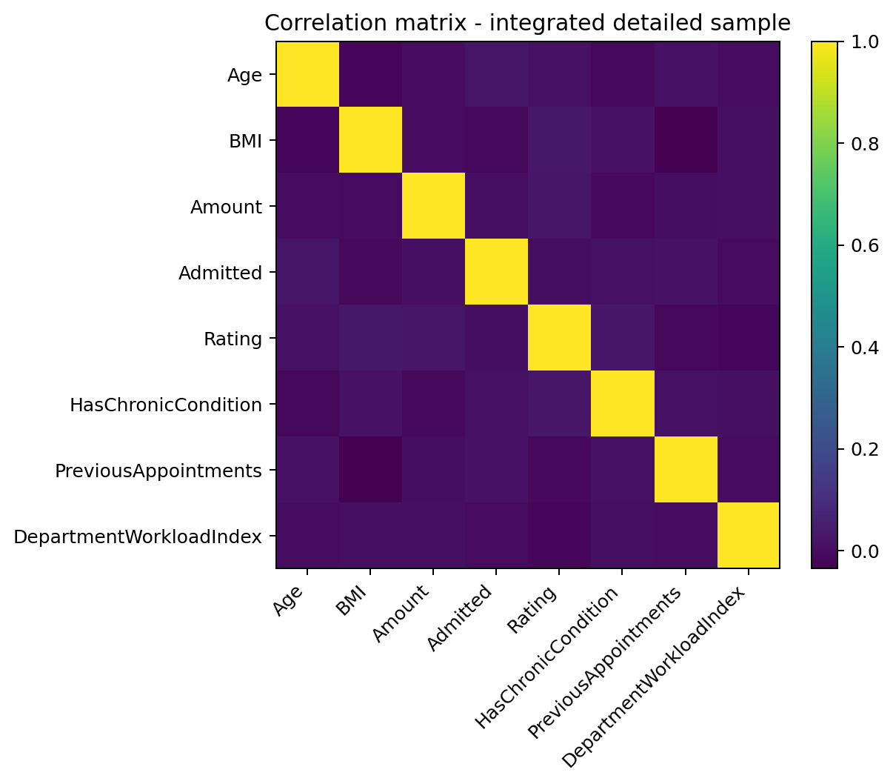
Figure 2. Correlation matrix for selected analytical variables.

