HealthConnect Model Testing & Refinement Report
Testing, Error Analysis, Evidence-Based Refinement and Week 8 Readiness
AnalystLab Africa Experience Lab - Week 7 | Data Science Track
Scope statement. This report continues the exact Week 6 HealthConnect Rwanda Data Science work. AnalystLab Africa clarified that Week 7 must use the same Week 6 dataset. No attendance/no-show outcome exists in that data, so the report does not fabricate one. The genuine Week 6 hospital-admission classification component is tested and refined instead.

1. Week 6 to Week 7 Transition
- Main Week 6 output: an integrated HealthConnect Rwanda Data Science project covering data quality, EDA, statistical testing, forecasting, admission prediction, satisfaction prediction and clustering.
- Most important Week 6 classification result: Gradient Boosting ranked first by ROC-AUC, but ROC-AUC was only 0.4967, indicating near-random discrimination.
- Main dependency/limitation: the supplied appointment data has no attendance/no-show/cancellation outcome; therefore the overall missed-appointment objective cannot be directly modelled from the supplied Week 6 Rwanda data.
- Week 7 component tested: hospital-admission prediction, because it is the genuine classification model already developed in Week 6.
- Week 7 objective: reproduce the candidate, test generalisation and errors, refine only where evidence supports it, re-test, and decide suitability for the intended HealthConnect use case.

2. Assignment Alignment
The Week 7 Data Science track requires candidate-model review, appropriate validation data, classification metrics, error analysis, false-positive/false-negative analysis, segment performance, feature review, overfitting/generalisation checks, baseline comparison, refinement, retesting, suitability assessment, cross-track evidence, limitations/risks and Week 8 recommendations. This report and the executed notebook cover those elements, including a completed Data Analytics -> Data Science HC-POD validation with Agu Precious.

3. Data and Target Audit
The integrated Week 6 detailed sample contains 5,000 records and 51 fields. Hospital admission prevalence is 11.72%. No attendance/no-show-like field was found. This is treated as a documented data limitation, not replaced with a proxy target.

4. Week 6 Candidate Reproduction
Model | ROC AUC | Accuracy | Precision | Recall | F1 | TN | FP | FN | TP
Gradient Boosting | 0.4967 | 0.8810 | 0.0000 | 0.0000 | 0.0000 | 881 | 2 | 117 | 0
Logistic Regression | 0.4959 | 0.5320 | 0.1091 | 0.4188 | 0.1731 | 483 | 400 | 68 | 49
Random Forest | 0.4829 | 0.7280 | 0.1026 | 0.1709 | 0.1282 | 708 | 175 | 97 | 20
Reproduction confirms the historical Week 6 result: Gradient Boosting has the highest ROC-AUC of the tested models, but its ROC-AUC is approximately 0.497 and its default-threshold recall is 0. This establishes continuity without overstating model quality.

5. Week 7 Testing Protocol
The original 20% Week 6 test set is preserved as the final holdout. The original 80% development portion is split into 60% training and 20% validation. Refinement and threshold decisions are based on validation data only. Five-fold stratified cross-validation on the development data is used to assess stability.

6. Candidate Test Results
Model | ROC AUC | PR AUC | Accuracy | Balanced Accuracy | Precision | Recall | F1 | FP | FN | TP
Dummy Prior | 0.5000 | 0.1170 | 0.8830 | 0.5000 | 0.0000 | 0.0000 | 0.0000 | 0 | 117 | 0
Logistic Regression | 0.5107 | 0.1207 | 0.5650 | 0.5053 | 0.1196 | 0.4274 | 0.1869 | 368 | 67 | 50
Random Forest | 0.4952 | 0.1150 | 0.7710 | 0.4959 | 0.1111 | 0.1368 | 0.1226 | 128 | 101 | 16
Week 6 Candidate - Gradient Boosting | 0.4917 | 0.1244 | 0.8830 | 0.5037 | 0.5000 | 0.0085 | 0.0168 | 1 | 116 | 1
On the final holdout, the Week 6 candidate ROC-AUC is 0.4917 and PR-AUC is 0.1244. Recall is only 0.0085. The model therefore provides no reliable discrimination and misses almost all positive admissions at threshold 0.50.
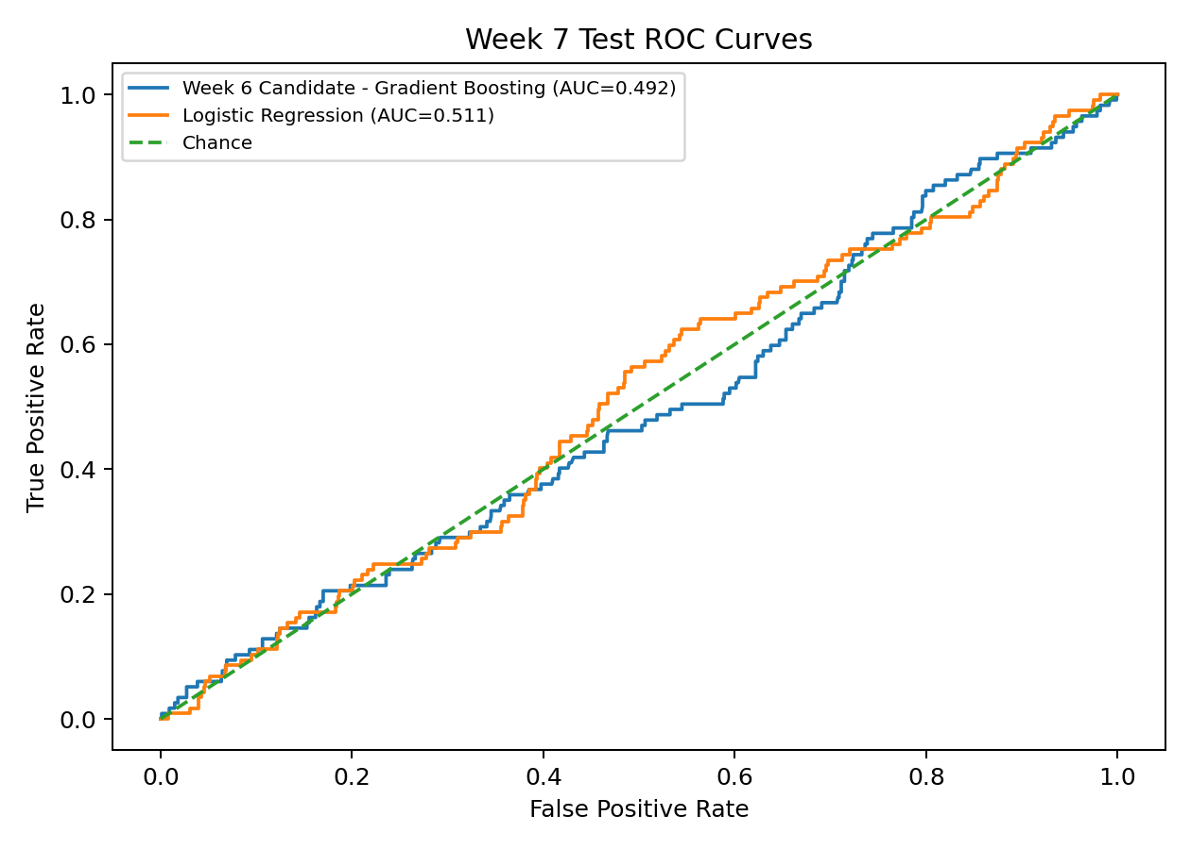
Figure 1. Test ROC curves; the candidate remains close to chance.
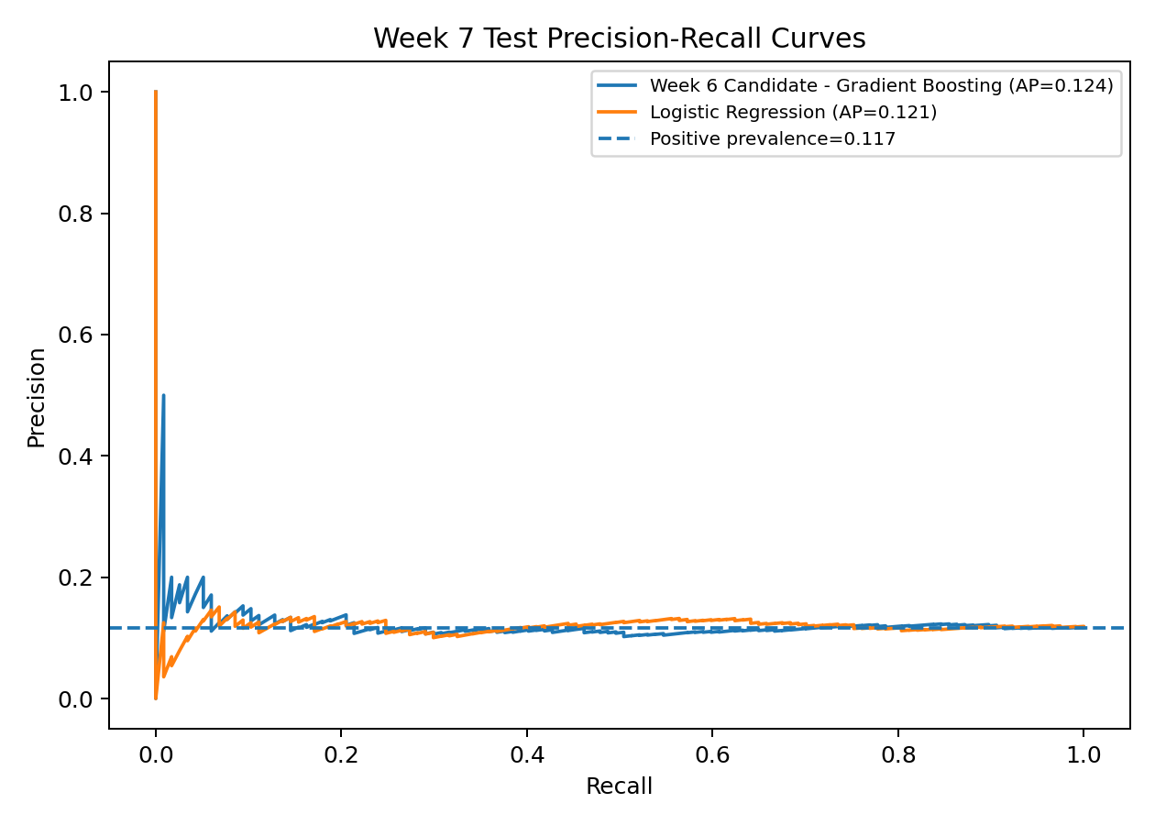
Figure 2. Test precision-recall curves relative to positive-class prevalence.

7. Error Analysis
The final test confusion matrix contains TN=882, FP=1, FN=116 and TP=1. The dominant error is false negatives: the model classifies almost every admission as non-admission.
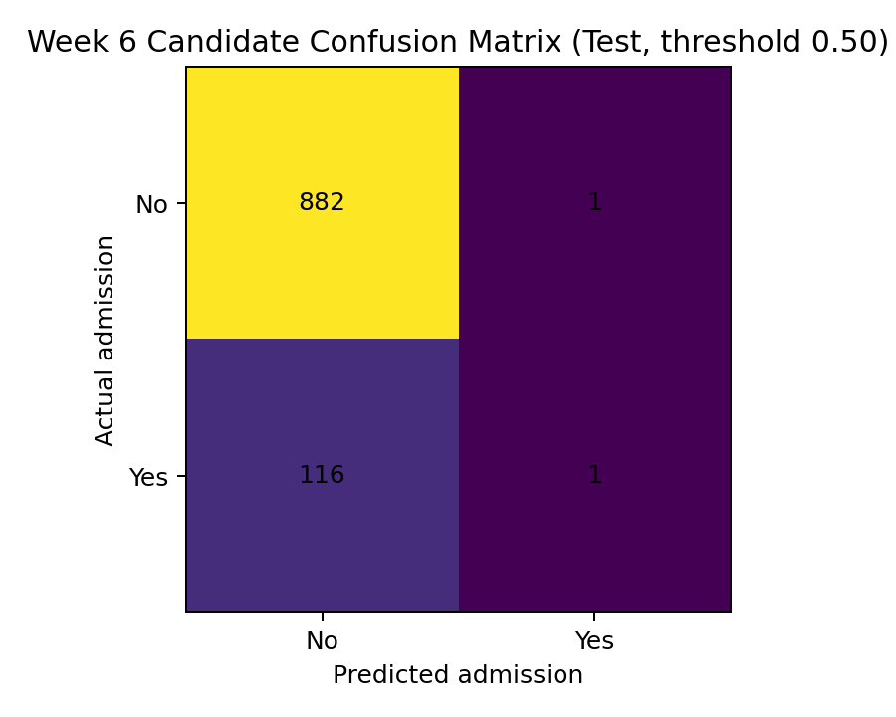
Figure 3. Candidate confusion matrix on the untouched test set.
Operational implication: nominal accuracy is misleading because the class is imbalanced. A model that predicts almost everyone as non-admitted can appear accurate while providing little clinical/administrative value. Balanced accuracy, recall, PR-AUC and the confusion matrix are therefore essential.

8. Generalisation and Segment Testing
Model | Mean | Std
Logistic Regression | 0.5054 | 0.0171
Week 6 Candidate - Gradient Boosting | 0.4811 | 0.0205
Five-fold cross-validation confirms that the weakness is not just one unlucky split. Mean ROC-AUC remains around chance. Segment testing across gender, visit type, severity and age groups also does not identify a subgroup with sufficiently reliable performance for deployment.
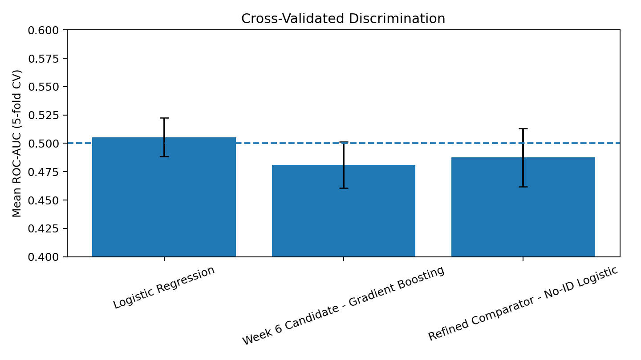
Figure 4. Cross-validated ROC-AUC; chance-level reference shown at 0.50.
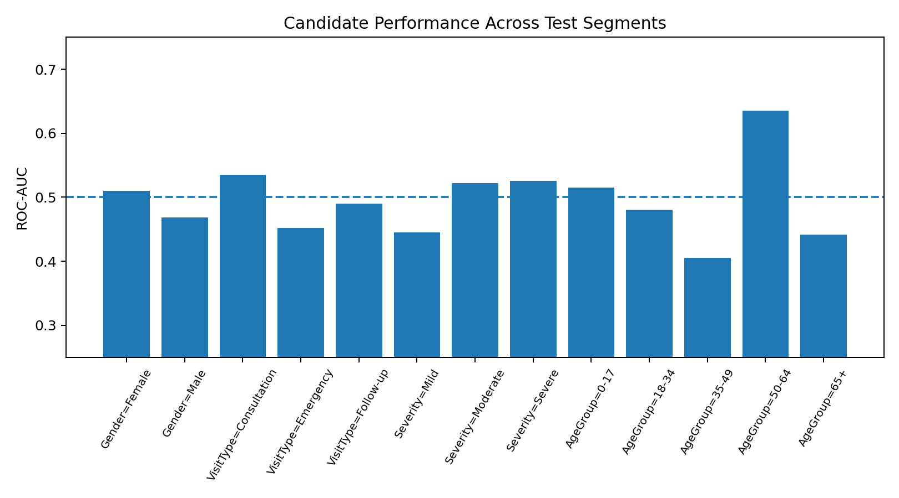
Figure 5. Candidate ROC-AUC across selected test segments.

9. Feature Review and Refinement
Permutation importance values are small and unstable, consistent with weak predictive signal. An initial refinement removed FacilityID and DepartmentID and tested a class-balanced Logistic Regression comparator. The later cross-track review with Data Analytics refined this interpretation: non-significant facility/department rating differences do not prove FacilityID or DepartmentID lack predictive value. They were therefore retained with caveats in the cross-track re-test, while Diagnosis and Severity were held back because their prediction-time availability could create leakage.
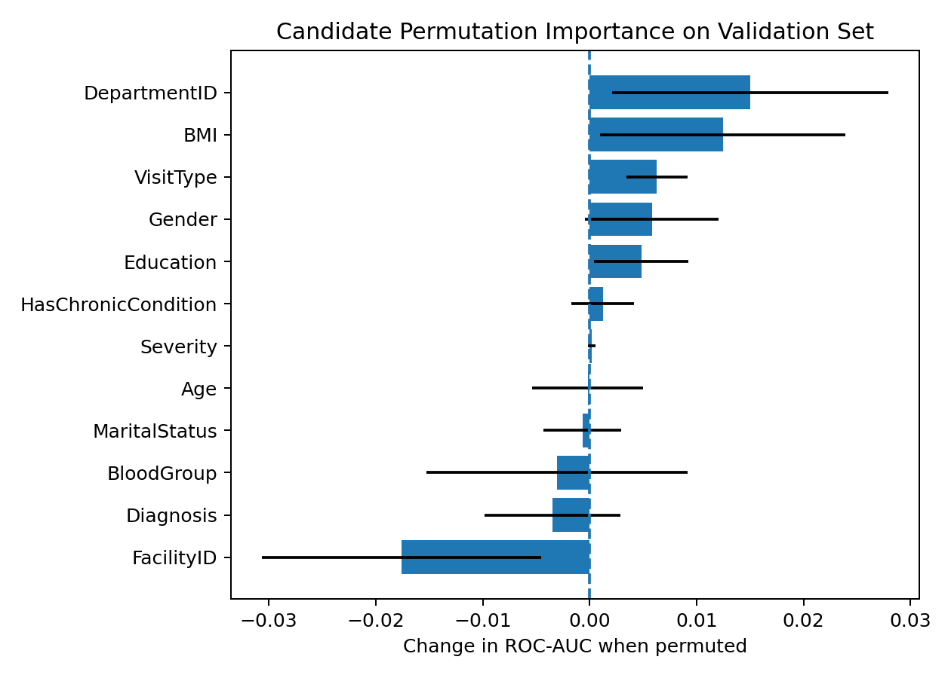
Figure 6. Candidate permutation importance on validation data.
Split | Threshold | ROC AUC | PR AUC | Accuracy | Balanced Accuracy | Precision | Recall | F1 | FP | FN | TP
validation | 0.4150 | 0.4875 | 0.1119 | 0.2530 | 0.5288 | 0.1241 | 0.8889 | 0.2178 | 734 | 13 | 104
test | 0.4150 | 0.5420 | 0.1303 | 0.2370 | 0.5086 | 0.1191 | 0.8632 | 0.2093 | 747 | 16 | 101

10. Refinement Retest and Decision
The refined comparator reaches test ROC-AUC 0.5420, recall 0.8632 and precision 0.1191. However, its five-fold cross-validated ROC-AUC is only 0.4875 ± 0.0257. The holdout increase is therefore not a stable, validated improvement. The low precision also means a very large false-positive burden.
Decision: reject the refinement as a validated operational model. Do not promote either candidate to deployment. The correct evidence-based result is that the current feature set does not support reliable individual admission prediction.

11. Baseline Comparison and Week 5 Continuity Gap
The official generic brief refers to a Week 5 HealthConnect baseline classification model. The preserved project history for this user does not contain a valid Week 5 HealthConnect attendance/admission classifier; Week 5 was a different SwiftLog project. This report therefore does not fabricate a Week 5 model. It uses a Dummy Prior classifier and the Week 6 Logistic Regression comparator as transparent technical baselines, while clearly labelling the continuity gap.

12. Business Relevance and Model Suitability
The current admission model is not suitable for operational HealthConnect use. It does not reliably rank admissions, its default threshold misses almost all positives, and the tested high-recall refinement generates too many false positives. Model outputs should not be used for clinical decisions, patient prioritisation or automated resource allocation.
For the broader appointment-attendance objective, the supplied Week 6 Rwanda data does not contain an attendance/no-show target. Any attendance prediction claim would therefore be unsupported.

13. HC-POD Cross-Track Testing
A genuine Data Analytics -> Data Science validation was completed with Agu Precious. Her validation summary and feature review supported Gender, HasChronicCondition and VisitType; supported Age with appointment-date calculation; retained FacilityID and DepartmentID with caveats; identified MaritalStatus, Education, BloodGroup and BMI as requiring further validation; and flagged Diagnosis and Severity for prediction-time leakage review. She also recommended time-safe PriorVisits, appointment month and weekday. The Data Science prediction point was defined as patient arrival / before initial clinical assessment. The resulting pre-assessment feature set used AgeAtAppointment, Gender, HasChronicCondition, VisitType, FacilityID, DepartmentID, PriorVisits, AppointmentMonth and AppointmentWeekday. Re-testing produced Gradient Boosting holdout ROC-AUC 0.5189 and 5-fold CV ROC-AUC 0.5237 +/- 0.0246. Balanced Logistic Regression produced holdout ROC-AUC 0.5024 and CV ROC-AUC 0.4986 +/- 0.0322. The collaboration therefore improved feature governance and leakage control, but did not validate an operationally useful model.

14. Limitations, Risks and Dependencies
Issue ID | Category | Issue | Status | Severity | Impact | Mitigation
W7-01 | Data | Attendance/no-show target absent | Open | High | Week 7 business scenario cannot be directly evaluated for attendance using supplied Rwanda data. | Do not invent target; document limitation; request attendance status field for future iteration.
W7-02 | Modelling | Week 6 admission candidate ROC-AUC near 0.50 | Open | High | Model does not discriminate admitted vs non-admitted reliably. | Reject operational deployment; collect stronger pre-admission predictors and revisit target design.
W7-03 | Threshold | Gradient Boosting default 0.50 yields almost no positive predictions | Tested | High | Recall collapses despite high nominal accuracy due to class imbalance. | Evaluate threshold on validation; do not use accuracy alone.
W7-04 | Refinement | No-ID balanced logistic comparator improves one holdout AUC but not CV | Rejected refinement | Medium | Apparent holdout improvement is unstable and operational precision remains low. | Do not claim validated improvement; retain conclusion of model unsuitability.
W7-05 | Cross-track | Mandatory HC-POD testing evidence not yet supplied | Pending external evidence | High | Submission would be incomplete without genuine collaboration evidence. | Complete one Data Science→ML Engineering or Data Analytics→Data Science test and attach evidence.

15. Week 8 Recommendations
- Preserve the completed Data Analytics -> Data Science cross-track evidence and carry its prediction-time feature governance into Week 8.
- If appointment attendance remains the intended business target, collect or request a true attendance/no-show/cancellation status field and define the prediction time point.
- Collect stronger pre-admission predictors that are available before the prediction decision; then reassess admission modelling.
- Retain ROC-AUC, PR-AUC, balanced accuracy, recall and error-cost analysis as primary validation measures; do not use raw accuracy alone.
- Keep the current negative validation result in the project history rather than replacing it with a stronger-looking but unsupported model.
- Prepare Week 8 integration around validated findings and documented limitations rather than deployment of the current model.

16. Conclusion
Week 7 demonstrates genuine forward progress: the Week 6 candidate was reproduced, systematically tested, subjected to error and segment analysis, refined, re-tested and assessed for suitability. A genuine Data Analytics -> Data Science validation also informed a leakage-safer pre-assessment feature set and an additional re-test. The evidence still does not validate an operational model. That negative result, together with the completed cross-track validation, provides a clear and defensible Week 8 direction.

References
AnalystLab Africa. Week 7: HealthConnect Testing, Refinement & End-to-End Validation. Official Weekly Assignment.
AnalystLab Africa 001. Slack clarification supplied by the user: use the same dataset as Week 6 for the Week 7 task.
Week6_DataScience_HealthConnect_TakudzwaGumbo_FINAL.zip. SHA-256: 123ccd7e70aa5161a2e4848ed03b8bdf5eeb2cfb13f175ad5c110577ff3a7a94.
Agu Precious. HealthConnect Rwanda Validation Summary and Week 7 Data Analytics feature-review response, 1 November 2026.

