ANALYSTLAB AFRICA
SwiftLog Logistics — Executive Data Science Summary
Supply Chain Intelligence & Feature Engineering for Predictive Logistics
Takudzwa Jeffrey Gumbo | Week 5 | Data Science Track

Executive headline
SwiftLog's most material observed operational issue is delivery performance: 63.7% of 5,000 shipments are labelled delayed, with an average delay of 3.57 days. The analysis integrates all linkable datasets, preserves structural gaps explicitly and prepares a 5,000-row order-level feature dataset for future predictive work.
KPI | Result
Observed revenue | $21,668,065.85
Orders with item/revenue coverage | 4,764 / 5,000
Delayed rate | 63.7%
Average delay | 3.57 days
Returned-order rate | 9.5%
Top revenue category | Fashion — $8,059,602.65
Peak demand month | August — 654 orders
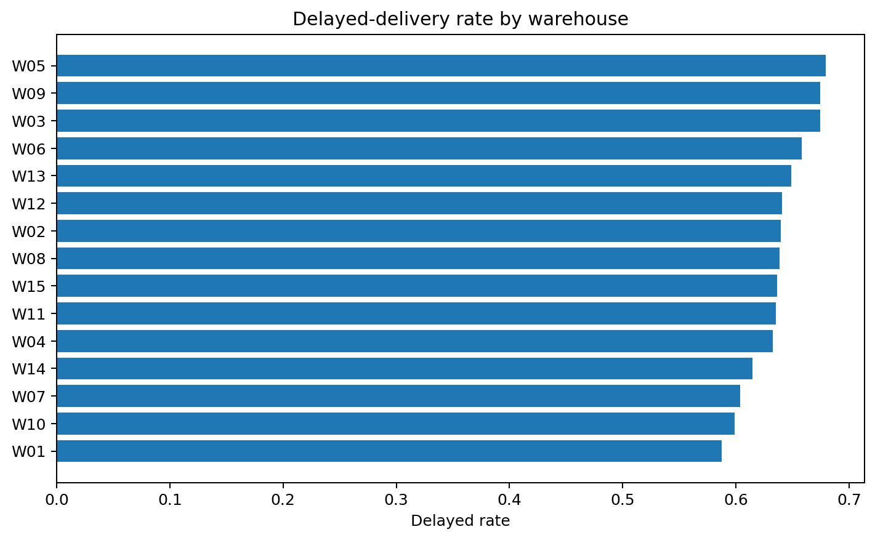
Observed delayed-delivery rates by warehouse. The formal warehouse test is not statistically significant.

What management should know
- August is the highest order-volume and revenue month, supporting forward capacity planning.
- High-Value Loyal customers are the largest customer value segment and should receive retention/service monitoring priority.
- Fashion is the largest observed revenue category; P040 is the highest-revenue individual product.
- Late Delivery is the most common recorded return reason, but returned and non-returned orders do not have statistically different overall delay distributions.
- Observed warehouse delayed rates vary, but the Kruskal-Wallis test does not support a significant difference across warehouses.
- Supplier performance cannot be measured from the supplied data because SupplierID has no operational linkage.
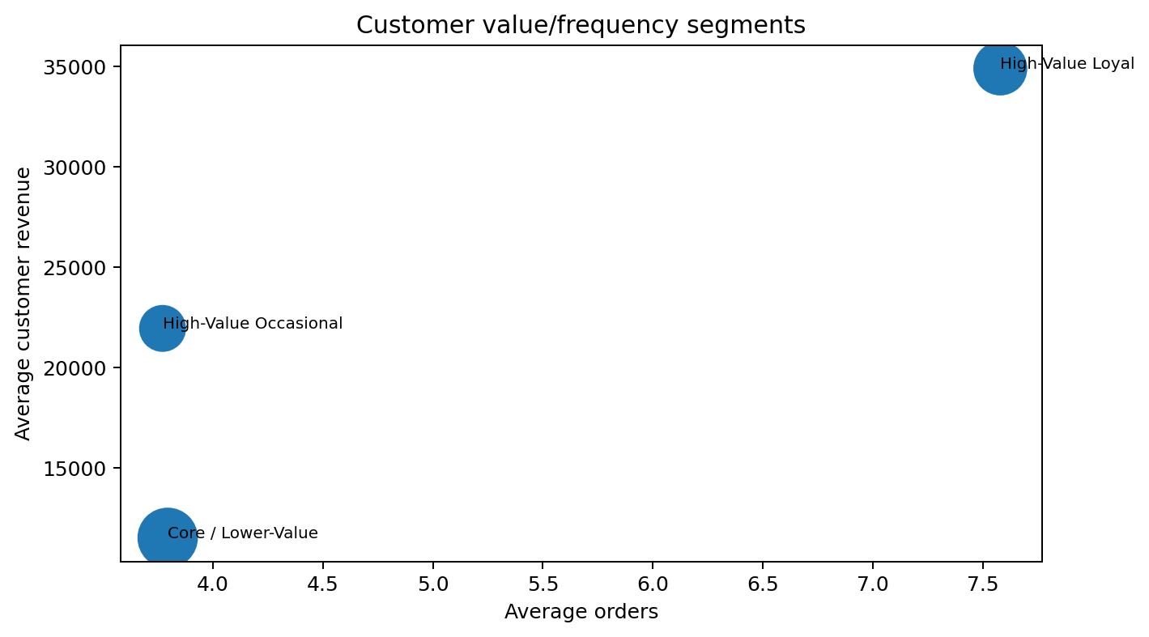
Customer value/frequency segments.

Priority recommendations
1. Create a focused delay-reduction programme and track delayed rate/average delay weekly; the overall delayed rate is 63.7%.
2. Investigate W05/W09/W03 first while treating observed rankings as diagnostic priorities rather than causal proof.
3. Review processes at W01/W10/W07 as lower-delay operational references.
4. Increase capacity planning and staffing review ahead of August, the highest order-volume and revenue month.
5. Protect High-Value Loyal customers with service-level monitoring and targeted retention because they contribute the largest segment revenue.
6. Protect Fashion availability while balancing concentration risk across Food and Electronics.
7. Use product segments to define differentiated replenishment and merchandising rules for leaders, premium products, volume drivers and long-tail items.
8. Treat Late Delivery as a priority complaint reason, but improve return data before attributing product-level quality problems.
9. Add SupplierID to product/contract/shipment records so supplier reliability can be measured rather than assumed.
10. Capture true capacity, space used and dated inventory snapshots so true utilisation and turnover can replace proxies.

Data limitations that affect decisions
Gap | Management implication
No SupplierID link | Supplier performance and reliability cannot be evidenced.
No warehouse capacity | True utilisation cannot be calculated.
No dated inventory snapshots | True inventory turnover and stock ageing cannot be calculated.
Returns lack product/line identifier | True product return rates are unavailable.
236 orders lack Order_Items | Revenue/product analysis has incomplete order coverage.
September partial through 8 Sep | Monthly totals are not comparable with full months.

Next analytical step
Use the engineered order-level dataset as the foundation for delivery-delay prediction, demand forecasting and return-risk modelling. Before expanding to supplier reliability or warehouse optimisation, improve source-system keys and operational measurements so models are learning real business drivers rather than proxies.
Prepared for SwiftLog leadership by Takudzwa Jeffrey Gumbo — AnalystLab Africa Experience Lab.

