ANALYSTLAB AFRICA — DATA SCIENCE INTERNSHIP
SwiftLog Logistics Analytics & AI Transformation
Week 5 Technical Report — Supply Chain Intelligence & Feature Engineering for Predictive Logistics
Takudzwa Jeffrey Gumbo (TJ)
Data Science Track | AnalystLab Africa Experience Lab — Batch E
Document control | Detail
Week | Week 5
Track | Data Science
Mission | DS05 — Supply Chain Intelligence & Feature Engineering for Predictive Logistics
Intern | Takudzwa Jeffrey Gumbo
Project | SwiftLog Logistics Analytics & AI Transformation
Submission deadline | 18 October 2026, 11:59 PM WAT
Data period | 1 January 2026 — 8 September 2026
Core analytical dataset | 5,000 orders; 4,764 with order-item/revenue coverage
Key limitation | Supplier table has no operational join key; warehouse capacity absent

Contents
1. Executive Summary
2. Business Context and Analytical Objectives
3. Data Acquisition & Understanding
4. Data Cleaning & Preprocessing
5. Exploratory Data Analysis
6. Statistical Analysis
7. Feature Engineering & ML Readiness
8. Segmentation & Pattern Discovery
9. Business Insights — Assignment Questions
10. Strategic Recommendations
11. Assumptions, Data Limitations & Risks
12. Testing, QA & Decision Log
13. Future Machine Learning Opportunities
14. Conclusion
15. Appendices

1. Executive Summary
This Week 5 Data Science engagement integrates SwiftLog's operational data into a reproducible analytical foundation for future predictive logistics. The final order-level dataset preserves all 5,000 orders and links customer, shipment, delivery and warehouse information; 4,764 orders have product-level item records from which revenue and basket features can be calculated, while 236 orders are retained and explicitly flagged as lacking item detail.
Headline measure | Result | Business interpretation
Revenue represented | $21,668,065.85 | Calculated from available order-item quantities × product prices
Average observed order value | $4,548.29 | Across orders with order-item coverage
Delayed-delivery rate | 63.7% | Primary operational concern; nearly two thirds labelled delayed
Average delay | 3.57 days | Observed across all 5,000 shipments
Returned-order rate | 9.5% | Order-level outcome; product-level return rate unavailable
Largest revenue category | Fashion — $8,059,602.65 | Fashion contributes the largest category revenue
Peak order month | August — 654 orders | Capacity planning should reflect this demand peak
Warehouse delay range | 58.7% to 68.0% | Observed spread, but H1 finds no statistically significant distributional difference
- All three formal hypothesis tests failed to reject their null hypotheses: warehouse delay differences, delay differences for returned versus non-returned orders, and city-level revenue distribution differences were not statistically supported.
- The strongest customer segment by total revenue is High-Value Loyal; product segmentation separates revenue-and-volume leaders, premium-revenue products, volume drivers and long-tail items.
- Supplier performance cannot be calculated responsibly because SupplierID exists only in the standalone supplier table. No mapping was fabricated.
- Warehouse utilisation and inventory turnover are reported only as clearly named proxies because capacity and time-stamped inventory snapshots are missing.
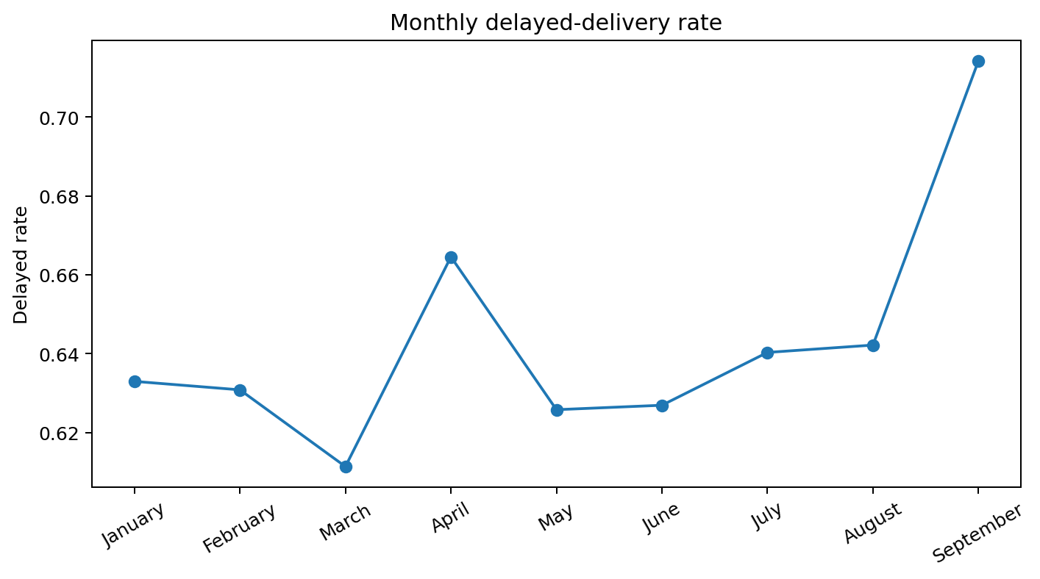
Figure 1 — Monthly delayed-delivery rate. September is a partial month and should be interpreted cautiously.

2. Business Context and Analytical Objectives
SwiftLog is a growing logistics and supply-chain business seeking greater visibility into delivery efficiency, customer value, inventory, warehouse operations and product performance. The Data Science mission is deliberately upstream of predictive modelling: the goal is to integrate imperfect operational data, identify patterns and limitations, engineer meaningful features and deliver an analytical dataset suitable for later Machine Learning work.
Objective | How this submission addresses it
Integrate data | Validated joins across customers, orders, items, products, shipments, delivery, warehouses, employees and returns.
Understand operations | 21+ professional figures and descriptive statistics across demand, revenue, delivery, inventory, returns and staffing.
Test business hypotheses | Three non-parametric inferential tests with effect sizes and business interpretation.
Engineer predictive features | Order value/size, prior customer history, seasonality, warehouse load proxies, delay/return outcomes and inventory-turnover proxy.
Discover segments | Exploratory K-Means segmentation for customers, products and warehouses.
Prepare for ML | Self-contained Colab notebook plus exported order-level feature dataset and explicit leakage/availability notes.

3. Data Acquisition & Understanding

3.1 Dataset portfolio
Dataset | Rows | Cols | Missing cells | Exact duplicate rows
Customers | 1,000 | 3 | 0 | 0
Orders | 5,000 | 9 | 0 | 0
Order_Items | 15,000 | 4 | 0 | 0
Products | 250 | 3 | 0 | 0
Suppliers | 150 | 2 | 0 | 0
Warehouses | 15 | 2 | 0 | 0
Inventory | 4,000 | 3 | 0 | 3
Shipments | 5,000 | 4 | 0 | 0
Delivery_Performance | 5,000 | 3 | 0 | 0
Employees | 200 | 2 | 0 | 0
Returns | 500 | 3 | 0 | 0
Data_Dictionary | 11 | 2 | 0 | 0
All supplied CSVs have zero missing cells, but structural completeness issues remain. Most importantly, 236 Orders have no matching Order_Items record. Referential integrity checks show that every child foreign key that is present resolves to a valid parent; this does not imply every parent record has children.
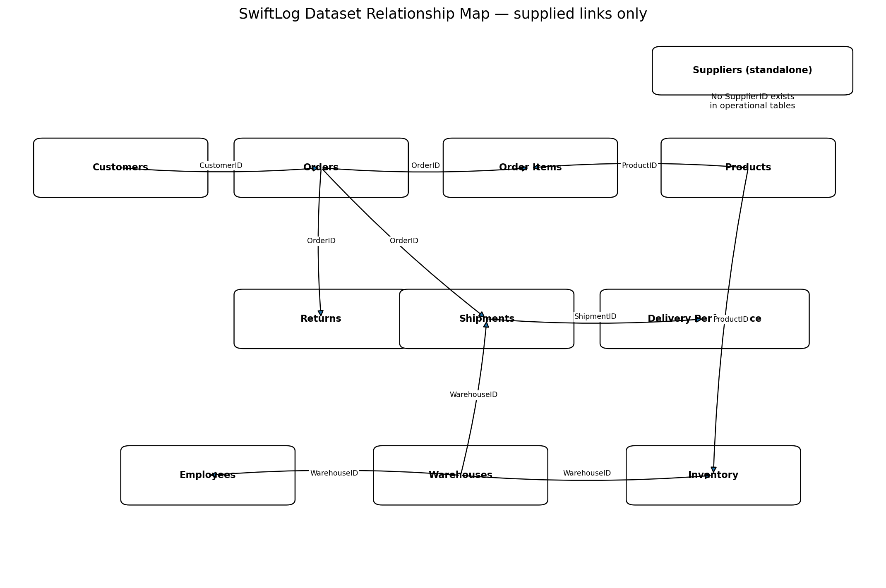
Figure 2 — Validated SwiftLog relationship map. Suppliers remain standalone because no SupplierID exists elsewhere.

3.2 Critical structural findings
Finding | Evidence | Treatment
Supplier disconnect | SupplierID occurs only in SwiftLog_Suppliers.csv | Keep table standalone; supplier reliability not calculated.
Order-item coverage gap | 236 of 5,000 Orders have no Order_Items | Retain orders; mark OrderItemDataAvailable=0; exclude missing revenue only from revenue-specific statistics.
Inventory repetition | 1,545 repeated Warehouse–Product rows beyond first; 3 exact repeated rows | Retain as stock movements per official guidance; aggregate separately for reporting.
No warehouse capacity | Warehouses contains WarehouseID + Location only | Use explicitly labelled load proxies, never true utilisation.
Order-level returns | Returns contains ReturnID, OrderID, Reason only | Do not claim true product return rates; use returned-order exposure proxy.
Simplified dictionary | Dataset names only | Infer cautiously and record every assumption.

4. Data Cleaning & Preprocessing
Cleaning was intentionally conservative. No row was deleted simply because it looked repetitive. Strings were trimmed, OrderDate was parsed to datetime, calendar features were derived, positive/non-negative range assertions were applied, Shipment and Delivery_Performance delay values were cross-checked, and inventory movement rows were preserved.
Step | Action | Result
Text standardisation | Trim whitespace from object fields | Consistent categorical matching without recoding business values.
Date handling | Parse OrderDate; derive year, month, month name, quarter, day of week | Supports demand/seasonality analysis.
Range validation | Quantity/price > 0; stock/delay >= 0 | All checks passed.
Delay cross-check | Compare Shipments.DelayDays with Delivery_Performance.DelayDays by ShipmentID | No mismatches.
Inventory treatment | Preserve all movement records; aggregate Warehouse–Product view separately | 2,455 aggregated Warehouse–Product combinations from 4,000 movement rows.
Return treatment | Aggregate multiple ReturnID records to order-level HasReturn / ReturnCount | 473 unique returned orders across 500 return records.

5. Exploratory Data Analysis
More than the required 15 visualisations were generated. The report highlights the most decision-relevant charts; the full figure set is stored under Visualizations/Charts and reproduced in the notebook.

5.1 Demand and revenue
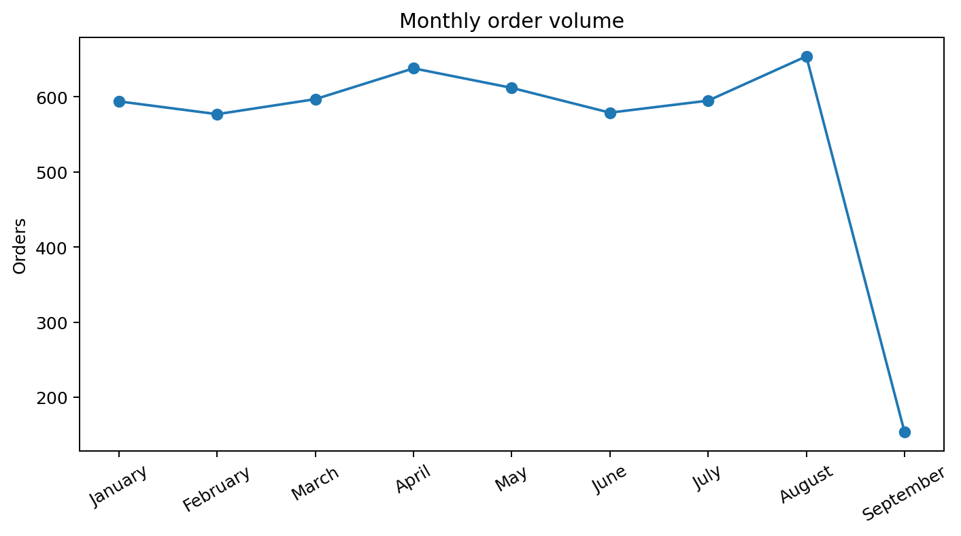
Figure 3 — Monthly order volume. August is the peak month with 654 orders; September is partial.
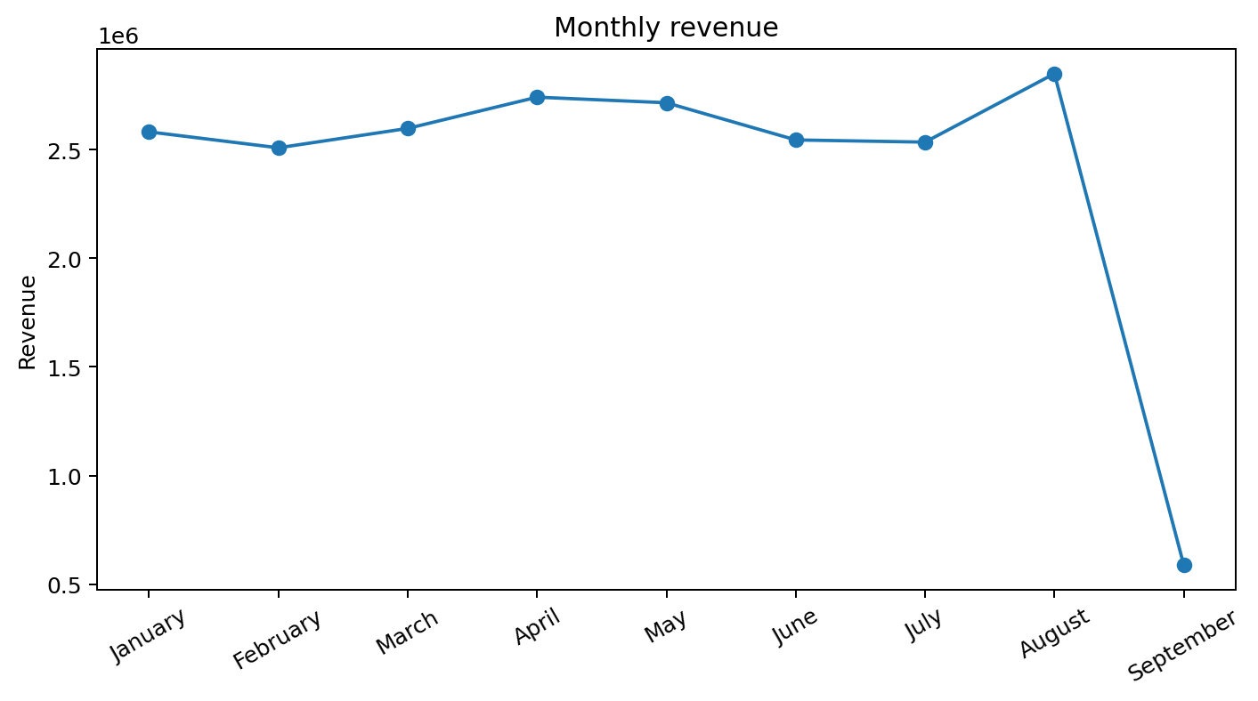
Figure 4 — Monthly observed revenue. August is also the highest-revenue month.
Observed order-item revenue totals $21,668,065.85. The top category is Fashion at $8,059,602.65; Food and Electronics follow. Because 236 orders lack items, this is observed revenue from the available line-item data rather than a guaranteed complete ledger total.
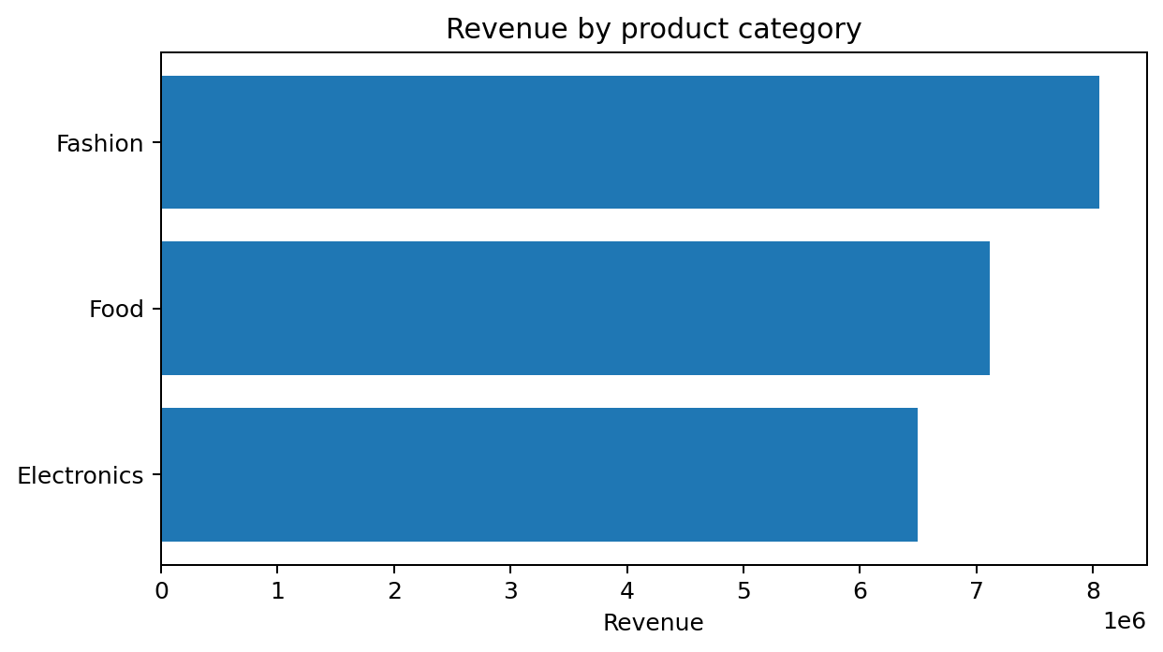
Figure 5 — Revenue by product category.
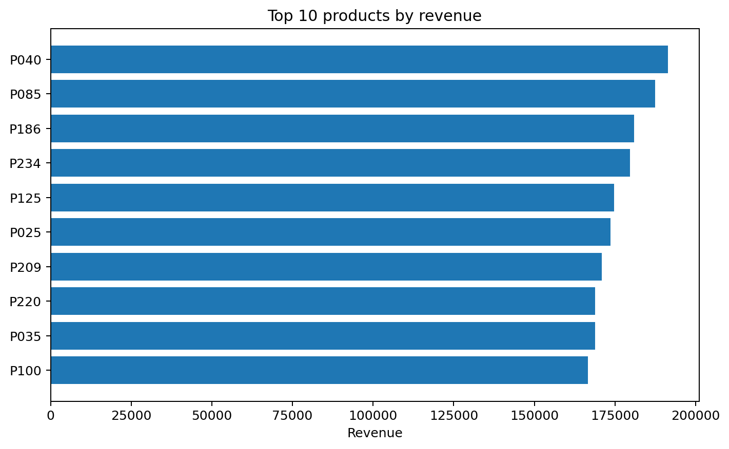
Figure 6 — Top 10 products by revenue. Product P040 leads the observed product portfolio.

5.2 Delivery and warehouse operations
The overall delayed-delivery rate is 63.7%, with average delay of 3.57 days. W05 has the highest observed delayed rate (68.0%) while W01 has the lowest (58.7%); however, inferential testing later shows the warehouse delay distributions are not significantly different.
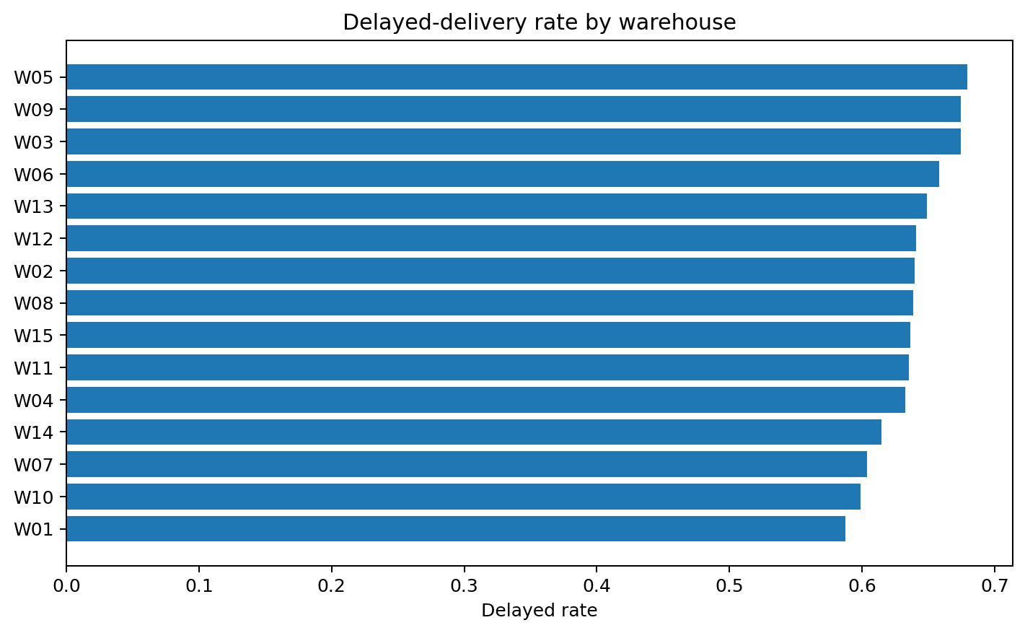
Figure 7 — Observed delayed-delivery rate by warehouse.
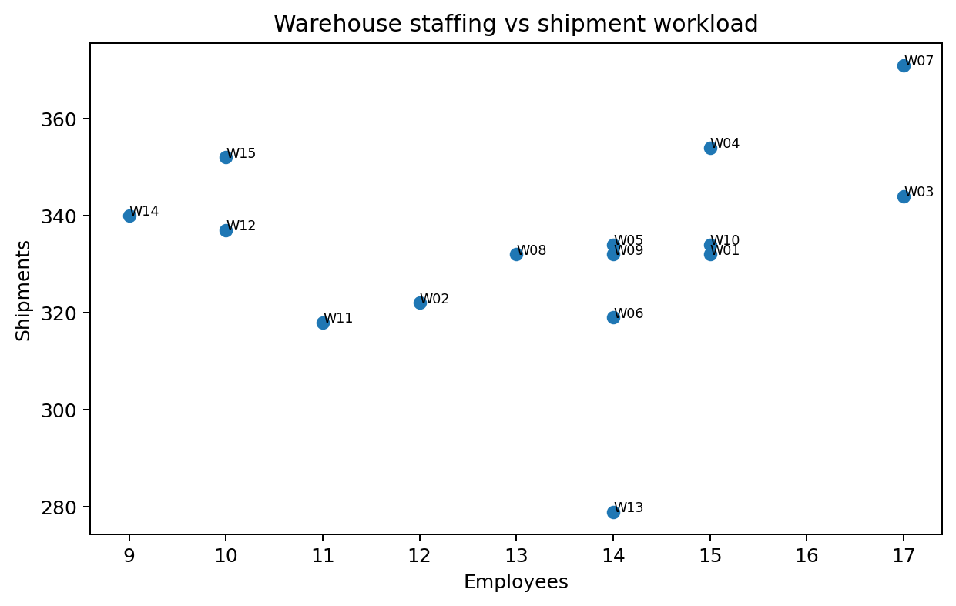
Figure 8 — Staffing vs shipment workload. This is descriptive because staffing productivity standards are not supplied.

5.3 Returns and inventory
The order-level return rate is 9.5%. Late Delivery is the most common stated return reason (185 records), followed by Wrong Item (163) and Damaged (152). Returns cannot be assigned to a specific product because ProductID/OrderItemID is absent from Returns.
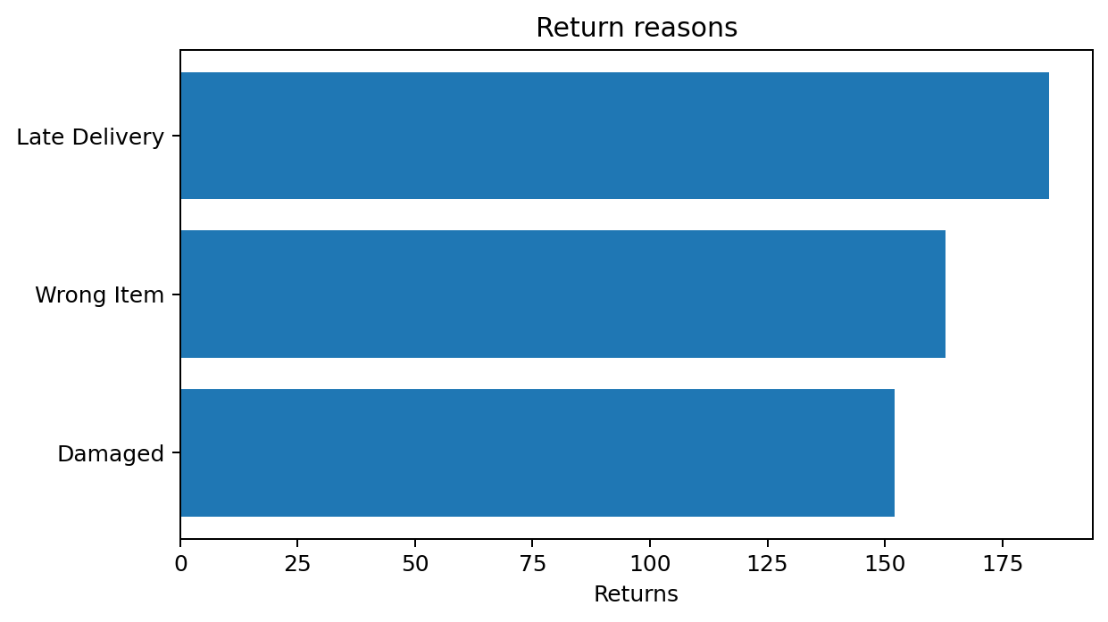
Figure 9 — Return reasons.
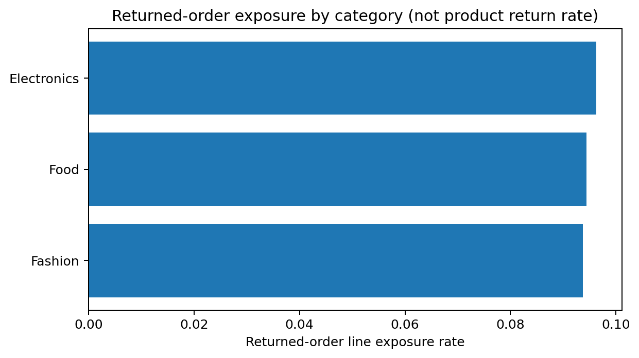
Figure 10 — Category exposure to returned orders. This is not a true product return rate.
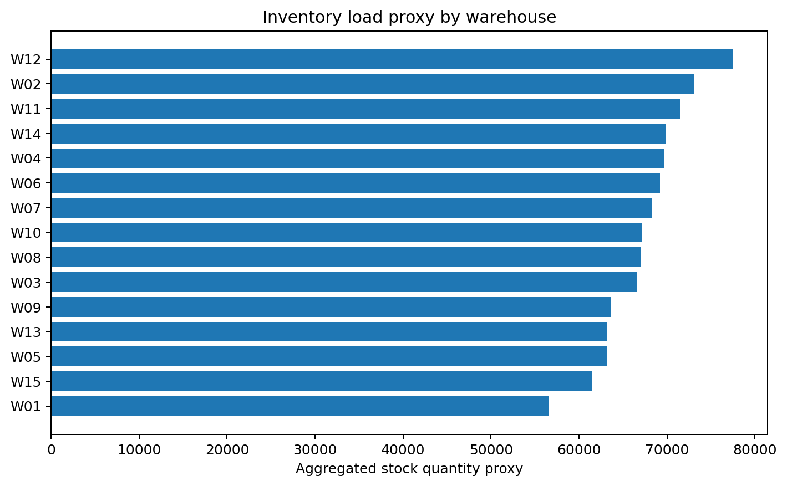
Figure 11 — Warehouse inventory-load proxy using summed stock movements. True capacity utilisation cannot be computed.

6. Statistical Analysis
Non-parametric tests were selected because delay days are discrete and order revenue is highly skewed. The project keeps unsupported hypotheses visible as results rather than quietly discarding them.
ID | Test | Statistic | p-value | Effect size | Decision
H1 | Kruskal-Wallis | 10.039 | 0.7594 | 0.0000 | Fail to reject
H2 | Mann-Whitney U | 1069995.000 | 0.9828 | 0.0006 | Fail to reject
H3 | Kruskal-Wallis | 3.432 | 0.3297 | 0.0001 | Fail to reject
- H1 — Delivery delays across warehouses: fail to reject (p=0.7594). The visible rate spread is not statistically strong enough to conclude warehouse-specific delay distributions differ.
- H2 — Returned vs non-returned orders: fail to reject (p=0.9828). Overall delivery delay does not distinguish returned orders from non-returned orders in this synthetic sample.
- H3 — Order revenue across customer cities: fail to reject (p=0.3297). City revenue totals are not evidence of different per-order revenue distributions.
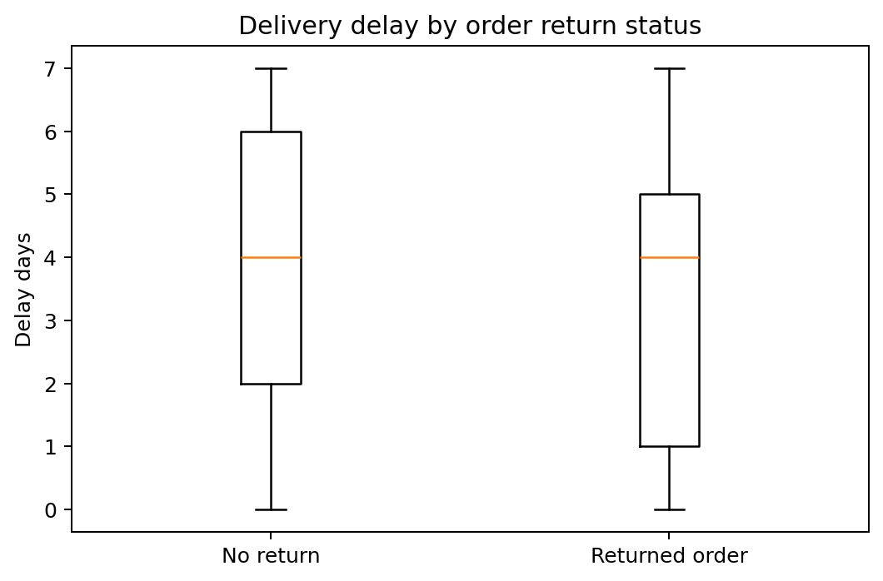
Figure 12 — Delivery delay by order return status; the distributions overlap strongly.

7. Feature Engineering & ML Readiness
The final feature dataset is order-level and preserves all 5,000 orders. Outcome-derived variables such as IsDelayed, DelayDays and DeliveryEfficiencyScore are included for analysis/target definition but must not be used as predictors when modelling delay. Historical customer features are constructed from prior orders only to reduce temporal leakage risk.
Feature / feature group | Construction | Business / modelling value | Caution
OrderRevenue | Σ Quantity × UnitPrice by OrderID | Order value and customer value modelling | Missing for 236 orders without items.
TotalUnits / DistinctProducts / UniqueCategories | Order-level item aggregation | Basket size and complexity | Unavailable where Order_Items absent.
PriorCustomerOrders / PriorCustomerSpend | Strict cumulative history before each order | Customer familiarity/value without future orders | Revenue history depends on available item coverage.
SeasonalDemandIndicator | Monthly order volume above median | Peak-demand planning | Descriptive; full-period threshold should be re-fit inside ML training.
WarehouseOperationalLoadProxy | 50% normalized stock proxy + 50% normalized shipment volume | Operational workload context | Not true utilisation; no capacity.
InventoryTurnoverProxy | Units shipped / aggregated stock movement quantity | Relative stock-demand signal | Not accounting turnover; no dated inventory/average stock.
DeliveryEfficiencyScore | 100 × (1 - DelayDays/max delay) | Descriptive operational index | Outcome-derived; never use to predict delay.
HasReturn / ReturnCount | Order-level aggregation of Returns | Potential return-modelling target | Cannot identify returned product.
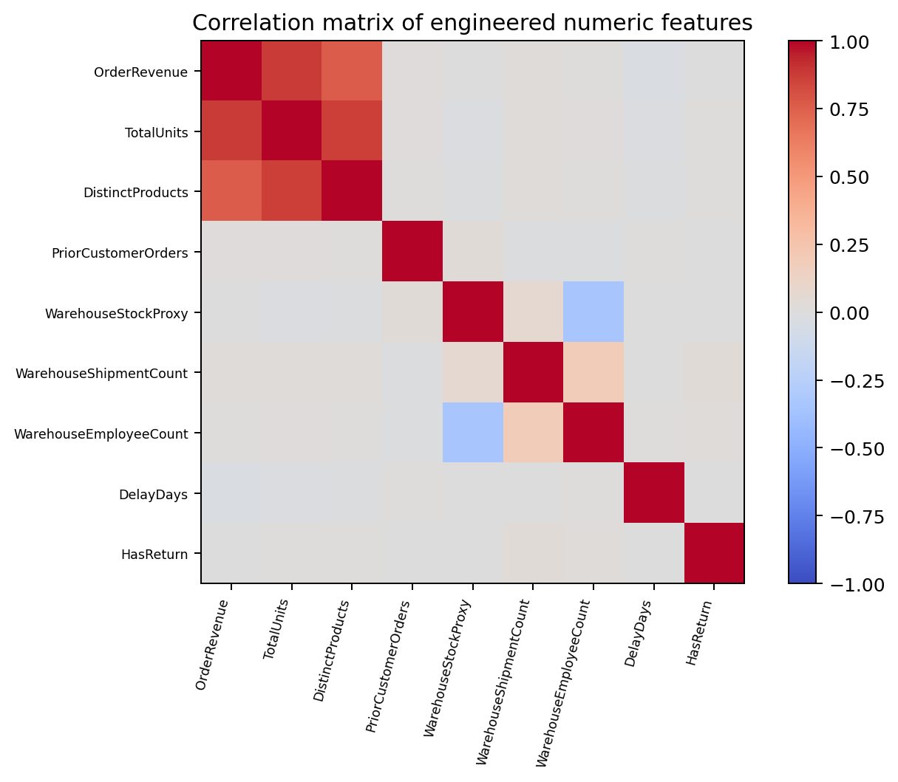
Figure 13 — Correlation matrix of selected engineered numeric features.

8. Segmentation & Pattern Discovery

8.1 Customer segmentation
Segment | Customers | Total revenue | Avg revenue | Avg orders | Avg order value
High-Value Loyal | 329 | $11,480,070 | $34,894 | 7.58 | $4,846
High-Value Occasional | 246 | $5,398,755 | $21,946 | 3.77 | $6,210
Core / Lower-Value | 416 | $4,789,241 | $11,513 | 3.80 | $3,183
Customer clustering uses value/frequency variables only and achieves silhouette 0.360. This is moderate exploratory separation, not evidence of naturally discrete customer classes. High-Value Loyal customers contribute the largest segment revenue.
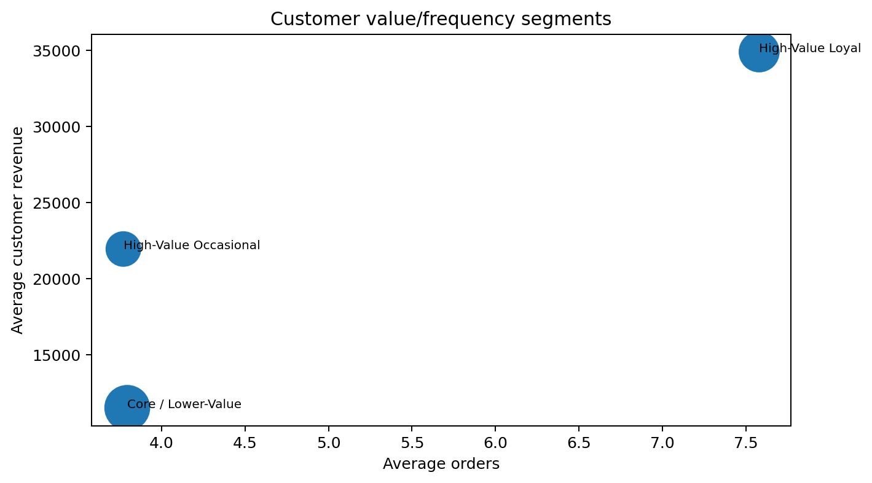
Figure 14 — Customer value/frequency segments.

8.2 Product and warehouse patterns
Product segmentation silhouette is 0.330; warehouse segmentation silhouette is 0.301. Both are exploratory, particularly warehouse clustering where only 15 warehouses exist.
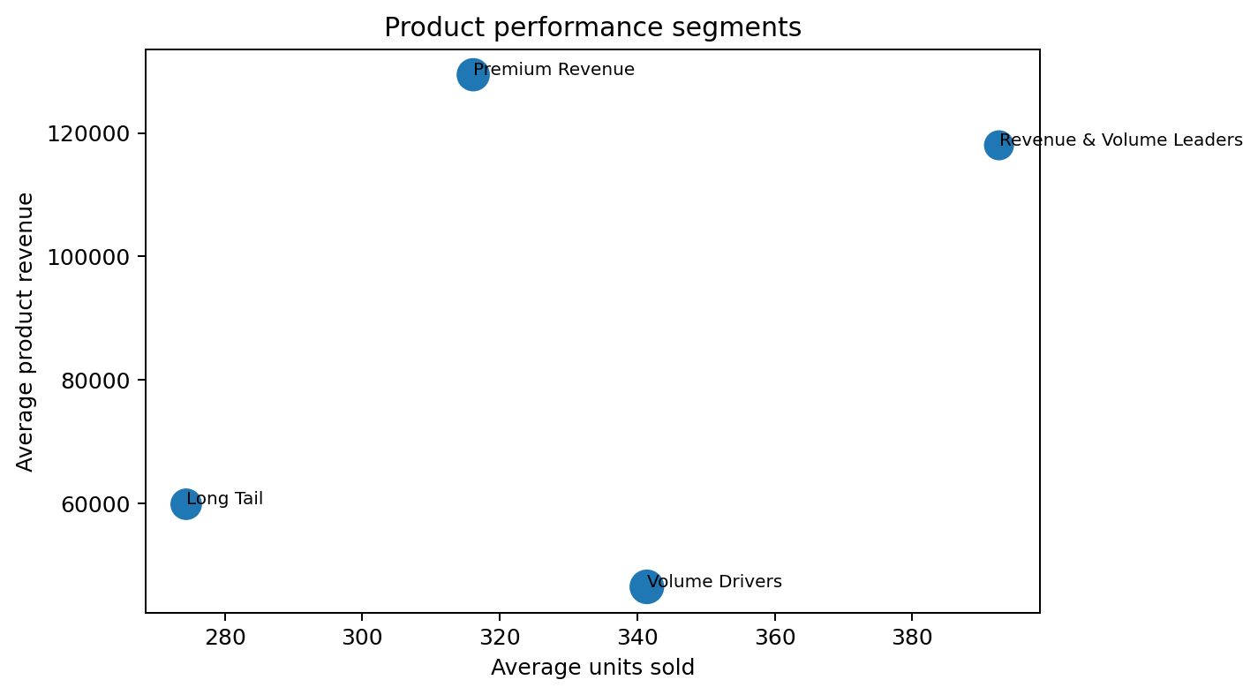
Figure 15 — Product performance segments.
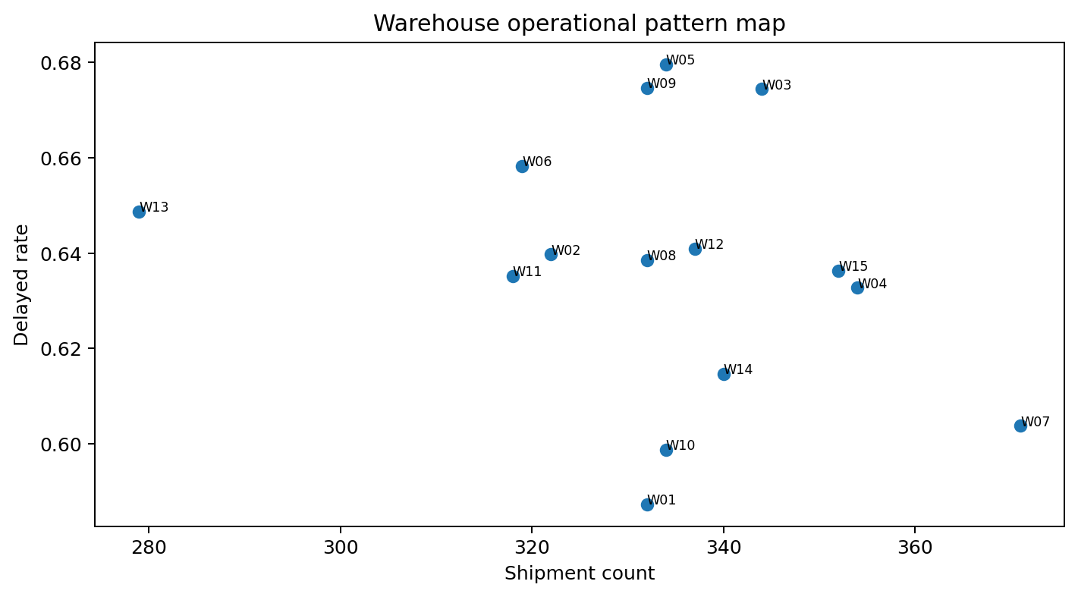
Figure 16 — Warehouse operational pattern map.

9. Business Insights — Assignment Questions
1. Which customer segments generate the highest business value?
High-Value Loyal customers lead total revenue at approximately $11.48m across 329 customers, with the highest average order frequency.
2. Which products contribute most to revenue?
P040 is the highest-revenue individual product at $191,463.68; Fashion is the highest-revenue category at $8,059,602.65.
3. Which suppliers consistently underperform?
Not determinable from the provided data. Suppliers has no operational join key; creating supplier scores would require an invented mapping, which this submission does not do.
4. Which warehouses require operational improvements?
W05, W09 and W03 have the highest observed delayed rates, with W05 at 68.0%. However H1 p=0.759 means this ranking is a monitoring priority, not statistical proof of warehouse-caused delay.
5. Which products have the highest return rates?
Not determinable exactly because Returns is order-level. Electronics has the highest returned-order line exposure proxy (~9.6%), but this must not be called a true product return rate.
6. Which regions experience the greatest delivery delays?
Using warehouse location as the geographic proxy, Lagos has the highest average delay (~3.59 days), slightly above Kano and Abuja.
7. What operational bottlenecks were identified?
The strongest operational signal is the 63.7% delayed-delivery rate. Data-system bottlenecks include the supplier disconnect, missing warehouse capacity, undated inventory movements, order-level-only returns and 236 orders without item records.
8. Which variables are most suitable for predictive modelling?
Order size/value, product mix, calendar/seasonal features, prior customer history, warehouse/location, staffing and load proxies. Delay-derived fields are targets/outcomes and must be excluded from delay predictors.
9. What hidden patterns did the analysis uncover?
Warehouse delay differences and return-related delay differences look plausible descriptively but are statistically unsupported. August is the demand/revenue peak; Fashion leads revenue; customer value segmentation is more distinct than warehouse segmentation.
10. What recommendations improve operations?
Prioritise delay reduction, improve data capture, protect high-value customers, use product segments for inventory prioritisation, prepare for August demand, and collect supplier/capacity/return-line data before advanced optimisation.

10. Strategic Recommendations
Area | Recommendation
Delivery optimisation | Create a focused delay-reduction programme and track delayed rate/average delay weekly; the overall delayed rate is 63.7%.
Warehouse process review | Investigate W05/W09/W03 first while treating observed rankings as diagnostic priorities rather than causal proof.
Benchmarking | Review processes at W01/W10/W07 as lower-delay operational references.
Peak planning | Increase capacity planning and staffing review ahead of August, the highest order-volume and revenue month.
Customer retention | Protect High-Value Loyal customers with service-level monitoring and targeted retention because they contribute the largest segment revenue.
Category strategy | Protect Fashion availability while balancing concentration risk across Food and Electronics.
Product portfolio | Use product segments to define differentiated replenishment and merchandising rules for leaders, premium products, volume drivers and long-tail items.
Returns | Treat Late Delivery as a priority complaint reason, but improve return data before attributing product-level quality problems.
Supplier data governance | Add SupplierID to product/contract/shipment records so supplier reliability can be measured rather than assumed.
Warehouse data governance | Capture true capacity, space used and dated inventory snapshots so true utilisation and turnover can replace proxies.
Returns granularity | Add ProductID/OrderItemID and return quantity to Returns to enable valid product/category return rates.
Order completeness | Resolve the 236 orders missing Order_Items and add automated referential/completeness controls in the source system.

11. Assumptions, Data Limitations & Risks
Area | Limitation / assumption | Impact | Mitigation
Suppliers | No SupplierID outside Suppliers | Supplier performance analysis not possible | Keep standalone; recommend source-system mapping.
Warehouse utilisation | No capacity metric | True utilisation cannot be computed | Use labelled load proxies only.
Inventory | No date/current-record indicator | Stock movements cannot form time-series inventory | Aggregate for reporting; call turnover a proxy.
Returns | No ProductID/OrderItemID | Cannot determine returned product | Use order-level return analysis and exposure proxy.
Order items | 236 Orders have no Order_Items | Observed revenue is incomplete for those orders | Retain orders and flag coverage; avoid zero imputation.
Data dictionary | No field-level definitions | Business meanings partly inferred | Document rules; recommend governed dictionary.
September | Data ends 8 September | September monthly figures are partial | Do not compare September totals directly with full months.
Segmentation | Unsupervised clusters depend on chosen features/k | Segments are exploratory | Report silhouette and avoid causal claims.

12. Testing, QA & Decision Log
Work completed | Test / evaluation | Finding | Action | Result
Dataset integration | Foreign-key anti-joins | Zero unmatched child keys | Retain validated relationships | Join integrity confirmed.
Order completeness | Parent-to-child coverage check | 236 Orders lack Order_Items | Use left merge + coverage flag | All 5,000 orders preserved.
Shipment/delivery consistency | Compare DelayDays by ShipmentID | No mismatches | Use delivery table status and validated delay | One consistent delay measure.
Inventory cleaning | Check duplicate and Warehouse–Product repetition | Repeated rows are expected movements per guidance | Retain; aggregate separately | No incorrect de-duplication.
Hypotheses | Kruskal-Wallis / Mann-Whitney | All three nulls fail to reject | Report as findings | No p-value fishing.
Segmentation | Silhouette scoring | Customer separation strongest; warehouse/product moderate | Treat clusters as exploratory | No overclaiming.
Notebook reproducibility | Clean end-to-end execution | All cells completed successfully | Keep self-contained Drive file search | Colab-ready submission.

12.1 Decision log
Decision | Reason | Evidence | Impact
D1: do not fabricate supplier mapping | No SupplierID relationship | Official AnalystLab guidance + schema | Supplier scoring omitted honestly.
D2: retain inventory repeats | They represent movements | Official AnalystLab guidance | No false data loss.
D3: preserve itemless orders | Delivery/customer evidence remains valid | 236 parent orders lack child lines | 5,000-order analytical grain preserved.
D4: label warehouse metrics as proxies | Capacity absent | Warehouse schema contains only ID and location | Prevents false utilisation claims.
D5: use non-parametric tests | Skewed/discrete variables | Revenue and DelayDays distributions | Robust statistical inference.
D6: keep unsupported hypotheses | Null findings are informative | p-values 0.759, 0.983, 0.330 | Avoid cherry-picking.

13. Future Machine Learning Opportunities
Opportunity | Potential target | Candidate predictors | Precondition
Delivery-delay prediction | IsDelayed / DelayDays | Order size, product mix, month, prior customer history, warehouse/location/load | Do not use DelayDays, DeliveryStatus or DeliveryEfficiencyScore as predictors.
Demand forecasting | Monthly/category/product units | Historical quantities, seasonality, product/category | Longer time series and dated inventory recommended.
Return-risk modelling | HasReturn | Order/product mix, customer history, delivery context | Add returned ProductID/OrderItemID for product-level modelling.
Supplier reliability | Future supplier outcome | Supplier, product, shipment, delay | Requires SupplierID mapping.
Warehouse optimisation | Delay/load/service metrics | Capacity, staffing, inventory, shipments | Requires true capacity and dated stock snapshots.

14. Conclusion
The SwiftLog analysis delivers a defensible, reproducible foundation for later Machine Learning without pretending that imperfect data is complete. The strongest operational issue is delivery performance, while the strongest data-governance gaps are supplier disconnection, absent warehouse capacity, undated inventory and order-level-only returns. Revenue and demand patterns identify clear priorities — August peak planning, protection of high-value customers and product/category portfolio management — while statistical tests prevent descriptive differences from being overstated. The final feature-engineered dataset, notebook, figures, profiling report and documentation provide a transparent handoff for future predictive logistics work.

15. Appendices

15.1 File manifest
- Data/Original_Datasets/ — 12 supplied CSVs
- Data/Cleaned_Datasets/ — cleaned tables + aggregated inventory
- Data/Feature_Engineered_Dataset.csv — 5,000-row order-level analytical dataset
- Notebook/Week5_DataScience.ipynb — self-contained executable notebook
- Reports/Data_Profiling_Report.html
- Reports/Technical_Report.pdf / .docx
- Reports/Executive_Summary.pdf / .docx
- Visualizations/Charts/ — 20+ generated figures
- Presentation/Executive_Presentation.pptx
- README.md, WEEK5_SUBMISSION_CHECKLIST.md, social_posts_week5.md, requirements.txt

15.2 Reproducibility statement
All numerical claims in this report trace to code executed against the supplied CSV files. The notebook searches recursively under /content/drive/MyDrive/Analyst Lab Africa when run in Colab, reproduces the cleaning, integration, analysis, hypothesis tests, feature engineering and segmentation, and exports the resulting artifacts. Random seed 42 is fixed for K-Means segmentation.

15.3 Responsible interpretation
This is an educational consulting project using supplied synthetic/fictional business data. Proxies are labelled as proxies; unsupported relationships are not fabricated; statistical associations are not presented as causal conclusions; and future Machine Learning opportunities are recommendations rather than claims of deployed predictive performance.

