ECE 445L Lab 7B
PCB Layout for an Embedded System
This laboratory assignment accompanies the book, Embedded Systems: Real-Time Interfacing to ARM Cortex M Microcontrollers, ISBN-13: 978-1463590154, by Jonathan W. Valvano, copyright © 2024.

Table of Contents
Table of Contents 1
Team Size 2
Goals 2
Review 2
Required Hardware 2
Teamwork evaluations 2
Lab Overview 2
Preparation 2
Preparation Deliverables 4
Procedure 4
Lab Checkout 8
TA and Professor Review 8
Lab Report 8
Deliverable 1 8
Deliverable 2 8
Deliverable 3 8
Deliverable 4 8
Deliverable 5 8
Deliverable 6 8
Hints 9

Team Size
The team size for this lab is 4.

Goals
- Layout a PCB design for your embedded system.
- Consider power and enclosure for your embedded systems.

Review
- Data sheets for your microcontroller.
- Data sheets for your hardware components.

Required Hardware
The PCB should have at least 10 test points for DVM and scope measurements: 6 for signals, two for power and two for ground. There should be a simple and convenient way to connect at least 6 digital signals to a logic analyzer. Depending on which logic analyzer you plan to use in Lab 10, layout the PCB to simplify connections.

Teamwork evaluations
Each student will get a significant evaluation of their teamwork performance (5% of the total ECE445L grade). There should be four or more major components to the project, so we expect each member of the team to be responsible for at least one major component. The TA will show you your teamwork score after Lab 7B, and you will have a second teamwork performance grade for Labs 8, 9, and 10. The grading rubric considers:
- Completion and understanding of your assigned responsibilities(s) for the project.
- The number of meaningful commits you made to your teams GitHub repo.
- The effort you contributed to the project.
- Your ability to resolve conflicts.
- Your participation in your teams’ communications. You are encouraged to show your TA the communication during Labs 7A and 7B.

Lab Overview
In Lab 7B, you will finalize the design of your embedded system. Taking the schematic developed from Lab 7A, you will convert your electrical design into a PCB design that will be fabricated for your final project submission in Lab 10.

Preparation
- To finalize the design, consider how the system will be power and decide which enclosure to use. Even if you are using the TM4C LaunchPad, you still are required to have a regulator. Add the power regulation to the schematic and BOM. Your schematic in your KiCAD project should pass ERC and have a footprint assigned to every component.
- Take your finalized schematic and import it into the PCB editor.
- Place the components on the PCB and arrange them such that it meets your teams’ requirements, including:
  - Expected board outline: what is the size and shape of your PCB and how does it mount to your mechanical enclosure and/or systems?
  - Expected user inputs: where is the user expected to interface with any sensors or actuators?
  - Design for test: are the test points or high-risk circuitry easily reachable?
  - Design for manufacturing: are the components oriented in positions that make it easy to solder and assemble?
- Receive approval from your TA that your parts placement is satisfactory (BEFORE YOU BEGIN ADDING TRACES).
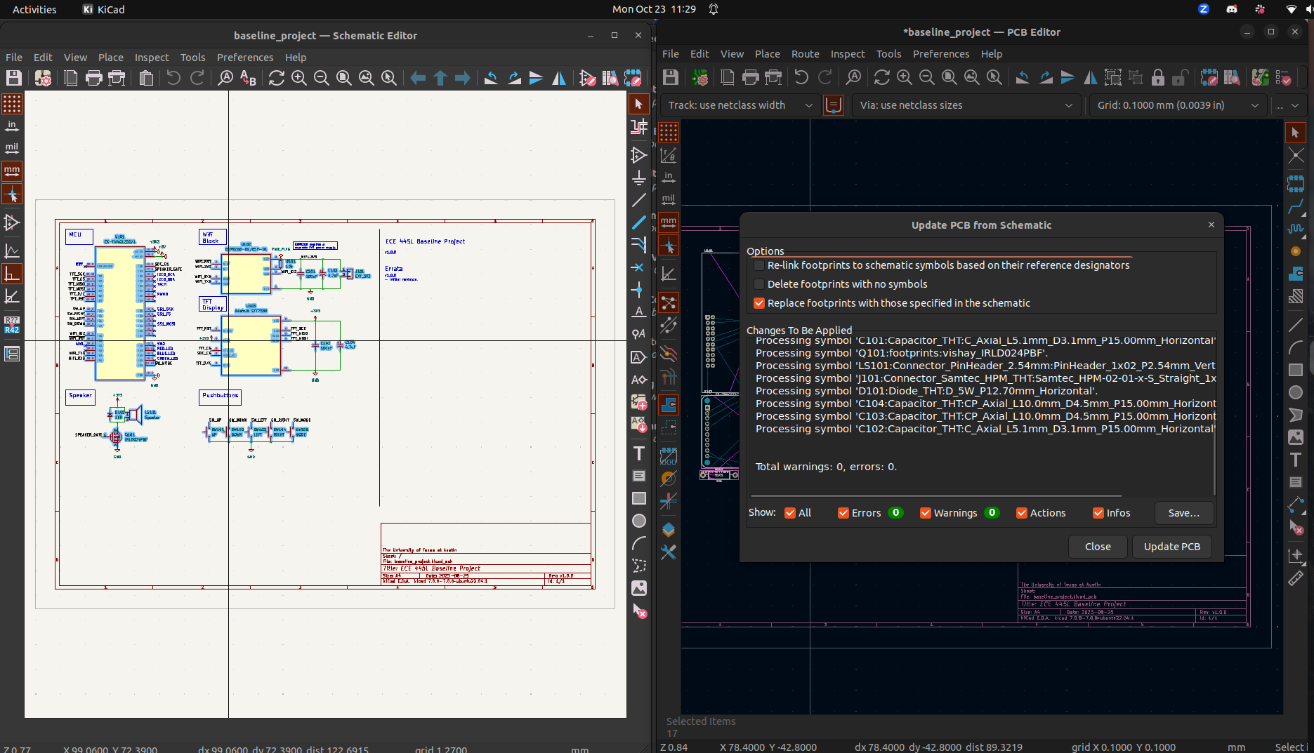
Figure 7B.1. Importing Footprints to PCB Editor.
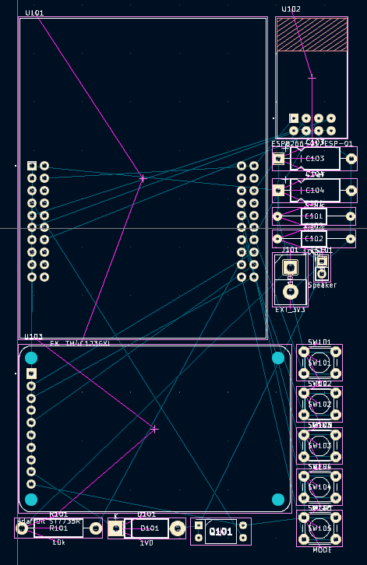
Figure 7B.2. Imported Footprints in PCB Editor.

Preparation Deliverables
- Final KiCad schematic file and preliminary PCB file (placement of parts)
- Updated Bill of materials

Procedure
- Perform PCB layout using KiCad. Make sure that the design passes DRC. Please do a little bit of Lab 7B layout and then have someone check it. DO NOT DO THE COMPLETE DESIGN SCH/PCB THEN GET IT CHECKED. Ensure that the following silkscreen is added to the PCB:
  - Team names, UTX_FALL_2025, TA’s name, project name.
  - Test point and debug labels.
  - Assembly labels (e.g., dot for first pin of IC).
- Install the JLCPCB Fabrication Toolkit plugin from the KiCad project menu and use the plugin in the PCB editor. When generated, it should open a browser window to a folder with the production files.
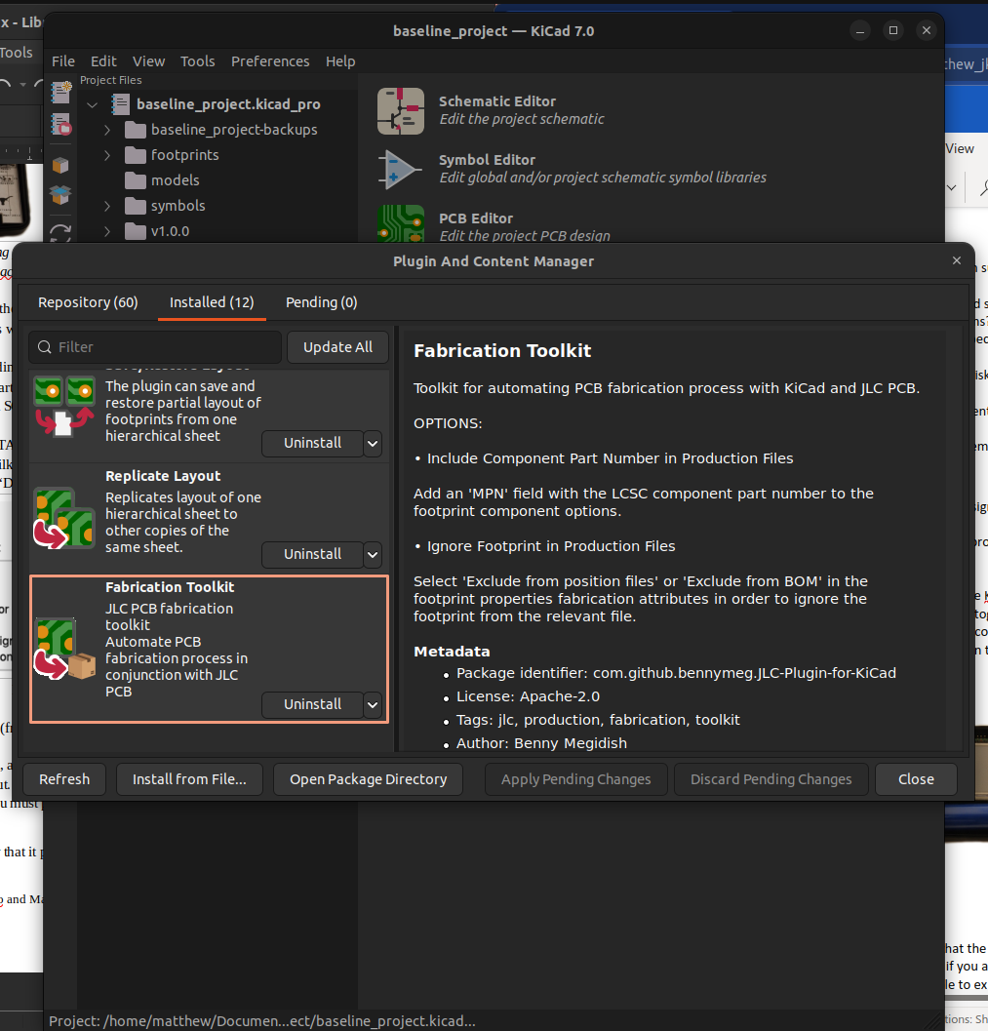
Figure 7B.3. JLCPCB Fabrication Toolkit Plugin.
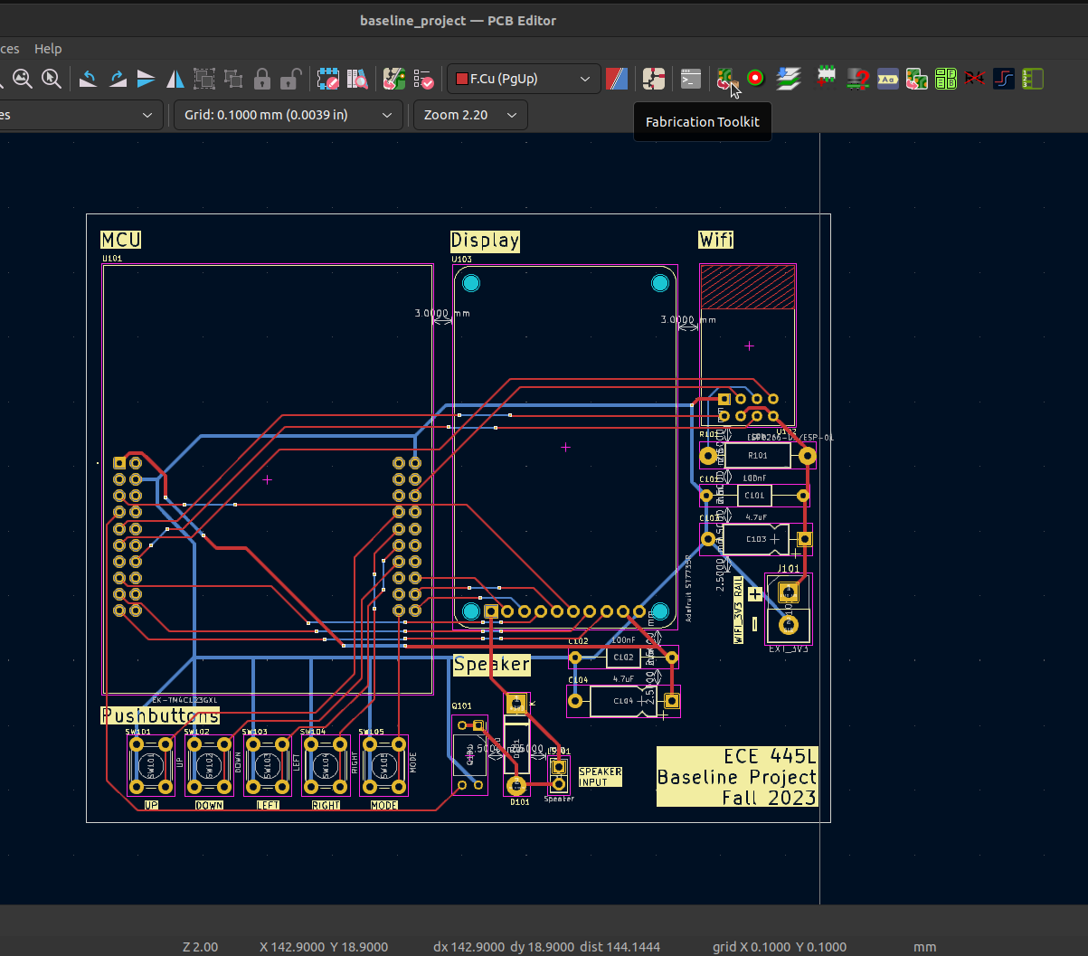
Figure 7B.4. JLCPCB Fabrication Toolkit Plugin (PCB Editor).
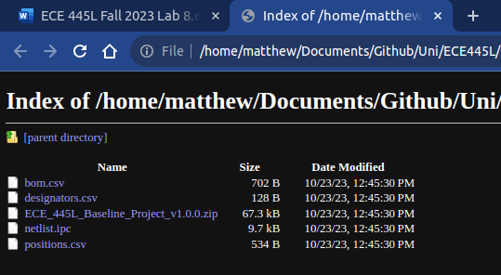
Figure 7B.5. JLCPCB Fabrication Outputs.

- Go to the JLCPCB site and provide the zip file when asked to upload Gerbers. Verify that the board loads properly in the viewer and the dimensions and costs are not unexpected.
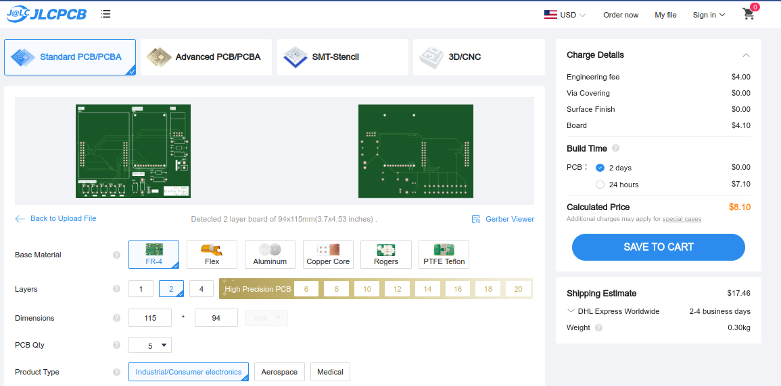
Figure 7B.6. JLCPCB Upload.
- Print out the PCB on paper and glue the two pieces together. Punch and drill holes to place components on the simulated “PCB”. Verify that all components fit in the spaces allocated for them. Presumably you have had somebody to design the enclosure by now.
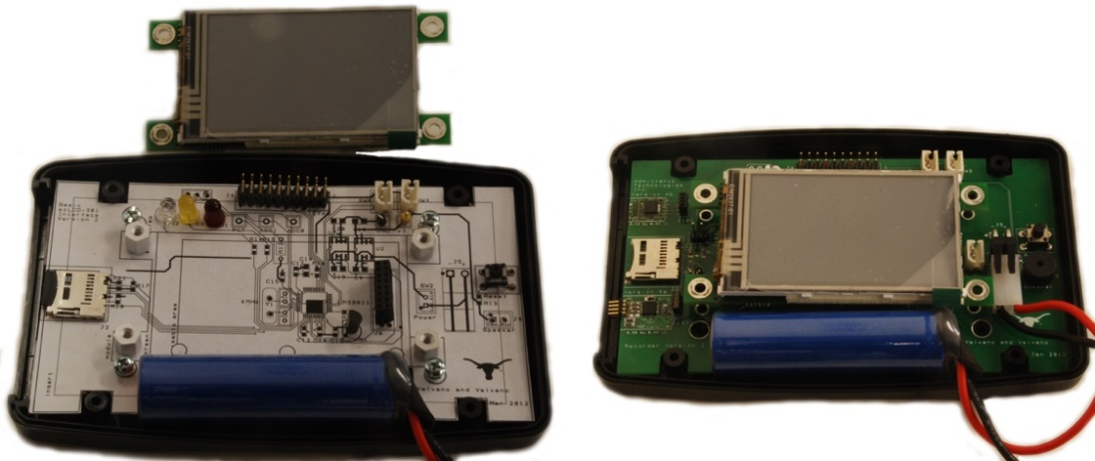
Figure 7B.7. Lab7B on left and Lab 10 on right.
- Write integration tests to confirm that your subcircuits work together without breaking functionality. In other words, take the 4 or 5 projects developed as unit tests in Lab 7A and combine them into one project the runs all unit tests at the same time. You are looking to avoid pin conflicts and unexpected interactions between modules. Lab 7B remains low-level I/O testing, whereas functional testing of high-level tasks will be completed during Lab 10.

Lab Checkout
- Open your project in KiCAD and demonstrate that the layout is complete and passes DRC.
- Explain how the system will be powered. You should be able to explain how the regulator works.
- Demonstrate that your breadboard circuits are functional when running the integration tests, so there are no major design flaws that may show up in Lab 10.
- Explain your testing procedure for when the PCB arrives. This needs to be a list of 4 or 5 steps, detailing the bottom-up construction and test procedures. Each step will include hardware to be built, software to be written, debugging tools to be used, and expected results to be collected.
- Show any connectors, I/O devices, or other devices that will connect to the PCB. Explain how they will be powered and communicate with your system.
- Show that the simulated PCB has correct sizing of the components and that it fits within the enclosure.

TA and Professor Review
Students shall submit KiCad .kicad_pro .kicad_sch and kicad_pcb files to GitHub. See syllabus for due dates

Lab Report

Deliverable 1
Updated Requirements Document including a Data flow graph and Call graph.

Deliverable 2
Complete your KiCad Project, Schematic, and PCB files.

Deliverable 3
Final BOM. Additionally, record the total cost of only the components which count towards competition eligibility.

Deliverable 4
Print out the top and bottom (mirrored) of the PCB showing all components are the correct size and the PCB fits in the box (Figure 7A.2 and Figure 7B.7).

Deliverable 5
Integration test code.

Deliverable 6
Describe the tests that you added in lab 7B to verify your modules and their integration. Integration test code showing all modules run at the same time.

Hints
- Lab 7B hint: Everyone’s embedded system must be placed in a box, so you should think about the box during Lab 7B. Starting to think about squeezing all the components into the little box once you get to Lab 10 will be difficult. Placing components in the proper place on the PCB during Lab 7B will greatly simplify the box-building process.
- Lab 7B hint: KiCad has a feature that allows for ground planes (copper pour). WE DO NOT ALLOW you to use this feature. Ground planes are useful for high frequency and/or low noise systems. The ground plane makes it much harder to visually see what wire connects to what pin, it makes it much harder to cut/add traces in Lab 10 to fix mistakes, and it makes it harder to create good solder joints without using a high-temperature soldering iron.
- Lab 7B hint: One common mistake new PCB layout designers make is placing two wires too close to each other. Subsequently, during fabrication, these two wires may become shorted because of the tolerance of the manufacturing process. A general rule of thumb is that you should allow enough space between two wires to fit the smallest allowable trace between them. For this PCB manufacturer, separate all traces by at least 0.007 inch.
- Lab 7B hint: Male-male header pins. This photo shows a straight header with 0.1in separation. This can be broken into any number of pins and used for connectors or mode selection.
