Практическое занятие №6. Шаблоны в FastAPI.
Новый POST маршрут:
@todo_router.post("/todo")
async def add_todo(request: Request, todo: Todo = Depends(Todo.as_form)):
todo.id = len(todo_list) + 1
todo_list.append(todo)
return templates.TemplateResponse("todo.html",
{
"request": request,
"todos": todo_list
})

Новый маршрут GET:
@todo_router.get("/todo", response_model=TodoItems, status_code=201)
async def retrieve_todo(request: Request):
return templates.TemplateResponse("todo.html", {
"request": request,
"todos": todo_list
})

Базовый шаблон home.html:
<!DOCTYPE html>
<html lang="en">
<head>
<meta charset="UTF-8">
<meta http-equiv="X-UA-Compatible" content="IE=edge">
<meta name="viewport" content="width=devicewidth, initial-scale=1.0">
<title>Packt Todo Application</title>
<link rel="stylesheet" href="https://stackpath.bootstrapcdn.com/bootstrap/4.1.0/css/bootstrap.min.css" integrity="sha384-9gVQ4dYFwwWSjIDZnLEWnxCjeSWFphJiwGPXr1jddIhOegiu1FwO5qRGvFXOdJZ4" crossorigin="anonymous">
<link rel="stylesheet" href="https://use.fontawesome.com/releases/v5.0.10/css/all.css" integrity="sha384-+d0P83n9kaQMCwj8F4RJB66tzIwOKmrdb46+porD/OvrJ+37WqIM7UoBtwHO6Nlg" crossorigin="anonymous">
</head>
<body>
<header>
<nav class="navar">
<div class="container-fluid">
<center>
<h1>Packt Todo
Application</h1>
</center>
</div>
</nav>
</header>
<div class="container-fluid">
{% block todo_container %}{% endblock %}
</div>
</body>
</html>
</html>

Шаблон todo:
{% extends "home.html" %}
{% block todo_container %}
<main class="container">
<hr>
<section class="container-fluid">
<form method="post">
<div class="col-auto">
<div class="input-group mb-3">
<input type="text" name="item" value="{{item}}" class="formcontrol" placeholder="Purchase Packt's Python workshop course" aria-label="Add a todo" aria-describedby="button-addon2" />
<button class="btn btn-outlineprimary" type="submit" id="button-addon2" data-mdb-ripplecolor="dark">
Add Todo
</button>
</div>
</div>
</form>
</section>
{% if todo %}
<article class="card container-fluid">
<br />
<h4>Todo ID: {{ todo.id }} </h4>
<p>
<strong>
Item: {{ todo.item }}
</strong>
</p>
</article>
{% else %}
<section class="container-fluid">
<h2 align="center">Todos</h2>
<br>
<div class="card">
<ul class="list-group list-groupflush">
{% for todo in todos %}
<li class="list-group-item">
{{ loop.index }}.
<a href="/todo/{{loop.index}}"> {{todo.item }} </a>
</li>
{% endfor %}
</ul>
</div>
{% endif %}
</section>
</main>
{% endblock %}

Отображаемый список задач:
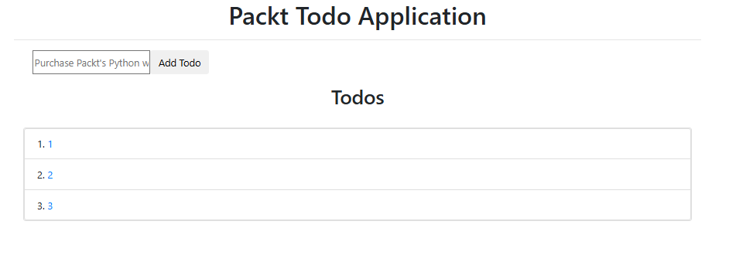

Одна страница задач:
