|  |  |  |
| --- | --- | --- |
|  |  | Program  Development  Task 2 Part 2 |

Daniel Scott

# 

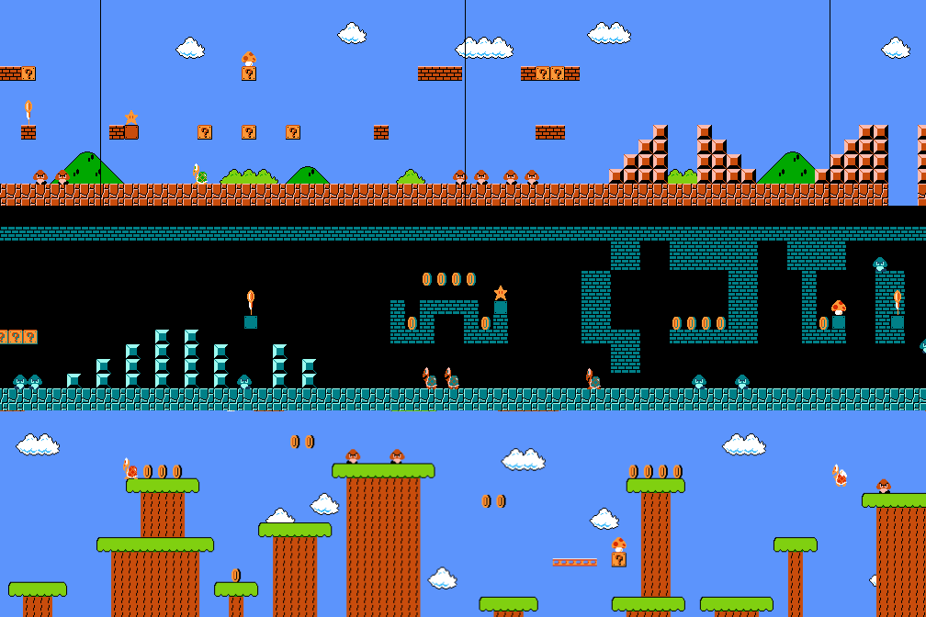The remake of the classic Mario NES game

## Overview

This write up is the second part of two and involves the development, testing, debugging, implementing and evaluating stages of the Software Development Cycle (SDC). The main problems faced were due to restraints on programming language capabilities and the time pressures, so I had to cut some features from the traditional version of Mario NES.

## Fu