**Annexure-I**

**Astha Seva Sansthan /Community Development Project**

**A Project report**

Submitted in partial fulfillment of the requirements for the award of degree of

**Summer Internship (Corona Warriors)**

**Submitted to**

**LOVELY PROFESSIONAL UNIVERSITY**

# PHAGWARA, PUNJAB



**From 06/01/20 to 06/30/20**

**Submitted By: Aditya Raj**

**Name of student: Aditya Raj**

**Registration Number: 11905310**

**Annexure-II: Student Declaration**

# To whom so ever it may concern

I, **Aditya Raj,11905310** hereby declare that the work done by me on “spreading awareness about covid-19” from **JUNE, 2020** to **JULY, 2020**, is a record of original work for the partial fulfillment of the requirements for the award of the degree, Corona Warriors .

Name of the Student (Registration Number)

**Aditya Raj ,11905310**

Dated: 27th OCT,2020.

# CERTIFICATE

# 

**ACKNOWLEDGEMENT**

The secuss and final outcome of this project requied a lot of guidance and assistance from many people. All that I have done is only due to such supervision and assistance and I would not forget to thank them.

I respect and thank **Mr. Vishal Kumar** , for providing me an opportunity to do the **community devlopment projecct** for giving me all the support and guidance which made me complete the project duly.I amextremely thankful.to him for providing such a nice support and guidance.

I owe my deep gratitude to my project teacher…..,who took keen intetest on my project work and guided me all along,till the completion of my projrct work by providing all the necessary information.

I heartily thank **Mr. Anand**  for their guidance and suggestions during this project work.

I would not forget to remember their contribution on encoragement and more over for their support and guidance till complition of my project work.

And I am very thankful to and fortunate enough to get cinstant encouragement, support and guidance from all the staff members of **“We The People Foundation”** which helped me in sucessfully completing of my prioject work.

# 

# Brief description of the work done

**Introduction to the Project:**

I have done content writing for We the People Foundation an NGO built by the people for the people. Prospect through social platforms that enable us to cultivate our aim to stand by the people who need us. As we know India is one of the fastest-growing economies, a strict amount of two-third of its population still lives under poverty. What makes us cognizable and benevolent is our strife to work for better living conditions for these people who suffer from extremities. These undesirable instances of living is our motivation for the bigger future of an educated and hunger-free India. Our Objective of work is distributed in numerous areas such as Eradication of Farmer’s Suicide, Supporting Child Education in rural areas, Welfare of Elderly People, and in providing Disaster relief time to time. And helping the needy whenever required and through articles and social media posts creating awareness among the people.

**Activities/ equipment handled:**

I got a department of handling their content over any current issue and posting it in their social media handle. A Membership of a Prestigious NGO Network can help in supporting poor people and played a major role in COVID-19 pandemic.

**Learning outcomes:**

We share stories with the help of trusted communities and partners and with your help, of course, of how we reach the needy, who do not have anybody to help them in major crises and fallouts. We cannot be an overnight changer, however, our stories are put up so that it can reach more people and in turn, more people reach us. This plays a major role in influencing the the people who are visiting oue social media handle. And giving a positive message to the society.

# CHAPTER 1

# INTRODUCTION: COMMUNITY DEVLOPMENT PROJECT

I have contributed in this project by spreading awareness and this help us to motivate people, because words have the power to change the world. The world of smartphones and technology has made the life of humans less complicated. Reaching out to people far away from you has become effortless with a single click on your mobile phones or computers.

I have worked under NGO with their team to spread knowledge about global pandemic od covid-19 , where we talked to people make them aware of this vary situation and also make them aware about the protection measures.

Also our team distributed some masks, sanitizers so , that the poor people might not get panic as they can not afford to buy these things .



## INTRODUCTION TO ASTHA SEVA SANSTHAN/ COMMUNITY DEVLOPMENT PROJECT

# [Asha Sewa Sansthan Ngo In Samastipur Bihar](http://www.indiangoslist.com/ngo-address/asha-sewa-sansthan-in-samastipur-bihar_BR-2013-0062205)

## Asha Sewa Sansthan Ngo Information

**ASHA SEWA SANSTHAN Non Governmental Organization** is located in **SAMASTIPUR Bihar** . ASHA SEWA SANSTHAN is registered as a Society at PATNA of state Bihar with Ngo unique registration ID 'BR/2013/0062205' . The NGO registration is done by Registrar of Societies with registration number 589 on the date of **20-08-2007**, Its parent ORganaisation is Adarsh Gramodyog Vikas Sansthan. The Chairman of ASHA SEWA SANSTHAN is KIRAN KUMARI and Chief functionary officer is AMIT KUMAR VERMA. Promoter is GEETA SINHA



## CHAPTER 2

**THE IMPACT OF HUNGER FOR POOR PEOPLE IN INDIA**

From last two and a half month, India has been put on a lockdown nationwide to

decrease the spread of novel coronavirus. By the order of the Indian government

with the collaboration of state government 5th phase of lockdown is going on, to

save as much life as possible. Due to this situation, India is suffering from

economical crises.

The direct effect can be seen on 12 crore people who shifted to below poverty line.

Lakhs and lakhs of Laboure who are in metropolitan cities such as daily wage

Labourer, small shop owner have no work to do in this past two months. India is

amongst the poorest in the (GHI) global hunger index. Standing at 102 and of 117

countries. And due to COVID -19 crises and it is gradually increasing, with giving no

opportunity of earning and employment at this time.

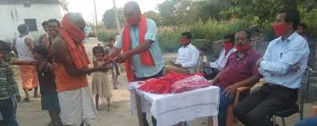

The low salary employed, labour, worker have directly triggered and facing hunger

since the lockdown has started. This makes crores of labour to migrate from cities

like Delhi, Mumbai, Bangalore, surat to their home town. The people & national

highways and railway tracks to reach their destination. Staying there might have led

to death from anger without food and might get the opportunity in the local area.

By looking over this situation many state governments have started public transport

like busses, train for a few days to reach their states as the lockdown keeps

increasing this migrant labour and worker have no source of income and spent all

their leftovers to come to their villages. Almost 100 millions people who are passed

below the poverty line are suffering from hunger every day. As the respective state

government has given out all the necessary ration to BPL cardholder and needy is

not a permanent solution. This only thing to stable the economic crises is to create

new job opportunities.

The world has come to a standstill. We are living a nightmare, a painful reality

that has impacted each and everyone of us. In this testing times, the most vulnerable

millions of invisibles among us the Daily wage labourers and house hold workers who

helped us build our cities, supported us in our daily lives are struggling to survive. Without

work, they are financially paralysed and unfortunately they can’t support their families.

The agony of Helpless children, crying women unknown to the extremity of situation

are begging to be fed. But poor beings, are just helpless. Or are they, if we could extend

our hands.

World never saw a pandemic of this scale. Humanity has to raise and stand for each other.

And at We the People Foundation, we have become a means to help and reach to the needy

end.

We have started an outreach for 15000 migrant workers, to help and stop the exodus

of thousands of scared migrant workers some of them have taken the extreme step

of walking hundreds of kilometres to reach to their homes. It’s in this regard that **We**

**the People Foundation** urges everyone to come forward and contribute in whatever best

way they can, we will reach out to people in need with your support and provide them with

grocery and food material to survive in this difficult time.

|  |  |
| --- | --- |
|  |  |
| **CHAPTER 3** |

|  |  |  |
| --- | --- | --- |
| |  |  | | --- | --- | | |  | | --- | | https://mail.google.com/mail/u/0/images/cleardot.gif | |   **Impact and challenges faced by elders in the time of COVID-19**    Since the lockdown has been started from 23rd of march our government has faced many difficulty in controlling the COVID-19 case which were increasing day by day. Resulting in decreasing GDP and leading to crisis. In this critical situation there is a hope that in recovery rate of corona cases are quite high. The ministry of Health and Family welfare has taken many steps and measure to spread awareness to among the people. And doctors and renouned organisation all over the globe and engaged in preparing the vaccine got didn't succeed till now, so the best measure for protection form Corona virus is social disatencing.  The recovery rate of corona survivors depends upon the age group they come from and the medical history of the patient. And by the reports it is seen that older people are more likely to get affected by corona virus and show complications during the treatment. The direct reason is because they have low immunity then the younger people. It is not because they not following the rule and protective measures but the circumstances they face like isolation, uncertainty, and income loss. The biggest challenge for the elders during the pandemic has been accessing healthcare, buying medicines, groceries, and banking. And many of their sons and daughters are stuck in the big cities due to lockdown, so there is no one to look over them. Reports says that 62 percent of older people suffer from chronic illness and many health related problems diseases such as asthma, cancer, hypertension, diabetes etc. Especially the older people from from rural areas who have no source of income during this lockdown has greatly affected the livelihood . Having no savings and no one to take care of them. The local small business if their area has also affected by about 71 percent of elder respondents stated that the income of the head of   their family who earns money was affected by the lockdown.  This are some of the major issues faced by the older people, but in my opinion it can be resolved by the general ways except other government policies. Like we can make a Facebook page and ask for helping the needy older people in their locality. We join NGO and bistribut rations and essential projects to help them. This pandamic has affected our country's economy and our income but if we are in a good state of living then we should help the needy especially the older people. |

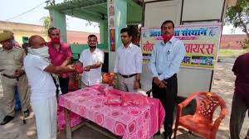

Recent data from the WHO, CDC and National Institute of Health (US) support the fact that the elderly can contract the infection easily, shed the virus more due to exaggerated respiratory symptoms, need hospitalisation more often and have significantly (3-4 times) increased chance of mortality. During the first wave of public health measures taken to deal with the outbreak, strict social isolation for the elders was recommended as an essential strategy as they were more vulnerable. In Italy, both male gender and age greater than 50 years were found to be risk factors for severe lung involvement.

What makes the elderly so vulnerable? Age is not just a biological phenomenon. It brings with it multiple physical and social factors for vulnerability to any infection. One such concept is called ‘frailty’ which basically means the sum total of risk in every level of physical, psychological and social systems that can arise with age. One of the major deciding factors in the Covid-19 infection is the body’s immune system that produces antibodies to keep the virus at check. With a successful immune response, there can be total recovery in two-three weeks with symptomatic treatment.

Elderly have a weakened immune system, which is further affected by chronic illnesses like diabetes, hypertension, obstructive pulmonary disease, heart and kidney problems. Both these factors, aided by frailty, contribute to the overall ‘stress’ of infection in their body. Though the most common cause of death due to Covid-19 is acute respiratory distress syndrome (ARDS) secondary to pneumonia, many elderly in China and Italy have died due to heart and sepsis (additional infection spreading in blood) complications, without signs of lung involvement. This shows that coronavirus can overwhelm the body as a whole with age. In addition, increased hospitalisation leads to other hospital-borne infections.

Further reasons are the already existing isolation and neglect of elderly in many retirement homes. They might either get deprived of routine health check-ups or stay in crowded environments with increased risk of contracting the illness. They will also have sensory issues (difficulty in vision, hearing), memory problems and mobility challenges that might impair self-care. Precautionary measures might not be comprehended or followed well, without adequate supervision. Stocking up of required supplies is compromised at times of isolation. The elderly are often victims of loneliness and social poverty if quarantined. Many

of them might even skip testing due to increased public chaos and competition. They are more vulnerable to misinformation as well as mental health issues like health anxiety, panic, stress reaction, depression and obsessive fear.

What is the way forward? Like any other age group, social distancing, hand and respiratory hygiene are the key. Special care and resources need to be allocated for the elderly. It is our collective responsibility to be aware of the seniors at our home and follow precautions ourselves to protect them. Those who have pre-existing health conditions need to be distanced from any visitors whatsoever. Further, distancing of around three feet and avoiding touch or groups are necessary.

Another key is communication. It is imperative to make the elderly aware of the precautionary measures in simple terms and supervise them so that they follow them. Social isolation and loneliness need to be combated effectively: hobbies (music, reading, etc.), self-care (yoga, relaxation, exercises), leisure time with family (even if digital contact) are helpful along with supportive counselling sessions if necessary. Their self-dignity and respect need to be preserved at all cost. Ageism should not contribute to them being stigmatised as ‘infected people’. Those in care homes need special precautions and overcrowding is to be prevented. Physicians, nurses and caregivers need to be sensitive to their physical and emotional needs. It is always helpful to raise our antennae for any early respiratory symptoms in the elderly so that they seek early healthcare and testing.

Every day we see how anxious seniors and their families are. Existential questions of ‘end of life’, ‘what after me’ and ‘care of family’ arise when they hear about their vulnerabilities to the pandemic. It is vital to remember that they are susceptible both physically and psychologically. Their fear, anxiety and apprehension need to be addressed, instead of an information overload. Please refrain from starting any over-the-counter medication for prophylactic or curative purposes, as they are often counterproductive in old age. An emphasis on a healthy diet, sleep and physical activity can boost immunity along with healthy family support. We all value our seniors; let us join hands to protect them from the pandemic.

Besides, the current pandemic has completely left the elderly couple at wit’s end despite their financial resources and has forced them to rethink the choices they have made. Struggling for basics, managing without house help and fretting about handling any medical emergencies have exacerbated their need for safety, wellbeing, and companionship. The upward growth projections of the elderly population signify the untapped market potential that this segment holds. As a services sub-sector, senior care can become a major contributor to India’s economic growth in the next few decades. While several elderly care facilities in different shapes and forms exist in the country, it is at best a fragmented ecosystem. It is both urgent and imperative that we focus on the fundamentals that facilitate the establishment and flourishing of a sustainable ecosystem. With declining fertility and improvement in life expectancy, the elderly population will see a rapid rise in the next few decades. As the current discourse is centred more around taking advantage of its demographic dividend, it is also important to take necessary steps to ensure the wellbeing and comfortable living of the elderly population and identify possible areas to derive economic value out of this segment.

**CHAPTER 4**

* **VOCAL FOR LOCAL**



The new hashtag floating around in our imagination of a modern and national life of commerce and business in India is #vocalforlocal . India therefore has an all-new hashtag in the era of Covid. Go local. Trust local. Go for a self-sufficient and self-reliant India. Believe in Made-in-India and put your buying power into products and services that are made locally.

The report says that unlike a port or a railway line, Chinese tech investments are invisible assets in small sizes – rarely over $100 million – and made by the private sector, which doesn’t cause immediate alarm. All this adds up to just 1.5% of the total official Chinese (including Hong Kong) FDI into India.This doesn’t cover investments made by funds based out of Singapore and elsewhere, where the ultimate owner is Chinese, so the actual investment in India will be higher.

The single largest Chinese investment in India is the $1.1 billion acquisition of Gland Pharma by Fosun in 2018. This accounts for 17.7% of all Chinese FDI into India, but it is unique, the report said. Gateway House identified just five other investments by Chinese companies which exceed $100 million. This includes the $300-million investment by

MG Motors. China is most active in India in the start-up space. Gateway House has identified over 75 companies, with Chinese investors concentrated in e-commerce, fintech, media/social media, aggregation services and logistics. A majority – more than half – of India’s 30 Indian unicorns (start-ups with valuation of over $1 billion) have a Chinese investor.

These are some best replacements of Chinese products.

Wooden toys replacement for Chinese toys

Clay cups for coffee and chai

Stainless steel and ceramic plates for fancy Chinese plastic plates

Havels and Panasonic for Chinese light issue

Wipro for tech PC and Laptops

Local garments for made in china cheap cloths

ATA Birla for Other Chinese giants

Indian FMCG products like Godrej and Patanjali

Indian medical companies for other Chinese cheap medicos

Its our time and we have to laid emphasis on local products because we have to rebuild our economy and to save MSME’s.

In the Indian FMCG market, Indian brands have been leaders in ‘Indian categories’ such as hair oils, health supplements, whereas international brands have been leading in ‘international categories’ such as shampoo and toothpaste. Moreover, Indian brands have also been gaining market share even in these highly competitive categories such as toothpaste with their highly differentiated offering.

The trend within the food industry is total ‘vocal for local’ when it comes to consumer demand. in the past, the reason to buy a foreign brand was the limited presence of (Indian) brands. Along with that, there was a concern of trust in the local bands as far as the manufacturing is concerned. Now, there are a lot of national food brands, and they have developed over the years. More than 60% of the brands in the food industry are local brands unlike personal hygiene, cosmetic, and consumer durable segments.

**POSITIVES OF CORONAVIRUS LOCKDOWNS FOR SENIOR CITIZENS**

It was 25th march when the lockdown started since then people were not allowed to roam outside especially old people who love morning walks with there friends and children who love to play outside. People were not allowed to go to temples and mosques. No social gathering, no religious processions, only 50 people allowed at marriage, not more than 20 at funerals and last rites.

Many of peoples were also not able to join their families in need and were not able to attend the funerals of their loved ones which was very devastating. Senior citizens who are aged above 60 years and especially those with medical conditions, such as chronic respiratory disease, heart, liver and kidney disease, neurologic conditions, diabetes, hypertension and cancer, are particularly susceptible to infections during these times. Separate guidlines were issued for them.

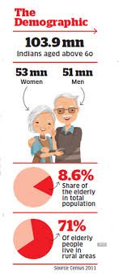

Fig4.3

Senior citizen are clearly adviced to refrain from the following

1.Come in close contact with those displaying symptoms of coronavirus disease.

2.Cough or sneeze into bare hands.

3.Touch eyes, face and nose.

4.Shake hand or hug friends.

5.Visit crowded places such as parks, markets.

6.Self-medicate.

7.Visit hospital for routine check-up.

The guidelines to be practiced and observed by senior citizens to fight the disease include staying at home, avoid visitors and gatherings, maintain hygiene, wash hands before and after meals, sneeze and cough into tissue paper and handkerchief, and keep monitoring one's health

.

These guidlines results in many benefits to the senior citizen. Much lesser count of senor citizen were affected to this fatal virus, following the few precaution and guidlines helped them in continuing their healthy life. Lockdown also help the grandfather and grandmother spending time with their family, their grandchildren. The police personnel who were above 55 years of age were not allowed to continue their jobs in pandemic.



Fig4.4

* **DEPRESSION IN YOUTH**

I waste at least an hour every day lying in bed. Then I waste time pacing. I waste time thinking. I waste time being quiet and not saying anything because I'm afraid I'll stutter.”

― Ned Vizzini

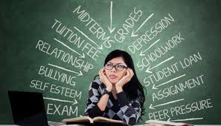

Fig 4.5

The medical science once had a thought that depression only occurs in the mind of adults. But nowadays depression is common among children or the early teens, however it is increasing steadily. Around 10-15% of people will have experienced the feeling of depression by the end of their teenage. It’s a real feeling that lead to suicidal thoughts and behaviour. In most of the cases the real cause of depression is success.pressure, nepotism, failure etc. When the teenage people work hard for there success but somehow they can’t achieve it ultimately it lead to to the depression and feeling of suicide. Best and living example are the students of Kota. According to the national crime record bureau(NCRB) In India every hour one student commits suicide with about 28 such suicides reported everyday. The NCRB data also shows that 10159 students died by suicide in 2018. For teens, a stressful home environment and violence also led to depression. The good news is that depression is also one of the most treatable conditions. Young people with depression and their families and friends often don't know how to spot the problem or where to seek help. Seek professional help if you suspect your teen suffers from depression, and choose a therapist who specializes in treating teenagers. Find a different counselor if the one you visit makes your son or daughter feel ill at ease or doesn't seem to understand your teen's needs. Don’t take depression at ease as any carelessness can lead to great loss.

Is social media a solution for young people to cope with lockdown? Researchers conducted the survey about the mental health of people during crisis and it was found that it is the most challenging

Is social media a solution for young people to cope with lockdown? Researchers conducted the survey about the mental health of people during crisis and it was found that it is the most challenging time since second world war, because there is major disruption in there routine, education, and social and economic lives. The recent lockdown may prove daunting in our psychological well being, due to lack of social mingling, outdoor and office routine. Over 300 cases of suicide had been reported during nationwide lockdown and this is due to the loneliness as they are not allowed to move anywhere. According to the data, 80 people killed themselves due to loneliness and fear of being tested positive for the virus. The suicides are followed by migrants dying in accidents on their way back home (51), deaths associated with withdrawal symptoms (45), and those related to starvation and financial distress (36). Social media is a cure to loneliness as many famous celebrities and normal people across the globe are sharing motivational posts on social media platforms to help people remain positive and inspired during the pandemic. Recently, king khan had posted a song titled ‘Sab shi ho jaega’ from his instagram handle sending positivity to their fans. Samir parikh, director, Mental health and behavioural sciences, fortis in new Delhi , said:”in regard of the ongoing global pandemic, it is likely to have an adverse effect on our mental health. At such a time, it is indeed helpful if celebrities come forward to share there thoughts as many people consider them as there idol. They follow them. Social media is also helping people connecting each other. People entertain themself by sharing there talent like cooking recipes, posting about workout sessions, gaming tutorials which ultimately keeps them busy and happy.

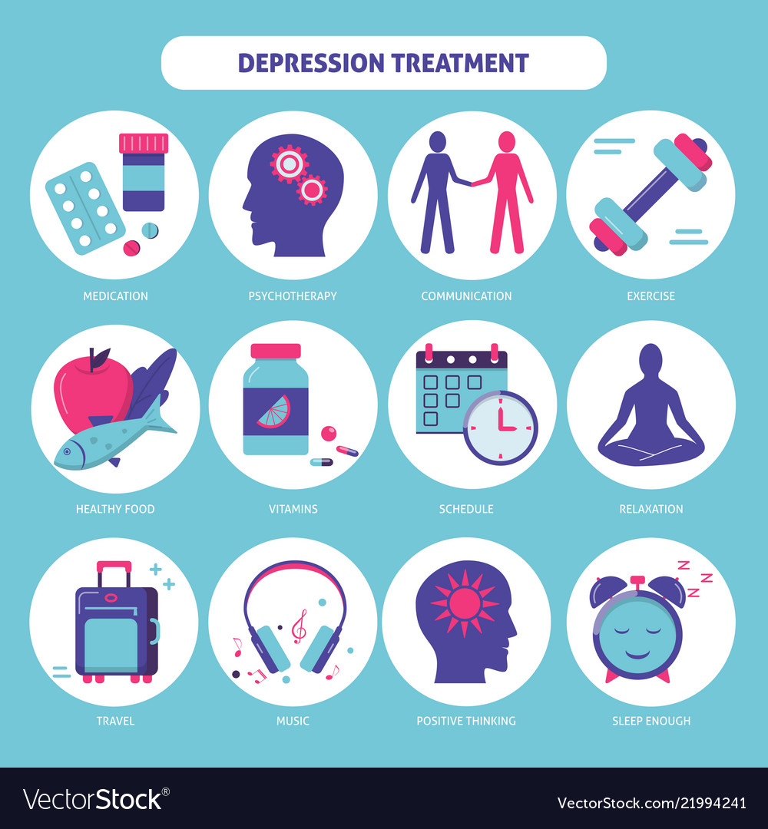

Fig 4.6

# FARMERS BILL

# The farmer has the ability to earn money from the mud. They are the ones that work in accannot progress, still, the farmers face many difficulties, and this time the government hers, not in hours. They are the son of the soil. If we are eating healthy today, farmers are the reason. Without them we have no existence, without farmers, mankind as introduced new techniques to increase the problem of farmers. Three farm bills — the Farmers’ Produce Trade and Commerce (Promotion and Facilitation) Bill (commonly referred to as the APMC Bypass Bill), and the Farmers (Empowerment and Protection) Agreement on Price Assurance and Farm Services Bill, the Essential Commodities (Amendment) Bill — were cleared by Parliament amid protests from the Opposition. On papers all the schemes are good but the ground reality is totally different. I will not explain the bill, I will mention the problems of the bill and why the farmers are protesting.

# The Farmers Produce Trade and Commerce (Promotion and Facilitation) Bill will lead to the closure of existing APMC mandi because for private companies there will be no tax in private mandi, while if they approach APMC they have to pay the tax to the government which will ultimately lead in the closure of APMC, because there is a high cost to maintain APMC. Another problem is small farmers may find it difficult to sell their crops to other states as of transport charge and more than 85% percent of farmers are small which means they have less than 2-hectare land and to survive in private mandi farmer need a strong negotiator.

# The contract farming bill will result in the removal of MSP and the government will have no control over it. If the government link MSP with this bill, it will result in favor of farmer

* **WOMEN EMPOWERMENT**



Fig 4.7

Women empowerment is one of the most critical and essential things that everyone should support. It is when women are given the most power and right to make decisions for themselves. Women have been subjected to injustice through decades. They have been treated as non-existent for decades.

Women were else was always making decisions for them. This is one of the biggest reasons for women’s empowerment. It was one of the essential things which were the need of the hour. Women were made aware of their rights. Along with their rights, women were taught how to be self-independent in all aspects of their lives. They were taught how to create a space for them where they can grow and become the people they want to be.

The men always had all the rights. However, the women didn’t have any of these rights, even a small right like voting. Things changed when women realized that they, too, need equal rights. This brought along the revolution by the women demanding their rights. It spread the awareness that gender shouldn’t be the reason for that things go in their favor.

Countries all over the world called themselves, ”progressive countries” but every one of them has a history of ill-treating the women. Women in these countries had to fight against the systems to get the freedom and status that they have achieved today. However, in India, women’s empowerment is still lagging. There is more awareness that needs to be created for the awareness to spread.

India is one of the countries which is not safe for women, and there are several reasons for the same. One of the reasons for their lack of safety is the danger of honor killing. Families think that it’s the right to kill the female if they have brought shame to the family and reputation of the family.

Another big problem that women face is that there’s a lack of education. Women are discouraged from pursuing higher education in the country. Along with that, they are married early. The men dominating the women think that the role of women is limited to work for them. They don’t let these women go, and these women have no freedom.

* The need for women empowerment is one of the most significant needs of the hour. There are many ways in which women can be empowered. People should be united together to make the reality of the women empowerment. One of the significant steps towards women empowerment would be towards educating women. Education should be provided and encouraged so that more women can be literate. The education that they receive is going to help them pursue what they want to pursue. Women can have the life that they want to have and be happy in it

Another way of women empowerment is to be given the same and equal opportunities in every field. Women should be given the same chances that their counterparts get. Pay is another area that should be equal for women and men. Women should be paid equally for the work that they do.

* Women’s empowerment is essential because women hadn’t had the rights and freedoms for decades at all. The women were almost non-existent. Women are humans, too, and they need to have the same rights and freedoms as their fellow humans beings.
* Equal pay is significant because even today, women and men get paid different amounts for the same work. The different pay is usually where the men get paid a higher amount, and the women get a lower amount, even though their work and position are the same.
* If women are going through domestic violence and abuse, they don’t report it to anyone. One of the biggest reasons they don’t report is that the society they live in will make comments about them. This makes staying in abusive relationships.
* Women can be empowered through education, equal opportunities, equal pay, and free to do what they want to do.



fig 4.8

# LOCKDOWN REVEALS ACTUAL STATE OF E-EDUCATION IN INDIA

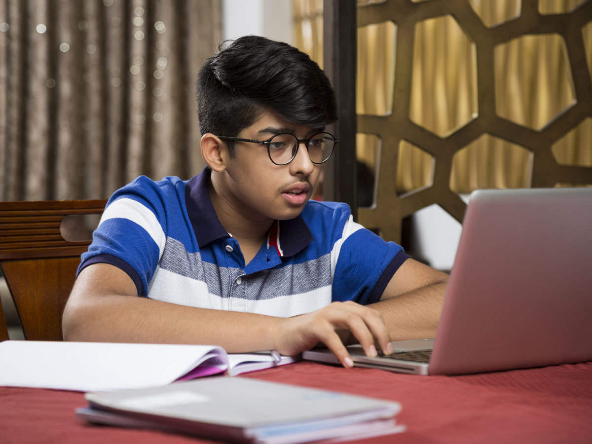

Fig 4.9

The thought of skipping college and studying from home has always sounded exciting—until you consider the logistics. How feasible it is to take a class at home while spending time with the family, instead of travelling far to attend college? Though e-learning is not a new phenomenon, the outbreak of Covid-19 and the country going under lockdown shifted the whole education system into a virtual mode.

According to UNESCO, since the outbreak of COVID-19 began, some 1.37 billion students in 138 countries worldwide have been affected by school and university closures. Nearly 60.2 million school teachers and university lecturers are no longer in the classroom. Since the whole country is under lockdown, e-education is the best bet left. University faculties are setting up accounts on online video conferencing platforms such as Zoom, Skype and Google Classroom, among other to engage with students.

Now new media holds out the possibility of on-demand access to content anytime, anywhere, on any digital devices but this spontaneous virtualization of education turned out to be challenging for both, the administration and students. Digital education today is a mix between existing cultural conventions like existing reading material and course books and conventions of software- new media like pdfs.

There are quite a few advantages of online classes that are worth consideration. Adjusting learning into the existing schedule is one of the best advantages. The flexibility helps in maintaining a job while working on education. Students of online classes are often given the freedom to complete lessons any time before a set deadline. This allows students to complete their coursework without sacrificing hours at their current job or precious time spent with family.

Online education is often more affordable, the expense of going to college is one of the biggest reasons aspiring students hold back from enrolling in a program. In addition to sparing students the cost of travelling to campus, the flexibility of online learning often allows them to continue earning money at their existing job.

While there’s plenty to like about taking online classes, that doesn’t mean it has reached a state of perfection.

The sudden shift of education to virtual mode comes with several challenges. In a report issued on April 21, the United Nations Educational, Scientific, and Cultural Organisation (UNESCO), the multi-dimensional agency, highlighted another concern about the online shift.   
  
Giving a global perspective, UNESCO noted, “Half of the total number of learners — some 826 million (82.6 crores) students — kept out of the classroom by the Covid-19 pandemic, do not have access to a household computer and 43 per cent (706 million or 70.6 crores) have no internet at home, at a time when digitally-based distance learning is used to ensure educational continuity in the vast majority of countries.”

**Teachers and students lacking digital skills**  
  
The main bottleneck is in the need for teachers to adapt their teaching methods to the instrument. The institutions with distant learning programs and e-courses already have access to the e-learning services, the syllabus is also designed likely with online recorded lectures and study material in the form of pdf and docs.  
Full-time students and teachers don’t have accounts on digital platforms, and most of them had never used the system before.

In a physical classroom, setting interaction is more dynamic and course instructors can stimulate feedback from students more easily but with online classes, teachers need to find more creative ways to make the conversation interesting.

**Internet accessibility**  
  
In a country like India where access to the internet is pitifully low, this new education model may fail miserably hence, the Internet comes out to be the biggest challenge of e-education. In the last two decades, there has been a conscious effort on the part of the government to improve access to the internet in every sector. But still, India has to face the internet challenge.

The Niti Aayog, in its “Strategy for New India@75” report, highlighted the quality and reliability of the internet as a major bottleneck. It also pointed out that 55,000 villages in the country are without mobile network coverage.

Holding classes for those students who have gone home during the crises is most problematic. Students belonging to urban households are more likely to have internet access, while students belonging to rural households merely have an internet connection. Among students from rural households, only 28% are likely to have internet access at home.  
  
While Kashmir doesn’t have access to 4G internet, students are still reeling under a double whammy of slower internet and it’s tough for them to keep pace with their counterparts in other states. College institutions are finding it difficult to reach out to students with 2G internet.

From coping with basic issues like internet connectivity and India’s notoriously undependable power supply to more issues like e-tests and e-exams, students have come under tremendous stress. Final year students are the worst affected. They haven’t passed out the course yet and preparation for placement and applications to Universities for higher education have all ground to a halt.

**Device availability**  
  
The University of Hyderabad carried out an in-house survey with about 2,500 students on issues related to online teaching. Though 90 per cent of the respondents have a mobile phone, about 63 per cent of them could only access online classes infrequently or not at all. Interestingly, among the concerns raised about online instruction, 40 per cent reported unreliable connectivity as being a major deterrent while 30 per cent cited the cost of data. Significantly, 10 per cent reported uncertain electricity supply as a concern.

Access to the internet does not necessarily mean that a household has internet at home as less than half of the households that have any access to the internet own a computing device. Some have access to mobile phones but students and teachers owning a computer and laptops are very few. Teaching on a mobile phone is very hectic for instance conducting lectures for 50 students on a mobile phone is a struggle in itself, teachers even won’t be able to see students.

Although about 78 per cent of India's 1.3 billion population has mobile phones, in rural areas is around 57 per cent, according to the Telecom Regulatory Authority of India. Nearly 68 per cent of the students in higher classes have access to a smartphone — a more staggered and online approach has been adopted for them. As soon as a child joins class 12, preparation for the board exams or competitive exams begins.

**Struggle for parents**

E-education turned out to be a new thing for school kids and more than them, their parents are struggling to help them understand the e-assignment. Many school students haven’t received their school course yet and without textbooks, it’s difficult for them to keep up with the virtual classroom activities. According to parents e-education isn’t helping their kids much and they fear if students will get enough time to prepare for exams, with so many lost schooling days.

School students of age 4- 12 hardly own mobile phones or know how to use them. Generally, teachers are connecting with them through their parent’s phones which ultimately indulges parents in the process and it consumes their time. Mostly parents who are working from the home struggle between their work and child’s education.

**Privacy concerns**

Over the past two months, the teleconference software Zoom has seen explosive growth, its easy and convenient in use. But the convenience has also come with increased scrutiny and a slew of uncovered security screwups. Privacy concerned people are finding it difficult to use such software.

The current situation is, of course, an unpredicted one. However, we should always be prepared for such situations. The issue is not of a few weeks of online teaching and online exams. The real question is why our education system in such a digital era is lagging so behind. The need for e-education isn’t confined to only such situations, our education planner needs to adopt more technological advancement in the curriculum.

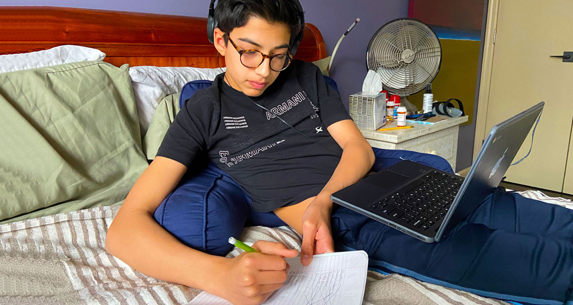

Fig4.10

* **ANIMALS ON THE STREET HIT BY LOCKDOWN**

Most of us grew up seeing stray dogs and cats being fed by the local households and markets. The stray cows who were fed by the vegetable shop owners have stopped putting their stalls due to the lock-down these days, and so have been the fate of the rest of the stray animals.

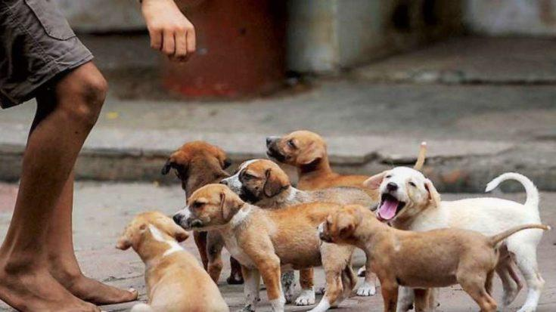

fig4.11

With the uncertainty prevailing in four lives right now, it becomes very important for us to step up during these trying times. Step Up, but How? Some misinformed people are even witnessed abandoning their domestic pets in the middle of the road amidst this chaos. Some are killing them without a hunch. It is at such times, I question the power of humanity.

Does it exist?

Yes, it does. Hence, we feel it falls under our daily responsibilities to take care of and feed these fur babies. It is also under our navigation to stop this violent treatment when we notice one. We believe it is as much of importance as it is to stock your daily edibles and washing hands.

India has an estimated amount of a billion stray animals including dogs, cats and cows. The number of stray dogs alone is 30 million. It only takes ₹50 to feed each one a two-time meal. We the People, are setting up a fundraiser for the assurance of daily meals and medical facilities for the stray animals. It is our earnest request to all you who have supported us so far and who wants to be a part of our cause, to donate as much as you can. Your donation can make these lives count and make them survive this horrid pandemic.

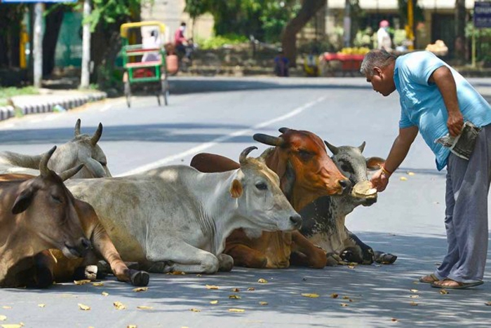

Fig 4.12

All of you animal lovers, this is a chance to save our friends and live with peace in our minds knowing they won’t die of such uncalled circumstances. We the People believe there are plenty of animal lovers who would like to ensure daily meals and safe assistance for these helpless animals. We the People, pledge for a safe and secure India, we hope you could join your hands along with us to achieve our aim.

Focusing on the bigger picture often leads to the neglection of everyday, seemingly banal things, and something similar is happening with stray puppies who were born just before the lockdown was announced. These puppies, in search of food, run towards cars thinking that they are feeders, and often end up getting run over.

“Lot of these babies were born just before the lockdown and started emerging a month ago. There’s hardly any traffic and the streets are like highways for them. They move freely without looking out and get run over by cars. Even the older dogs, who had knowledge of traffic and would sit on the sides, are now sitting in the middle of the roads. These dogs have lost their sense of traffic,” says, Amritika Phool, a Gurugram resident who is involved in animal welfare work.

# How Covid-19 pandemic has impacted Teaching profession and is changing its dynamics

The current situation is challenging but the it has also provided online learning opportunities, a virtual class where teachers can be connected to their students. The online leaning dynamics are different compared to the school teaching dynamic. However, adopting a new approach will have challenges and positive experience. In today’s world, technology has become an integral part of every individual’s life making complex tasks easier and seamless.

Teaching is beyond just a profession; it requires a teacher to keep learning and expanding the horizons for serving and shaping the future of tomorrow. Remote learning has provided teachers with an opportunity to use the innovation and creativity methods with assessments. This also helps to analyse the teacher-student relationship and to work on the progress. With remote learning there might be students struggling to cope-up and without having to meet friends at school there might be some challenges as well. Teaching profession here is evolving with an extra afford to help the students overcome these troubles and guide them to focus on their academics.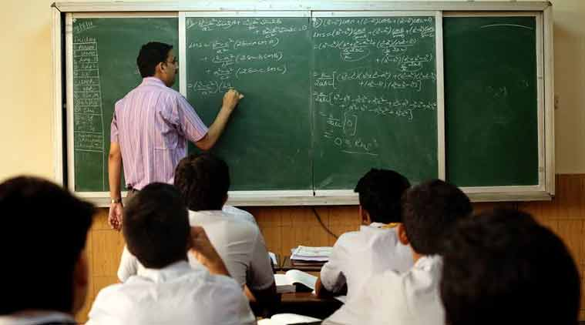

Fid 4.18

As difficult the situation is for the students, it is equally challenging to manage the timetable co-ordinating with the fellow teachers. The virtual teaching scenario has helped even the colleagues to work in more efficient ways. Discussing virtually on facetime or group meeting on Zoom or other video call apps has helped to recreate unique ways of helping students to prepare for their academics. Remote learning has also helped teachers to understand the emotional status of students. It has made them more empathetic and flexible and help the students keep-up their emotional wellbeing. Teachers are moving beyond their traditional teaching concepts and building a communication bridge with their students. Students need to understand that they are not operating in a vacuum, for this the teachers are individually connecting with every student.

Teachers for kindergarten have to be more innovative as kids of that age-group seek more attention. Kindergarten has always been a playschool with games, toys, etc to help the kids learn the basic in a creative and engaging way. With remote learning coming into the picture, teachers had to create fun yet learning videos while taking one-on-one session with the parents. Virtual learning has also helped build a strong connection between the kids and the teach**er as they play games, narrate stories engage with the teacher. It is a fun experience for both teachers and the** kids as they get to meet them virtually which earlier limited to only kindergarten. Kids of such young age connect easily through videos and other virtual means.

Teachers have also started initiating various technologies to communication with the students. Teachers are exploring various technologies or tools to explain about various concepts from the syllabus to their students. Virtual learning is not just about a skype classroom, it is also about engaging the students with the respective subjects. For instance, teachers are exploring YouTube and other platforms to showcase real-life examples or to explain scientific methods, experiments, etc. Teachers are going beyond the traditional textbooks to teach about a particular subject.

The integral part of the teaching profession considering the current situation is innovation and change as a response to the complexities in the society. Teachers are learning to make online notes, videos and study materials for students accessing to multiple technologies and information available to make the transition smooth. There are complicated subjects like math, science, etc for which teachers are creating gaming approach, experimental or practical approach to help students understand and engage with the subject. The entire distance learning has been opened opportunities for teachers to upgrade and embrace the opportunities.

With remote learning, evaluating the weekly tests or assignment has also become easier. The creative and engaging assignments as helped teachers assess the progress of every student while designing various methods to guide them further. Learning modules like game based or tech based are witnessing active student participation more than ever. Teachers are helping students to connect with various study groups across the world to prepare them better for their academics. This has led to great collaboration and exchange of productive ideas across the world.

As students are mostly connected to social media these days, teachers have adopted the digital social media mode to hold discussions on projects, subjects, competition, etc. Teachers are possibly adopting to every means of communication and technologies to help students with their academics. The present situation is a battle for teachers to make their students excel in every aspect and to ensure that teachers are undergoing through extensive learning modules themselves.

The dynamic of teaching is changing considering the current scenario but imparting knowledge is a continues process. Teachers across the world will continue to upskill themselves to build a better future for their students.



## CONCLUSION

I am glad that I was the part of an amazing project. I thank “Astha Seva Sansthan**”** for allowing me to contribute regarding the global issue.

In this project I have discussed about some current topics and the issue faced by the general public during this pandemic and the and also discussed about some burning issues. These articles directly or indirectly connect the problems and give a message in the awareness in the society. And our organization is also engaged in collecting or raising funds for the needy ones. And this article writing is a part of connecting people and showing awareness in the society. This pandemic has affected each one of us and the GDP of our country is also fallen up to 29%, by looking at this tragic situation as a responsible citizen we should contribute in relief funds or by the help of social media we can motive the public. As I have discussed in my report about vocal for local ,online education in this pandemic ,effect of COVID -19 to the elderly people , farmers bill and many more . by this article I am influencing or spreading awareness among the people , so that our youth or who so ever is visiting our social media can look over it.

Lastly I want to thank our university for providing us such an amazing project of community development (MGN 231). After this project I am full with knowledge of handling the responsibilities and managing it well.

## REFERENCES

## Astha Seva Sansthan: [https://asthasevasansthan.org.in/](https://wethepeople.org.in/)

## CONTENT REFERED FROM WEBSITE:

## <https://www.weforum.org/agenda/2020/04/coronavirus-education-global-covid19-online-digital-learning/>

## <https://hotviralpost.com/situation-and-social-status-of-teachers-in-india/>

## <https://www.financialexpress.com/education-2/how-covid-19-pandemic-has-impacted-teaching-profession-and-is-changing-its-dynamics/2111760/>

## 

## <http://timesofindia.indiatimes.com/articleshow/77155592.cms?utm_source=contentofinterest&utm_medium=text&utm_campaign=cppst>

* <https://www.thehindu.com/news/cities/Delhi/feeding-stray-dogs-other-animals-during-coronavirus-lockdown-hc-seeks-centre-aap-govt-stand/article31444943.ece>
* <https://www.thehindubusinessline.com/brandhub/vocalforlocal/how-modis-vocal-for-local-campaign-is-going-places/article31917030.ece>
* <https://www.actionagainsthunger.in/hunger/underlying-causes-malnutrition>