**Website Bio**

**This site has a description about the Novel Corona Virus (COVID19), that is spreading fastly wholeover the world.**

**Site contains the dynamic updation of cases in India, and also a list of all the states in India, mentioning the cases seperately for each states. A basic intro about the virus has been mentioned with all the possible symptoms that could take place and the precautions that are being suggested to stay safe from this pandemic.**

**Site contains the in-body YouTube videos for the same, need of ‘Aarogya Setu App’ have also been shared in the site with a video.**

**Multiple social media links have been included to get the public know more about the situation that are happening all around the world. Link for the Facebook, Twitter and Youtube are mentioned for the more knowledge acquiring.**

**The site holds a pdf about the basic FAQs of the public, through which they can easily get their answers for questions about the virus or the situation.**

**A short fevicon graphicals are used to get some good user interaction with the website.**

**\*---------------\***

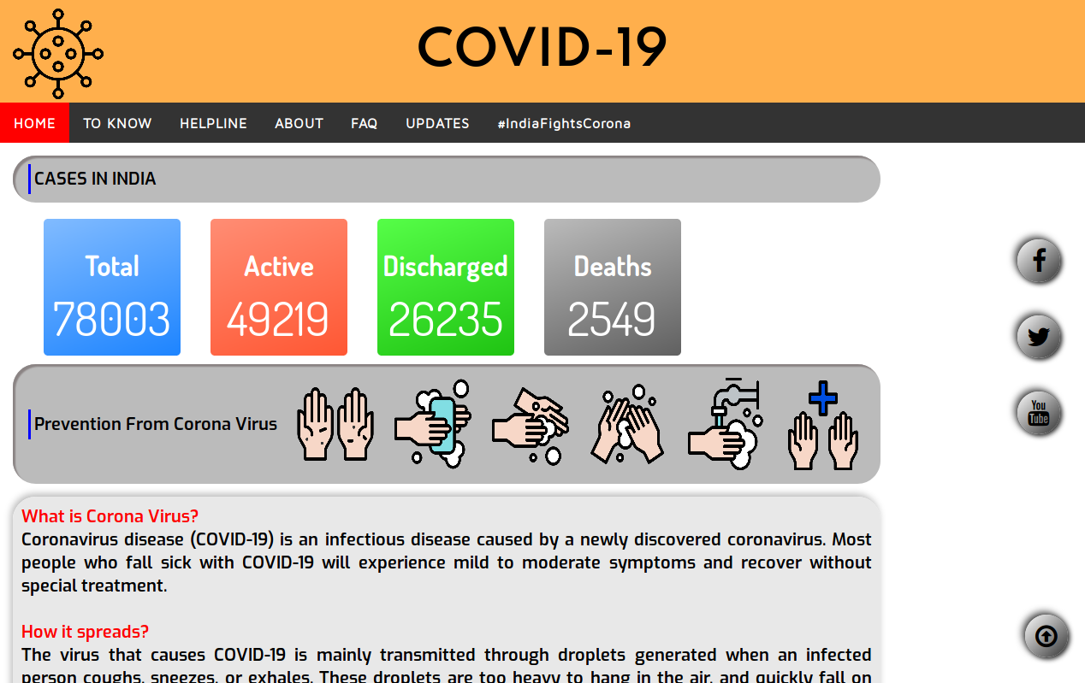

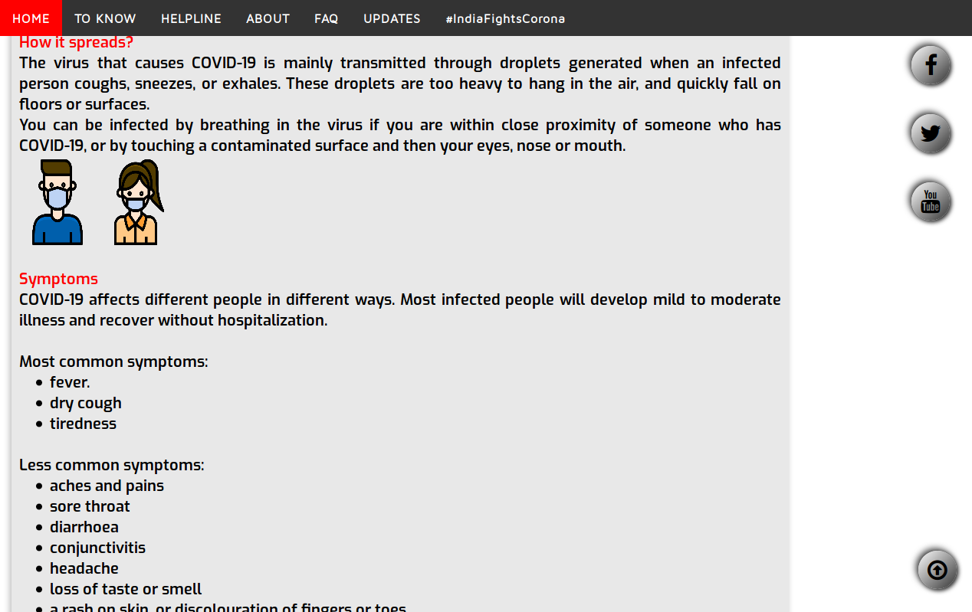

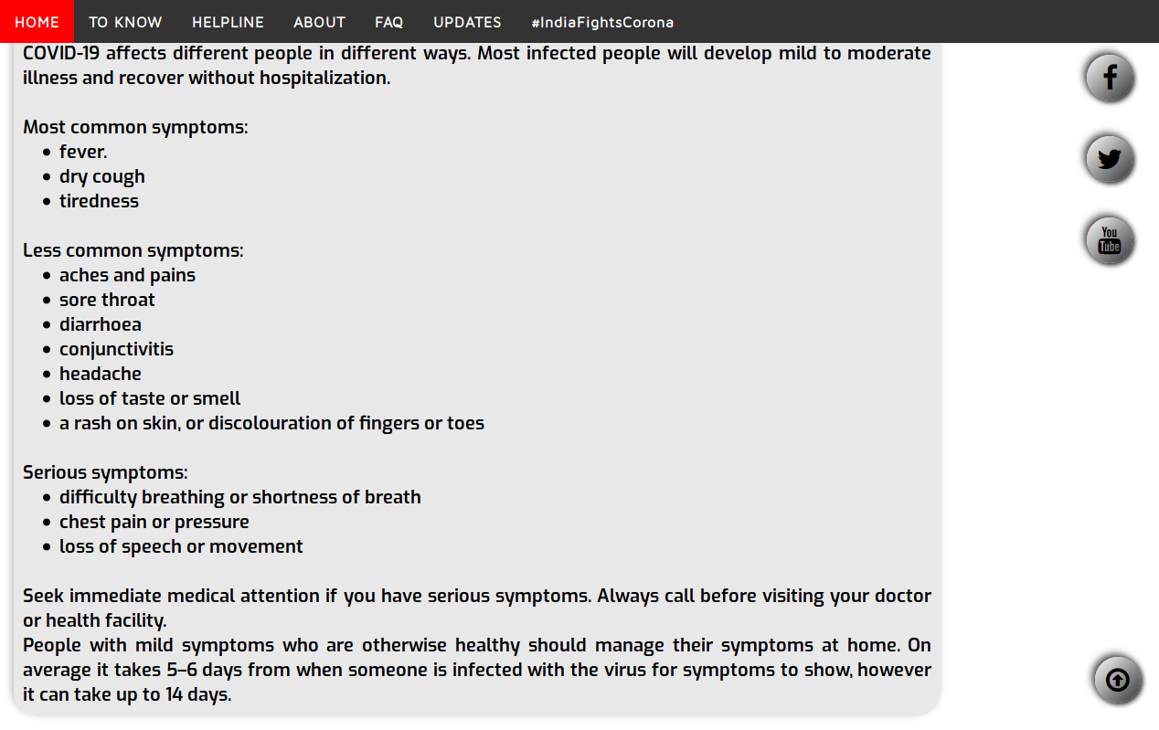

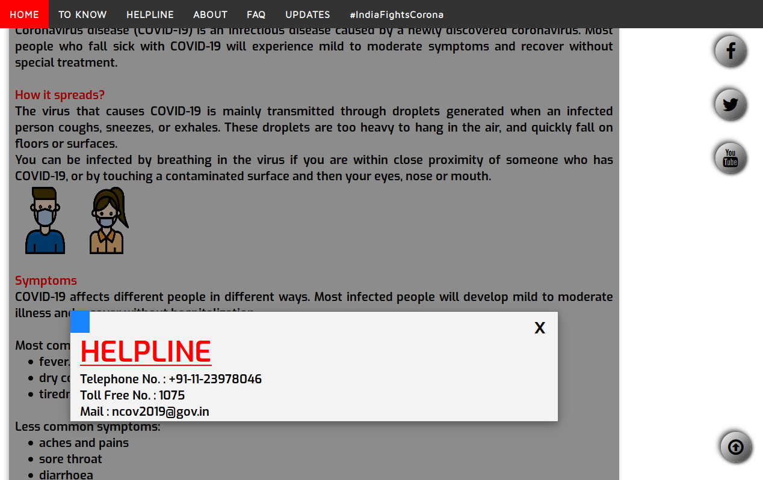

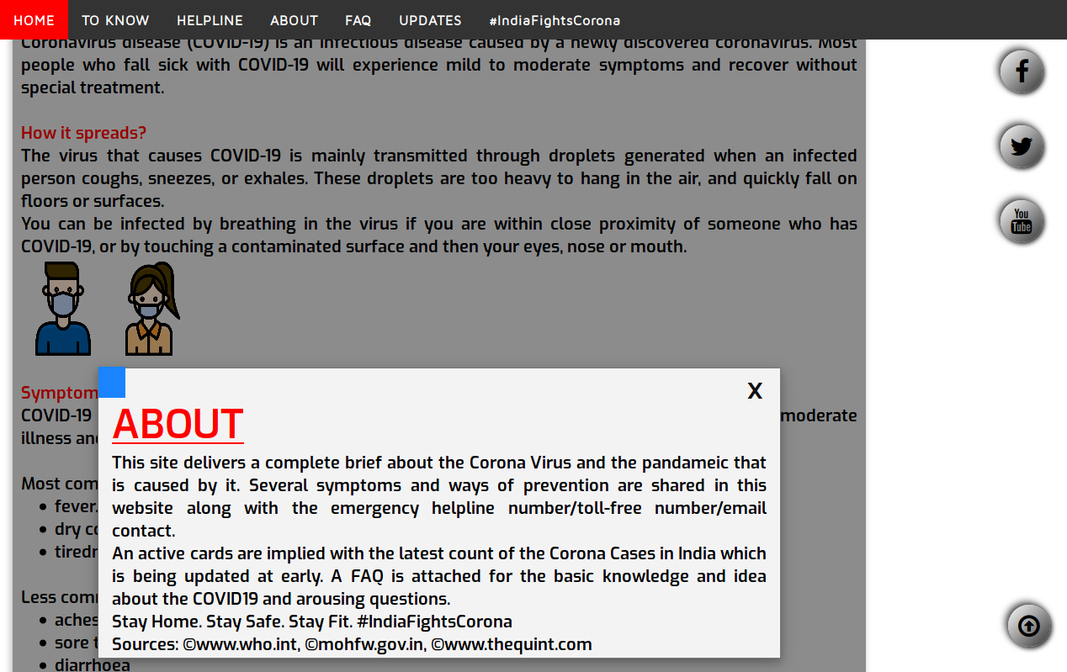

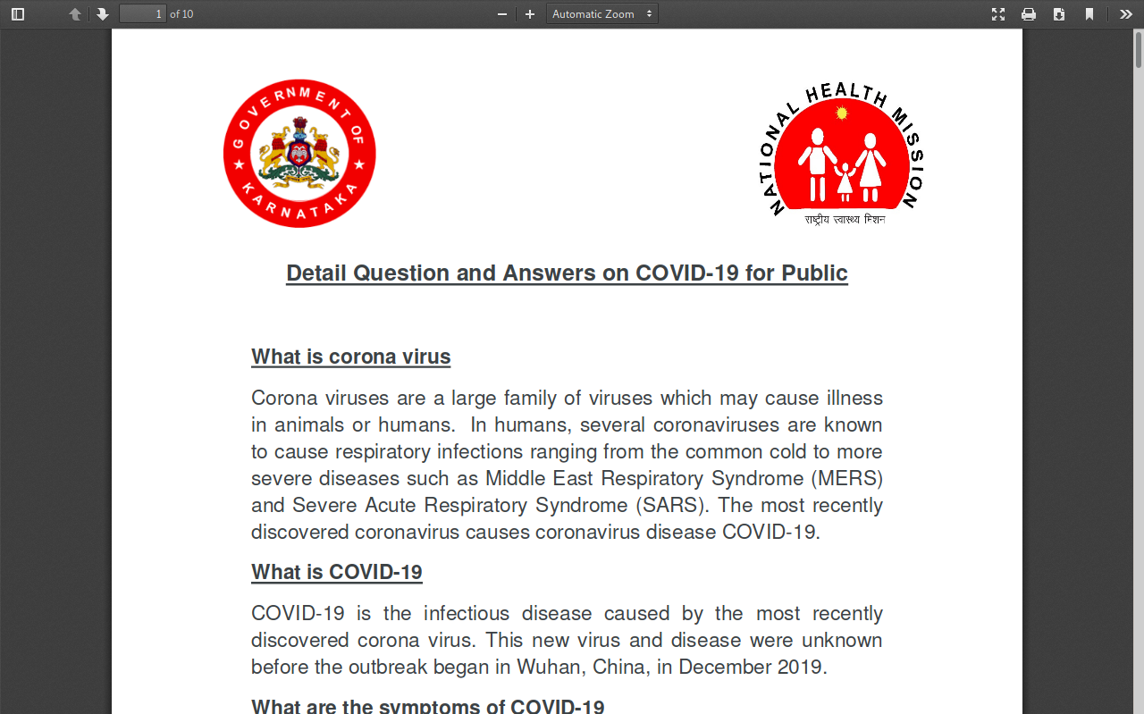

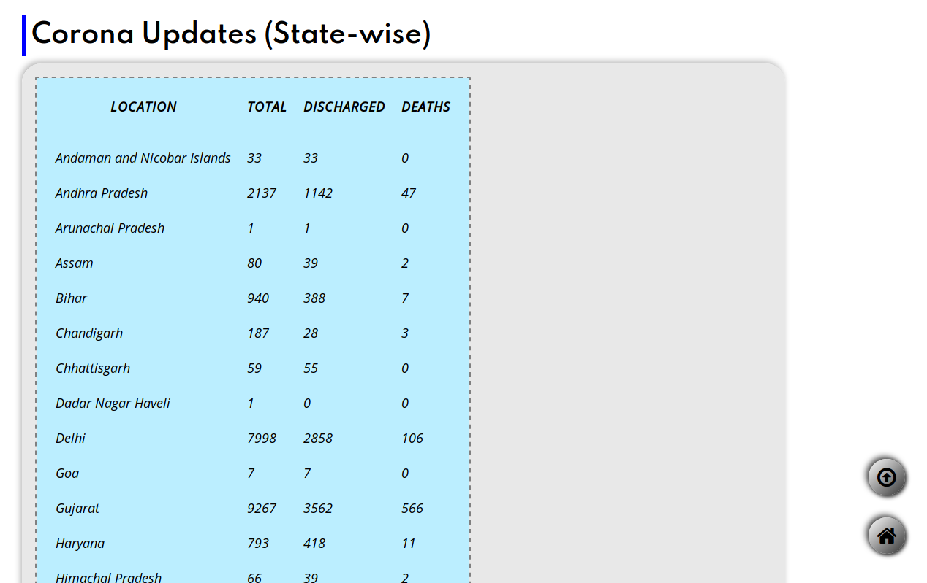

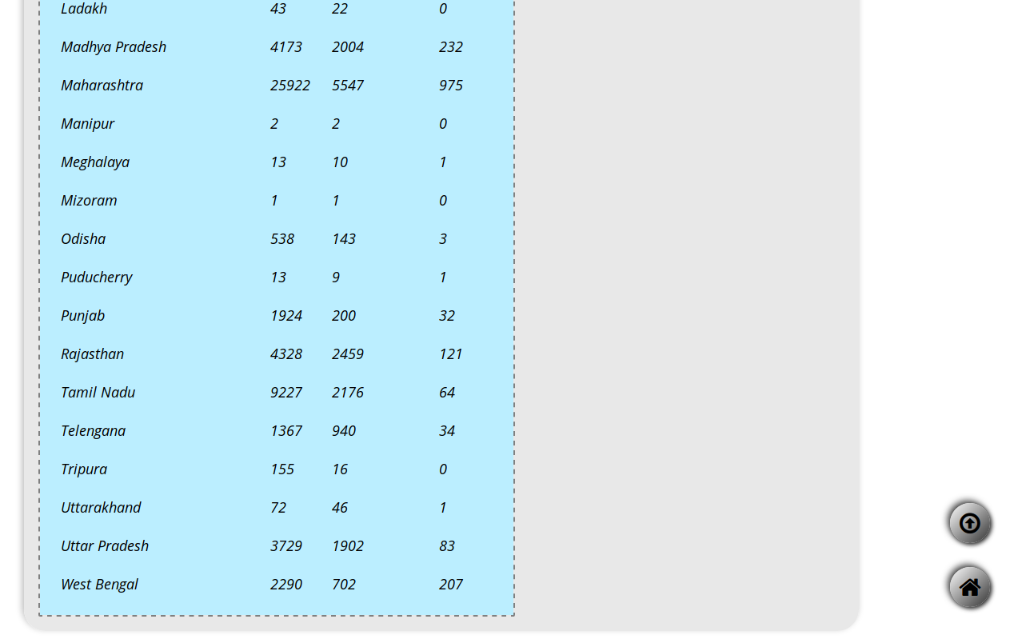

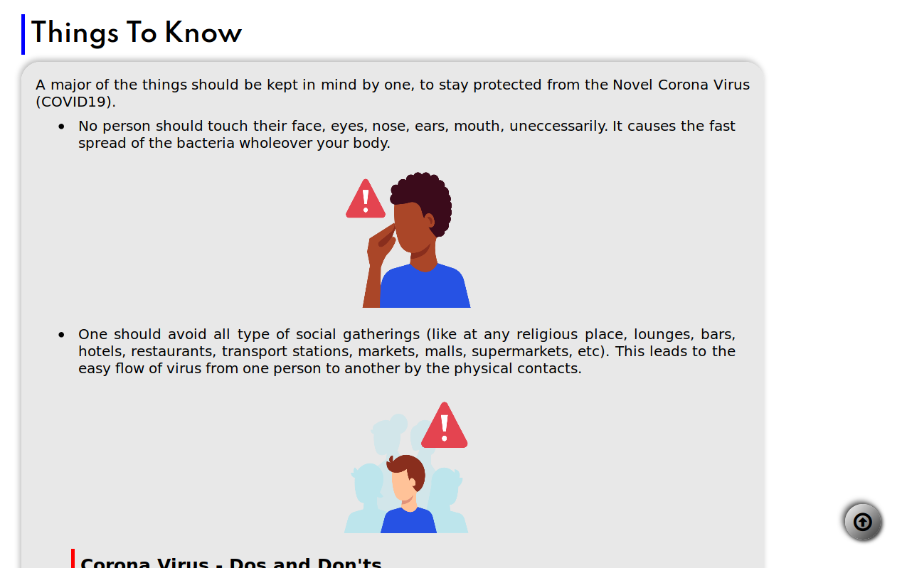

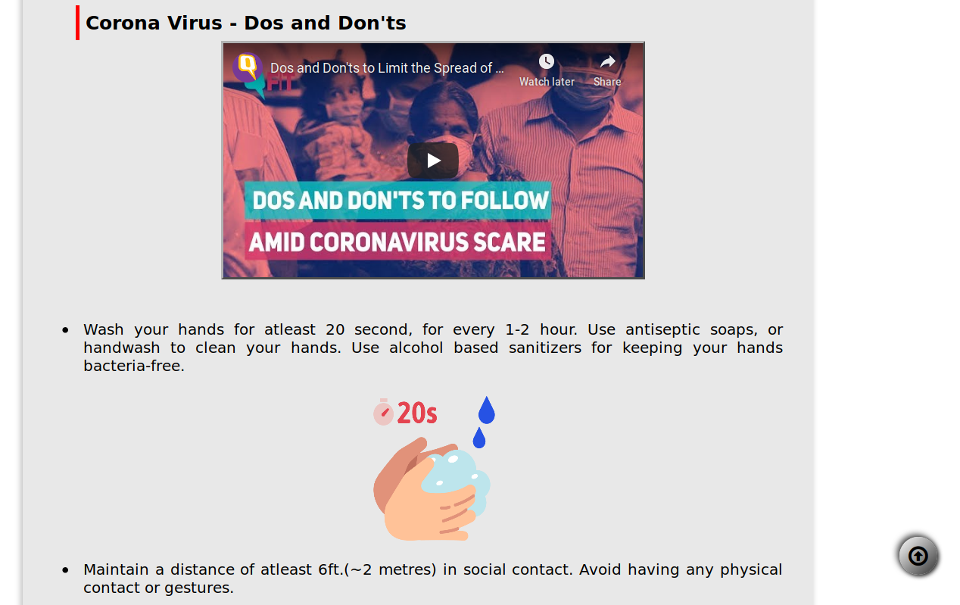

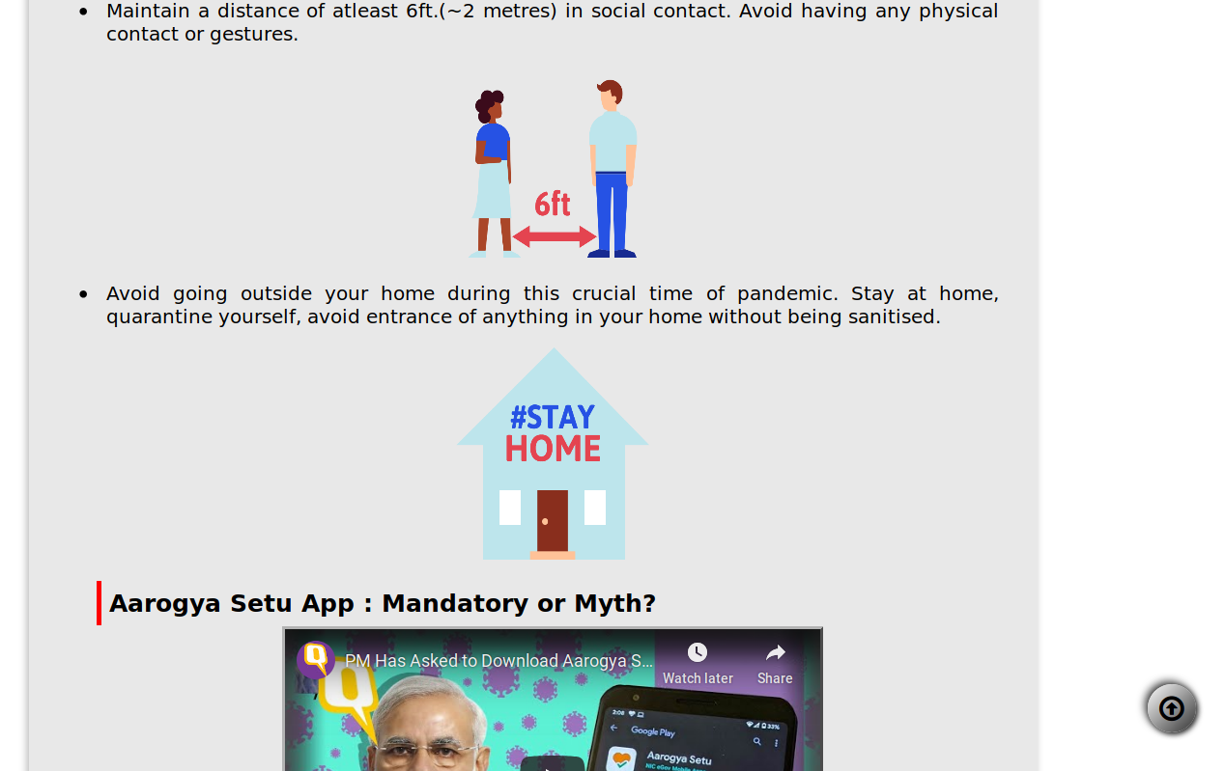

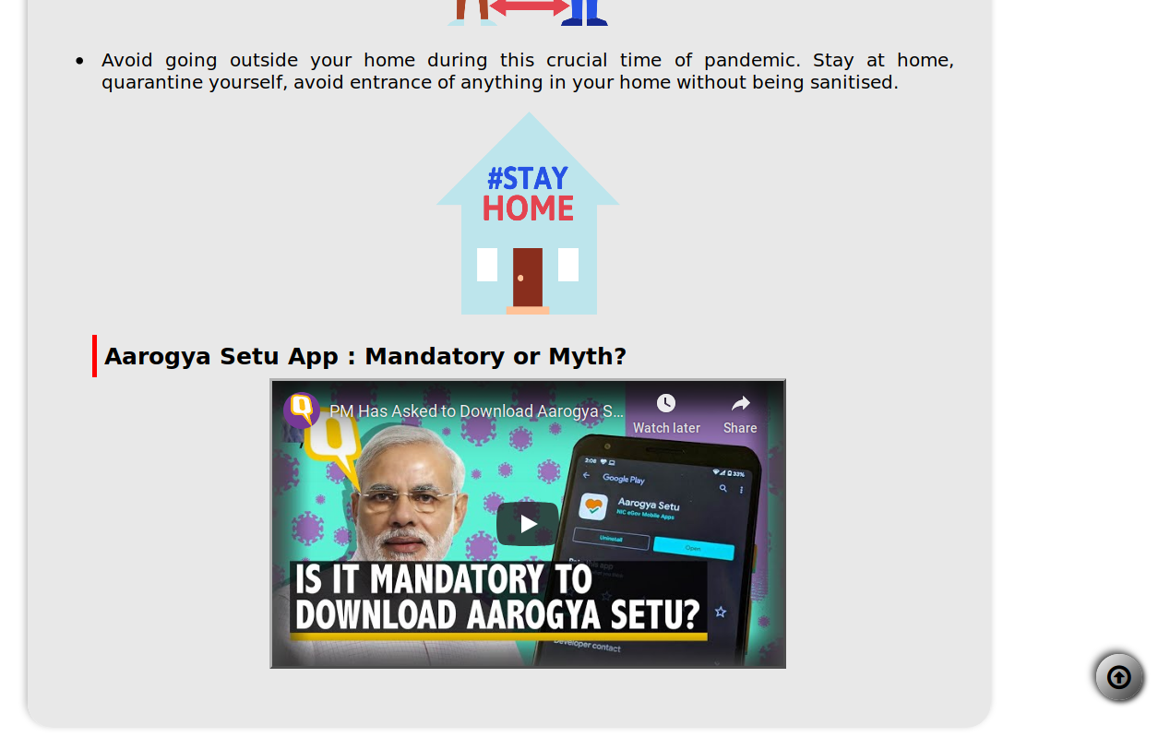

**\*---------------\***

**Source Code**

**<!--MAIN PAGE-->**

**<!DOCTYPE html>**

**<html>**

**<head>**

**<title>COVID-19 | INDIA</title>**

**<!--Responsive Website-->**

**<meta name="viewport" content="width=device-width,initial-scale=1,maximum-scale=1,user-scalable=no">**

**<meta http-equiv="X-UA-Compatible" content="IE=edge,chrome=1">**

**<meta name="HandheldFriendly" content="true">**

**<meta charset="UTF-8">**

**<!--Adding tab icon-->**

**<link rel="icon" href="icons/5859233.png" type="image/png">**

**<!--Adding logos for neumorphic buttons-->**

**<link rel="stylesheet" type="text/css"**

**href="https://stackpath.bootstrapcdn.com/font-awesome/4.7.0/css/font-awesome.min.css">**

**<link href="https://fonts.googleapis.com/css?family=Josefin+Sans&display=swap"rel="stylesheet">**

**<link rel="stylesheet" href="https://cdnjs.cloudflare.com/ajax/libs/animate.css/3.7.2/animate.min.css">**

**<!--Google Fonts Families-->**

**<link href="https://fonts.googleapis.com/css2?family=Open+Sans:ital@1&family=Roboto&family=Spartan:wght@500;600&display=swap" rel="stylesheet">**

**<link href="https://fonts.googleapis.com/css2?family=Dosis:wght@400;500&family=Exo:wght@600&family=Krub:wght@600&family=Maven+Pro&display=swap" rel="stylesheet"> <!--Including cases Javascript file-->**

**<script type="text/javascript" src="cases.js"></script>**

**<!-- Add icon library -->**

**<link rel="stylesheet" href="https://cdnjs.cloudflare.com/ajax/libs/font-awesome/4.7.0/css/font-awesome.min.css">**

**<!-- Main CSS file -->**

**<link rel="stylesheet" type="text/css" href="css/styles.css">**

**</head>**

**<body>**

**<header>**

**<img src="icons/5803961.png" class="topicon" alt="Corona Virus"><span>COVID-19</span>**

**</header>**

**<div class="divmenu">**

**<ul class="menu">**

**<li class="lmenu"><a href="#" class="active">HOME</a></li>**

**<li class="lmenu"><a href="know.html" target="_blank">TO KNOW</a></li>**

**<li class="lmenu"><a href="#id02">HELPLINE</a></li>**

**<li class="lmenu"><a href="#id01">ABOUT</a></li>**

**<li class="lmenu"><a href="FAQ.pdf" target="_blank">FAQ</a></li>**

**<li class="lmenu"><a href="state.html">UPDATES</a></li>**

**<li class="lmenu"><a href="">#IndiaFightsCorona</a></li>**

**</ul>**

**</div>**

**<div class="card">**

**<font style="border-width: 0 0 0 3px; border-color: blue; border-style: solid; text-align: left; padding: 4px; margin-left: 8px;">**

**CASES IN INDIA</font>**

**</div>**

**<casedet>**

**<div class="cardtotal" id="total"><b><font size=6px>Total</font></b><p></div>**

**<div class="cardconf" id="active"><b><font size=6px>Active</font></b><p></div>**

**<div class="carddisc" id="discharged"><b><font size=6px>Discharged</font></b><p></div>**

**<div class="carddeath" id="deaths"><b><font size=6px>Deaths</font></b><p></div>**

**</casedet>**

**<div class="footer">**

**<a href="https://www.facebook.com/facebookmedia/solutions/coronavirus-resources" class="fa fa-facebook" target="_blank"></a>**

**<p><br>**

**<a href="https://www.twitter.com/hashtag/coronavirus" class="fa fa-twitter" target="_blank"></a>**

**<p><br>**

**<a href="https://www.youtube.com/watch?v=sWjYs7aILZ8" class="fa fa-youtube" target="_blank"></a>**

**<p><br><br>**

**<div id="topbtn"><a href="#" class="fa fa-arrow-circle-o-up"></a></div>**

**</div>**

**<div class="card">**

**<font style="border-width: 0 0 0 3px; border-color: blue; border-style: solid; text-align: left; padding: 4px; margin-left: 8px;">Prevention From Corona Virus**

**</font>**

**<img src="icons/4443508.png" height=120px width=100px alt="Hand Washing">**

**<img src="icons/4443536.png" height=120px width=100px alt="Hand Washing">**

**<img src="icons/4443517.png" height=120px width=100px alt="Hand Washing">**

**<img src="icons/4443519.png" height=120px width=100px alt="Hand Washing">**

**<img src="icons/4443528.png" height=120px width=100px alt="Hand Washing">**

**<img src="icons/4443505.png" height=120px width=100px alt="Hand Washing">**

**</div>**

**<div class="textcard">**

**<font color=red>What is Corona Virus?</font>**

**<p>**

**Coronavirus disease (COVID-19) is an infectious disease caused by a newly discovered coronavirus.**

**Most people who fall sick with COVID-19 will experience mild to moderate symptoms and recover without special treatment.**

**</p>**

**<br>**

**<font color=red>How it spreads?</font>**

**<p>**

**The virus that causes COVID-19 is mainly transmitted through droplets generated when an infected person coughs, sneezes, or exhales. These droplets are too heavy to hang in the air, and quickly fall on floors or surfaces.</p>**

**<p>You can be infected by breathing in the virus if you are within close proximity of someone who has COVID-19, or by touching a contaminated surface and then your eyes, nose or mouth.**

**</p>**

**<p>**

**<img src="icons/5879324.png" height=120px width=100px alt="MaleMasked" style="vertical-align:middle;">**

**<img src="icons/5879325.png" height=120px width=100px alt="FemaleMasked" style="vertical-align:middle;">**

**<p><br>**

**<font color=red>Symptoms</font>**

**<p>**

**COVID-19 affects different people in different ways. Most infected people will develop mild to moderate illness and recover without hospitalization.**

**</p>**

**<br>**

**Most common symptoms:**

**<ul>**

**<li>fever.</li>**

**<li>dry cough</li>**

**<li>tiredness</li>**

**</ul>**

**<br>**

**Less common symptoms:**

**<ul>**

**<li>aches and pains</li>**

**<li>sore throat</li>**

**<li>diarrhoea</li>**

**<li>conjunctivitis</li>**

**<li>headache</li>**

**<li>loss of taste or smell</li>**

**<li>a rash on skin, or discolouration of fingers or toes</li>**

**</ul>**

**<br>**

**Serious symptoms:**

**<ul>**

**<li>difficulty breathing or shortness of breath</li>**

**<li>chest pain or pressure</li>**

**<li>loss of speech or movement</li>**

**</ul>**

**<br>**

**<p>**

**Seek immediate medical attention if you have serious symptoms. Always call before visiting your doctor or health facility.**

**</p>**

**<p>People with mild symptoms who are otherwise healthy should manage their symptoms at home. On average it takes 5–6 days from when someone is infected with the virus for symptoms to show, however it can take up to 14 days.**

**</p>**

**<div id="id01" class="modal">**

**<div class="modal-dialog">**

**<div class="modal-content">**

**<abthead class="container">**

**<a href="#" class="closebtn">x</a>**

**</abthead>**

**<div class="container">**

**<font color=red size=14><u>ABOUT</u></font>**

**<p>This site delivers a complete brief about the Corona Virus and the pandameic that is caused by it. Several symptoms and ways of prevention are shared in this website along with the emergency helpline number/toll-free number/email contact.<p>**

**<p>An active cards are implied with the latest count of the Corona Cases in India which is being updated at early. A FAQ is attached for the basic knowledge and idea about the COVID19 and arousing questions.</p>**

**<p>Stay Home. Stay Safe. Stay Fit. #IndiaFightsCorona</p>**

**<p>Sources: &copy;www.who.int, &copy;mohfw.gov.in, &copy;www.thequint.com</p>**

**</div>**

**</div>**

**</div>**

**</div>**

**<div id="id02" class="modal">**

**<div class="modal-dialog">**

**<div class="modal-content">**

**<abthead class="container">**

**<a href="#" class="closebtn">x</a>**

**</abthead>**

**<div class="container">**

**<font color=red size=14><u>HELPLINE</u></font>**

**<p>Telephone No. : +91-11-23978046</p>**

**<p>Toll Free No. : 1075</p>**

**<p>Mail : ncov2019@gov.in</p>**

**</div>**

**</div>**

**</div>**

**</div>**

**</div>**

**</body>**

**</html>**

**<!--TO KNOW PAGE-->**

**<!DOCTYPE HTML>**

**<html>**

**<head>**

**<title>Things To Know</title>**

**<meta charset="UTF-8">**

**<!--Responsive Website-->**

**<meta name="viewport" content="width=device-width,initial-scale=1,maximum-scale=1,user-scalable=no">**

**<meta http-equiv="X-UA-Compatible" content="IE=edge,chrome=1">**

**<meta name="HandheldFriendly" content="true">**

**<!--Adding tab icon-->**

**<link rel="icon" href="icons/4443501.png" type="image/png">**

**<!--Adding the CSS Stylesheet-->**

**<link rel="stylesheet" href="css/style.css" type="text/css">**

**<!--Google Font Families-->**

**<link href="https://fonts.googleapis.com/css2?family=Open+Sans:ital@1&family=Roboto&family=Spartan:wght@500;600&display=swap" rel="stylesheet">**

**<!-- Add icon library -->**

**<link rel="stylesheet" href="https://cdnjs.cloudflare.com/ajax/libs/font-awesome/4.7.0/css/font-awesome.min.css">**

**<head>**

**<body>**

**<div class="headpg2">**

**Things To Know**

**</div>**

**<div style="display: block; position: fixed; bottom: 20px; right: 10px; z-index: 1;"><a href="#" class="fa fa-arrow-circle-o-up"></a></div>**

**<div class="textcard">**

**<p>A major of the things should be kept in mind by one, to stay protected from the Novel Corona Virus (COVID19).</p>**

**<ul>**

**<li><p>No person should touch their face, eyes, nose, ears, mouth, uneccessarily. It causes the fast spread of the bacteria wholeover your body.</li></p>**

**<center><img src="icons/5964543.png" height=200px width=180px alt="no face contact"></img></center>**

**<li><p>One should avoid all type of social gatherings (like at any religious place, lounges, bars, hotels, restaurants, transport stations, markets, malls, supermarkets, etc). This leads to the easy flow of virus from one person to another by the physical contacts.</li></p>**

**<center><img src="icons/5925235.png" height=200px width=180px alt="no social gathering"></img></center>**

**<span id="vidhead">Corona Virus - Dos and Don'ts</span><br>**

**<iframe width="560" height="315" src="https://www.youtube.com/embed/EbLD-xT-mSw" frameborder="0" allow="accelerometer; autoplay; encrypted-media; gyroscope; picture-in-picture" allowfullscreen></iframe><br>**

**<li><p>Wash your hands for atleast 20 second, for every 1-2 hour. Use antiseptic soaps, or handwash to clean your hands. Use alcohol based sanitizers for keeping your hands bacteria-free.</li></p>**

**<center><img src="icons/5964550.png" height=200px width=180px alt="handwash 20sec"></img></center>**

**<li><p>Maintain a distance of atleast 6ft.(~2 metres) in social contact. Avoid having any physical contact or gestures.</li></p>**

**<center><img src="icons/5964546.png" height=200px width=180px alt="6ft distance"></img></center>**

**<li><p>Avoid going outside your home during this crucial time of pandemic. Stay at home, quarantine yourself, avoid entrance of anything in your home without being sanitised.</li></p>**

**<center><img src="icons/5964549.png" height=220px width=200px alt="stay home"></img></center>**

**<span id="vidhead">Aarogya Setu App : Mandatory or Myth?</span><br>**

**<iframe width="560" height="315" src="https://www.youtube.com/embed/pwyCQ0T74YA" frameborder="0" allow="accelerometer; autoplay; encrypted-media; gyroscope; picture-in-picture" allowfullscreen></iframe><br>**

**</ul>**

**</div>**

**</body>**

**</html>**

**<!--STATE-WISE CASE UPDATES-->**

**<!DOCTYPE HTML>**

**<html>**

**<head>**

**<title>Response Form</title>**

**<!--Responsive Website-->**

**<meta name="viewport" content="width=device-width,initial-scale=1,maximum-scale=1,user-scalable=no">**

**<meta http-equiv="X-UA-Compatible" content="IE=edge,chrome=1">**

**<meta name="HandheldFriendly" content="true">**

**<meta charset="UTF-8">**

**<!--Google Font Families-->**

**<link href="https://fonts.googleapis.com/css2?family=Open+Sans:ital@1&family=Roboto&family=Spartan:wght@500;600&display=swap" rel="stylesheet">**

**<!--Including stylesheet-->**

**<link rel="stylesheet" href="css/style.css" type="text/css">**

**<!--Including .js script-->**

**<script type="text/javascript" src="states.js"></script>**

**<!-- Add icon library -->**

**<link rel="stylesheet" href="https://cdnjs.cloudflare.com/ajax/libs/font-awesome/4.7.0/css/font-awesome.min.css">**

**</head>**

**<body>**

**<div class="headpg2">**

**Corona Updates (State-wise)**

**</div>**

**<div style="display: block; position: fixed; bottom: 100px; right: 10px; z-index: 1;"><a href="#" class="fa fa-arrow-circle-o-up"></a></div>**

**<div style="display: block; position: fixed; bottom: 20px; right: 10px; z-index: 1;"><a href="index.html" class="fa fa-home"></a></div>**

**<div class="textcard">**

**<table align="center" cellspacing=20px class="sttable">**

**<thead align="center">**

**<tr>**

**<th>LOCATION</th>**

**<th>TOTAL</th>**

**<th>DISCHARGED</th>**

**<th>DEATHS</th>**

**</tr>**

**</thead>**

**<tbody id="resfinal">**

**<td></td>**

**</tbody>**

**</table>**

**</div>**

**</body>**

**</html>**

**/*--INDEX PAGE CSS FILE--*/**

**/*--MAIN LAYOUT--*/**

**\***

**{**

**margin: auto;**

**box-sizing: border-box;**

**}**

**/*---------------*/**

**/*--HEADER--*/**

**header**

**{**

**vertical-align: middle;**

**display: flex;**

**background-color: rgba(255,141,0,0.7);**

**text-align: center;**

**font-family: "Spartan", sans-serif;**

**font-size: 55px;**

**font-weight: bold;**

**padding: 8px;**

**height: 120px;**

**width: 100%;**

**}**

**/*---------------*/**

**/*--TOP ICON--*/**

**img.topicon**

**{**

**vertical-align: middle;**

**height: 110px;**

**width: 110px;**

**margin-left: 5px;**

**float: left;**

**padding: 2px;**

**position: absolute;**

**}**

**/*---------------*/**

**/*--HEADING TEXT--*/**

**span.heading**

**{**

**vertical-align: middle;**

**font-weight: bold;**

**text-decoration: none;**

**padding: 5px;**

**}**

**/*---------------*/**

**/*--MENU LINKS (HOME-NEWS-HELPLINE-ABOUT)--*/**

**.divmenu**

**{**

**font-family: "Maven Pro", sans-serif;**

**font-weight: bold;**

**height: 20%;**

**width: 100%;**

**background-color: #dddddd;**

**position: sticky;**

**top: 0px;**

**z-index: 1;**

**}**

**/*--STYLING ON 'UL' LIST--*/**

**.menu**

**{**

**list-style-type: none;**

**margin: 0px;**

**padding: 0px;**

**width: auto;**

**overflow: hidden;**

**background-color: #333;**

**}**

**/*--STYLING ON 'LI' ITEMS--*/**

**.lmenu**

**{**

**float: left;**

**}**

**/*--STYLING ON 'LI' ITEMS LINK--*/**

**.lmenu a**

**{**

**float: left;**

**display: inline-block;**

**color: white;**

**text-align: center;**

**padding: 14px 16px;**

**text-decoration: none;**

**}**

**.lmenu a:hover**

**{**

**background-color: #111;**

**}**

**.active**

**{**

**background-color: red;**

**}**

**/*--DROPDOWN FOR 'ABOUT'--*/**

**li.dropdown {**

**position: relative;**

**display: inline-block;**

**}**

**.dropdown-content {**

**display: none;**

**position: absolute;**

**background-color: #f9f9f9;**

**min-width: 160px;**

**height: 100%;**

**box-shadow: 0px 8px 16px 0px rgba(0,0,0,0.2);**

**padding: 12px 16px;**

**z-index: 1;**

**}**

**.dropdown:hover .dropdown-content {**

**display: block;**

**z-index: 1;**

**}**

**/* Add animation (Chrome, Safari, Opera) */**

**@-webkit-keyframes example {**

**from {top:-100px;opacity: 0;}**

**to {top:0px;opacity:1;}**

**}**

**/* Add animation (Standard syntax) */**

**@keyframes example {**

**from {top:-100px;opacity: 0;}**

**to {top:0px;opacity:1;}**

**}**

**/* The modal's background */**

**.modal {**

**display: none;**

**position: fixed;**

**left: 0;**

**top: 0;**

**width: 100%;**

**height: 100%;**

**overflow: auto;**

**background-color: rgb(0, 0, 0);**

**background-color: rgba(0, 0, 0, 0.4);**

**}**

**/* Display the modal when targeted */**

**.modal:target {**

**display: table;**

**position: absolute;**

**}**

**/* The modal box */**

**.modal-dialog {**

**display: table-cell;**

**vertical-align: middle;**

**}**

**/* The modal's content */**

**.modal-dialog .modal-content {**

**margin: auto;**

**background-color: #f3f3f3;**

**position: relative;**

**padding: 0;**

**outline: 0;**

**border: 1px #777 solid;**

**text-align: justify;**

**width: 80%;**

**box-shadow: 0 4px 8px 0 rgba(0, 0, 0, 0.2), 0 6px 20px 0 rgba(0, 0, 0, 0.19);**

**/* Add animation */**

**-webkit-animation-name: example; /* Chrome, Safari, Opera */**

**-webkit-animation-duration: 0.5s; /* Chrome, Safari, Opera */**

**animation-name: example;**

**animation-duration: 0.5s;**

**}**

**/* The button used to close the modal */**

**.closebtn {**

**text-decoration: none;**

**float: right;**

**margin-right: 20px;**

**font-size: 35px;**

**font-weight: bold;**

**color: #111111;**

**}**

**.closebtn:hover,**

**.closebtn:focus {**

**color: rgb(200,0,0);**

**text-decoration: none;**

**cursor: pointer;**

**}**

**.container {**

**padding: 2px 16px;**

**width: auto;**

**}**

**abthead {**

**background: #1984fe;**

**width: 100%;**

**font-size: 25px;**

**padding: 14px;**

**color: black;**

**}**

**/*---------------*/**

**/*--3D BUTTONS--*/**

**#topbtn**

**{**

**display: block;**

**position: fixed;**

**bottom: 20px;**

**right: 10px;**

**z-index: inherit;**

**}**

**.footer**

**{**

**position: sticky;**

**top: 50px;**

**float: right;**

**display: relative;**

**list-style-type: none;**

**margin: 18px 0px 2px;**

**width: 7%;**

**height: auto;**

**}**

**/*--FORMATTING OF 3D BUTTONS--*/**

**.fa**

**{**

**padding: 10px;**

**font-size: 30px;**

**width: 50px;**

**height: 50px;**

**text-align: center;**

**text-decoration: none;**

**margin: 10px;**

**color: black;**

**border-radius: 50%;**

**background: linear-gradient(315deg, #323232, #ffffff);**

**box-shadow: -3px -3px 8px #414141,**

**2px 2px 5px #1d1d1d;**

**transition: 0.1s border-radius ease;**

**}**

**.fa:hover**

**{**

**border-radius: 50%;**

**background: linear-gradient(315deg, #ffffff, #323232);**

**box-shadow: -3px -3px 8px #1d1d1d,**

**2px 2px 5px #414141;**

**transition: 0.5s border-radius ease;**

**}**

**/*---------------*/**

**/*--CORONA CASE UPDATES--*/**

**casedet**

**{**

**display: flex;**

**float: left;**

**margin-left: 4%;**

**margin-top: 4px;**

**margin-bottom: 10px;**

**}**

**/*--CARD DETAIL--*/**

**.cardtotal**

**{**

**border-radius: 5px 5px 5px 5px;**

**font-family: "Dosis", sans-serif;**

**font-weight: 100px;**

**text-align: center;**

**width: 160px;**

**margin-right: 35px;**

**padding: 10px 0 10px 0;**

**background: linear-gradient(340deg, #1d84ff, #81bbff);**

**color: white;**

**font-size: 55px;**

**}**

**.cardconf**

**{**

**border-radius: 5px 5px 5px 5px;**

**font-family: "Dosis", sans-serif;**

**font-weight: 100px;**

**text-align: center;**

**width: 160px;**

**margin-right: 35px;**

**padding: 10px 0 10px 0;**

**background: linear-gradient(340deg, #ff5733, #ff8d74);**

**color: white;**

**font-size: 55px;**

**}**

**.carddisc**

**{**

**border-radius: 5px 5px 5px 5px;**

**font-family: "Dosis", sans-serif;**

**font-weight: 100px;**

**text-align: center;**

**width: 160px;**

**margin-right: 35px;**

**padding: 10px 0 10px 0;**

**background: linear-gradient(340deg, #1fc312, #56fe48);**

**color: white;**

**font-size: 55px;**

**}**

**.carddeath**

**{**

**border-radius: 5px 5px 5px 5px;**

**font-family: "Dosis", sans-serif;**

**font-weight: 100px;**

**text-align: center;**

**width: 160px;**

**margin-right: 35px;**

**padding: 10px 0 10px 0;**

**background: linear-gradient(340deg, #606060, #bbbbbb);**

**color: white;**

**font-size: 55px;**

**}**

**/*---------------*/**

**/*--BODY CONTENT CARDS--*/**

**div.card**

**{**

**font-family: "Exo", sans-serif;**

**font-size: 20px;**

**display: flex;**

**position: relative;**

**width: 80%;**

**height: auto;**

**margin: 15px;**

**padding: 10px;**

**color: rgba(0,0,0,1);**

**text-align: justify;**

**border-radius: 27px;**

**background: #bbbbbb;**

**box-shadow: inset 3px 3px 1px #8b8484,**

**inset 3px 3px 1px #bbbbbb;**

**}**

**/*--TEXT CARDS--*/**

**div.textcard**

**{**

**font-family: "Exo", sans-serif;**

**font-size: 20px;**

**position: relative;**

**width: 80%;**

**height: auto;**

**margin: 15px;**

**padding: 10px;**

**color: rgba(0,0,0,1);**

**text-align: justify;**

**border-radius: 27px;**

**background: #e8e8e8;**

**box-shadow: -2px -3px 8px #b7b7b7,**

**1px 1px 3px #ffffff;**

**}**

**/*---------------*/**

**/*--SECONDARY PAGES CSS--*/**

**/*--Main Layout--*/**

**\* {**

**margin: 10px;**

**box-sizing: border-box;**

**}**

**/*--Style the header--*/**

**.headpg2**

**{**

**font-family: Spartan, sans-serif;**

**border-width: 0 0 0 5px;**

**border-color: blue;**

**border-style: solid;**

**padding: 8px;**

**text-align: left;**

**font-size: 35px;**

**font-weight: bold;**

**color: black;**

**}**

**#vidhead**

**{**

**border-width: 0 0 0 5px;**

**border-color: red;**

**border-style: solid;**

**padding: 8px;**

**text-align: left;**

**font-size: 25px;**

**font-weight: bold;**

**color: black;**

**}**

**/*---------------*/**

**/*--Body Cards--*/**

**div.textcard**

**{**

**font-family: "Exo", sans-serif;**

**font-size: 20px;**

**position: relative;**

**width: 85%;**

**height: auto;**

**padding: 10px;**

**color: rgba(0,0,0,1);**

**text-align: justify;**

**border-radius: 27px;**

**background: #e8e8e8;**

**box-shadow: -2px -3px 8px #b7b7b7,**

**1px 1px 3px #ffffff;**

**}**

**/*---------------*/**

**/*--iframe alteration--*/**

**iframe**

**{**

**display: block;**

**margin: 0 auto;**

**border: 3px outset;**

**}**

**/*---------------*/**

**/*--FORMATTING OF 3D BUTTONS--*/**

**a.fa**

**{**

**padding: 10px;**

**font-size: 30px;**

**width: 50px;**

**height: 50px;**

**text-align: center;**

**text-decoration: none;**

**margin: 10px;**

**color: black;**

**border-radius: 50%;**

**background: linear-gradient(315deg, #323232, #ffffff);**

**box-shadow: -3px -3px 8px #414141,**

**2px 2px 5px #1d1d1d;**

**transition: 0.1s border-radius ease;**

**}**

**a.fa:hover**

**{**

**border-radius: 50%;**

**background: linear-gradient(315deg, #ffffff, #323232);**

**box-shadow: -3px -3px 8px #1d1d1d,**

**2px 2px 5px #414141;**

**transition: 0.5s border-radius ease;**

**}**

**/*---------------*/**

**/*--State-Case Table Formatting--*/**

**.sttable**

**{**

**font-family: "Open Sans", sans-serif;**

**font-size: 18px;**

**border-width: 0 0 0 5px;**

**border-color: blue;**

**padding: 5px;**

**outline: 2px dashed grey;**

**background: #bbeeff;**

**float: middle;**

**}**

**/*---------------*/**

**//----INDIA CASE UPDATES**

**fetch("https://api.rootnet.in/covid19-in/stats/latest")**

**.then((cases_time_series) => {**

**return cases_time_series.json();**

**})**

**.then((cases_time_series2) => {**

**console.log(cases_time_series2.data.summary.total);**

**console.log(cases_time_series2.data.summary.confirmedCasesIndian);**

**console.log(cases_time_series2.data.summary.discharged);**

**console.log(cases_time_series2.data.summary.deaths);**

**var act=cases_time_series2.data.summary.total-cases_time_series2.data.summary.discharged-cases_time_series2.data.summary.deaths;**

**//Total cases**

**document.getElementById("total").innerHTML+=cases_time_series2.data.summary.total;**

**document.getElementById("active").innerHTML+=act;**

**document.getElementById("discharged").innerHTML+=cases_time_series2.data.summary.discharged;**

**document.getElementById("deaths").innerHTML+=cases_time_series2.data.summary.deaths;**

**});**

**//----STATE-WISE UPDATES**

**fetch("https://api.rootnet.in/covid19-in/stats/latest")**

**.then(res=>{**

**return res.json();})**

**.then((resfinal)=>{**

**var temp = "";**

**var i;**

**for(i=0; i<33; i++)**

**{**

**temp +="<tr>";**

**temp +="<td>"+resfinal.data.regional[i].loc+"</td>";**

**temp +="<td>"+resfinal.data.regional[i].totalConfirmed+"</td>";**

**temp +="<td>"+resfinal.data.regional[i].discharged+"</td>";**

**temp +="<td>"+resfinal.data.regional[i].deaths+"</td></tr>";**

**}**

**//----Close for loop**

**document.getElementById("resfinal").innerHTML+=temp;**

**}**

**);**

**\*---------------\***