Part 2:
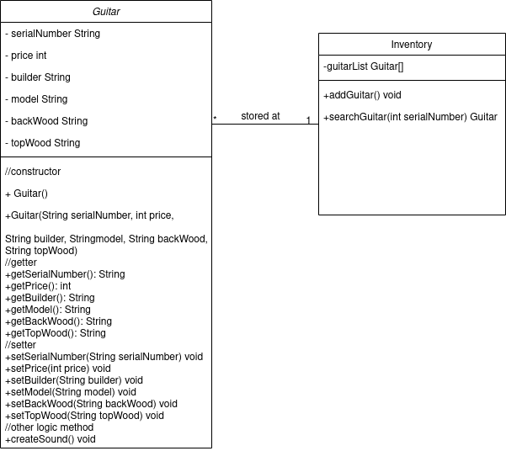
Part4:
static heap: the object2
stack the tester program
dynamic heap: object1
Objects: obj1, obj2
state: object1: not given all parameters, obj2 give all.
No, only give the price parameter.
Obj2
no, since this is only used in Guitar class.

