**Work Instruction to Prepare and SDcard for JouleX Display**

1. Double Click on the "C:\Program Files (x86)\ImageWriter" to open the software DiskImager.
2. Drag the file “V2r1SDcard” from your PC Desktop location into the DiskImager. Figure 1.
3. Insert an SDcard into a USB adapter then insert it to the PC USB port.
4. Identify the SDcard in the USB adapter. Its name should look like D:, E:, F:, shown in DiskImager.
5. Click ‘Write’ button to start. Figure 2. This step pops up a ‘Reminder’ dialog, Figure 3.
6. Click ‘Yes’ button to continue (Just make sure the Target Device is shown as such).
7. Watch the progress shown as it starts running. Figure 4.
8. Wait for the final dialog show up then click ‘OK’ to close then ‘Exit’ the DiskImager software.
9. Take the SDcard and try it out on your jouleX system.

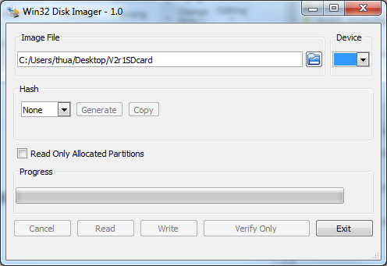

Figure 1.

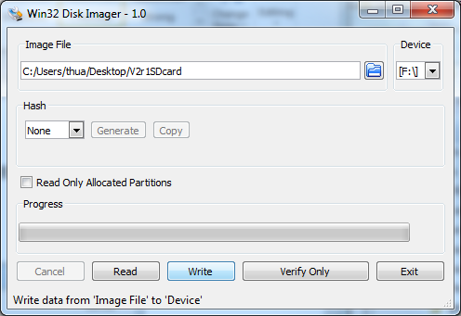

Figure 2.

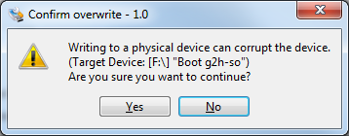

Figure 3.

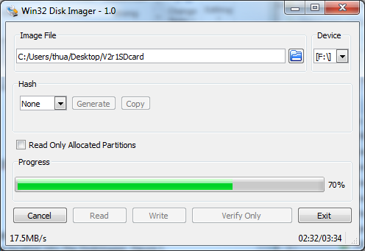

Figure 4.

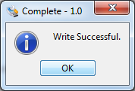

Figure 5.