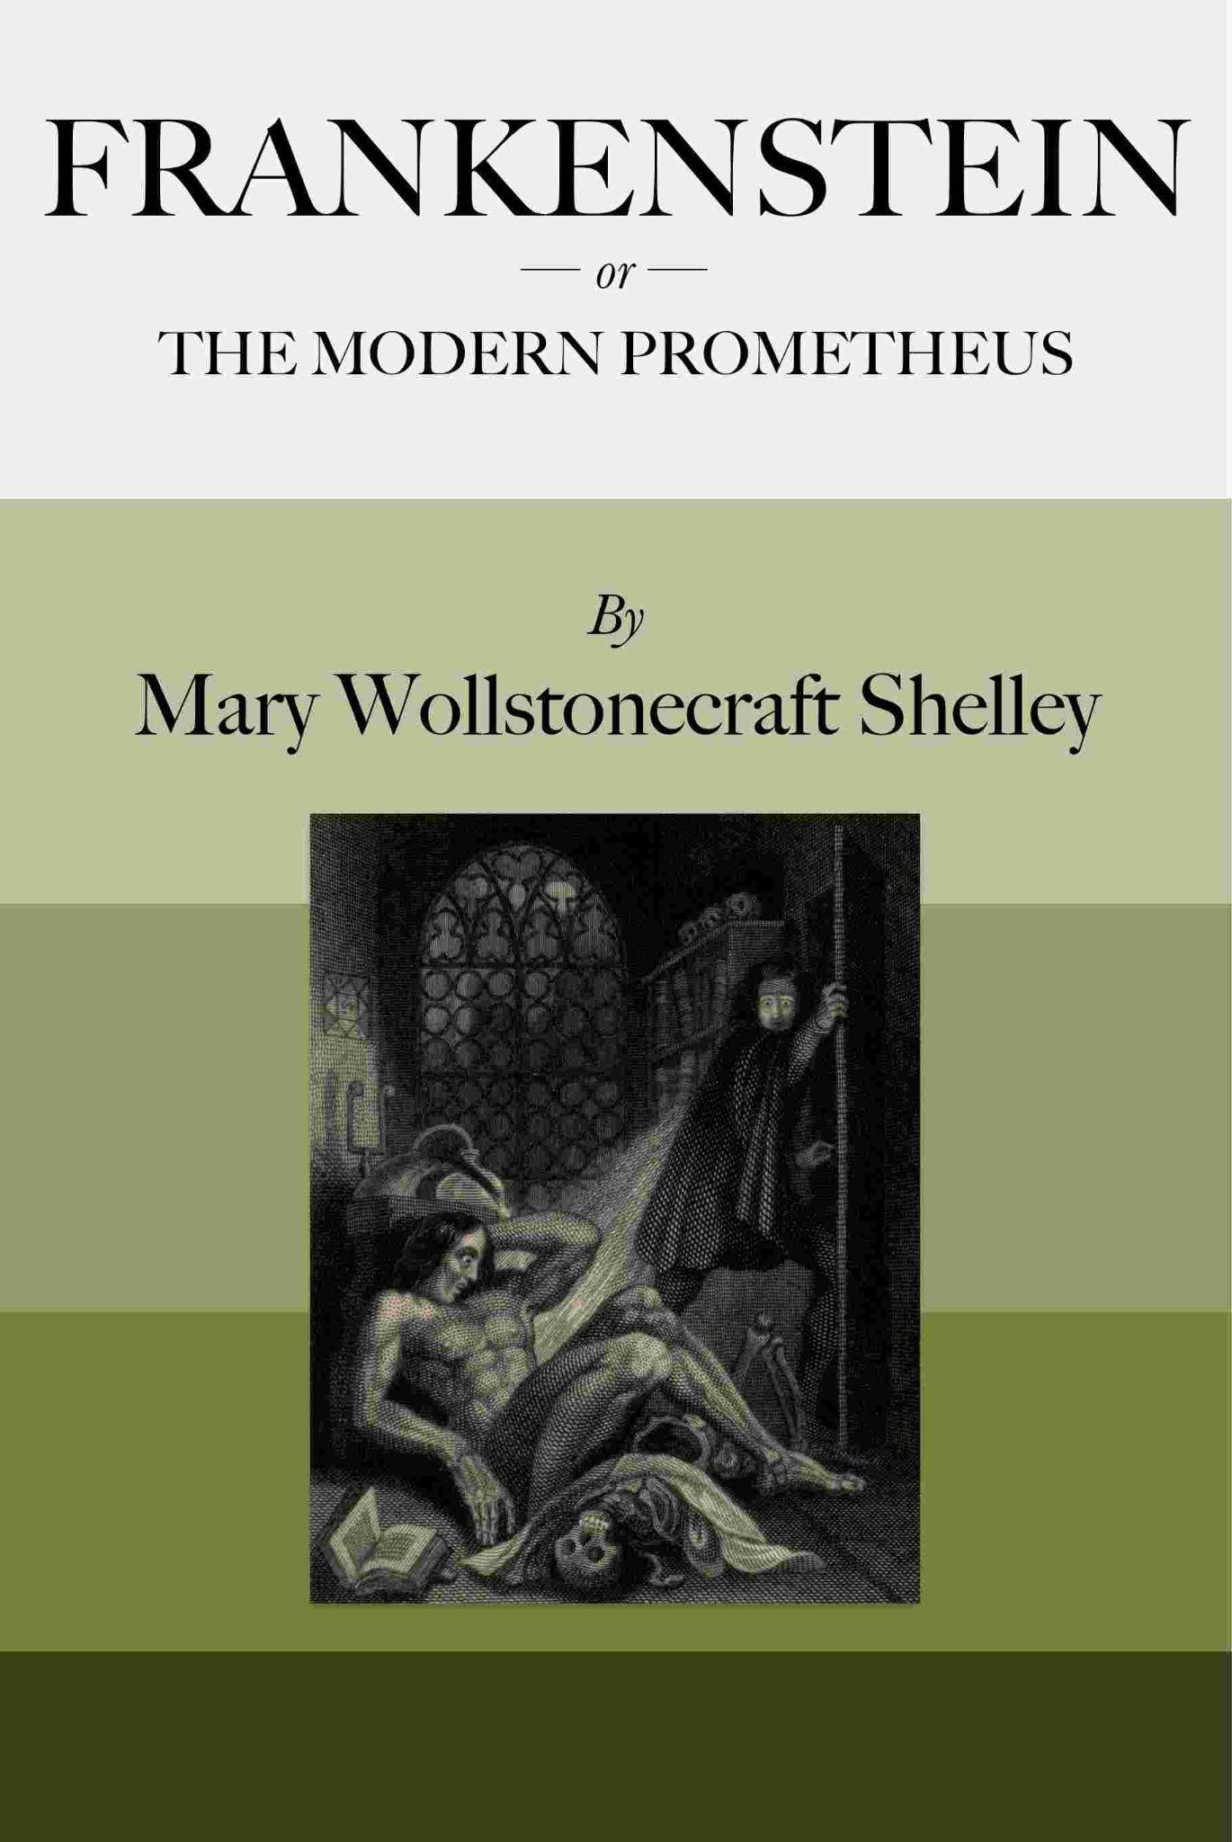

Chapter 1

I am by birth a Genevese, and my family is one of the most distinguished of that republic. My ancestors had been for many years counsellors and syndics, and my father had filled several public situations with honour and reputation. He was respected by all who knew him for his integrity and indefatigable attention to public business. He passed his younger days perpetually occupied by the affairs of his country; a variety of circumstances had prevented his marrying early, nor was it until the decline of life that he became a husband and the father of a family.

As the circumstances of his marriage illustrate his character, I cannot refrain from relating them. One of his most intimate friends was a merchant who, from a flourishing state, fell, through numerous mischances, into poverty. This man, whose name was Beaufort, was of a proud and unbending disposition and could not bear to live in poverty and oblivion in the same country where he had formerly been distinguished for his rank and magnificence. Having paid his debts, therefore, in the most honourable manner, he retreated with his daughter to the town of Lucerne, where he lived unknown and in wretchedness. My father loved Beaufort with the truest friendship and was deeply grieved by his retreat in these unfortunate circumstances. He bitterly deplored the false pride which led his friend to a conduct so little worthy of the affection that united them. He lost no time in endeavouring to seek him out, with the hope of persuading him to begin the world again through his credit and assistance.

Beaufort had taken effectual measures to conceal himself, and it was ten months before my father discovered his abode. Overjoyed at this discovery, he hastened to the house, which was situated in a mean street near the Reuss. But when he entered, misery and despair alone welcomed him. Beaufort had saved but a very small sum of money from the wreck of his fortunes, but it was sufficient to provide him with sustenance for some months, and in the meantime he hoped to procure some respectable employment in a merchant’s house. The interval was, consequently, spent in inaction; his grief only became more deep and rankling when he had leisure for reflection, and at length it took so fast hold of his mind that at the end of three months he lay on a bed of sickness, incapable of any exertion.

His daughter attended him with the greatest tenderness, but she saw with despair that their little fund was rapidly decreasing and that there was no other prospect of support. But Caroline Beaufort possessed a mind of an uncommon mould, and her courage rose to support her in her adversity. She procured plain work; she plaited straw and by various means contrived to earn a pittance scarcely sufficient to support life.

Several months passed in this manner. Her father grew worse; her time was more entirely occupied in attending him; her means of subsistence decreased; and in the tenth month her father died in her arms, leaving her an orphan and a beggar. This last blow overcame her, and she knelt by Beaufort’s coffin weeping bitterly, when my father entered the chamber. He came like a protecting spirit to the poor girl, who committed herself to his care; and after the interment of his friend he conducted her to Geneva and placed her under the protection of a relation. Two years after this event Caroline became his wife.

There was a considerable difference between the ages of my parents, but this circumstance seemed to unite them only closer in bonds of devoted affection. There was a sense of justice in my father’s upright mind which rendered it necessary that he should approve highly to love strongly. Perhaps during former years he had suffered from the late-discovered unworthiness of one beloved and so was disposed to set a greater value on tried worth. There was a show of gratitude and worship in his attachment to my mother, differing wholly from the doting fondness of age, for it was inspired by reverence for her virtues and a desire to be the means of, in some degree, recompensing her for the sorrows she had endured, but which gave inexpressible grace to his behaviour to her. Everything was made to yield to her wishes and her convenience. He strove to shelter her, as a fair exotic is sheltered by the gardener, from every rougher wind and to surround her with all that could tend to excite pleasurable emotion in her soft and benevolent mind. Her health, and even the tranquillity of her hitherto constant spirit, had been shaken by what she had gone through. During the two years that had elapsed previous to their marriage my father had gradually relinquished all his public functions; and immediately after their union they sought the pleasant climate of Italy, and the change of scene and interest attendant on a tour through that land of wonders, as a restorative for her weakened frame.

From Italy they visited Germany and France. I, their eldest child, was born at Naples, and as an infant accompanied them in their rambles. I remained for several years their only child. Much as they were attached to each other, they seemed to draw inexhaustible stores of affection from a very mine of love to bestow them upon me. My mother’s tender caresses and my father’s smile of benevolent pleasure while regarding me are my first recollections. I was their plaything and their idol, and something better—their child, the innocent and helpless creature bestowed on them by Heaven, whom to bring up to good, and whose future lot it was in their hands to direct to happiness or misery, according as they fulfilled their duties towards me. With this deep consciousness of what they owed towards the being to which they had given life, added to the active spirit of tenderness that animated both, it may be imagined that while during every hour of my infant life I received a lesson of patience, of charity, and of self-control, I was so guided by a silken cord that all seemed but one train of enjoyment to me.

Chapter 18
Day after day, week after week, passed away on my return to Geneva; and I could not collect the courage to recommence my work. I feared the vengeance of the disappointed fiend, yet I was unable to overcome my repugnance to the task which was enjoined me. I found that I could not compose a female without again devoting several months to profound study and laborious disquisition. I had heard of some discoveries having been made by an English philosopher, the knowledge of which was material to my success, and I sometimes thought of obtaining my father’s consent to visit England for this purpose; but I clung to every pretence of delay and shrank from taking the first step in an undertaking whose immediate necessity began to appear less absolute to me. A change indeed had taken place in me; my health, which had hitherto declined, was now much restored; and my spirits, when unchecked by the memory of my unhappy promise, rose proportionably. My father saw this change with pleasure, and he turned his thoughts towards the best method of eradicating the remains of my melancholy, which every now and then would return by fits, and with a devouring blackness overcast the approaching sunshine. At these moments I took refuge in the most perfect solitude. I passed whole days on the lake alone in a little boat, watching the clouds and listening to the rippling of the waves, silent and listless. But the fresh air and bright sun seldom failed to restore me to some degree of composure, and on my return I met the salutations of my friends with a readier smile and a more cheerful heart.

It was after my return from one of these rambles that my father, calling me aside, thus addressed me,

“I am happy to remark, my dear son, that you have resumed your former pleasures and seem to be returning to yourself. And yet you are still unhappy and still avoid our society. For some time I was lost in conjecture as to the cause of this, but yesterday an idea struck me, and if it is well founded, I conjure you to avow it. Reserve on such a point would be not only useless, but draw down treble misery on us all.”

I trembled violently at his exordium, and my father continued—

“I confess, my son, that I have always looked forward to your marriage with our dear Elizabeth as the tie of our domestic comfort and the stay of my declining years. You were attached to each other from your earliest infancy; you studied together, and appeared, in dispositions and tastes, entirely suited to one another. But so blind is the experience of man that what I conceived to be the best assistants to my plan may have entirely destroyed it. You, perhaps, regard her as your sister, without any wish that she might become your wife. Nay, you may have met with another whom you may love; and considering yourself as bound in honour to Elizabeth, this struggle may occasion the poignant misery which you appear to feel.”

“My dear father, reassure yourself. I love my cousin tenderly and sincerely. I never saw any woman who excited, as Elizabeth does, my warmest admiration and affection. My future hopes and prospects are entirely bound up in the expectation of our union.”

“The expression of your sentiments of this subject, my dear Victor, gives me more pleasure than I have for some time experienced. If you feel thus, we shall assuredly be happy, however present events may cast a gloom over us. But it is this gloom which appears to have taken so strong a hold of your mind that I wish to dissipate. Tell me, therefore, whether you object to an immediate solemnisation of the marriage. We have been unfortunate, and recent events have drawn us from that everyday tranquillity befitting my years and infirmities. You are younger; yet I do not suppose, possessed as you are of a competent fortune, that an early marriage would at all interfere with any future plans of honour and utility that you may have formed. Do not suppose, however, that I wish to dictate happiness to you or that a delay on your part would cause me any serious uneasiness. Interpret my words with candour and answer me, I conjure you, with confidence and sincerity.”

I listened to my father in silence and remained for some time incapable of offering any reply. I revolved rapidly in my mind a multitude of thoughts and endeavoured to arrive at some conclusion. Alas! To me the idea of an immediate union with my Elizabeth was one of horror and dismay. I was bound by a solemn promise which I had not yet fulfilled and dared not break, or if I did, what manifold miseries might not impend over me and my devoted family! Could I enter into a festival with this deadly weight yet hanging round my neck and bowing me to the ground? I must perform my engagement and let the monster depart with his mate before I allowed myself to enjoy the delight of a union from which I expected peace.

I remembered also the necessity imposed upon me of either journeying to England or entering into a long correspondence with those philosophers of that country whose knowledge and discoveries were of indispensable use to me in my present undertaking. The latter method of obtaining the desired intelligence was dilatory and unsatisfactory; besides, I had an insurmountable aversion to the idea of engaging myself in my loathsome task in my father’s house while in habits of familiar intercourse with those I loved. I knew that a thousand fearful accidents might occur, the slightest of which would disclose a tale to thrill all connected with me with horror. I was aware also that I should often lose all self-command, all capacity of hiding the harrowing sensations that would possess me during the progress of my unearthly occupation. I must absent myself from all I loved while thus employed. Once commenced, it would quickly be achieved, and I might be restored to my family in peace and happiness. My promise fulfilled, the monster would depart for ever. Or (so my fond fancy imaged) some accident might meanwhile occur to destroy him and put an end to my slavery for ever.

These feelings dictated my answer to my father. I expressed a wish to visit England, but concealing the true reasons of this request, I clothed my desires under a guise which excited no suspicion, while I urged my desire with an earnestness that easily induced my father to comply. After so long a period of an absorbing melancholy that resembled madness in its intensity and effects, he was glad to find that I was capable of taking pleasure in the idea of such a journey, and he hoped that change of scene and varied amusement would, before my return, have restored me entirely to myself.

The duration of my absence was left to my own choice; a few months, or at most a year, was the period contemplated. One paternal kind precaution he had taken to ensure my having a companion. Without previously communicating with me, he had, in concert with Elizabeth, arranged that Clerval should join me at Strasburgh. This interfered with the solitude I coveted for the prosecution of my task; yet at the commencement of my journey the presence of my friend could in no way be an impediment, and truly I rejoiced that thus I should be saved many hours of lonely, maddening reflection. Nay, Henry might stand between me and the intrusion of my foe. If I were alone, would he not at times force his abhorred presence on me to remind me of my task or to contemplate its progress?

To England, therefore, I was bound, and it was understood that my union with Elizabeth should take place immediately on my return. My father’s age rendered him extremely averse to delay. For myself, there was one reward I promised myself from my detested toils—one consolation for my unparalleled sufferings; it was the prospect of that day when, enfranchised from my miserable slavery, I might claim Elizabeth and forget the past in my union with her.

I now made arrangements for my journey, but one feeling haunted me which filled me with fear and agitation. During my absence I should leave my friends unconscious of the existence of their enemy and unprotected from his attacks, exasperated as he might be by my departure. But he had promised to follow me wherever I might go, and would he not accompany me to England? This imagination was dreadful in itself, but soothing inasmuch as it supposed the safety of my friends. I was agonised with the idea of the possibility that the reverse of this might happen. But through the whole period during which I was the slave of my creature I allowed myself to be governed by the impulses of the moment; and my present sensations strongly intimated that the fiend would follow me and exempt my family from the danger of his machinations.

It was in the latter end of September that I again quitted my native country. My journey had been my own suggestion, and Elizabeth therefore acquiesced, but she was filled with disquiet at the idea of my suffering, away from her, the inroads of misery and grief. It had been her care which provided me a companion in Clerval—and yet a man is blind to a thousand minute circumstances which call forth a woman’s sedulous attention. She longed to bid me hasten my return; a thousand conflicting emotions rendered her mute as she bade me a tearful, silent farewell.

I threw myself into the carriage that was to convey me away, hardly knowing whither I was going, and careless of what was passing around. I remembered only, and it was with a bitter anguish that I reflected on it, to order that my chemical instruments should be packed to go with me. Filled with dreary imaginations, I passed through many beautiful and majestic scenes, but my eyes were fixed and unobserving. I could only think of the bourne of my travels and the work which was to occupy me whilst they endured.

After some days spent in listless indolence, during which I traversed many leagues, I arrived at Strasburgh, where I waited two days for Clerval. He came. Alas, how great was the contrast between us! He was alive to every new scene, joyful when he saw the beauties of the setting sun, and more happy when he beheld it rise and recommence a new day. He pointed out to me the shifting colours of the landscape and the appearances of the sky. “This is what it is to live,” he cried; “now I enjoy existence! But you, my dear Frankenstein, wherefore are you desponding and sorrowful!” In truth, I was occupied by gloomy thoughts and neither saw the descent of the evening star nor the golden sunrise reflected in the Rhine. And you, my friend, would be far more amused with the journal of Clerval, who observed the scenery with an eye of feeling and delight, than in listening to my reflections. I, a miserable wretch, haunted by a curse that shut up every avenue to enjoyment.

We had agreed to descend the Rhine in a boat from Strasburgh to Rotterdam, whence we might take shipping for London. During this voyage we passed many willowy islands and saw several beautiful towns. We stayed a day at Mannheim, and on the fifth from our departure from Strasburgh, arrived at Mainz. The course of the Rhine below Mainz becomes much more picturesque. The river descends rapidly and winds between hills, not high, but steep, and of beautiful forms. We saw many ruined castles standing on the edges of precipices, surrounded by black woods, high and inaccessible. This part of the Rhine, indeed, presents a singularly variegated landscape. In one spot you view rugged hills, ruined castles overlooking tremendous precipices, with the dark Rhine rushing beneath; and on the sudden turn of a promontory, flourishing vineyards with green sloping banks and a meandering river and populous towns occupy the scene.

We travelled at the time of the vintage and heard the song of the labourers as we glided down the stream. Even I, depressed in mind, and my spirits continually agitated by gloomy feelings, even I was pleased. I lay at the bottom of the boat, and as I gazed on the cloudless blue sky, I seemed to drink in a tranquillity to which I had long been a stranger. And if these were my sensations, who can describe those of Henry? He felt as if he had been transported to Fairy-land and enjoyed a happiness seldom tasted by man. “I have seen,” he said, “the most beautiful scenes of my own country; I have visited the lakes of Lucerne and Uri, where the snowy mountains descend almost perpendicularly to the water, casting black and impenetrable shades, which would cause a gloomy and mournful appearance were it not for the most verdant islands that relieve the eye by their gay appearance; I have seen this lake agitated by a tempest, when the wind tore up whirlwinds of water and gave you an idea of what the water-spout must be on the great ocean; and the waves dash with fury the base of the mountain, where the priest and his mistress were overwhelmed by an avalanche and where their dying voices are still said to be heard amid the pauses of the nightly wind; I have seen the mountains of La Valais, and the Pays de Vaud; but this country, Victor, pleases me more than all those wonders. The mountains of Switzerland are more majestic and strange, but there is a charm in the banks of this divine river that I never before saw equalled. Look at that castle which overhangs yon precipice; and that also on the island, almost concealed amongst the foliage of those lovely trees; and now that group of labourers coming from among their vines; and that village half hid in the recess of the mountain. Oh, surely the spirit that inhabits and guards this place has a soul more in harmony with man than those who pile the glacier or retire to the inaccessible peaks of the mountains of our own country.”

Clerval! Beloved friend! Even now it delights me to record your words and to dwell on the praise of which you are so eminently deserving. He was a being formed in the “very poetry of nature.” His wild and enthusiastic imagination was chastened by the sensibility of his heart. His soul overflowed with ardent affections, and his friendship was of that devoted and wondrous nature that the worldly-minded teach us to look for only in the imagination. But even human sympathies were not sufficient to satisfy his eager mind. The scenery of external nature, which others regard only with admiration, he loved with ardour:—

——The sounding cataract
Haunted him like a passion: the tall rock,
The mountain, and the deep and gloomy wood,
Their colours and their forms, were then to him
An appetite; a feeling, and a love,
That had no need of a remoter charm,
By thought supplied, or any interest
Unborrow’d from the eye.

[Wordsworth’s “Tintern Abbey”.]

And where does he now exist? Is this gentle and lovely being lost for ever? Has this mind, so replete with ideas, imaginations fanciful and magnificent, which formed a world, whose existence depended on the life of its creator;—has this mind perished? Does it now only exist in my memory? No, it is not thus; your form so divinely wrought, and beaming with beauty, has decayed, but your spirit still visits and consoles your unhappy friend.

Pardon this gush of sorrow; these ineffectual words are but a slight tribute to the unexampled worth of Henry, but they soothe my heart, overflowing with the anguish which his remembrance creates. I will proceed with my tale.

Beyond Cologne we descended to the plains of Holland; and we resolved to post the remainder of our way, for the wind was contrary and the stream of the river was too gentle to aid us.

Our journey here lost the interest arising from beautiful scenery, but we arrived in a few days at Rotterdam, whence we proceeded by sea to England. It was on a clear morning, in the latter days of December, that I first saw the white cliffs of Britain. The banks of the Thames presented a new scene; they were flat but fertile, and almost every town was marked by the remembrance of some story. We saw Tilbury Fort and remembered the Spanish Armada, Gravesend, Woolwich, and Greenwich—places which I had heard of even in my country.

At length we saw the numerous steeples of London, St. Paul’s towering above all, and the Tower famed in English history.

