Tree Library
Features

Feb 11, 2009

Tuukka Haapasalo
thaapasa@cs.hut.fi

General
The Tree Library is a collection of different database index structures, visualization tools and tools for operating on the index structures.
The current status of the library is that it supports a single transaction at a time. The concurrency control algorithms are not yet implemented. Also, recovery is not supported, and the operations are not logged.
However, the pages of a database are properly stored in a database file that is used through a fully functional page buffer. The algorithms therefore contain page fixing instructions, but not latching instructions.

Configuration
Practically everything in the tree library is configurable. The application is constructed by using the Spring Framework (http://www.springsource.org/) which is configured using XML configuration files. Thus, all the settings can be changed simply by changing the XML configuration files.

Key and value types
The tree library does not enforce the user to a specific key or value data type, but the data types can be configured. Thus, the user can select what data types to use for keys (and for values) in any of the databases (integers, longs, floats, and so on). This is implemented by using wrapper classes for the primitive types, and defining a common interface that is used by the trees when dealing with the keys and values.
Currently, the following key types are supported (wrapper classes have been created):
- 32-bit single-precision floating point numbers
- 32-bit integers
- 64-bit long integers
- MBRs constructed using any of the previous types

Features

Implemented database features
- Page buffer, page fixing
- Page storage (two implementations: file storage and memory storage)
- Space allocation maps for the database files
- Statistics logging (how many page fixes taken, how many pages read from disk, ...)

Not yet implemented features
- Concurrency control features
- Page latching
- Key locking
- Logging
- Recovery algorithms

Testing
Parts of the tree library have been developed using the test driven development method (TDD), so that unit tests are written first, and the implementation only afterwards. There are unit tests for most of the data structures, iterators, value generating functions and so on. In other words, tests exist for classes that are easy (and important) to unit test. However, the graphical user interface components and similar do not have unit tests.
For the index structures, there is a common test set that inserts entries, validates that they are returned from the database, deletes the entries, and checks that they are no longer returned. These tests serve as a quick first test when creating a new index structure. Also, as is emphasized by the agile programming mantras, the unit tests have been an invaluable aid when refactoring the structure of the tree library.

External dependencies
The tree library uses the Spring Framework for configuring and initializing the objects used by the applications; log4j and commons-logging logging APIs for debug logging, and xmlgraphics-commons for creating EPS images. There is also a general utility library (created by the author), which holds some general-purpose data structures and algorithms. Otherwise, everything is implemented in the application itself.

Index structures

Single-version, single-dimension

B⁺-tree
A standard B⁺-tree, with page merges and splits. Splits are 2-to-1, but page merges also support entry redistribution.
Found in package fi.hut.cs.treelib.btree.

Multiversion index structures

Multiversion B⁺-tree (MVBT)
As described in [Becker 1996]. Each user action causes the database version number to increase.
Found in package fi.hut.cs.treelib.mvbt.

Transactional Multiversion B⁺-tree (TMVBT)
As described in [Haapasalo 2009], except that concurrency control is not implemented even for read-only transactions. Supports a single active transaction. Shares most of the classes with the MVBT implementation, but implements the B⁺-tree-style page splits and merges for active pages. Database version number is increased when a new transaction is created.
Found in package fi.hut.cs.treelib.mvbt.

Concurrent Multiversion B+-tree (CMVBT)
Work in progress: concurrent version of the MVBT. This index structure uses a versioned B⁺-tree (based on the B⁺-tree implementation) for the temporary index, and a transactional multiversion B⁺-tree for storing the data.
Found in package fi.hut.cs.treelib.mvbt.

Time-Split B⁺-tree (TSBT)
An implementation of the TSBT as presented in [Lomet 1989] and [Lomet 1990]. Quite similar to the MVBT, but pages are never consolidated, and the splitting rules are different. Allows live entries to be copied in multiple pages. Does not have guarantees on the amount of alive entries in any given page.
Found in package fi.hut.cs.treelib.tsbt.

Multidimension structures

R-tree
Implements a standard R-tree with two selectable splitting algorithms: the R*-split [Beckmann 1990] and the new linear split [Ang 1997]. The splits from the original R-tree paper are not implemented. The quadratic split could be implemented next. Pages are currently not merged, they are only removed if they become empty.
Found in package fi.hut.cs.treelib.rtree.

Hilbert R-tree
The Hilbert R-tree is a multidimensional tree in which there is an ordering imposed on the entry MBRs. This simplifies page splitting, because we only need to select the split position: all entries before this position must go to the left page, and all entries after the position must go to the right page. The ordering imposed by the Hilbert R-tree is defined by the entry position in a Hilbert curve of some degree.
The current implementation uses a general algorithm for calculating the Hilbert curve value for any floating point MBRs. The algorithm works as follows:
- X, Y = the center point of the MBR (float values)
- Take the bits of the float values and treat them as bits of integer values
  - This is a one-to-one mapping
  - The represented numerical values are different, of course, but the ordering is preserved, so this does not matter
- Convert the integers to long values
- Add the absolute value of the largest negative possible value of integers to X and Y to force them to be positive
- Now, X and Y are long values that are guaranteed to be positive, and use 32 bits. The ordering is also the same as with the original float values, so that X < Y (floats) implies X < Y (converted long values)
- Calculate the Hilbert curve value for the converted values using a Hilbert curve of order 32. This creates a long value that has 64 bits. This long values is the search key used in Hilbert R-trees.
Note that since the implementation uses Java, and there are no unsigned integer or long values, the actual implementation converts the floats to only 31 bits (by discarding the LSB of the converted integer value), and uses a Hilbert curve of order 31 to generate a long value that uses at most 62 bits. Thus all the values used in the calculations are always positive.
Found in package fi.hut.cs.treelib.mdtree.

J-tree
The J-tree is another multidimensional tree, in which an ordering is enforced to the entry MBRs. The implementation of the J-tree uses the same classes as the Hilbert R-tree. The only difference is the search key creation. In J-trees, the search key is the minimum coordinate of the entry MBR. The search keys are ordered first by the X-coordinate, then by the Y-coordinate.
Found in package fi.hut.cs.treelib.mdtree.

Packed J-tree
With large data sets, the J-tree ordering creates thin and long pages that have much overlapping with each other, thus degrading window-query performance. The packed J-tree uses a separate structure to slice the contents into slices that are separated by their Y-coordinates. A single slice is implemented as a normal J-tree.
This structure must be bulk-loaded to create the slices. When bulk-loading, the STR (Sort-Tile-Recursive) algorithms [Leutenegger 1997] are used to create the slices. This works, because STR orders entries based on their coordinates. Thus, inside a slice, the entries will be ordered correctly by their minimum X-coordinates; and the separate root has entries ordered by their minimum Y-coordinates.
Found in package fi.hut.cs.treelib.mdtree.

User interfaces

Tree visualizer
This tool allows the user to see what the index structures look like. The tool always scans through the entire tree when drawing it, so it is not very efficient and can only be used to draw small instances of the tree structures. Currently, the visualizer is configured to use memory storage for the databases, so the modifications are not stored to disk; rather, the databases are always reconstructed from scratch when the visualizer is started.
All the index structures implement a basic Tree-interface, which the visualizer uses to determine the layout of the tree.

The visualizer can be operated in several ways. First of all, the visualizer can load preconfigured sets of operations that will be performed on the tree. Furthermore, the user can manually enter operations from the visualizer GUI by typing in keys and values to be inserted, deleted or queried. The visualizer also tracks the operations performed on a tree, and these can be saved to a log file (which can be later on loaded to the visualizer if the user wishes to recreate the same situation to the tree).
The user can also save the tree visualization as a vectorized EPS graphics file.
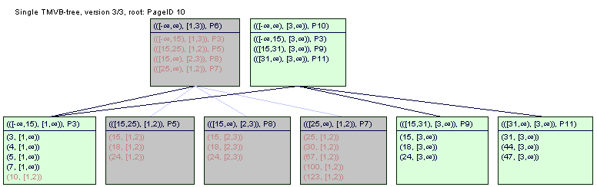
Screenshot of the Tree Visualizer program
For multiversion databases, the tree visualizer highlights the live pages and entries to separate them from old (killed) pages and entries. The user can also browse between versions to see what parts of the tree belong to what version. Furthermore, the visualizer can show a page map of the multiversion pages. This map draws all pages of a single level of the tree as a two-dimensional rectangles, using key ranges as the X-component and version ranges as the Y-component. With this map, the user can see how the pages have been split and merged during the history of the multiversion database.
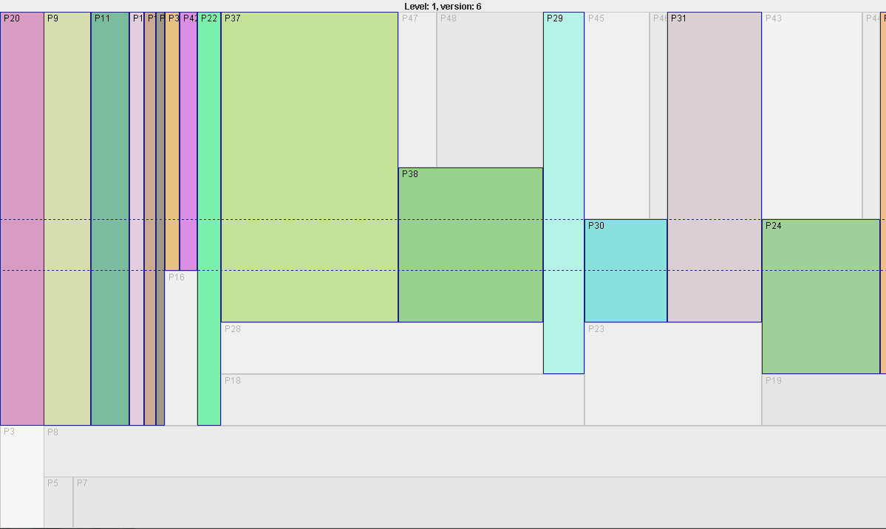
Screenshot of the multiversion page map with a single version highlighted
Main executable class is fi.hut.cs.treelib.gui.TreeVisualizer.

Tree console
There is also a console GUI for manually performing tree modifications and inspections. This tool is mainly meant for inspecting the contents of an existing database file. From the console application, the user can run various consistency checking and debugging operations (for example, for dumping page contents to manually browse the database). However, basic transaction actions are also available (queries, insertions and deletions).
For multidimensional trees, there is also a visualization tool that draws the contents of pages as two-dimensional rectangles. This tool works in such a way that the user manually adds pages to be drawn.
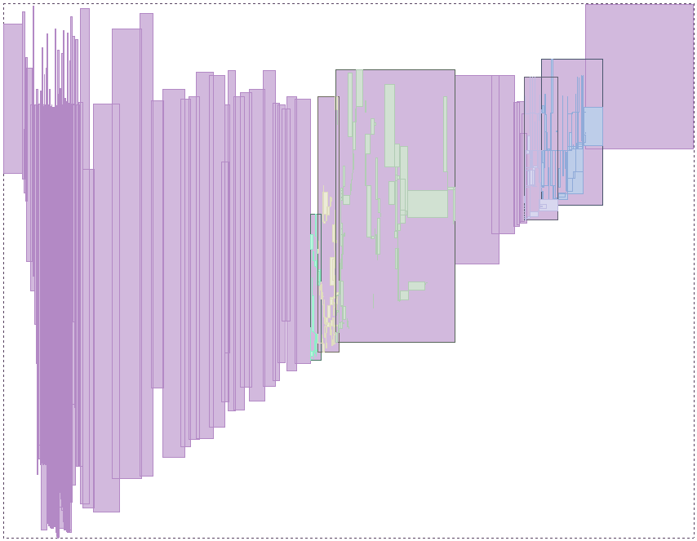
Screenshot of the multidimensional page visualization tool with a few pages drawn
Main executable class is fi.hut.cs.treelib.console.TreeConsole.

Operation executor
This tool is a batch runner tool for running queries with large data sets (for testing the performance of the different index structures). The operation executor can either be run by specifying an operation (insert, delete, exact-query, window-query) and a key file; or by specifying a transaction log file (a file that contains transaction action specifications).
The operation executor also supports bulk-loading for some databases. The operations is currently implemented for the following databases:
- R-tree (using the STR split algorithm, [Leutenegger 1997])
- Hilbert R-tree (entries are ordered, so this is a standard bulk-load operation)
- J-tree (entries are ordered, so this is a standard bulk-load operation)
- Packed J-tree (using the STR split algorithm, [Leutenegger 1997])
Main executable class is fi.hut.cs.treelib.operations.OperationExecutor.

Transaction log generator
This tool can be used to create randomized transaction logs that can be fed to the operation executor. The user can specify the range of keys to create, the size of MBRs (when creating multidimensional keys), the amount of operations to create, the frequency of different operations (how many inserts, deletes, and queries), and the amount of transactions to create.
This tool can be configured to track the entries that should be in the database, and thus the randomized deletion operations actually delete something from the database.
Main executable class is fi.hut.cs.treelib.data.TransactionLogGenerator.

References
- [Ang 1997] C.H. Ang and T.C. Tan. New linear splitting algorithm for R-trees. In Proceedings of the 5th International Symposium on Advances in Spatial Databases, pages 339–349, 1997.
- [Becker 1996] B. Becker, S. Gschwind, T. Ohler, B. Seeger and P. Widmayer. An Asymptotically optimal multiversion B-tree. The VLDB Journal, 5(4):264-275, 1996.
- [Beckmann 1990] N. Beckmann, H.-P. Krieger, R. Schneider and B. Seeger. The R*-tree: An efficient and robust access method for points and rectangles. In Proceedings of the ACM SIGMOD International Conference on Management of Data, pages 322–331, 1990.
- [Haapasalo 2009] T. Haapasalo, I. Jaluta, B. Seeger, S. Sippu, E. Soisalon-Soininen. Transactions on the multiversion B⁺-tree. In Proceedings of the International Conference on Extending Database Technologies, 2009.
- [Leutenegger 1997] S.T. Leutenegger, M.A. Lopez and J. Edgington. STR: a simple and efficient algorithm for R-tree packing. In Proceedings of the 13th International Conference on Data Engineering, pages 497–506, 1997.
- [Lomet 1989] D. Lomet, B. Salzberg. Access methods for multiversion data. In Proceedings of the 1989 ACM SIGMOD International Conference on Management of Data, pages 315–324, 1989.
- [Lomet 1990] D. Lomet, B. Salzberg. The performance of a multiversion access method. In Proceedings of the 1990 ACM SIGMOD international conference on Management of data, pages 353–363, 1990.

