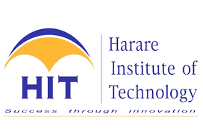

**LEARNMORE NDLOVU**

**INFORMATION TECHNOLOGY**

**H160170B**

**PLATFORM TECHNOLOGIES  
ASSIGNMENT 1**

1. Advantages and Disadvantages of each hardware virtualization technique. **[12]**

**Full Virtualization**

Full virtualization involves virtualizing the main physical server to support applications and software to operate in a much similar way on virtualized divisions. This creates an environment as if it is working on a unique server. Full virtualization technique enables the administrators to run unchanged and an entirely virtualized operating system.

Advantages

* Full virtualization technique grants the potential to combine existing systems on to the newer ones with increased efficiency and a well-organized hardware.
* Enables trimming down of the operating costs engaged in repairing and enhancing older systems.
* Power-pack less competent systems while reducing the physical space and augmenting the overall performance of the company.

Disadvantages

* Maintaining and troubleshooting the system is complex and require expert knowledge.
* Increases the security management burden as it requires additional security controls.
* If systems are combined onto a single physical computer, causes a larger impact when a security breach occurs.
* It has got easy attack vectors, if not carefully controlled or regulated since sharing of information is easy on virtualised systems.

**Operating System level Virtualization**

This model is specially intended to grant the necessary security and separation to run manifold applications and replications of the same operating system on the same server.  Operating system virtualization helps to create virtualized layer of software on the top of host operating system that resides above the hardware layer. Unlike other virtualization, they create an OS interfaces for applications to run, giving the feeling of a complete OS for the applications.

Advantages

* When compared with all the above mentioned techniques, OS level virtualization is considered to give the best performance and measurability.
* This technique is easy to control and comparatively uncomplicated to manage as everything can be administered from the host system.

Disadvantages

* They support only one operating system as base, so if that O/S goes down or is rebooted, they all go down.
* Containers are not great for permanent data storage as they are easy to destroy.
* Additional security concerns since containers share the same kernel

**Para-Virtualization**

Para-Virtualization runs modified versions of operating systems. Only the software and programs are carried out in a precise manner to work for their exclusive websites without executing any kind of hardware simulation. Using Para-Virtualization, the guest is very well aware of its environment as the para-virtualized OS is altered to be alert about its virtualization.

Advantages

* It allows running many operating systems on a single server.
* It augments the performance per server without the operating cost of a host operating system.
* Backups are easy, fast migrations, improved system utilization, server consolidation and power conservation
* Para virtualization can be deployed on hardware platforms that do not offer hardware-assisted virtualization.
* Low virtualization overhead.

Disadvantages

* It requires the modification of the OS.
* Creates a large dependency between the OS and hypervisor thus limiting further updates.
* It is difficult to predict performance gains as performance varies with workload.
* It requires modification of the guest operating system to execute and communicate with the hypervisor.
* The tight coupling between the OS and hypervisor creates a dependency that can potentially be broken with a hypervisor or OS update or upgrade.

**Virtual machines**

Virtual machines are popularly known as VMs, imitate certain factual or illusory hardware requiring the valid resources from the host, which is nothing but the actual machine operating the VMs. A virtual machine monitor (VMM) is used in certain cases where the CPU directives need extra privileges and may not be employed in user space.

Advantages

* This methodology benefits numerous system emulators who use it for running a random guest operating system without altering the guest OS.
* VMMs are used to examine the performed code and facilitate its secure running. For such varied benefits it is widely used by Microsoft Virtual Server, QEMU, Parallels, VirtualBox and many other VMware products.

Disadvantages:

* Requires big hard drive space and memory.
* Require expert users.
* Virtual machines are less efficient than real machines.

1. Discuss on the VMWare architecture. **[8]**

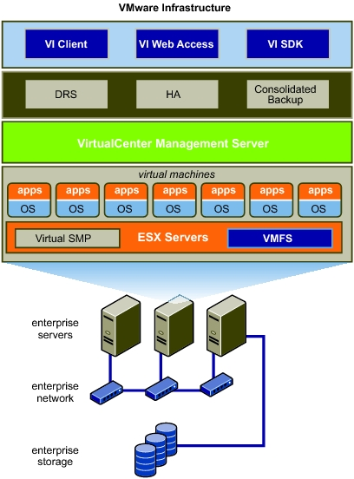Mware ESX Server: A production-proven virtualization layer run on physical servers that abstract processor, memory, storage and networking resources to be provisioned to multiple virtual machines.

VMware Virtual Machine File System (VMFS): A high-performance cluster file system for virtual machines.

VMware Virtual Symmetric Multi-Processing (SMP): Enables a single virtual machine to use multiple physical processors simultaneously.

VirtualCenter Management Server: The central point for configuring, provisioning and managing virtualized IT infrastructure.

Virtual Infrastructure Client (VI Client): An interface that allows administrators and users to connect remotely to the Virtual Center Management Server or individual ESX Server installations from any Windows PC.

Virtual Infrastructure Web Access: A Web interface for virtual machine management and remote consoles access.

VMware VMotion: Enables the live migration of running virtual machines from one physical server to another with zero downtime, continuous service availability and complete transaction integrity.

VMware High Availability (HA): Provides easy-to-use, cost effective high availability for applications running in virtual machines. In the event of server failure, affected virtual machines are automatically restarted on other production servers that have spare capacity.

VMware Distributed Resource Scheduler (DRS): Intelligently allocates and balances computing capacity dynamically across collections of hardware resources for virtual machines.

VMware Consolidated Backup: Provides an easy to use, centralized facility for agent-free backup of virtual machines. It simplifies backup administration and reduces the load on ESX Server installations.

VMware Infrastructure SDK: Provides a standard interface for VMware and third-party solutions to access VMware

Infrastructure