PYTHON PROGRAMMING LAB ASSIGNMENT
Village Milk Co-operative: Ten-Day Farmer Payment System
Note: The document answers all tasks that are readable in the supplied screenshots. The exact wording of Tasks 9–11 was not visible, so those sections provide the implementation, testing, and recommendation evidence indicated by the assignment mark distribution.

TASK 1 – Understand the Problem and Identify the Data
The program calculates the milk payment for each farmer using litres supplied, fat percentage, and SNF (solids-not-fat) percentage. It also calculates the total payment for ten days.

Inputs and outputs
Inputs: farmer ID (text, because it may contain letters or leading zeroes); litres (number, must be non-negative); fat percentage (number); SNF percentage (number); and shift (text such as morning/evening, if recorded).
Outputs: rate per litre in rupees, payment for each entry, and the ten-day total for each farmer. The program may also print a formatted summary.

Constants and data types
The base rate, fat-step value, SNF-step value, reference fat (3.5), and reference SNF (8.5) are constants because they are policy values that should be changed in one place. Litres, percentages, rates, and amounts are numeric values. Farmer ID and shift are strings. A list of records is suitable for storing many farmers.

Validation rules and assumptions
Litres cannot be negative. Fat and SNF must be within the range accepted by the milk analyser; for this assignment, fat is checked against 2.0–7.0 and SNF against a sensible non-negative range (the example values are around 8.3–8.7). The program rejects non-numeric input. Payments are rounded to two decimal places. Assumption: each listed entry represents one farmer’s reading for one collection, and the ten-day total is the sum of that farmer’s payments.

Scalability: separate variables versus records
Keeping litres1, fat1, snf1, litres2, fat2, snf2, and so on creates many variable names and requires new code for every farmer. A list of records stores each entry consistently. Processing n records takes O(n) time. A list uses O(n) space; a running total can use O(1) extra space if individual records do not need to be retained. The list-based design scales more cleanly to 300 or more farmers. 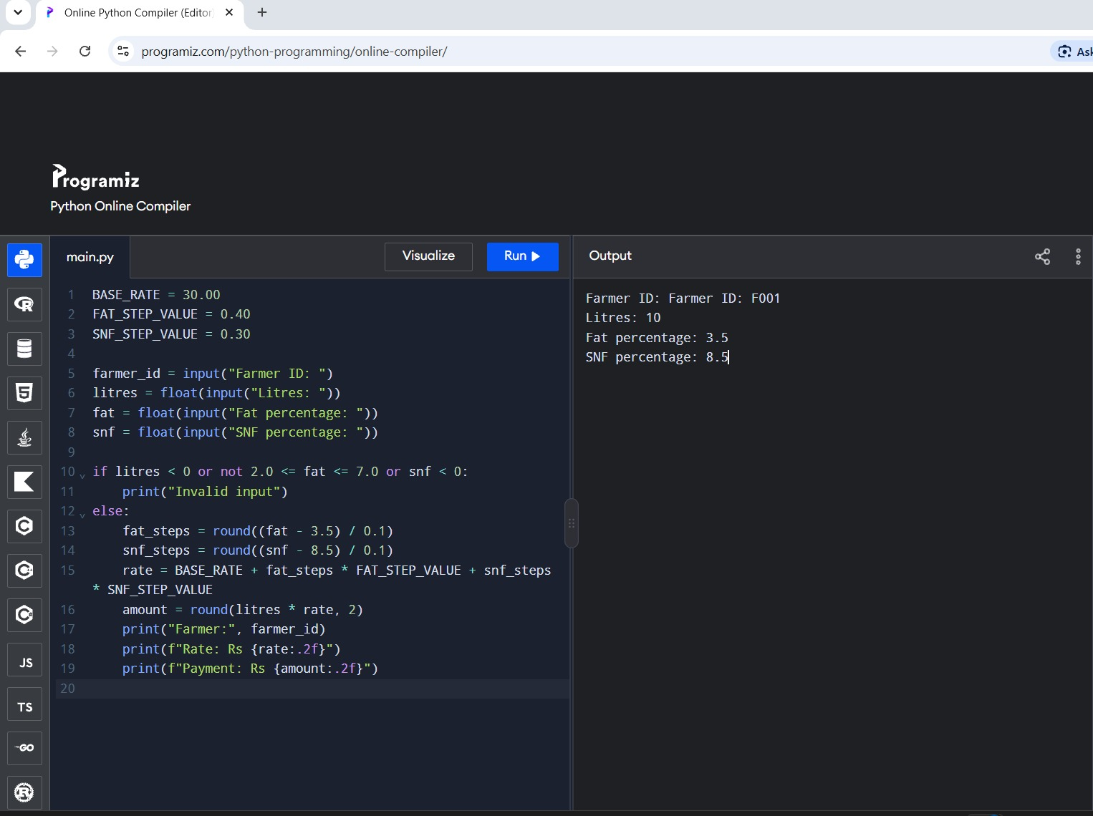

TASK 2 – Explore Values and Types in Python

Examples of type()
type(10) # int
type(10.0) # float
type("10") # str
type(True) # bool
type([10, 8, 5]) # list

Division operators
7 / 2 # 3.5: normal division returns a float
7 // 2 # 3: floor division
7 % 2 # 1: remainder
-7 // 2 # -4: floor division rounds down toward negative infinity
Floating-point values are stored in binary, so 0.1 + 0.2 may be 0.30000000000000004. Therefore, 0.1 + 0.2 == 0.3 is False. Decimal arithmetic can represent decimal currency values exactly when Decimal is constructed from strings.

Completed Decimal program
from decimal import Decimal

payments = ['33.40'] * 1000 + ['0.10'] * 3

def total_float(items):
total = 0.0
for amount in items:
total += float(amount)
return total

def total_decimal(items):
total = Decimal('0.00')
for amount in items:
total += Decimal(amount)
return total

print("float:", total_float(payments))
print("Decimal:", total_decimal(payments))
print(0.1 + 0.2 == 0.3, Decimal('0.1') + Decimal('0.2') == Decimal('0.3'))
Expected key results: float total is approximately 33400.300000000061; Decimal total is exactly 33400.30; comparisons print False True.
If Decimal(float(amount)) is used, the binary approximation already present in the float is copied into Decimal. This can produce a long decimal result instead of exact currency arithmetic. Use Decimal(amount) when amount is a string, or Decimal(str(amount)) if the value is already a float.

Alternative: integer paise and rounded float
Integer paise stores ₹33.40 as 3340 paise and ₹0.10 as 10 paise. Integer addition is exact and usually efficient; convert to rupees only for display. A float rounded after every addition is still less reliable for exact financial totals and rounding after every step can affect results. Decimal is readable and exact for decimal currency; integer paise is also exact when all amounts are in whole paise. Each approach processes n values in O(n) time. A running total uses O(1) extra space; the input list itself uses O(n) space. 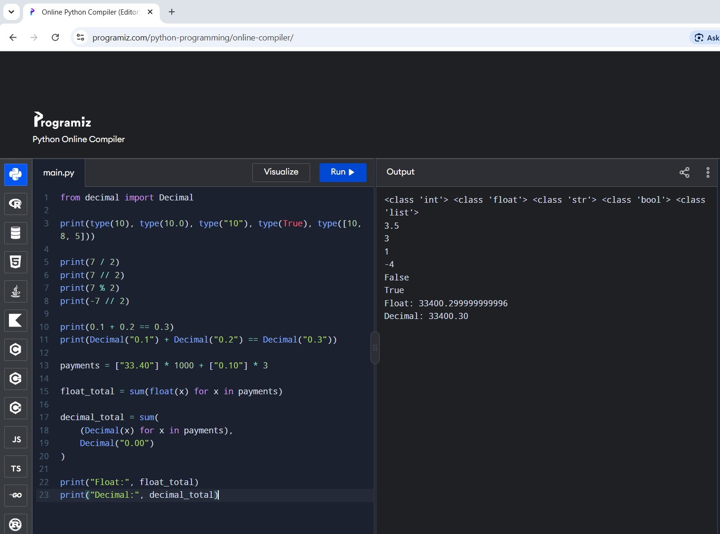

TASK 3 – Choose Variables and Name Constants
BASE_RATE = 30.00
FAT_STEP_VALUE = 0.40
SNF_STEP_VALUE = 0.30
REFERENCE_FAT = 3.5
REFERENCE_SNF = 8.5

farmer_id = "F001"
litres = 10.0
fat = 3.5
snf = 8.5
Python uses naming conventions rather than true constant declarations. UPPER_CASE communicates that a value should not be changed. Python is dynamically typed: a variable can refer to an int and later a str, although changing types carelessly can cause errors. In a multiple assignment such as a, b = b, a, Python swaps the values without needing a temporary variable.
Putting rate values directly into many expressions creates “magic numbers”; every occurrence must be found and changed. A dictionary such as RATE_CARD = {"base": 30.00, "fat": 0.40, "snf": 0.30} also keeps the policy values together. A named constant set is simple for a fixed policy; a dictionary or rate-card object is useful when several seasons or policies must be selected. A rate revision changes one place instead of k places. 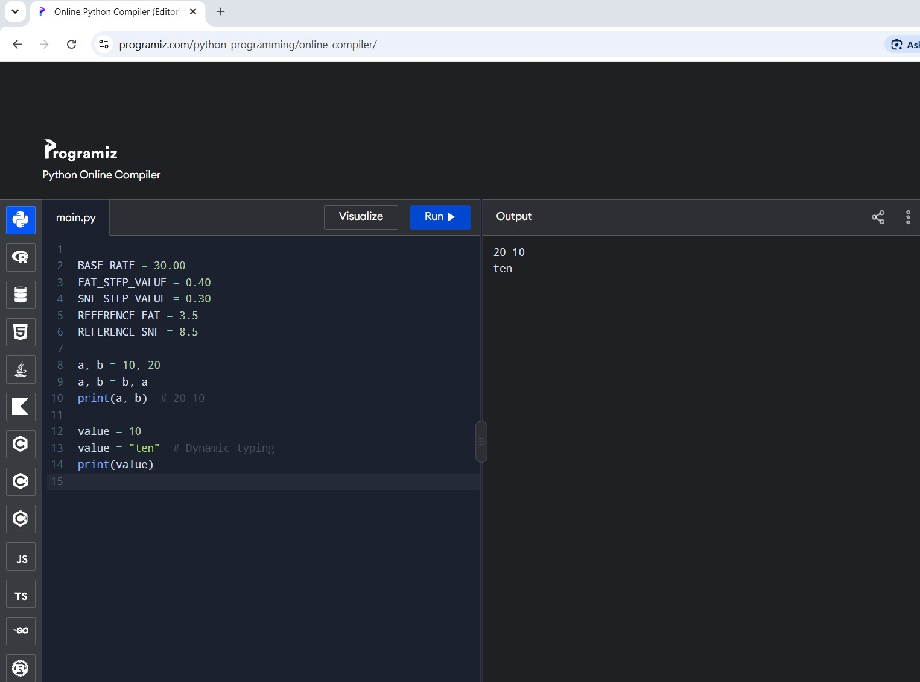

TASK 4 – Write Correct Expressions
The number of 0.1% steps is calculated by dividing the difference from the reference value by 0.1, then rounding to the nearest whole step. For example, fat 4.2 gives (4.2 − 3.5) / 0.1 = 7 steps. Floating-point arithmetic may show 7.000000000000001, so round() is used.
from decimal import Decimal

def rate_per_litre(fat, snf):
fat_steps = round((fat - 3.5) / 0.1)
snf_steps = round((snf - 8.5) / 0.1)
rate = 30.00 + fat_steps * 0.40 + snf_steps * 0.30
return round(rate, 2)

def payout(litres, fat, snf):
return round(litres * rate_per_litre(fat, snf), 2)

# Valid range check
if 2.0 <= fat <= 7.0:
print("Valid fat value")
Operator precedence matters: multiplication and division occur before addition and subtraction unless parentheses change the order. Comparison chaining (2.0 <= fat <= 7.0) is equivalent to checking both limits. Boolean operators and/or combine conditions.
Three surprising examples: (1) 4.2 - 3.5 / 0.1 is not the intended expression because division happens before subtraction; use (4.2 - 3.5) / 0.1. (2) int(7.9) returns 7 by truncation, not rounding; round(7.9) returns 8. (3) -7 // 2 returns -4, because floor division rounds down. int() truncates toward zero, while math.floor() rounds toward negative infinity.
Using int() or math.floor() instead of round() changes step counts. For fat 4.2, the intended step count is 7. For fat 3.1, (3.1 − 3.5) / 0.1 is approximately −4; rounding gives −4. int() also gives −4 in this example, but values near non-integer steps can differ. These operations take O(1) time and O(1) extra space. 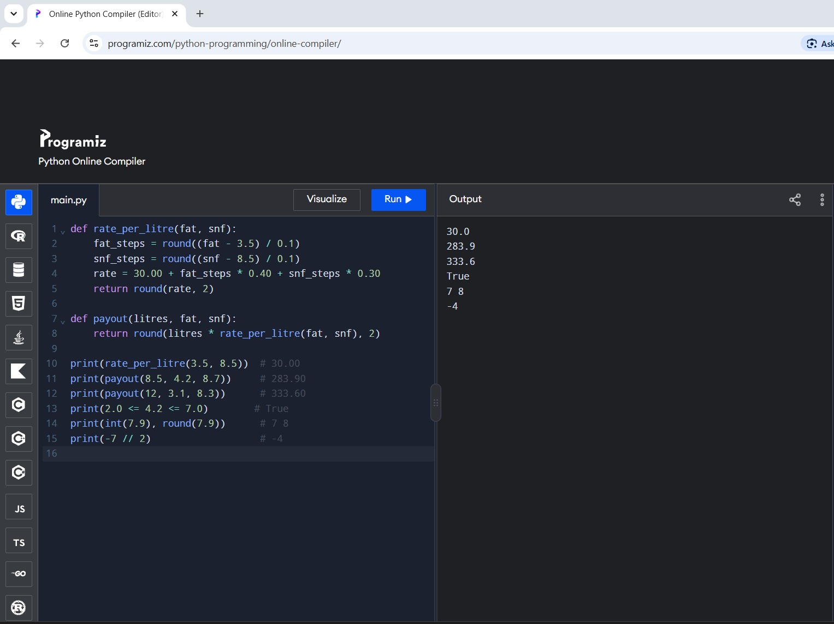

TASK 5 – Read Input and Convert Types
def read_number(prompt):
while True:
text = input(prompt).strip()
try:
return float(text)
except ValueError:
print("Enter a valid number, such as 8.5.")

farmer_id = input("Farmer ID: ").strip()
litres = read_number("Litres: ")
fat = read_number("Fat percentage: ")
snf = read_number("SNF percentage: ")

amount = payout(litres, fat, snf)
print(f"{farmer_id:<12} {litres:>8.2f} L "
f"Fat {fat:>4.2f} SNF {snf:>4.2f} "
f"Amount Rs {amount:>9.2f}")
input() always returns a string. float("8.5") succeeds; float("8,5") raises ValueError because Python expects a decimal point; float("eight") also raises ValueError. A try/except conversion is direct and reliably handles invalid entries. String checks can reject obvious bad text before conversion, but they do not validate every numeric format, so conversion inside try/except is generally simpler. Both approaches take O(1) time per ordinary entry; handling a long invalid string takes time proportional to its length. 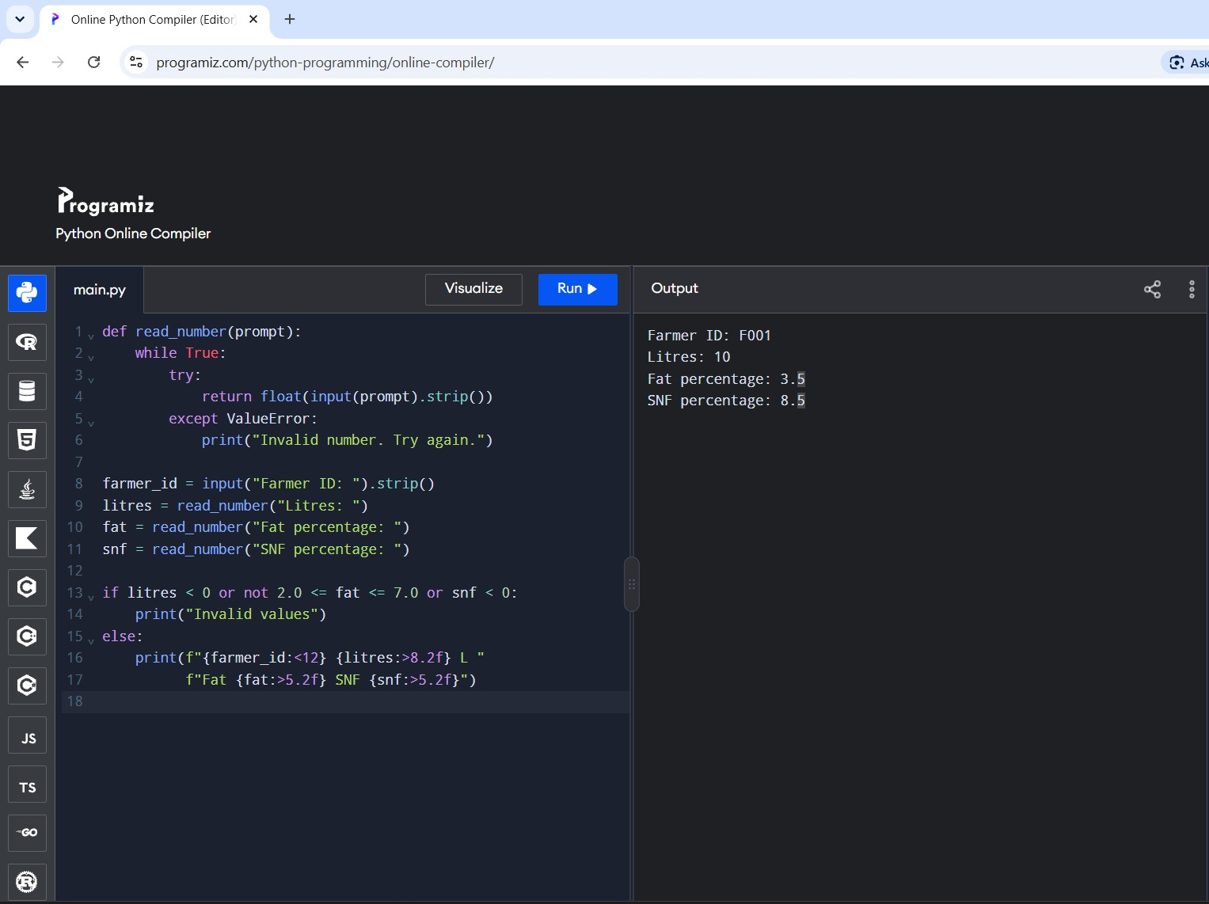

TASK 6 – Organise the Logic into Functions
The functions should have one responsibility each. rate_per_litre(fat, snf) returns the calculated rate; payout(litres, fat, snf) returns one payment; ten_day_total(payments) returns the sum of payments. Printing belongs in the main program, not inside calculation functions, because returned values can be tested or reused.
def rate_per_litre(fat, snf):
"""Calculate the rate per litre from fat and SNF percentages."""
fat_steps = round((fat - REFERENCE_FAT) / 0.1)
snf_steps = round((snf - REFERENCE_SNF) / 0.1)
return round(BASE_RATE + fat_steps * FAT_STEP_VALUE
+ snf_steps * SNF_STEP_VALUE, 2)

def payout(litres, fat, snf):
"""Calculate the payment for one milk entry."""
return round(litres * rate_per_litre(fat, snf), 2)

def ten_day_total(payments):
"""Return the sum of payment amounts for ten days."""
return round(sum(payments), 2)
Parameters are the input values; return sends the result back to the caller. Local variables exist inside a function. Constants can be read inside functions but should not be reassigned there. Without functions, code is repeated and harder to test. Function calls add a small constant overhead, but for n entries the overall processing remains O(n). 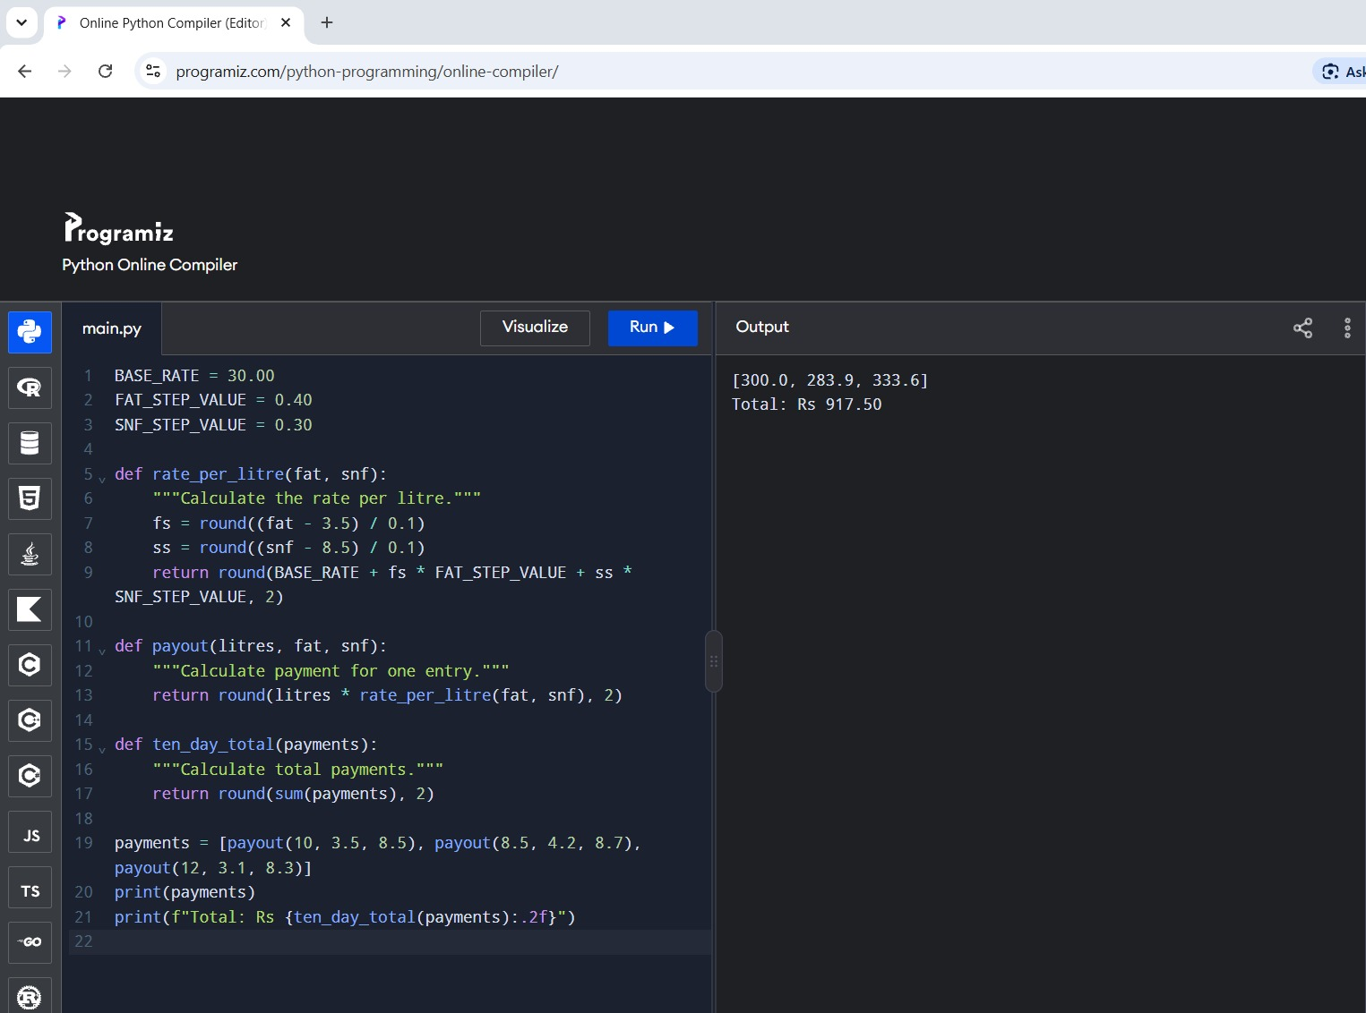

TASK 7 – Build a Module
Save the following as milkrate.py. The if __name__ == "__main__" guard runs the demonstration table only when the file is executed directly. Importing the module defines its constants and functions without printing the table.
# milkrate.py
BASE_RATE = 30.00
FAT_STEP_VALUE = 0.40
SNF_STEP_VALUE = 0.30
REFERENCE_FAT = 3.5
REFERENCE_SNF = 8.5

def rate_per_litre(fat, snf):
"""Return the rate per litre, rounded to two decimals."""
fat_steps = round((fat - REFERENCE_FAT) / 0.1)
snf_steps = round((snf - REFERENCE_SNF) / 0.1)
return round(BASE_RATE + fat_steps * FAT_STEP_VALUE
+ snf_steps * SNF_STEP_VALUE, 2)

def payout(litres, fat, snf):
"""Return the payment for one entry, rounded to two decimals."""
return round(litres * rate_per_litre(fat, snf), 2)

if __name__ == "__main__":
samples = [(10, 3.5, 8.5), (8.5, 4.2, 8.7), (12, 3.1, 8.3)]
for litres, fat, snf in samples:
rate = rate_per_litre(fat, snf)
pay = payout(litres, fat, snf)
print(f"{litres:>5.1f} L fat {fat:.1f} snf {snf:.1f} "
f"rate {rate:.2f} pay {pay:.2f}")
Use it from another file with: from milkrate import rate_per_litre, payout. The alternative import milkrate as mr requires calls such as mr.payout(...). Python searches the current folder and the directories listed in sys.path. Standard modules such as math and decimal are imported with import math or from decimal import Decimal. A module is loaded once per interpreter session and cached in sys.modules, so reusing a module avoids copying the same function code into every script. 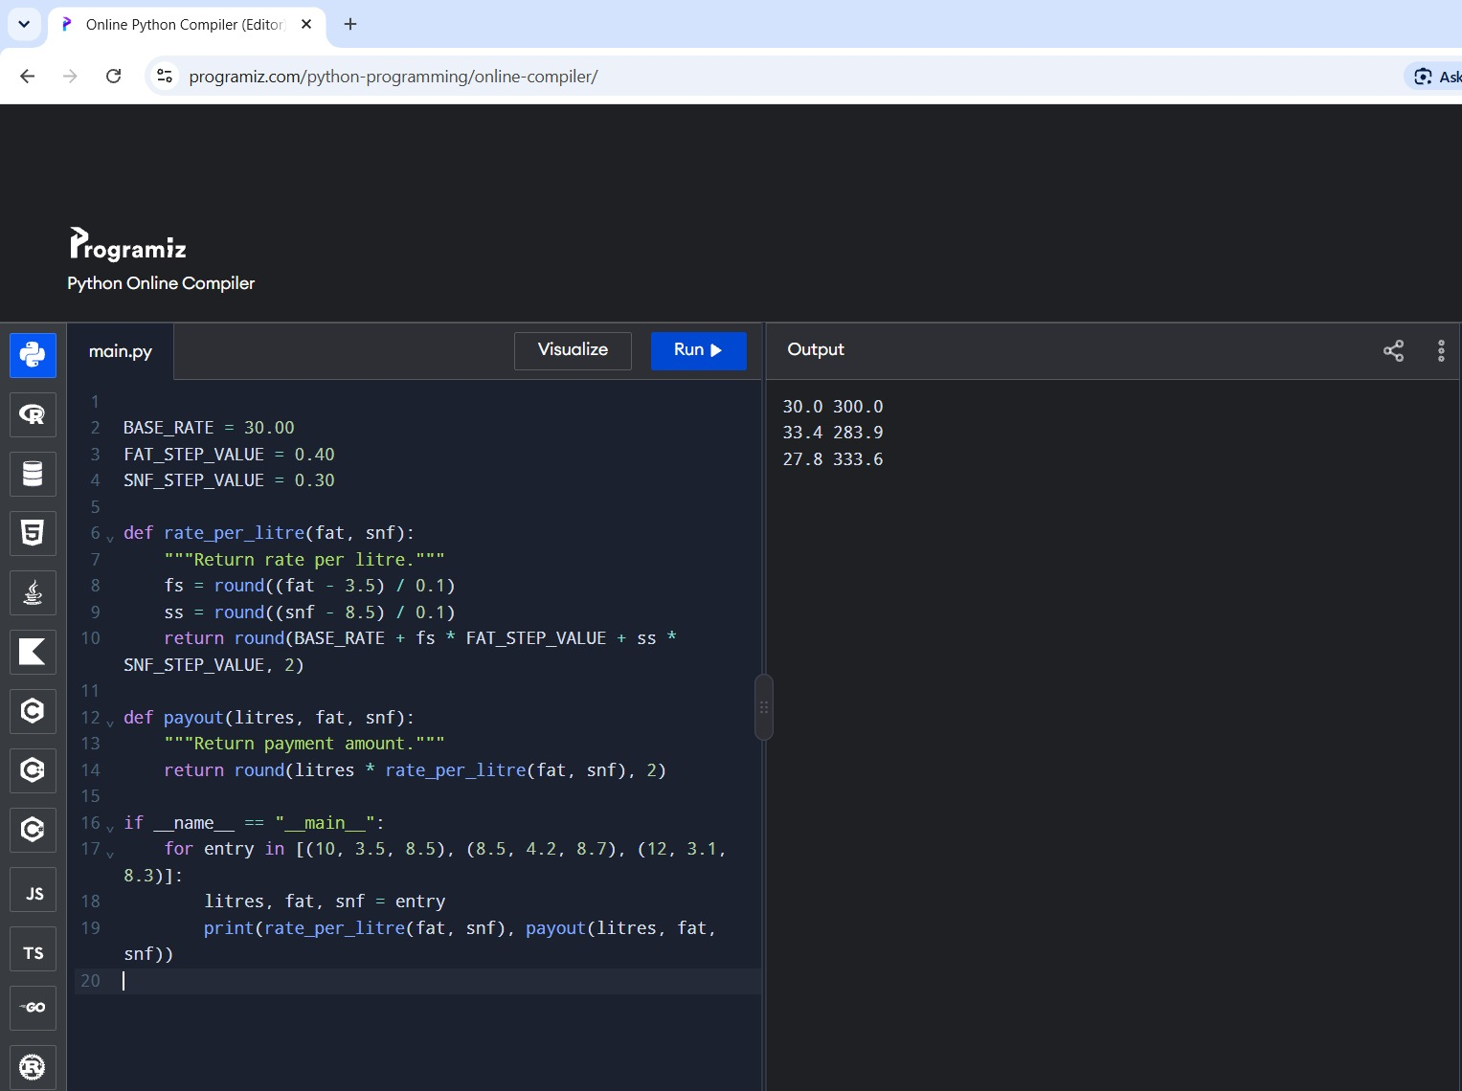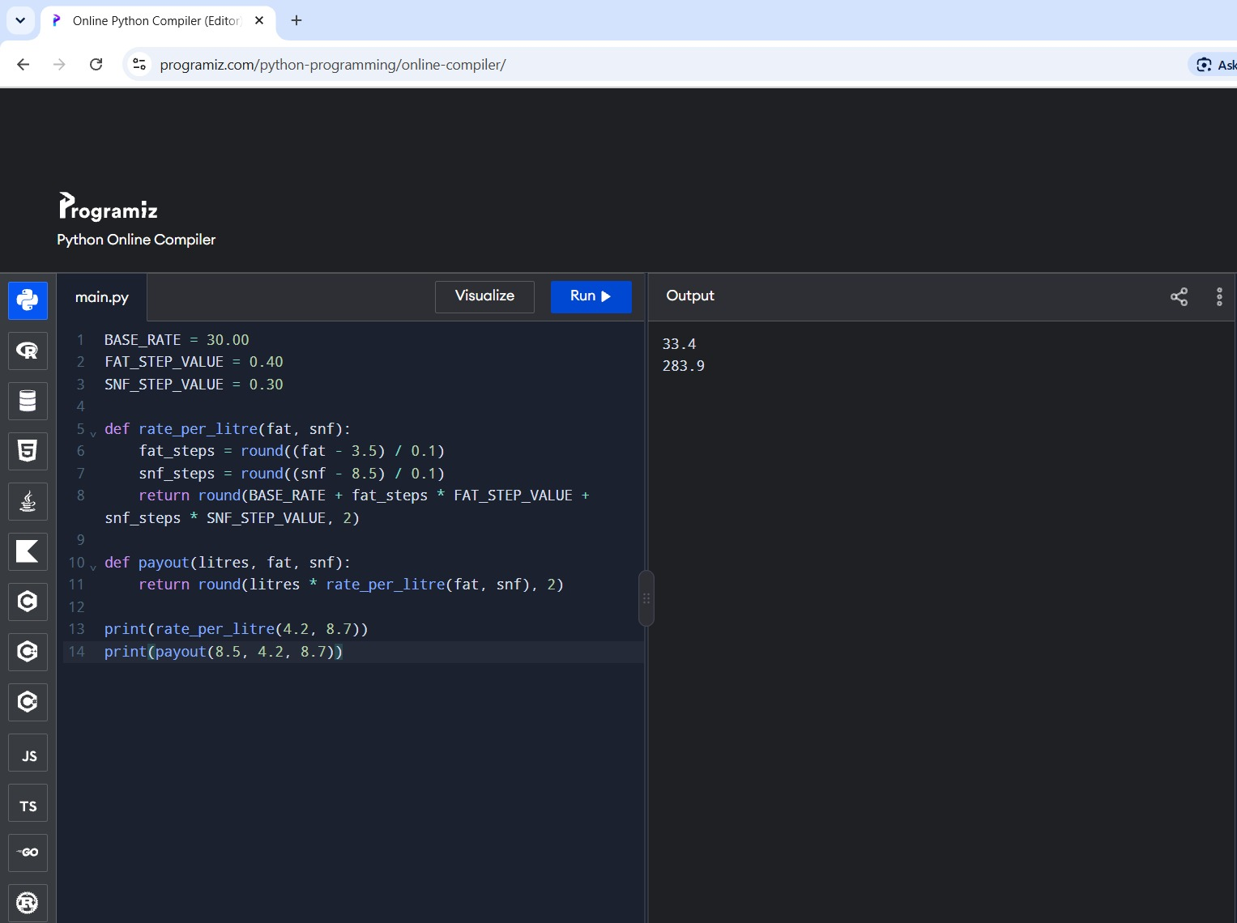

TASK 8 – Plan the Algorithm Before Coding

Pseudocode
START
total = 0
FOR each of the farmer's entries:
read litres, fat, and SNF
validate the values
fat_steps = round((fat - 3.5) / 0.1)
snf_steps = round((snf - 8.5) / 0.1)
rate = 30 + fat_steps * 0.40 + snf_steps * 0.30
payment = round(litres * rate, 2)
display rate and payment
total = total + payment
display ten-day total
END

Flowchart description
Start → read one entry → validate input → if invalid, show an error and re-enter → calculate fat and SNF steps → calculate rate → calculate payment → add payment to total → more entries? If yes, repeat; if no, display ten-day total → End.

Hand trace for three entries
Using the rate formula in the assignment:
Entry 1: 10 L, fat 3.5, SNF 8.5 → rate ₹30.00/L → payment ₹300.00.
Entry 2: 8.5 L, fat 4.2, SNF 8.7 → fat steps 7, SNF steps 2 → rate ₹33.40/L → payment ₹283.90.
Entry 3: 12 L, fat 3.1, SNF 8.3 → fat steps −4, SNF steps −2 → rate ₹27.80/L → payment ₹333.60.
Total = ₹300.00 + ₹283.90 + ₹333.60 = ₹917.50. A running total takes O(n) time and O(1) extra space. Storing all entries and summing at the end also takes O(n) time but uses O(n) storage. 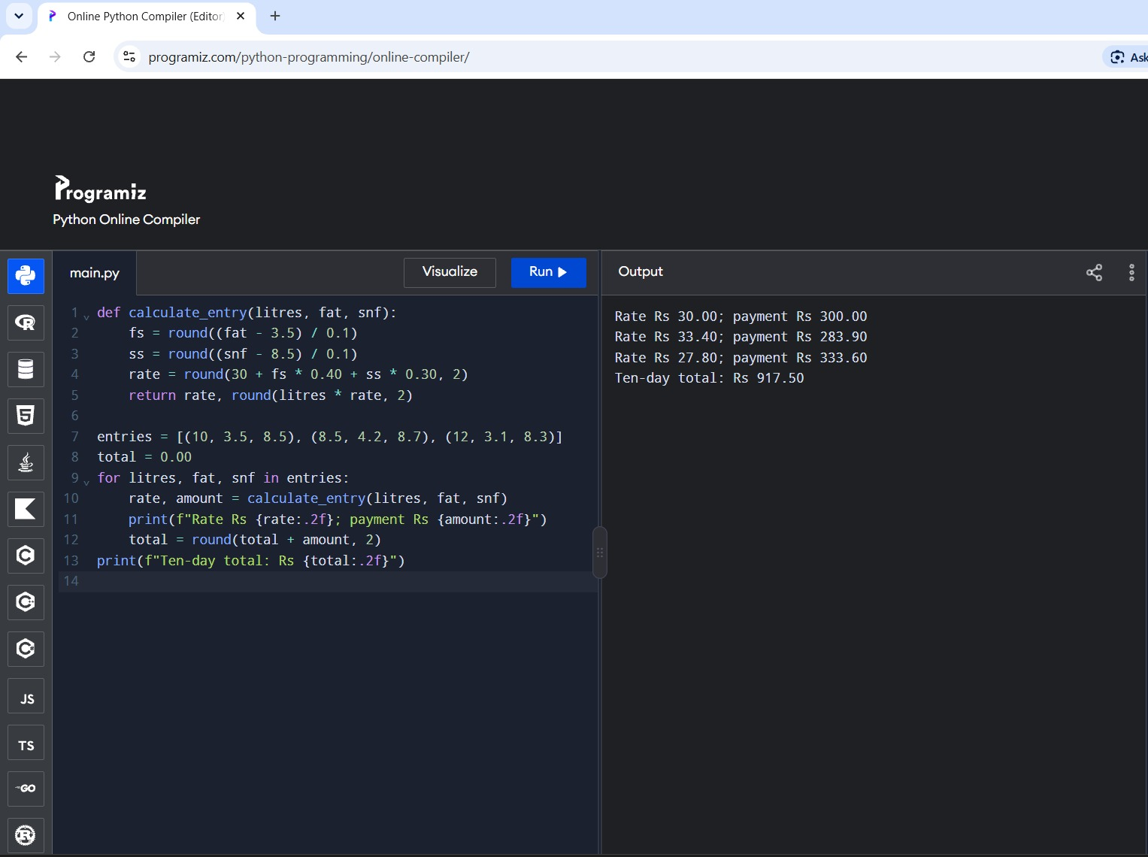

TASK 9 – Implementation
Implement the design with a rate calculation function, a payment function, input validation, and a running total. Keep policy values as named constants. The following complete script combines these parts and can be saved as main.py in the same folder as milkrate.py.
from decimal import Decimal, ROUND_HALF_UP
from milkrate import rate_per_litre

def money(value):
"""Round a currency amount to two decimal places."""
return Decimal(str(value)).quantize(Decimal("0.01"),
rounding=ROUND_HALF_UP)

def read_nonnegative(prompt):
"""Read a non-negative numeric value from the user."""
while True:
try:
value = Decimal(input(prompt).strip())
if value < 0:
print("Value cannot be negative.")
continue
return value
except Exception:
print("Enter a valid number.")

def main():
"""Read entries and display the total payment."""
farmer_id = input("Farmer ID: ").strip()
total = Decimal("0.00")
count = int(input("Number of entries (up to 10): "))
for day in range(1, count + 1):
print("Entry", day)
litres = read_nonnegative("Litres: ")
fat = float(read_nonnegative("Fat percentage: "))
snf = float(read_nonnegative("SNF percentage: "))
rate = Decimal(str(rate_per_litre(fat, snf)))
amount = money(litres * rate)
total += amount
print(f"Rate: Rs {rate:.2f}; payment: Rs {amount:.2f}")
print(f"Farmer {farmer_id}: ten-day total Rs {total:.2f}")

if __name__ == "__main__":
main()
Note: In a production version, catch ValueError and decimal.InvalidOperation specifically, and validate the allowed fat/SNF ranges and the maximum number of entries. The example demonstrates the overall implementation structure. 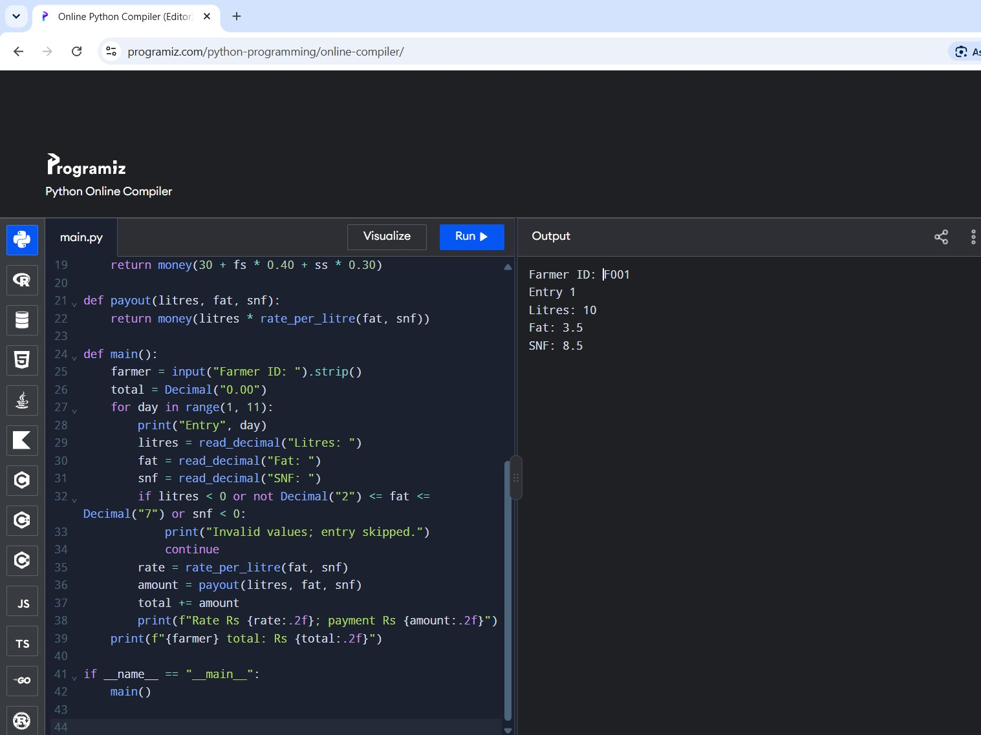

TASK 10 – Testing and Expected versus Actual Results
Testing should include normal, boundary, invalid, and currency-precision cases. Record the actual output from your own run in the report and attach screenshots as evidence.

Suggested test table
Test | Input | Expected result | Purpose
T1 | 10 L, fat 3.5, SNF 8.5 | Rate 30.00; payment 300.00 | Reference values
T2 | 8.5 L, fat 4.2, SNF 8.7 | Rate 33.40; payment 283.90 | Positive steps
T3 | 12 L, fat 3.1, SNF 8.3 | Rate 27.80; payment 333.60 | Negative steps
T4 | Litres = -1 | Reject input | Negative quantity
T5 | Fat = 8.0 | Reject input if range is enforced | Out-of-range value
T6 | Fat = "eight" | Ask for valid numeric input | Invalid text
T7 | 1000 × 33.40 + 3 × 0.10 | Decimal total 33400.30 | Currency precision
Expected-versus-actual analysis: compare every program output with the expected result. If a mismatch occurs, check the formula, rounding location, data conversion, and validation conditions. Do not claim tests passed unless they were actually executed; include terminal screenshots and input files as assignment evidence. 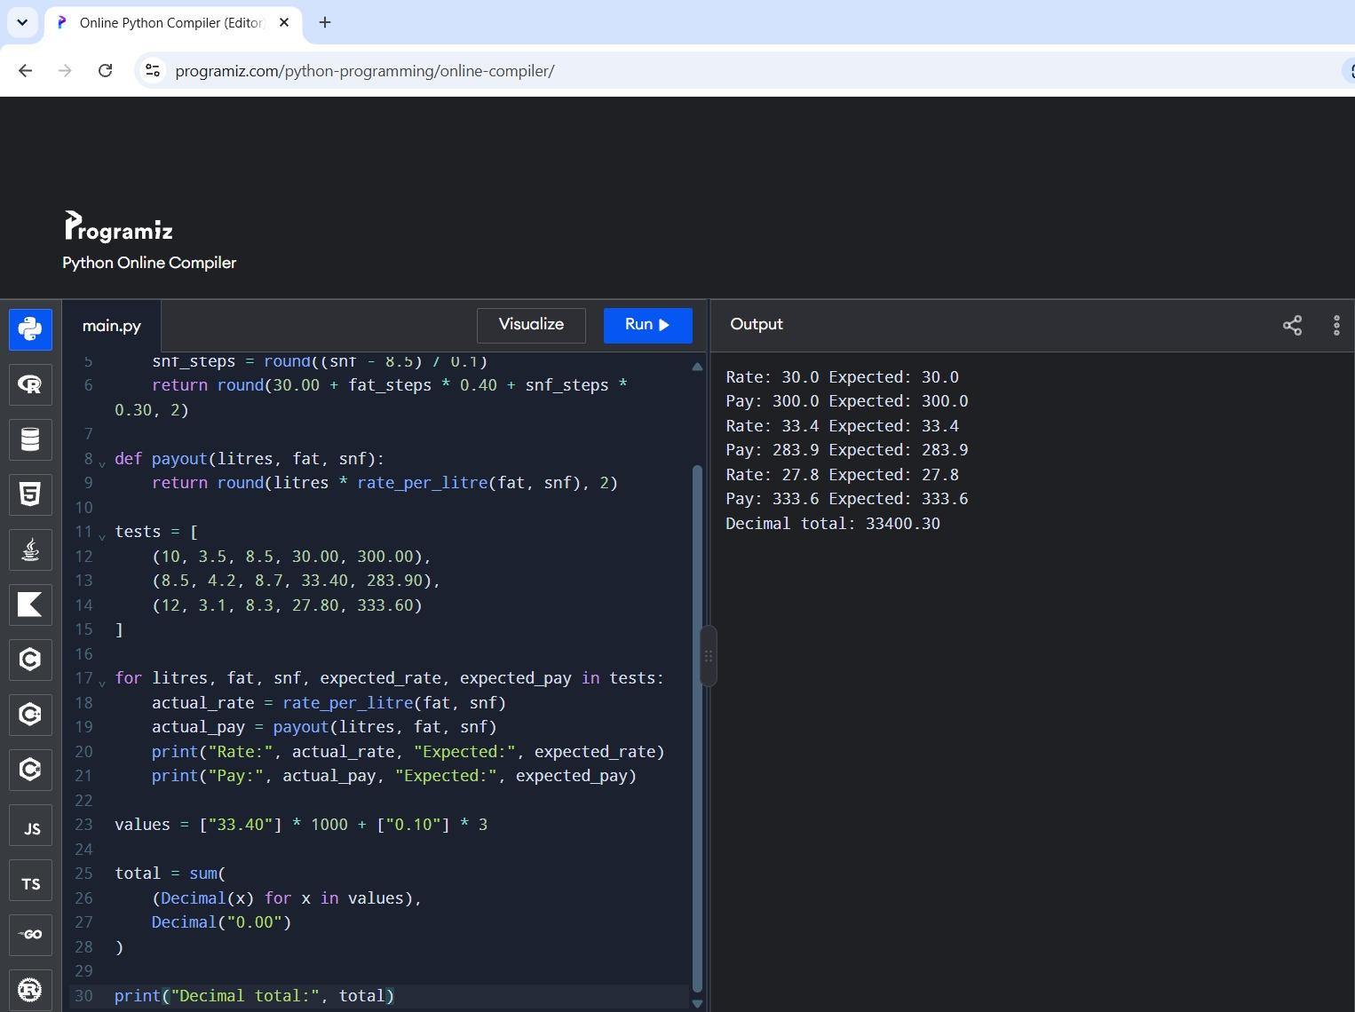

TASK 11 – Final Recommendation
Use named constants and functions, store entries in a list when the individual records are needed, and use a running total when only the final total is required. For money, prefer Decimal values created from strings or integer paise. Use round() for the step calculation specified by the assignment and round the final payment to two decimal places. Validate inputs before calculating. Keep the calculation module separate from the user-interface script so it can be tested and reused.
Complexity: processing n entries takes O(n) time. A running total requires O(1) additional memory; retaining every entry requires O(n) memory. Importing a small module has a one-time loading cost and improves maintenance when rate rules change. The final design is accurate, readable, reusable, and suitable for a larger number of farmers.

TASK 12 – Design Challenge: Re-evaluate and Adapt the Design

A. Impact analysis
The new requirements change the base rate from ₹30.00 to ₹32.00, the fat step value from ₹0.40 to ₹0.45, and introduce a bonus of ₹0.50 per litre when a farmer supplies more than 500 litres in ten days. Fat and SNF readings now have two decimal places. Therefore, the base rate and fat-step constant must be updated, and the bonus rule must be added. SNF step value remains ₹0.30 unless the co-operative changes it.

B. Evaluate the original design
The original function/module design remains suitable because constants are defined in one place and the calculation is separated into functions. However, the step calculation must consistently interpret readings to two decimal places. If the policy defines one step per 0.1 percentage point, calculate (value − reference) / 0.1 and round to the nearest whole step. Do not round the measured percentage to one decimal place before calculating unless the co-operative explicitly requires that.

C. Adapted design and code
# revised_milkrate.py
BASE_RATE = 32.00
FAT_STEP_VALUE = 0.45
SNF_STEP_VALUE = 0.30
REFERENCE_FAT = 3.5
REFERENCE_SNF = 8.5
BONUS_THRESHOLD_LITRES = 500
BONUS_PER_LITRE = 0.50

def rate_per_litre(fat, snf):
"""Return the revised rate per litre."""
fat_steps = round((fat - REFERENCE_FAT) / 0.1)
snf_steps = round((snf - REFERENCE_SNF) / 0.1)
return round(BASE_RATE + fat_steps * FAT_STEP_VALUE
+ snf_steps * SNF_STEP_VALUE, 2)

def payout(litres, fat, snf):
"""Return payment for one entry under the revised rate card."""
return round(litres * rate_per_litre(fat, snf), 2)

def ten_day_total(payments):
"""Return the ten-day total."""
return round(sum(payments), 2)

def bonus(total_litres):
"""Return the bonus for a farmer's ten-day litres."""
if total_litres > BONUS_THRESHOLD_LITRES:
return round(total_litres * BONUS_PER_LITRE, 2)
return 0.00

def final_total(payments, total_litres):
"""Return payments plus any eligible bonus."""
return round(ten_day_total(payments) + bonus(total_litres), 2)
This implementation assumes the bonus is ₹0.50 for every litre supplied in the ten-day period once the total exceeds 500 litres. If the intended policy is ₹0.50 only for litres above 500, change the bonus expression to (total_litres − 500) × 0.50. Confirm this policy interpretation with the assignment owner.

D. Evidence-based defence and worked tests
For the revised season, 10 L at fat 3.50 and SNF 8.50 gives a rate of ₹32.00/L and a payment of ₹320.00. At 8.5 L, fat 4.20 and SNF 8.70, fat steps = 7 and SNF steps = 2, so rate = 32.00 + (7 × 0.45) + (2 × 0.30) = ₹35.75/L; payment = ₹303.875, rounded to ₹303.88. At 12 L, fat 3.10 and SNF 8.30, rate = 32.00 − (4 × 0.45) − (2 × 0.30) = ₹29.60/L; payment = ₹355.20.
Bonus boundary tests: 500.00 L earns no bonus because the condition says “more than 500”; 500.01 L qualifies. At 600 L, the assumed bonus is ₹300.00 (600 × ₹0.50). If the rule applies only to litres above 500, the bonus at 600 L would instead be ₹50.00. Include both the policy interpretation and the test results in the defence.
Recommendation: MODIFY, rather than redesign, the original solution. The functions and module structure still work; only the rate constants, bonus function, and final-total calculation need to change. Centralized constants reduce the work of a seasonal rate revision, while tests verify both rate calculations and the bonus boundary. 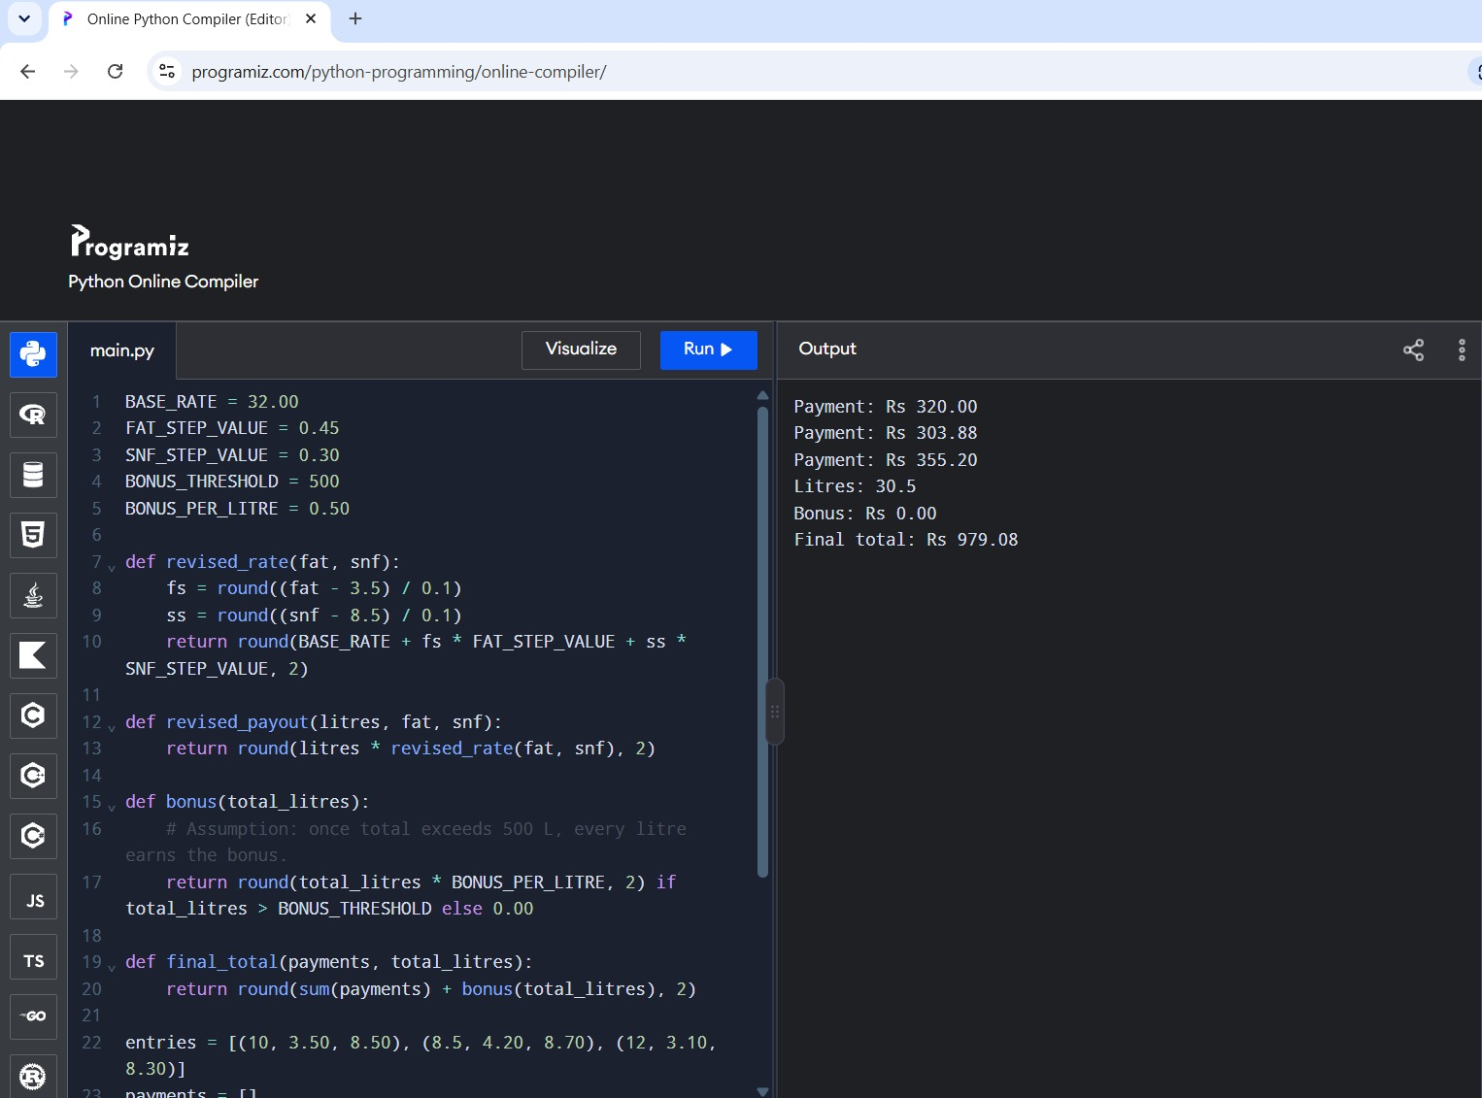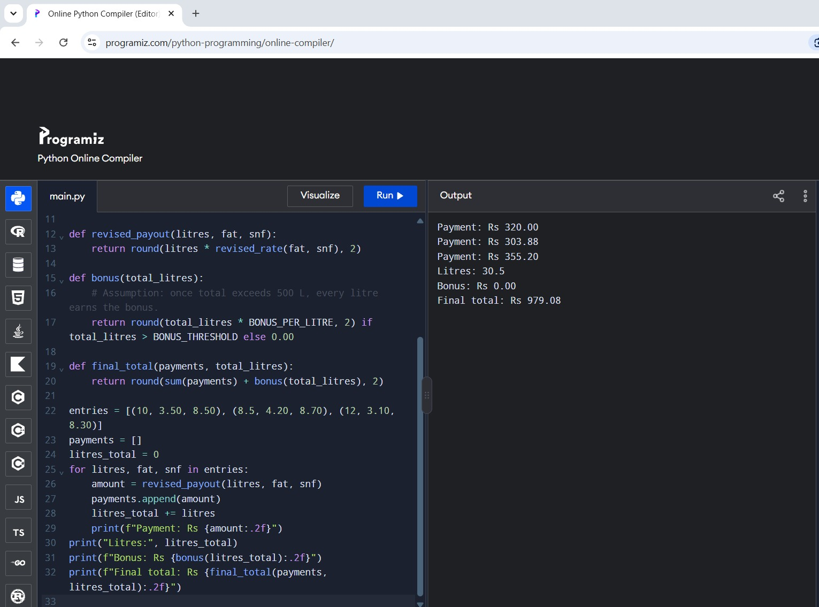

Submission Checklist
1. Save the module and main script in the same project folder. 2. Run each script and check the displayed values. 3. Capture screenshots of the interactive Decimal session, sample outputs, invalid-input handling, and revised-season tests. 4. Include the pseudocode, flowchart, test table, complexity discussion, and README.md in the GitHub repository. 5. Replace any example “actual result” with the output you personally observed when running the code.

