PYTHON PROGRAMMING
ASSIGNMENT 3 – CO3
Lists • Tuples • Dictionaries • Sets • List Comprehensions

Student Details | Information
Name | S.THABASHYA SRI
Register Number | 192520015
Department | B.Tech BIOINFORMATICS
Course Code | CSA08 – Python Programming
Assignment | Assignment 3 – CO3
GitHub Repository Link

CO3 Coverage: Implement Python data structures such as lists, tuples, dictionaries and sets to store, access and manipulate unstructured data effectively, including operations, slicing, mutability, copying and list comprehension.
Nature of Assignment: Individual | Total Marks: 50 | Duration: 1 Week

Declaration
I declare that I have completed the programs and explanations in this assignment and will execute, test and explain the work during verification.
Student Signature: __________________________

General Notes and Execution Instructions
This report follows the seven questions and the terminology used in the supplied CO3 assignment sheet. The programs are written for Python 3. The code blocks are independent programs unless stated otherwise.
- Create a GitHub repository named CSA08-<RegisterNumber>-Assignment3.
- Create separate folders such as Task01 through Task07. Save each program as a .py file.
- Run each program, capture the actual output, and commit the work progressively.
- Add a README.md with student details, Python version, run commands, libraries and a short result note for each task.
- Timing values depend on the computer, Python version and system load. Do not report invented timings; run the benchmark code and enter the measured values in the tables provided.

How complexity is described
Notation | Meaning
O(1) | Constant-time average operation; does not grow with input size.
O(n) | Work grows approximately in proportion to n.
O(n log n) | Typical comparison-sort growth.
O(n²) | Work grows approximately with the square of n.

Theoretical complexity describes how the algorithm scales. Actual execution time must be measured on the machine used for submission.

Task 1 – Lists and Slicing: Daily Rainfall Records (6 Marks)
Bloom’s Level: K3 – Apply

1. Aim and problem understanding
The rainfall station stores one rainfall value in millimetres for each day of a 365-day year. A list is suitable because it preserves the order of days, supports indexing and slicing, and can be updated when a reading is corrected.

2. Algorithm / pseudocode
INPUT: readings, a list of daily rainfall values
FOR start = 0, 7, 14, ... while start < length(readings):
weekly_total = sum(readings[start : start + 7])
store weekly_total
FOR each day index i from 0 to n - 7:
calculate average of readings[i : i + 7]
dry_days = all day positions where rainfall equals 0
wettest_week = position of maximum weekly total
driest_week = position of minimum weekly total

3. Python implementation
import random
random.seed(42)
readings = [round(random.uniform(0, 35), 1) for _ in range(365)]
# Weekly totals (the final group may contain fewer than 7 days)
weekly_totals = [
sum(readings[i:i + 7])
for i in range(0, len(readings), 7)
]
wettest_index = weekly_totals.index(max(weekly_totals))
driest_index = weekly_totals.index(min(weekly_totals))
# A 7-day moving average; no result is produced if fewer than 7 days exist
moving_average = [
round(sum(readings[i:i + 7]) / 7, 2)
for i in range(len(readings) - 6)
]
dry_days = [i + 1 for i, value in enumerate(readings) if value == 0]
print("Number of readings:", len(readings))
print("Number of weekly totals:", len(weekly_totals))
print("Wettest week:", wettest_index + 1, "Total:", weekly_totals[wettest_index])
print("Driest week:", driest_index + 1, "Total:", weekly_totals[driest_index])
print("Number of 7-day averages:", len(moving_average))
print("Dry days:", dry_days)

4. Meaning of the required slices
Expression | Result
readings[7:14] | Values at indexes 7 through 13; the second seven-day block.
readings[-7:] | The last seven readings. If fewer than seven exist, it returns all available values.
readings[::7] | Every seventh value, starting at index 0; it is not a list of weekly totals.

5. List operations and complexity
Operation | Typical cost | Explanation
append(x) | O(1) amortized | Adds an item at the end; occasional resizing can cost O(n).
insert(i, x) | O(n) | Later elements may need to shift to make room.
pop() | O(1) | Removes the final item.
pop(i) | O(n) | Elements after index i may shift.
sort() | O(n log n) | Python uses Timsort; sorting changes the list order.

A list is appropriate for sequential daily records. If a late reading must be inserted at its date, list.insert() can take O(n) because later elements shift. For a small fixed year, this is acceptable. For frequent date-based insertion, a date-keyed database or dictionary combined with sorted reporting may be more suitable.

6. Naive and running-sum moving averages
For n readings and a window of 7, the naive method adds up to 7 values for each of n−6 windows: 7(n−6) additions, which is O(7n) and therefore O(n) when the window size is fixed. A running-sum method calculates the first window once, then subtracts the outgoing value and adds the incoming value for each next window. It uses about 7 + 2(n−7) additions/subtractions and is O(n).
def moving_average_naive(values, window=7):
if len(values) < window:
return []
return [sum(values[i:i + window]) / window
for i in range(len(values) - window + 1)]
def moving_average_running(values, window=7):
if len(values) < window:
return []
current = sum(values[:window])
result = [current / window]
for i in range(window, len(values)):
current += values[i] - values[i - window]
result.append(current / window)
return result
# Edge-case checks
print(moving_average_naive([]))
print(moving_average_running([2, 4, 6]))
assert moving_average_naive(readings) == moving_average_running(readings)

7. Experimental investigation
Run this benchmark on the computer used for the assignment. It measures both implementations for the required input sizes. Record the printed seconds in the table; timings are machine-dependent.
import random
import time
def benchmark(n):
data = [random.random() * 40 for _ in range(n)]
start = time.perf_counter()
a = moving_average_naive(data)
naive_time = time.perf_counter() - start
start = time.perf_counter()
b = moving_average_running(data)
running_time = time.perf_counter() - start
assert all(abs(x-y) < 1e-9 for x, y in zip(a, b))
print(n, "naive:", round(naive_time, 6),
"running:", round(running_time, 6))
for size in (365, 36500, 365000):
benchmark(size)
Readings | Naive time (seconds) – fill after run | Running-sum time (seconds) – fill after run
365 | ____________ | ____________
36,500 | ____________ | ____________
365,000 | ____________ | ____________

8. Alternative concept: deque or dictionary
A collections.deque(maxlen=7) can hold only the current seven readings. When a new reading arrives, the oldest one is automatically removed. Maintain a running total: add the new reading, subtract the value that leaves the window, and calculate the average. Each update is O(1), so processing n readings is O(n), while the window uses O(7) = O(1) extra space. A dictionary keyed by date provides average O(1) lookup or update by date, but it does not automatically maintain chronological order; sorting dates for a report costs O(n log n).
from collections import deque
window = deque(maxlen=7)
for value in readings:
window.append(value)
if len(window) == 7:
print("Current average:", sum(window) / 7)
Evaluation: the list is simplest for a complete ordered year. A deque is efficient for streaming recent readings. A date-keyed dictionary is useful when corrections and lookups by date are frequent. 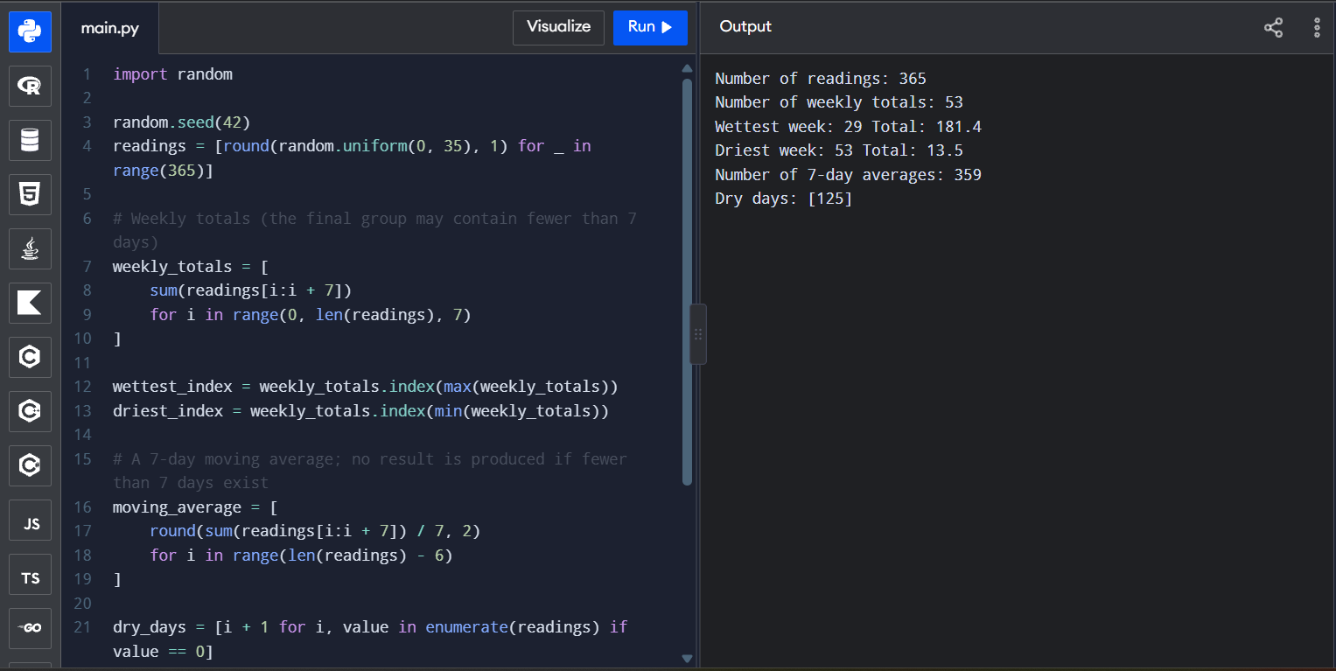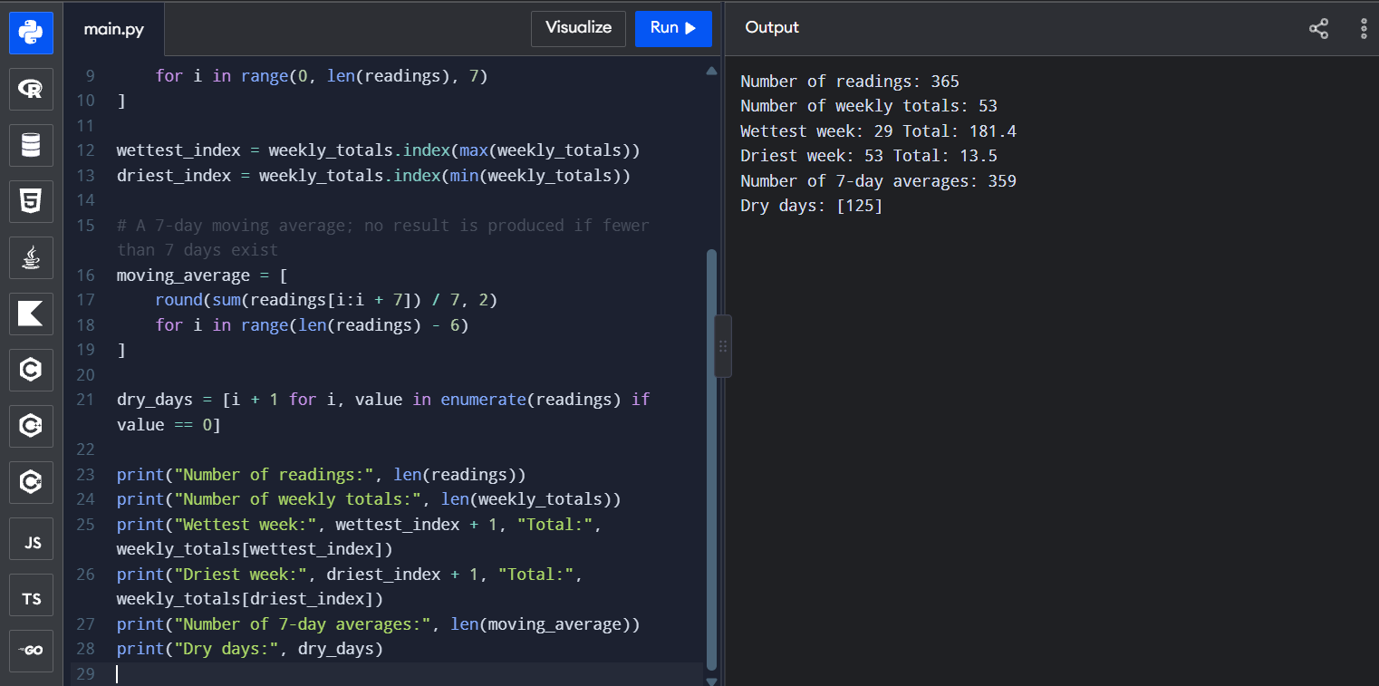

Task 2 – Tuples, Mutability and Copying (7 Marks)
Bloom’s Level: K4 – Analyse

1. Aim
GPS coordinates are naturally represented as tuples because a latitude-longitude pair is a fixed record. Tuples can be dictionary keys when all their elements are hashable. A zone grid must use independent row lists to prevent accidental aliasing.

2. Complete the given code – corrected program
import copy
import sys
import time
rows, cols = 3, 4
bad = [[0] * cols] * rows
bad[0][1] = 7
# TODO 1: each row is a different list
good = [[0 for _ in range(cols)] for _ in range(rows)]
good[0][1] = 7
print("bad :", bad)
print("good:", good)
print(bad[0] is bad[1], good[0] is good[1])
stops = {
(13.0827, 80.2707): "Chennai Central",
(13.0418, 80.2341): "T. Nagar"
}
print(stops[(13.0418, 80.2341)])
Expected output:
bad : [[0, 7, 0, 0], [0, 7, 0, 0], [0, 7, 0, 0]]
good: [[0, 7, 0, 0], [0, 0, 0, 0], [0, 0, 0, 0]]
True False
T. Nagar

3. Tuples as keys; list key error
A tuple is immutable, so its hash remains stable when used as a dictionary key, provided all elements inside it are hashable. A list is mutable and unhashable, so it cannot be used as a dictionary key.
try:
locations = {}
locations[[13.0418, 80.2341]] = "T. Nagar"
except TypeError as error:
print(type(error).__name__ + ":", error)

4. Aliasing and memory diagrams
Bad grid: all three outer-list positions refer to the same inner list.
bad ──> [ row_ref, row_ref, row_ref ]
│
▼
[0, 7, 0, 0]
Correct grid: each outer-list position refers to a separate inner list.
good ──> [ row_A, row_B, row_C ]
│ │ │
▼ ▼ ▼
[0,7,0,0][0,0,0,0][0,0,0,0]

5. Shallow copy and deep copy
original = [[1, 2], [3, 4]]
alias = original
shallow_a = copy.copy(original)
shallow_b = original[:]
deep = copy.deepcopy(original)
print(alias is original) # True
print(shallow_a is original) # False
print(shallow_a[0] is original[0]) # True
print(deep[0] is original[0]) # False
original[0][0] = 99
print(shallow_a) # nested list is shared
print(deep) # nested list is independent
An alias is another reference to the same object. A shallow copy creates a new outer container but retains references to nested objects. It is enough when the elements are immutable or shared nested objects are intentionally retained. A deep copy recursively copies nested objects and is needed when independent nested data is required.
A function that mutates a list argument changes the caller’s list because both names refer to the same list object. Rebinding the local parameter to a new list does not replace the caller’s reference.

6. Tuple unpacking and mutable object inside a tuple
stop = (13.0827, 80.2707)
latitude, longitude = stop
print(latitude, longitude)
for latitude, longitude in [(13.0827, 80.2707), (13.0418, 80.2341)]:
print("Lat:", latitude, "Lon:", longitude)
record = ("bus stop", [10, 20])
record[1].append(30)
print(record) # tuple structure is fixed, but its contained list can mutate
Immutability protects the tuple’s structure and prevents reassignment of its elements. It does not make mutable objects stored inside the tuple immutable.

7. Experimental investigation
import sys, timeit
values = list(range(1_000_000))
tuple_values = tuple(values)
print("List container bytes:", sys.getsizeof(values))
print("Tuple container bytes:", sys.getsizeof(tuple_values))
list_create = timeit.timeit("list(range(10000))", number=100)
tuple_create = timeit.timeit("tuple(range(10000))", number=100)
list_index = timeit.timeit("values[5000]", globals={"values": values}, number=1_000_000)
tuple_index = timeit.timeit("values[5000]", globals={"values": tuple_values}, number=1_000_000)
print("Create list:", list_create)
print("Create tuple:", tuple_create)
print("Index list:", list_index)
print("Index tuple:", tuple_index)
sys.getsizeof() reports the container’s shallow size, not the complete memory of every referenced integer object. Both list and tuple indexing are O(1). The exact memory and time values depend on the Python build and machine.

8. Alternative concept: sparse dictionary grid
rows, cols = 3, 4
# Only non-empty zones are stored
passengers = {(0, 1): 7, (2, 3): 4}
passengers[(1, 2)] = passengers.get((1, 2), 0) + 5
print(passengers.get((0, 1), 0))
A full list-of-lists grid uses O(rows × cols) space and gives O(1) indexing. A dictionary keyed by (row, col) has average O(1) lookup, but uses space proportional to the number of non-empty zones. The dictionary is preferable when the grid is very large and mostly empty; a list grid is simpler when most zones contain data.

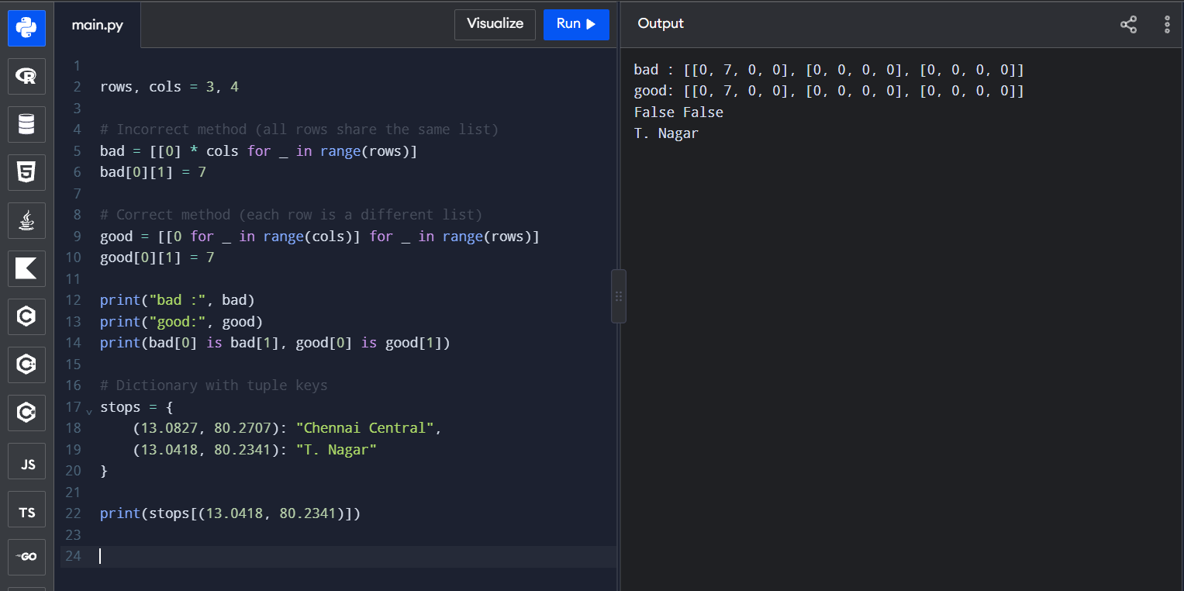Task 3 – Dictionaries: Farmer Helpline Complaint Analysis (7 Marks)
Bloom’s Level: K4 – Analyse

1. Aim
The program counts meaningful words in complaints, groups complaints by district and identifies the most frequent words. A dictionary maps each word to its count; a set stores stop words for fast membership checks.

2. Complete the given code
calls = [
"seeds not received seeds delayed",
"fertiliser price high",
"seeds price high subsidy not received",
]
STOP = {"not", "high"}
def frequencies(texts, stop):
counts = {}
for text in texts:
for word in text.lower().split():
if word not in stop:
counts[word] = counts.get(word, 0) + 1
return counts
def top(counts, k):
return sorted(counts.items(), key=lambda item: (-item[1], item[0]))[:k]
print(top(frequencies(calls, STOP), 3))
Expected output: [('seeds', 3), ('price', 2), ('received', 2)]
Price appears before received because both have a count of two. The required tie-break rule sorts words alphabetically, and 'price' comes before 'received'.

3. Improved complaint processing
import re
from collections import Counter, defaultdict
def clean_words(text):
# Keep alphabetic words and convert them to lowercase
return re.findall(r"[a-z]+", text.lower())
def analyse_complaints(records, stop_words):
counts = {}
by_district = defaultdict(list)
by_crop = defaultdict(list)
for record in records:
complaint = record["text"]
district = record["district"]
crop = record["crop"]
by_district[district].append(complaint)
by_crop[crop].append(complaint)
for word in clean_words(complaint):
if word not in stop_words:
counts[word] = counts.get(word, 0) + 1
return counts, dict(by_district), dict(by_crop)
records = [
{"district": "Chennai", "crop": "rice", "text": "Seeds not received!"},
{"district": "Madurai", "crop": "cotton", "text": "Fertiliser price high."},
{"district": "Chennai", "crop": "rice", "text": "Seeds delayed; seeds needed."},
]
stop_words = {"not", "high", "the", "is"}
counts, district_groups, crop_groups = analyse_complaints(records, stop_words)
print("Word counts:", counts)
print("Top words:", sorted(counts.items(), key=lambda x: (-x[1], x[0]))[:5])
print("By district:", district_groups)
print("By crop:", crop_groups)

4. Dictionary concepts
- A dictionary stores key-value pairs. A hash function maps a key to a hash value, which helps Python locate the key’s storage position.
- Dictionary lookup, insertion and update are O(1) on average; collisions and unusual worst cases can make an operation slower.
- Python dictionaries preserve insertion order in Python 3.7 and later.
- keys() returns a dynamic view of keys; values() returns a view of values; items() returns a view of key-value pairs.
- get(key, default) reads a value safely and supplies a default when the key is absent. setdefault(key, default) inserts the default if the key is absent and returns the stored value.

5. Dictionary vs list.count() vs Counter
Method | Approximate time | Reason
Dictionary loop | O(n) average | Each word updates one dictionary entry.
list.count() for each distinct word | O(n × d) | The full word list is scanned for each of d distinct words.
collections.Counter | O(n) average | Purpose-built frequency counter.

from collections import Counter
words = [word for text in calls for word in clean_words(text)]
counter_result = Counter(w for w in words if w not in STOP)
print(counter_result.most_common(3))

6. Experimental benchmark
import random, time
from collections import Counter
vocabulary = ["seed", "rice", "price", "water", "crop", "farmer", "soil"]
def make_texts(n):
return [" ".join(random.choices(vocabulary, k=12)) for _ in range(n)]
def dict_count(texts):
result = {}
for text in texts:
for word in text.split():
result[word] = result.get(word, 0) + 1
return result
def list_count_method(texts):
words = [w for text in texts for w in text.split()]
return {w: words.count(w) for w in set(words)}
for n in (1000, 10000, 100000):
sample = make_texts(n)
for label, function in (("dict", dict_count),
("list.count", list_count_method),
("Counter", lambda x: Counter(w for t in x for w in t.split()))):
start = time.perf_counter()
function(sample)
print(n, label, round(time.perf_counter() - start, 6))
Complaints | Dictionary time | list.count time | Counter time
1,000 | ________ | ________ | ________
10,000 | ________ | ________ | ________
100,000 | ________ | ________ | ________

7. Edge cases and engineering decision
Empty text produces no words and therefore does not change the counts. Converting text to lowercase combines 'SEEDS' and 'seeds'. The regular expression removes punctuation so 'seed,' is counted as 'seed'. For 100,000 complaints per day, I would deploy a dictionary loop or Counter because both process the words in approximately linear time. list.count() repeatedly scans the data and becomes inefficient as the number of distinct words grows.
Alternative: Counter can replace the manual dictionary update. A dictionary/list approach uses O(d) frequency storage, where d is the number of distinct words. The flattened word list uses O(n) additional space if retained. 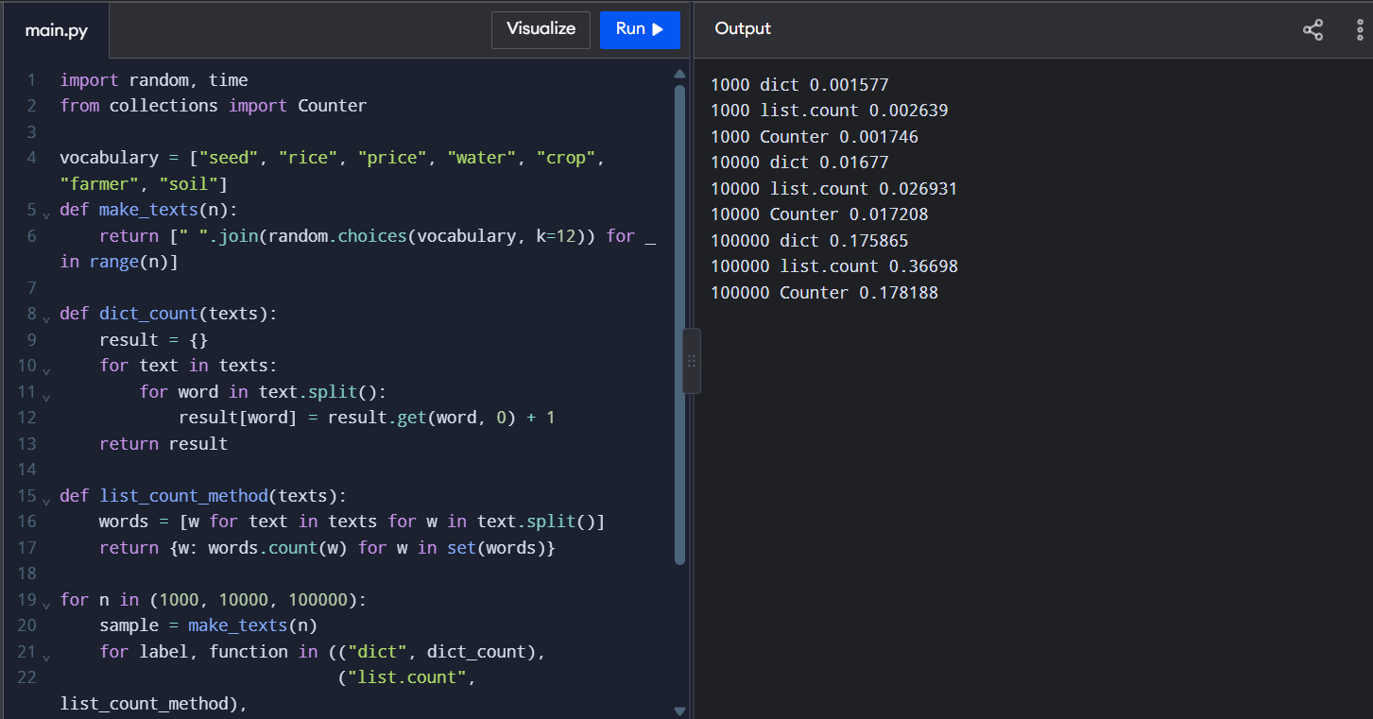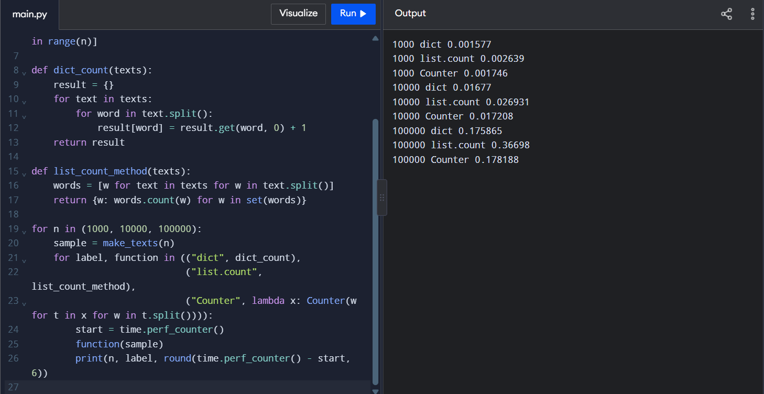

Task 4 – Sets: Elective Registration Clash Detection (7 Marks)
Bloom’s Level: K4 – Analyse

1. Aim and set operations
Each elective is represented by a set of register numbers. Sets automatically remove duplicate registrations and support union, intersection, difference and symmetric difference.

2. Complete the given code using set operators
ai_elective = {"192311001", "192311004", "192311007", "192311009"}
iot_elective = {"192311002", "192311004", "192311009", "192311010"}
all_students = {f"1923110{i:02d}" for i in range(1, 11)}
both = ai_elective & iot_elective
exactly_one = ai_elective ^ iot_elective
neither = all_students - (ai_elective | iot_elective)
print("clash :", sorted(both))
print("exactly one:", sorted(exactly_one))
print("neither :", sorted(neither))
Expected output:
clash : ['192311004', '192311009']
exactly one: ['192311001', '192311002', '192311007', '192311010']
neither : ['192311003', '192311005', '192311006', '192311008']

3. Rewrite using set methods
both_method = ai_elective.intersection(iot_elective)
exactly_one_method = ai_elective.symmetric_difference(iot_elective)
registered = ai_elective.union(iot_elective)
neither_method = all_students.difference(registered)
assert both == both_method
assert exactly_one == exactly_one_method
assert neither == neither_method

4. Venn diagram explanation
Let A be the AI elective and B be the IoT elective.
- A ∩ B (intersection): the overlapping region; students registered for both electives.
- A △ B (symmetric difference): the two non-overlapping regions; students registered for exactly one elective.
- U − (A ∪ B) (neither): the part of the universe outside both circles; students registered for neither elective.
- A ∪ B (union): everyone registered in at least one of the two electives.

5. Why sets are useful
- Sets automatically keep only unique elements, so repeated register numbers are removed.
- Membership testing is O(1) on average for a set because it uses hashing; a list membership test is O(n) because items may be checked one by one.
- Lists are mutable and unhashable, so they cannot be elements of a set. Tuples can be set elements if all their contents are hashable.
- Set iteration order is not a reporting order; use sorted() to create a predictable report.

6. Experimental investigation
import random, time
for n in (10_000, 100_000, 1_000_000):
values = list(range(n))
value_set = set(values)
target = n - 1
start = time.perf_counter()
target in values
list_time = time.perf_counter() - start
start = time.perf_counter()
target in value_set
set_time = time.perf_counter() - start
print(n, "list:", round(list_time, 8),
"set:", round(set_time, 8))
# Compare intersections
a = set(range(0, 20000, 2))
b = set(range(10000, 30000, 3))
start = time.perf_counter()
common = a & b
print("Set intersection time:", time.perf_counter() - start,
"common count:", len(common))
A nested-loop intersection compares each item in one list with each item in the other, taking O(n × m). Set intersection takes O(n + m) average time and requires extra storage for the result. Run the benchmark and record your local timings.
Number of registrations | List membership time | Set membership time
10,000 | ________ | ________
100,000 | ________ | ________
1,000,000 | ________ | ________

7. Test cases and conclusion
Test | Expected result
One or both electives empty | Intersection is empty when either side is empty.
Identical electives | Intersection is the complete set; symmetric difference is empty.
Duplicate input values | Duplicates disappear when converted to a set.
Small sample checked manually | The printed sorted reports must match the hand-calculated result.

Convert a list to a set when uniqueness and fast membership tests are more important than order and duplicate counts. Converting to a set loses the original order and the number of occurrences of repeated values.

8. Alternative concept: lists and sorting
Nested loops require O(n × m) comparisons. Sorting both lists and walking through them together takes O(n log n + m log m) time. Set operations take O(n + m) average time. Sets use O(n + m) storage for the input sets and potentially O(min(n,m)) or more for the result. Sorting uses additional memory depending on the implementation and input representation. 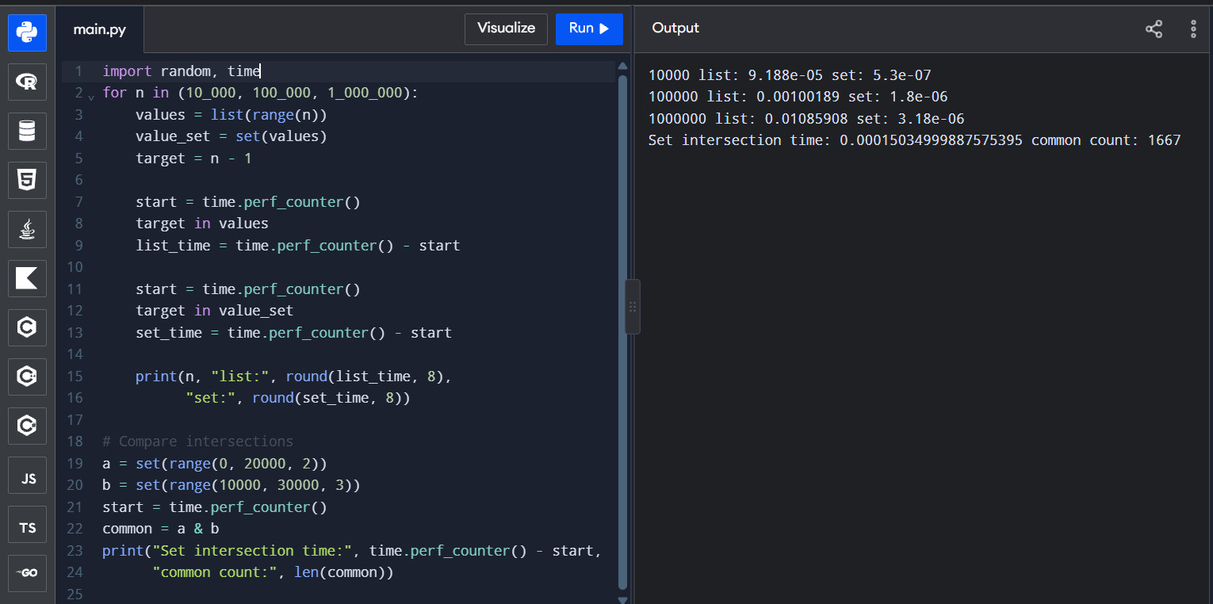

Task 5 – List Comprehension: Cleaning Sensor Readings (6 Marks)
Bloom’s Level: K3 – Apply

1. Aim
A sensor records temperatures in Celsius. Values below −50 °C or above 50 °C are invalid sensor errors. The program retains valid readings, converts them to Fahrenheit and identifies the minutes outside the safe 2–8 °C interval.

2. Python implementation: loop, comprehension, map/filter
readings = [4.0, 7.5, 9.2, 55.0, -60.0, 3.5, 1.0, 6.0]
# Version 1: for loop with append()
valid_loop = []
for celsius in readings:
if -50 <= celsius <= 50:
valid_loop.append(celsius)
fahrenheit_loop = [(c * 9 / 5) + 32 for c in valid_loop]
# Version 2: list comprehension
valid_comp = [c for c in readings if -50 <= c <= 50]
fahrenheit_comp = [(c * 9 / 5) + 32 for c in valid_comp]
# Version 3: filter() and map() with lambda
valid_map_filter = list(filter(lambda c: -50 <= c <= 50, readings))
fahrenheit_map = list(map(lambda c: c * 9 / 5 + 32, valid_map_filter))
# Original position is treated as minute number starting at 1
alarm_minutes = [
minute for minute, c in enumerate(readings, start=1)
if -50 <= c <= 50 and not (2 <= c <= 8)
]
print("Valid Celsius:", valid_comp)
print("Valid Fahrenheit:", [round(x, 2) for x in fahrenheit_comp])
print("Alarm minutes:", alarm_minutes)
assert valid_loop == valid_comp == valid_map_filter

3. General form and related comprehensions
# General list comprehension
new_list = [expression for item in iterable if condition]
# Dictionary comprehension: minute -> valid temperature
valid_by_minute = {
minute: c for minute, c in enumerate(readings, start=1)
if -50 <= c <= 50
}
# Set comprehension: distinct valid temperatures
valid_temperature_set = {
c for c in readings if -50 <= c <= 50
}
# Generator expression: values are produced one at a time
valid_generator = (c for c in readings if -50 <= c <= 50)
A comprehension is concise for a simple transformation or filter. A normal loop is easier to read when there are several conditions, error handling, logging or multiple actions. A generator expression produces values lazily and does not build the entire result list.

4. Complexity and memory
Approach | Time | Additional space
for loop + append | O(n) | O(n) for output list
list comprehension | O(n) | O(n) for output list
filter/map converted to list | O(n) | O(n) for output list
generator expression | O(n) to consume all values | O(1) generator state, excluding downstream storage

All three eager approaches inspect each reading once, so their time complexity is O(n). A list comprehension uses O(n) memory for the output. A generator is lazy and generally uses constant extra memory while being consumed, but converting it to a list again uses O(n) memory.

5. Experimental investigation
import random, time, sys
def loop_clean(data):
out = []
for x in data:
if -50 <= x <= 50:
out.append(x)
return out
def comp_clean(data):
return [x for x in data if -50 <= x <= 50]
def map_filter_clean(data):
return list(filter(lambda x: -50 <= x <= 50, data))
for n in (10_000, 100_000, 1_000_000):
data = [random.uniform(-60, 60) for _ in range(n)]
for name, fn in (("loop", loop_clean),
("comprehension", comp_clean),
("map/filter", map_filter_clean)):
start = time.perf_counter()
result = fn(data)
elapsed = time.perf_counter() - start
print(n, name, round(elapsed, 6), "items:", len(result))
gen = (x for x in readings if -50 <= x <= 50)
lst = [x for x in readings if -50 <= x <= 50]
print("Generator object bytes:", sys.getsizeof(gen))
print("List object bytes:", sys.getsizeof(lst))
Readings | Loop time | Comprehension time | map/filter time
10,000 | ________ | ________ | ________
100,000 | ________ | ________ | ________
1,000,000 | ________ | ________ | ________

For all-valid input, every reading is retained. For all-invalid input, the output is empty. Test both cases and confirm that all three versions return the same values. sys.getsizeof() measures the container object itself; it does not include the full memory occupied by every item.

6. Alternative concept: generator
valid_values = (c for c in readings if -50 <= c <= 50)
valid_sum = sum(valid_values)
print("Sum of valid readings:", valid_sum)
A generator is useful when values can be processed one at a time, such as calculating a sum or writing results to a file. It is not always best: if the values must be indexed repeatedly or reused, a list is more convenient. Both approaches take O(n) time when all values are consumed; the list stores O(n) results while a generator uses O(1) extra iteration state.

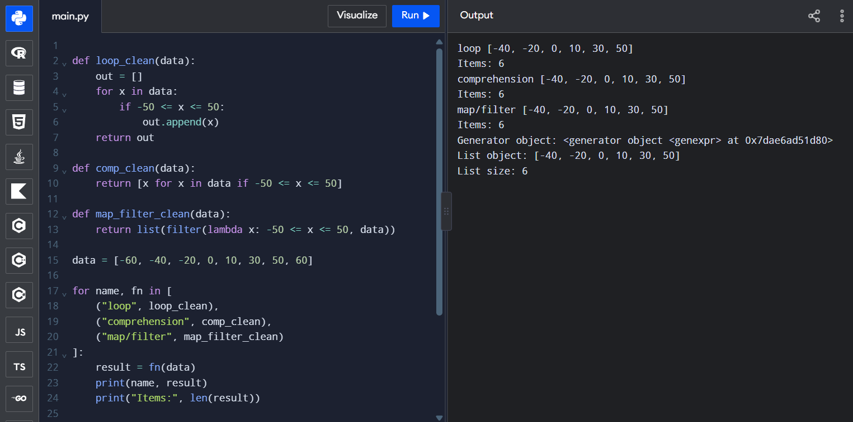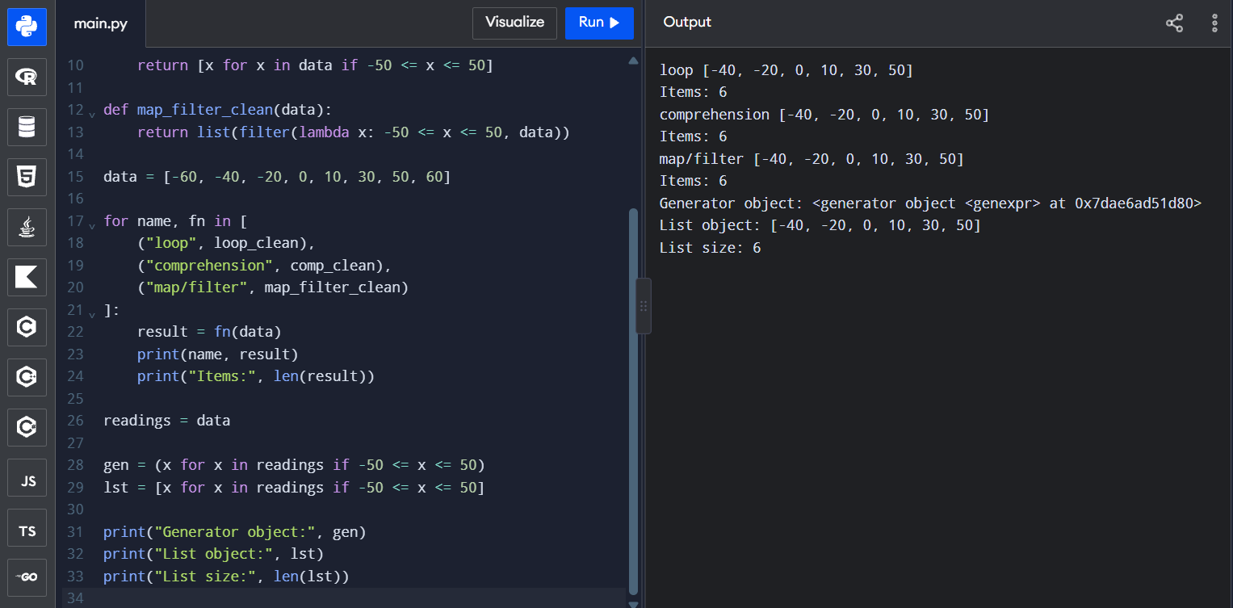Task 6 – Nested Data: A Railway Timetable (7 Marks)
Bloom’s Level: K4 – Analyse

1. Aim and data structure
The timetable uses a dictionary keyed by train number. Each train maps to a dictionary containing its name, an ordered list of station tuples and a set of running days. The list preserves station sequence, tuples represent fixed station-time records, and sets support fast day membership checks.

2. Build a timetable for five trains
timetable = {
"12601": {
"name": "Chennai Mail",
"stops": [
("Chennai", "06:00", "06:10"),
("Arakkonam", "07:20", "07:22"),
("Katpadi", "08:30", "08:35")
],
"days": {"Mon", "Tue", "Wed", "Thu", "Fri", "Sat", "Sun"}
},
"12602": {
"name": "Southern Express",
"stops": [
("Chennai", "07:00", "07:10"),
("Villupuram", "09:00", "09:05"),
("Tiruchirappalli", "12:00", "12:10")
],
"days": {"Mon", "Wed", "Fri"}
},
"12603": {
"name": "Coastal Passenger",
"stops": [
("Chennai", "08:00", "08:05"),
("Tambaram", "08:30", "08:32"),
("Chengalpattu", "09:15", "09:20")
],
"days": {"Tue", "Thu", "Sat"}
},
"12604": {
"name": "Hill Route",
"stops": [
("Katpadi", "10:00", "10:05"),
("Jolarpettai", "11:20", "11:25"),
("Bengaluru", "14:00", "14:10")
],
"days": {"Mon", "Tue", "Wed", "Thu", "Fri"}
},
"12605": {
"name": "Delta Intercity",
"stops": [
("Chennai", "16:00", "16:10"),
("Villupuram", "18:00", "18:05"),
("Thanjavur", "21:00", "21:05")
],
"days": {"Sat", "Sun"}
}
}
def find_trains(station, day):
matches = []
for number, info in timetable.items():
if day not in info["days"]:
continue
for stop, arrival, departure in info["stops"]:
if stop.lower() == station.lower():
matches.append((number, info["name"], departure))
break
return sorted(matches, key=lambda item: item[2])
print(find_trains("Chennai", "Mon"))
print(find_trains("Villupuram", "Sat"))

3. Sorting and printing timetable
for number, info in timetable.items():
print("\\nTrain:", number, "-", info["name"])
print("Running days:", ", ".join(sorted(info["days"])))
for station, arrival, departure in info["stops"]:
print(f"{station:18} Arrival {arrival:5} Departure {departure:5}")
# Departure time at the third station of a train:
# timetable[train_number]["stops"][2][2]
The expression timetable[train_number]['stops'][2][2] reaches the departure-time field of the third station tuple (using zero-based indexing).

4. Nested structure explanation
- Outer dictionary: fast average lookup of a train by its number.
- Inner dictionary: named fields ('name', 'stops', 'days') make the record clear.
- List of stops: maintains the order in which the train visits stations.
- Tuple: each stop has a fixed station, arrival and departure record.
- Set of days: removes duplicate day labels and supports average O(1) membership testing.

5. Station query complexity and index
Without an index, a query scans each train and its stops. If there are T trains and S average stops per train, the query costs O(T × S). Build an index mapping each station to a list of train-stop records. Then a station query examines only the trains listed for that station, approximately O(k), where k is the number of trains stopping there, plus sorting if departure order is required.
from collections import defaultdict
station_index = defaultdict(list)
for train_no, info in timetable.items():
for station, arrival, departure in info["stops"]:
station_index[station].append(
(train_no, info["name"], arrival, departure, info["days"])
)
def indexed_query(station, day):
result = [
(train_no, name, departure)
for train_no, name, arrival, departure, days
in station_index.get(station, [])
if day in days
]
return sorted(result, key=lambda item: item[2])
print(indexed_query("Chennai", "Mon"))
print(indexed_query("Unknown Station", "Mon"))

6. Experimental investigation
import random, time
stations = ["Chennai", "Tambaram", "Villupuram", "Katpadi",
"Salem", "Madurai", "Coimbatore", "Erode"]
days = ["Mon", "Tue", "Wed", "Thu", "Fri", "Sat", "Sun"]
def make_timetable(count):
data = {}
for i in range(count):
chosen = random.sample(stations, 5)
data[str(10000 + i)] = {
"name": "Train " + str(i),
"stops": [(s, "08:00", "08:05") for s in chosen],
"days": set(random.sample(days, 5))
}
return data
def build_index(data):
idx = {}
for no, info in data.items():
for station, arr, dep in info["stops"]:
idx.setdefault(station, []).append((no, dep, info["days"]))
return idx
for count in (100, 1000, 10000):
data = make_timetable(count)
idx = build_index(data)
start = time.perf_counter()
slow_result = [(no, info["name"]) for no, info in data.items()
if "Mon" in info["days"] and
any(s == "Chennai" for s, a, d in info["stops"])]
scan_time = time.perf_counter() - start
start = time.perf_counter()
fast_result = [(no, dep) for no, dep, run_days in idx.get("Chennai", [])
if "Mon" in run_days]
index_time = time.perf_counter() - start
print(count, "scan:", round(scan_time, 6),
"index:", round(index_time, 6))
print("Index entries:", sum(len(v) for v in idx.values()))
Trains | Scan query time | Indexed query time | Index memory / entries
100 | ________ | ________ | ________
1,000 | ________ | ________ | ________
10,000 | ________ | ________ | ________

Test an unknown station: the query should return an empty list. Test a train that does not run on the selected day: it must not appear. The index makes repeated queries faster but consumes additional memory and must be updated when the timetable changes.

7. Alternative concept: flat list
A flat list of (train, station, arrival, departure, days) tuples can be scanned for every query. It uses O(total stops) storage and takes O(total stops) per query. A station index takes extra O(total stops) storage but reduces the query work to O(trains at the requested station), plus filtering and sorting. A nested dictionary without an index still needs to scan stops for a station query.

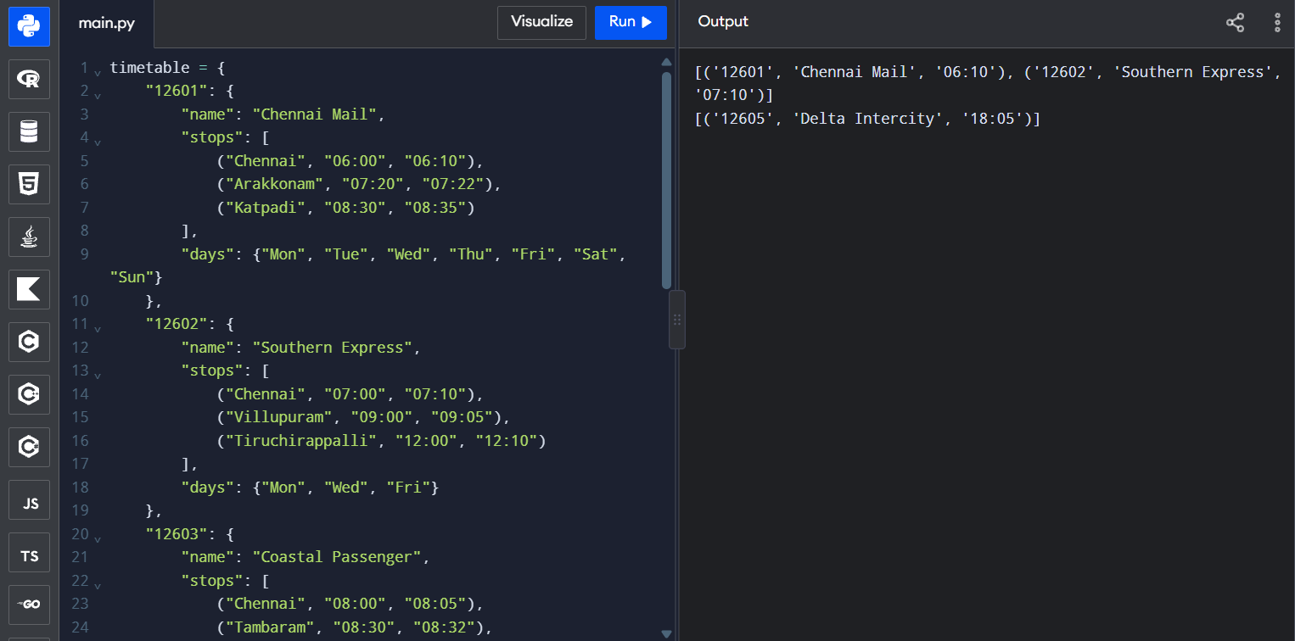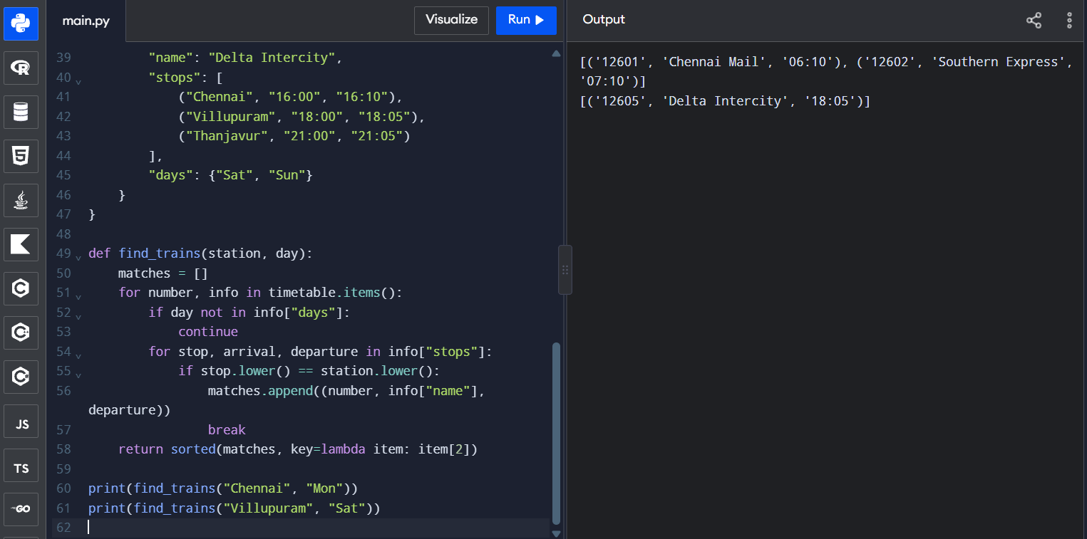Task 7 – Design a Contact-Merging Program from First Principles (10 Marks)
Bloom’s Level: K5 – Evaluate

Stage 1 – Interpret the problem

1. Input, output and matching rules
Input: contact records collected from two phones and a SIM card. A record may contain a name, phone number and e-mail address; some fields may be missing. Output: merged contact records, with each identified person represented once and all known numbers and e-mail addresses retained.
Matching rule: normalise a phone number by retaining digits only. If two records have the same non-empty normalised phone number, group them as the same contact. Names alone are not used as the identity key because different people can share a name. Records without a usable phone number need a separate review or fallback policy.

2. Measurable requirements
- Every output contact has one canonical identity key based on a normalised phone number.
- All distinct valid phone numbers and e-mail addresses from matching records are retained.
- Formatting differences such as spaces, hyphens and a +91 prefix are handled by the normalisation rule.
- Missing name, phone or e-mail fields do not crash the program.
- Input records are processed once, giving average O(n) grouping time for n contacts.
- Tests include duplicates, missing fields, different formats and a hand-verified small example.

Stage 2 – Design

3. Normalisation rules
- Phone: remove every non-digit character. For this sample, remove a leading country code 91 when the remaining number has 12 digits; retain the last 10 digits for Indian mobile numbers.
- Name: trim leading/trailing spaces and collapse repeated spaces. Convert to title case for display only.
- E-mail: trim spaces and convert to lowercase.
- Identity: use the normalised phone number as the dictionary key. Do not merge solely because names look similar.
Important limitation: phone normalisation rules depend on the country and numbering plan. The sample below is designed for Indian 10-digit mobile numbers and should be adapted before use in another country.

4. Pseudocode
FOR each contact:
normalise its phone number
normalise its name and e-mail
IF normalised phone is missing:
add record to manual-review list
ELSE:
IF phone key is not in merged dictionary:
create a record with empty sets
add name to the name set if present
add phone to the phone set
add e-mail to the e-mail set
RETURN merged contacts and manual-review records

Stage 3 – Implementation

5. Complete merging program
import re
import time
import random
def normalise_phone(phone):
if not phone:
return ""
digits = re.sub(r"\\D", "", str(phone))
if digits.startswith("91") and len(digits) == 12:
digits = digits[2:]
if len(digits) == 10:
return digits
return digits # keep other digit strings, but validate before production use
def normalise_name(name):
if not name:
return ""
return " ".join(str(name).strip().split()).title()
def normalise_email(email):
return str(email).strip().lower() if email else ""
def merge_contacts(contact_lists):
merged = {}
review = []
for contact in contact_lists:
name = normalise_name(contact.get("name"))
phone = normalise_phone(contact.get("phone"))
email = normalise_email(contact.get("email"))
if not phone:
review.append({
"name": name,
"email": email,
"reason": "No usable phone number"
})
continue
if phone not in merged:
merged[phone] = {
"names": set(),
"phones": set(),
"emails": set()
}
if name:
merged[phone]["names"].add(name)
merged[phone]["phones"].add(phone)
if email:
merged[phone]["emails"].add(email)
return merged, review
contacts = [
{"name": "Dr. Ravi", "phone": "+91 98400 12345", "email": "RAVI@MAIL.COM"},
{"name": "ravi kumar", "phone": "9840012345", "email": "ravi.alt@mail.com"},
{"name": "Meena", "phone": "98765-43210", "email": "meena@mail.com"},
{"name": "Ravi", "phone": "", "email": "unknown@mail.com"},
{"name": "", "phone": "9840012345", "email": ""}
]
merged, review = merge_contacts(contacts)
for phone, details in sorted(merged.items()):
print("Phone:", phone)
print("Names:", sorted(details["names"]))
print("Numbers:", sorted(details["phones"]))
print("Emails:", sorted(details["emails"]))
print("Manual review:", review)

6. Small example verified by hand
Input record | Normalised phone | Decision
Dr. Ravi / +91 98400 12345 | 9840012345 | Create first group.
ravi kumar / 9840012345 | 9840012345 | Add name and e-mail to existing group.
Meena / 98765-43210 | 9876543210 | Create a separate group.
Ravi / missing phone | (empty) | Send to manual review.

The first, second and fifth sample records share the same normalised phone identity where applicable. The record with no phone number is not automatically merged, even if its name resembles another contact.

7. Performance measurement
def generate_contacts(n):
data = []
for i in range(n):
number = 9000000000 + (i % max(1, n // 2))
data.append({
"name": "Person " + str(i),
"phone": str(number),
"email": "person" + str(i) + "@example.com"
})
return data
for n in (1000, 100000):
sample = generate_contacts(n)
start = time.perf_counter()
result, review_items = merge_contacts(sample)
elapsed = time.perf_counter() - start
print(n, "contacts:", round(elapsed, 6),
"seconds; merged groups:", len(result))
Input contacts | Measured time (seconds) | Merged groups
1,000 | ________ | ________
100,000 | ________ | ________

Stage 4 – Defend the design

8. Dictionary grouping vs pairwise comparison
A dictionary keyed by the normalised phone number groups contacts in one pass. Dictionary insertion and lookup are O(1) on average, so processing n contacts is O(n) average time, excluding the cost of normalising each field. Comparing every pair requires approximately n(n−1)/2 comparisons and therefore O(n²) time. At 100,000 contacts, pairwise comparison is impractical compared with a one-pass dictionary approach.
Approach | Time complexity | Extra space
Dictionary keyed by normalised number | O(n) average | O(n) for merged groups and stored values
Compare every pair | O(n²) | O(1) or O(n), depending on whether a separate result structure is built

9. Handling same names and remaining limitation
Two people with the same name but different phone numbers remain separate because the phone number is the identity key. A remaining limitation is that a person may change phone numbers, share a family phone, or have multiple numbers that are not linked by any shared record. Such cases require a review step or a stronger identity-verification process; names alone are not reliable proof.
Evaluation: the dictionary design is efficient and easy to explain. It preserves multiple e-mails and numbers using sets, avoids duplicate values, and sends records without a usable phone number to manual review rather than making an unsafe guess. 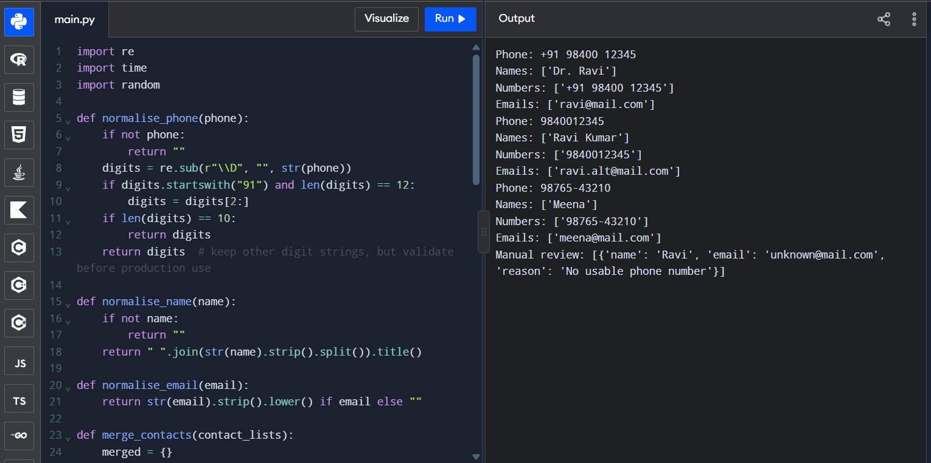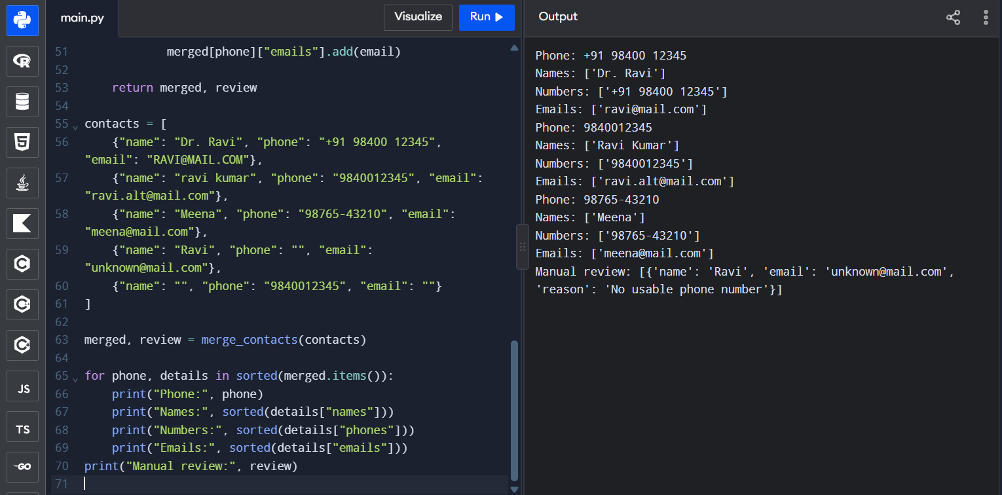

Overall Conclusion
This assignment demonstrates how Python data structures can be selected according to the shape and operations of the data. Lists preserve order and support slicing; tuples represent fixed records and can be dictionary keys; dictionaries provide average constant-time key access; sets efficiently represent unique values and set relationships; comprehensions express concise transformations; and nested structures model real-world records.
The experiments should be executed on the student’s own computer and the measured values entered in the blank tables. The theoretical analysis predicts the growth rate, while the local measurements provide evidence about actual performance. The best data structure depends on the required operations, data size, ordering needs, frequency of updates and available memory.

Submission Checklist
- ☐ Cover page includes name, register number and GitHub link.
- ☐ GitHub repository is named CSA08-<RegisterNumber>-Assignment3.
- ☐ Task01 to Task07 folders contain source code and any input files.
- ☐ Every program, including the completed TODO programs, has been executed.
- ☐ Output screenshots are saved in the correct task folders.
- ☐ Benchmark timings and memory measurements are filled using actual runs.
- ☐ README.md contains Python version, libraries, run commands and task summaries.
- ☐ At least one progressive commit has been made for each task.
- ☐ Repository access has been shared with the course faculty.

