AGSWORLD

Assessment
Installation

v1.00

How to install the applicatrion.

- Copy all contents of agsworld.zip into your server directory and unzip the file.
- Copy file `application/Config/database.conf.sample.php` and rename to `application/Config/database.conf.php` into same directory then edit the file to match your database settings.

public $default = array(
'datasource' => 'Database/Mysql',
'persistent' => false,
'host' => 'localhost', // HOST MACHINE
'user' => 'root', // HOST USERNAME
'password' => 'password', // HOST PASSWORD
'database' => 'contacts', // HOST DATABASE (*Optional to change)
);
- Navigate to agsworld and application should take you to the admin page and install the database and intialize tables.

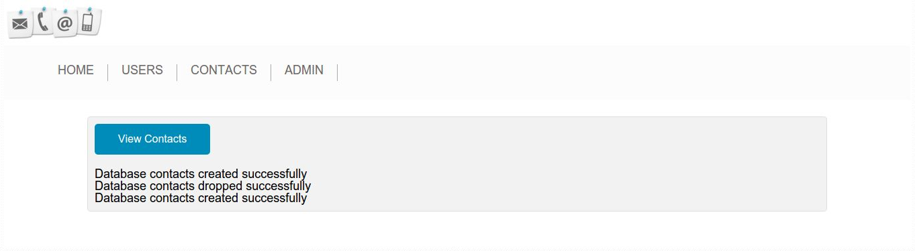
- Once all is done you can navigate through the application to add users, add contacts and add contact types (basics types are inserted on schema creation).
  - Add Users
    - Add users for contacts in 2.
  - Add Contacts
    - Add contacts for users in 1
  - Add Contact Types
    - Add contact types for contacts in 2

