**BREAZ Deliverable**

|  |  |  |
| --- | --- | --- |
| ID | Deliverable Name | Document Author |
| x.x.x.x | Interfaces – Inbound Detailed Design – 86 – DOT – TARGATS – CH – Daily Transfer | Prabesh Niraula, Consultant |
| CGI Document Reviewer(s) | | Deliverable Review Complexity |
| <reviewer name, role>  <reviewer name, role> | | Low |
| State Document Reviewer(s) | | Date Submitted/Comments Due |
| <reviewer name, role>  <reviewer name, role> | | Date Submitted: <date: mm/dd/yy> |
| Comments Due: <date: mm/dd/yy> |
| Comments | | |
|  | | |

Signatures below indicate acceptance of the attached document.

|  |  |  |
| --- | --- | --- |
| Name, Title | Signature | Date |
| Ken Estes | | |
| CGI Security Lead Signature: | |  |
| Karen Hansen | | |
| State Project Manager Signature: | |  |
| Michael Smarik | |  |
| State Project Director Signature: | |  |



**BREAZ Project**

Interfaces – Inbound Detailed Design –

#86 – DOT – TARGATS – CH – Daily Transfer

**March 4, 2014**



1. Table of Contents

1 Document Organization 6

1.1 Deliverable References 6

1.2 Terminology 6

1.3 Deliverable Organization 6

2 Overview 7

2.1 Assumptions 7

3 Detailed Design 8

3.1 Inbound Interface file 8

3.1.1 File Name 8

3.1.2 File Transfer Specifications 8

3.1.3 Frequency and Volume Specifications 8

3.1.4 Processing Logic 9

3.1.5 Inbound File Layout 9

3.1.6 Mapping Specifications 10

3.1.7 Crosswalk Specifications 11

3.1.8 Reconciliation 11

3.1.9 Error Handling 11

3.1.10 Software Files 11

4 Unit Testing 12

4.1 Basic Tests 12

4.2 Error Handling Tests 12

4.3 Security Related Tests 12

4.4 Volume / Performance Related Tests 12

5 Security Considerations 13

1. Table of Exhibits

Exhibit 3-1: File Transfer Specifications 8

Exhibit 3-2: CH Document Structure Diagram 9

Exhibit 3-3: Inbound File Layout 10

Exhibit 3-4: Sample Inbound File 10

Exhibit 3-5: Mapping 86 – TARGATS – CH – Daily Transfer 10

Revision History

|  |  |  |  |
| --- | --- | --- | --- |
| Version | Date | Author | Comments |
| 0.1 | <date of revision> | <author> | <Comments: Initial Version, Changes made to this version> |
| 1.0 |  |  |  |
|  |  |  |  |
|  |  |  |  |
|  |  |  |  |

# Document Organization

This section lists the deliverable document sections, references the related Deliverable Expectations Document, and defines any common terminology.

## Deliverable References

Deliverable #86 TARGATS: TARGATS inbound interface is referenced in the State’s RFP Attachment #5. Interfaces in addition to Attachment #3: Application Inventory.

|  |  |  |  |  |  |  |  |  |  |  |
| --- | --- | --- | --- | --- | --- | --- | --- | --- | --- | --- |
| **#** | **Planned Action** | **Sending System Owner** | **Sending System** | **Receiving System Owner** | **Receiving System** | **Brief Interface Description** | **Triggering** | **Type** | **Frequency** | **Volume (Per Frequency)** |
| **Event** |
| 86 | Redesign | Arizona Department of Transportation (ADOT) | TARGATS | Arizona Department of Transportation (ADOT) | AMS Advantage | Daily transfer data (this is replacing an Access data base - planned implementation is end of 2012). | Part of normal nightly batch process | Batch | Daily | Unknown |

## Terminology

PDI is Pervasive Data Integrator, the data mapping tool used to build and run the interface.

AFIS, Arizona Financial Information System, is the existing statewide legacy ERP system owned by the Arizona Department of Administration (ADOA) which is to be replaced by Advantage Financial. AFIS will refer to this legacy system, while the terms Advantage or “the new AFIS system” will refer to the Advantage Financial system being implemented

ADOT is the Arizona Department of Transportation.

This design document is written from the perspective of ADOA’s implementation of Advantage Financial; as such the terms inbound/outbound and input/output are with respect to that system. An inbound interface provides an input data file from some other agency or system which will be translated into Advantage-ready XML and uploaded into the Advantage Financial system, while an outbound interface extracts data from Advantage tables and writes it into an output file which is then be provided to some other agency or system.

SMU is System Maintenance Utility, also known as SysManUtil; it is the utility in Advantage used to actually load document data in XML format into the relevant system tables.

For definitions of any other terms or acronyms used in this document see the Project Glossary on the Ensemble SharePoint site.

## Deliverable Organization

This deliverable document is organized into the following sections:

* Section 2: Overview - Provides an overview – purpose of the interface, systems, scope, and any assumptions
* Section 3: Detailed Design - Provides the detail design of the Inbound Interface File
* Section 4: Unit Testing - Describes the unit tests that will be performed
* Section 5: Security Considerations – Describes any security considerations not already described.

# Overview

Interface #86 is an inbound interface, which transfers Daily data (replacing an Access database) from Arizona Department of Transportation (ADOT) – TARGATS system to AMS Advantage system within ADOT.

## Assumptions

* If necessary, the State through coordination with the BREAZ project team leads will be responsible for the analysis, planning, designing, and developing of modifications to the external systems to support the inbound/outbound interfaces. The Agencies are responsible for working with their software vendors to perform any necessary software modifications for their interfaces. CGI will assist with all analysis related to the Arizona Advantage application.

The State is responsible for ensuring that the input file provided by ADOT for this interface: adheres to the layout specifications provided as part of the requirements for this interface design, contains an extract of the relevant data from the ADOT Project Master system, and is sent to the AFIS system on a daily basis. The relevant Agencies are responsible

# Detailed Design

This section provides the details of the Daily Transfer Data Inbound Interface File TARGATS system of Arizona Department of Transportation (ADOT) interfaced to Arizona Advantage.

## Inbound Interface file

### File Name

The name of the Fixed Asset Inbound Interface #86 – TARGATS – CH- Daily Transfer is **MV675.D.TA400.TO.ADVANT(0).csv**

### File Transfer Specifications

<Provide details of the location where the Inbound Interface file will be available from the agencies. If no interface is provided for an environment, use “N/A” to indicate so. If any information is not known at the time of writing, mark it “TBD”>

Exhibit 3-: File Transfer Specifications

|  |  |  |
| --- | --- | --- |
| Environment | Server Name or IP | Directory |
| Baseline / Prototype | N/A | N/A |
| Sandbox | N/A | N/A |
| Gold Configuration | N/A | N/A |
| Development / Unit Test | TBD | TBD |
| System Test | TBD | TBD |
| Conversion Test | TBD | TBD |
| Training | N/A | N/A |
| Acceptance Test | TBD | TBD |
| Production | 192.192.192.192 | C:\BREAZ\Incoming |

### Frequency and Volume Specifications

* The interface will be run daily.
* A daily transaction of peak volume of unknown units.

### Processing Logic

1. The PDI mapping will be developed using the inbound file layout detailed in Exhibit 3-2 and Exhibit 3-3, and will map data to the relevant fields in an Advantage CH document as specified in Exhibit 3-4.
2. The following information will be written to the log file for the PDI map:
   1. Total number of records in the input (or source) file provided for this interface
   2. Total number of document records written to the XML file by the PDI map
3. The following is the logical, step-by-step process of the actual running of the interface:
   1. FTP Process

First, the inbound interface file submitted to Arizona Advantage adhering to the format in this design (Exhibits 3-2 and 3-3) will be transferred from the State’s Common Repository server to BREAZ’s File Drop-off server through FTP, and put into the dedicated Input directory.

* 1. PDI Transformation

Upon receipt of the Agency’s Inbound Interface file, the PDI mapping will be triggered by batch script and will transform the data into an Advantage Financial CH document XML file.

* 1. SMU Load and Submit

The data in the CH document XML file is imported into Advantage Financial as CH documents by running the SMU (System Maintenance Utility) Import Document job. The user will have the opportunity to check the log and see that all documents in the XML file have been loaded into the system without error. All documents are loaded into the system in Draft status. Finally, the documents can be submitted to Final status by running the SMU Submit Document job.

1. In order to ensure smooth performance of the Advantage Financial application, an upper limit is established on the number of detail lines (accounting lines for most document types) that will be permitted within a single document. Therefore, Inbound Interface maps will include logic to create a new document with a sequentially indexed document ID once 100 detail lines have been written to any one document.
2. The PDI map will begin a new CH document record whenever the value for the Trans-Number field changes in the input file.

The following logical processing occurs for the inbound CR interface.



Exhibit 3-: CH Document Structure Diagram

AMS Document

AMS_DOCUMENT

Document Header

CH_DOC_HDR

Accounting Line

CH_DOC_ACTG

### Inbound File Layout

The following information describes the fields and additional logic on the inbound file:

Exhibit 3-: Inbound File Layout



Exhibit 3-: Sample Inbound File



### Mapping Specifications

The mapping specifications (Exhibit 3-5: Mapping of Data) indicate the correspondence from the fields of the inbound file to the relevant fields in an Advantage CH document. The following columns in the spreadsheet provide the details on the target/Advantage side of the interface and if applicable to mapping logic:

* **Arizona Advantage Source Table** – The table that the data element is extracted from.
* **Arizona Advantage Attribute** – The column that the data element is extracted from.
* **UI Caption** – Caption on the Advantage page.
* **Description** – Descriptive information of the data element
* **Data Type/Size** – The data type of the data element with the size at the end.
  + Date – Date Format ”MMDDYYYY”.
    - Note: Pending on the Outbound File requirements, the dates may need to be reformatted to YYYYMMDD or MMDDYY
  + Decimal – Right justified numeric value with a specified decimal position (9,3) = 999999.999. Negative numbers must be prefixed with a negative sign.
  + Boolean/Flag –True/False. True conditions = 1, False conditions = 0.
  + Text (VarChar, Memo) – Left justified alphanumeric text field with a maximum number as defined for each field.
  + Numeric (Integer, Long) – Right justified numeric value, a whole number.
* **Comments** – Comments specific to the output of the data element including notes for format and extraction logic.

Exhibit 3-: Mapping 86 – TARGATS – CH – Daily Transfer



### Crosswalk Specifications

None as of March 3, 2014

### Reconciliation

None as of March 3, 2014

### Error Handling

SysManUtil work lists any error records during data load into Arizona Advantage.

### Software Files

|  |  |
| --- | --- |
| Name: | MV675.D.TA400.TO.ADVANT(0).csv |
| Path/Location: | TBD |
| Description: | Interface #86 is an inbound interface, which transfers Daily data (replacing an Access database) from Arizona Department of Transportation (ADOT) – TARGATS system to AMS Advantage system within ADOT. |

# Unit Testing

## Basic Tests

1. **Test**: Run the PDI map in Map Designer to convert input records from the provided inbound file to Advantage Financial XML records

**Expected Result**: PDI map executes without error; log file displays accurate count of records as specified in 3.1.4 Processing Logic

**Actual Result**: PDI transformation executes without error and log file displays accurate count of records as specified in the design.

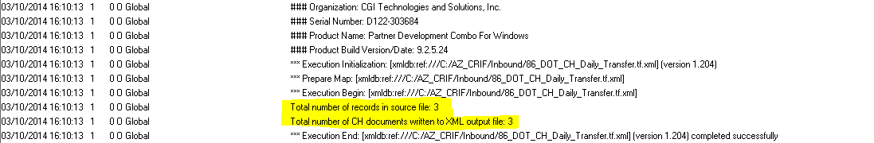

1. **Test**: Examine XML file for correct syntax and no empty fields; verify that each document record contains all the fields specified in Exhibit 3-4.

**Expected Result**: All fields should be populated correctly within the XML file.

**Actual Result**: Document records in XML file are written with correct syntax, contain the correct fields, have correct hard-coded values, and searching for empty fields “[]” returns no results.

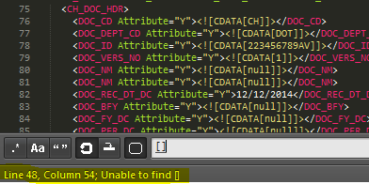

1. **Test**: Verify XML file contains the correct number of document records corresponding to sample input file used and PDI log count.

**Expected Result**: Number of document records in target XML file corresponds to input file and to PDI log count.

**Actual Result**: Searching the XML file for a string that occurs exactly once for each document record (part of AMS_DOCUMENT line) results in count of 3, which is the number of distinct document IDs in input file and corresponds to PDI log.

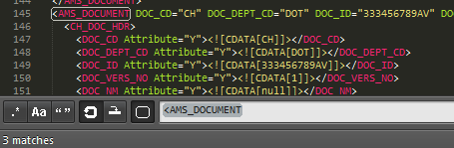

1. **Test**: Run SysManUtil Import Document job to load the XML file into Advantage Financial.

**Expected Result**: SysManUtil job runs without error, loads the correct number of document records into Advantage.

**Actual Result**: SysManUtil Import Document job runs without true errors and loads to correct number of documents (3) into Advantage tables.

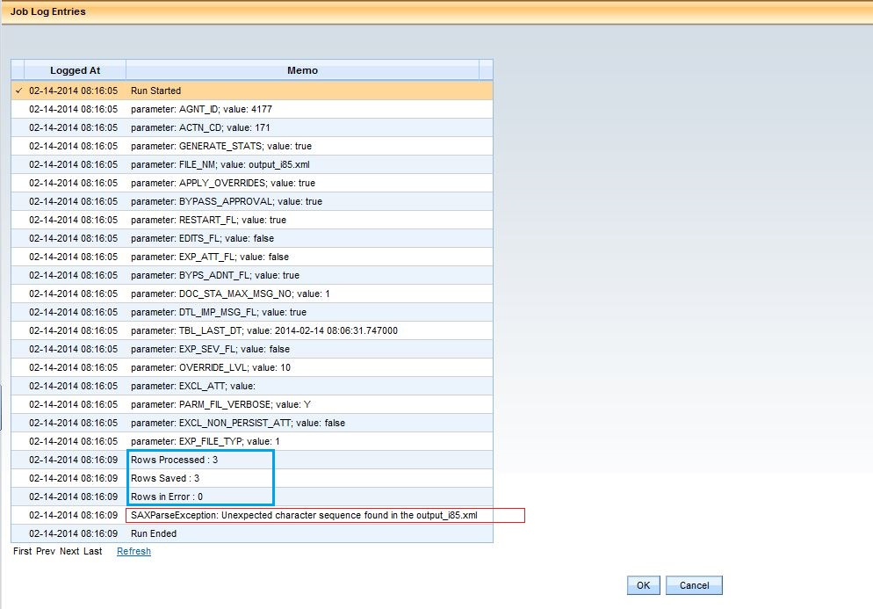

**<Note that SAXParseException error is displayed erroneous; this is an issue with the configuration of the current Advantage environment, cause still TBD>**

1. **Test**: Verify the data written into fields in Advantage Financial JV documents corresponds accurately to data from sample file and hardcoded values as specified in Exhibit 3-4.

**Expected Result**: All data displayed in document fields in Advantage corresponds accurately to sample file and/or hard-coded values.

**Actual Result**: The three documents written into the system have the correct accounting lines associated under each and data values in fields match those from the input file and/or hard-coded values in the map itself.

## Error Handling Tests

1. **Test**: Run PDI map with an input file having zero records (i.e. a blank file).

**Expected Result**: PDI map executes without error, but writes a blank target XML file; log correctly indicates zero records read or written.

**Actual Result: PDI map executes correctly, writes a blank output XML file, and log correctly indicates zero records read or written.**

**PDI Log**

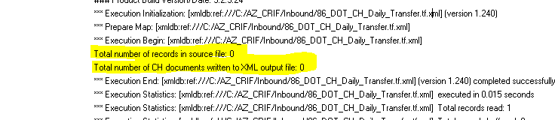

**Blank Output file**

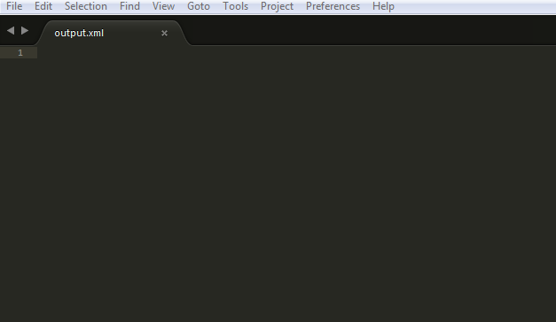

## Security Related Tests

TBD as of 03/10/2014

## Volume / Performance Related Tests

1. **Test**: Run PDI map with an input file containing 5-50 records, estimated average volume.

**Expected Result**: PDI map executes successfully, transformation is completed within adequate maximum time of TBD.

**Actual Result**: <document actual volume/performance test result here>

1. **Test**: Run PDI map with an input file containing 250+ records (five times estimated average volume).

**Expected Result**: PDI map executes successfully, transformation is completed within adequate maximum time of TBD.

**Actual Result**: <document actual volume/performance test result here>

# Security Considerations

TBD as of 03/10/2014