

**Al-Hussein Technical University**

**Project Title:**

Personal Portfolio

**By:**

Thabet Fahed Hasan Ajweh

**Supervised by:**

Khaled Oweis

Contents

Introduction 3

Overview 3

Why I should use the portfolio ? 3

In this project 3

Project Requirements 4

Use Case Digram 6

Class Digram 7

User Repository  10

Website Screens 19

Introduction:

If you have a desire to gain more customer volume, and to improve your personal brand, then a website that can promote your work is a must. Personal portfolios are consistent that need to be taken care of throughout your work. You can easily display the samples of your work, details about yourself, completed projects in the past and better explain to your clients why they must use your services for their advantages.

Overview:

A well-designed personal portfolio makes you stand out from the competitors and boost your business chances exceptionally. With the above-mentioned tips, you can easily build an impressive personal portfolio. It will surely increase your work credibility, and you will get more clients. This way, you will grow personally and professionally.

Why I should use the portfolio?

Carrying a full of papers portfolio became an old fashion way to share your information and personal documents, creating a technology computer-based implementation of the ordinary portfolio to handle this contained data is a must nowadays, so this report shall make a walk through my implementation of portfolio website.

In this project:

The site looks pretty much like any typical known social media sites with the home page that contains a few sections, authentication section to login / register in the site, an about section which includes an overview about what the site does, another section about our list of sponsors who really supported us in the hard times, contact section that contains a form  to send any comment on the site.

once you pass the authentication screen the site will re-direct you to the same home page with another section added for the authorized user called view portfolio that will take you to your E-Portfolio to begin the process of adding your information, once you done save your new info’s to get your portfolio URL and share it around (yes it is that easy).

Project Requirements:

1. This system consists of two users: Admin and User.
2. Requirements for User:
3. Upon entering the site, the main page of the site will appear which contains information about the site and some terms that indicate the definition of the personal portfolio.
4. The user must log in to the website to be able to create his own personal portfolio.
5. If the user does not have an account on the web site, they must create an account to access the web site services.
6. When creating a new account for the first time, the user will be moved to the Portfolio Create page and the user will fill in the information required of him.
7. The user will not be transferred to the other page unless all the information requested from him has been filled out, which are some personal information, information about his studies, information about the skills he possesses, information about the projects he has undertaken, and finally information to contact him.
8. When a user has filled out all his information and clicks the send button, an email is sent to him with a link to his personal wallet.
9. When the website sends an email to a user with a link to their personal wallet, the user is taken to their portfolio view page.
10. On the Portfolio View page, the user can choose between either returning to the main page or making an adjustment to his / her own portfolio.
11. If the user chooses the option to modify his wallet, he is transferred to the modification page for a wallet, and the user modifies the information he wants to modify.
12. Before pressing the submit button, the user must make sure that all fields are full of information, otherwise it will not move him to the next page.
13. When you click on the Submit button, the user will be moved to the Portfolio display page, and all the changes made by the user will be displayed.
14. But if the user chooses to press the home button, he will be taken to the main page of the site where there is general information about the site.
15. But if the user previously had an account on this site and created his own wallet, all he had to do was log in to the site using his email and password.
16. When logging in to the site, the user will be taken directly to the display page of his portfolio and displaying all his information that was previously filled in.
17. When the user finishes using the site, he logs out of his account.
18. When the user logs out from the site, he is moved to the site's home page.
19. The user must know that he must fill out all the information required of him on the portfolio creation page, otherwise the portfolio will not be created for him. This information includes his name in three sections, his personal photo, phone number, date of birth, address, email, some links to social media sites such as Twitter and LinkedIn the Facebook, Job title, about you, personal vision, and résumé. All this is contained in the personal information that he must fill in. As for the information related to his studies, he must fill in the name of the university in which he studied in addition to the academic degree and specialization he studied in this university, for information related to the projects he has undertaken, including a picture of this project in addition to a copy of this project in the form of a PDF file, and the name of the project A small description of the project, and finally information about the skills that the user possesses, whether they are technical skills or soft skills.
20. Requirements for Admin:
21. As for the admin, the first thing he must do when entering the site is to log in using his email and password.
22. When the admin logs into his account, be directly moves it to the private admin home page.
23. The admin home page contains a table containing all users who use this site in addition to a button to display the portfolio and a button to delete a university or skill.
24. When the administrator clicks the Show Clipboard button, he displays each user's portfolio.
25. When the admin presses the delete university button and delete a skill, this will move the admin to a special page chosen by the university or bystanders, who want to delete it, then press the delete button.
26. When the official clicks the “add university or skill” button, he moves it to a page where the admin adds the university or skill he wants.
27. When the admin finished all his work in the system, he logs out of the site to preserve his private data and is transferred directly to the main page of the site.

Use Case:

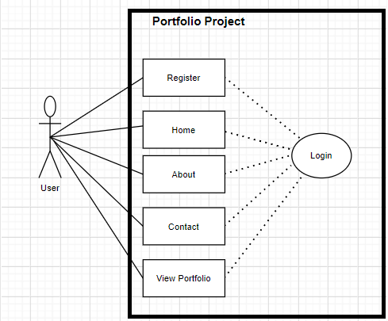

Class Diagram:

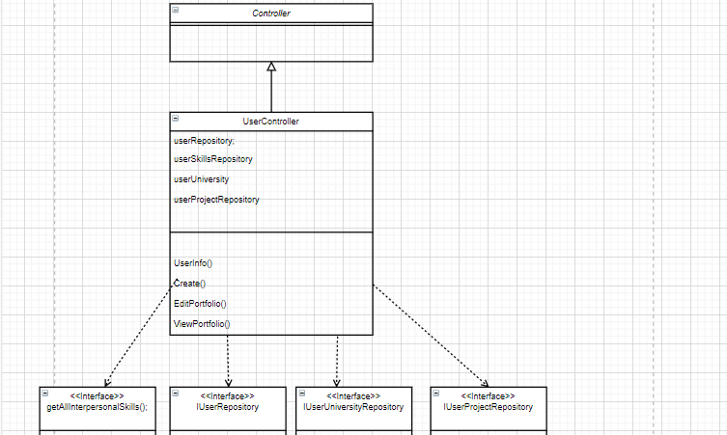

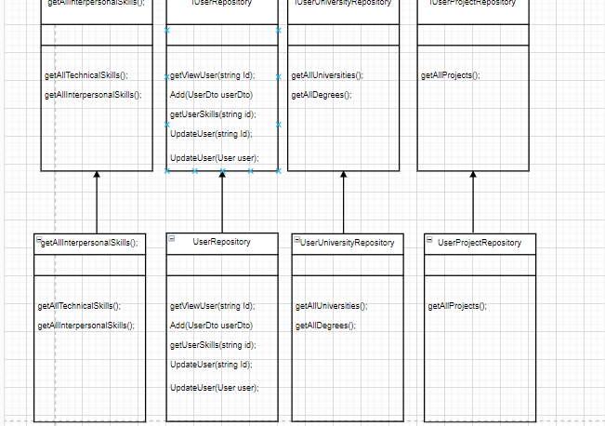

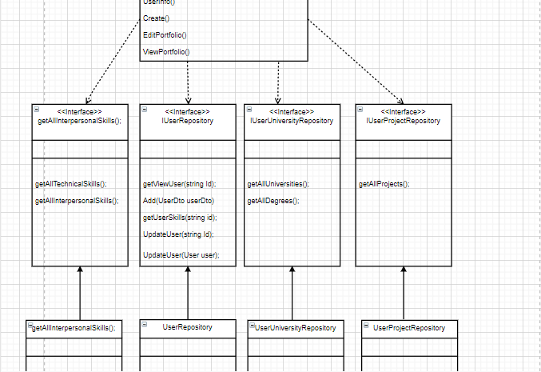

Source code for the Repositories:

1. User Repository:

صورة تحتوي على نص

تم إنشاء الوصف تلقائياًصورة تحتوي على نص

تم إنشاء الوصف تلقائياً

صورة تحتوي على نص

تم إنشاء الوصف تلقائياً

صورة تحتوي على نص

تم إنشاء الوصف تلقائياً

صورة تحتوي على نص

تم إنشاء الوصف تلقائياً

صورة تحتوي على نص

تم إنشاء الوصف تلقائياً

صورة تحتوي على نص

تم إنشاء الوصف تلقائياً

صورة تحتوي على نص

تم إنشاء الوصف تلقائياً

Make a standard queries on users such as add, update, get user by id and get all users there is also get user skills which take the user id and returns the skills.

1. User university repository:

صورة تحتوي على نص

تم إنشاء الوصف تلقائياً

صورة تحتوي على نص

تم إنشاء الوصف تلقائياً

صورة تحتوي على نص

تم إنشاء الوصف تلقائياً

To add university, get all universities to pick from, get all universities for a certain user and get all degrees .

1. User skill repository:

صورة تحتوي على نص

تم إنشاء الوصف تلقائياً

صورة تحتوي على نص

تم إنشاء الوصف تلقائياً

صورة تحتوي على نص

تم إنشاء الوصف تلقائياً

صورة تحتوي على نص

تم إنشاء الوصف تلقائياً

There is two types of skills each have its own add, remove, get all and get by id methods.

1. Degree Repository:

صورة تحتوي على نص

تم إنشاء الوصف تلقائياً

صورة تحتوي على نص

تم إنشاء الوصف تلقائياً

Degrees repo to add and remove a degree or get a certain degree by Id or get all of the degrees.

1. User project repository:

صورة تحتوي على نص

تم إنشاء الوصف تلقائياً

Get all projects stored or get one by id.

1. Website Screens:

Home Screen

This is the home page of the website; it contains some information and the purpose of this website.



Home Screen for user:

This is the user's home page, the difference between it and the web site home page is that it contains the action that the user can do.



About Screen

This is the second part of the home page, and this section contains some information related to the site and a simple definition of Portfolio.

صورة تحتوي على نص

تم إنشاء الوصف تلقائياً

Sponsors Screen:

This is the third part of the main page, and this section contains some sponsors of the project.

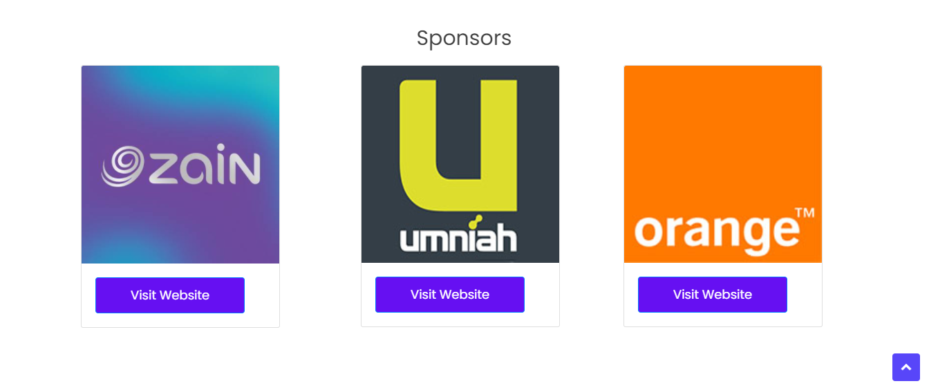

Contact and Footer:

This is the last part of the homepage. This section contains some information for the admin to communicate with.

صورة تحتوي على نص

تم إنشاء الوصف تلقائياً

can build his portfolio from this button:

Clicking this button takes you to the page where you can create your personal portfolio.

صورة تحتوي على نص

تم إنشاء الوصف تلقائياً

Create screen and fill information:

This is the portfolio creation page, the user fills in all the required information, and this information is his personal information in addition to information related to education and some projects he has undertaken in addition to the skills that he possesses.

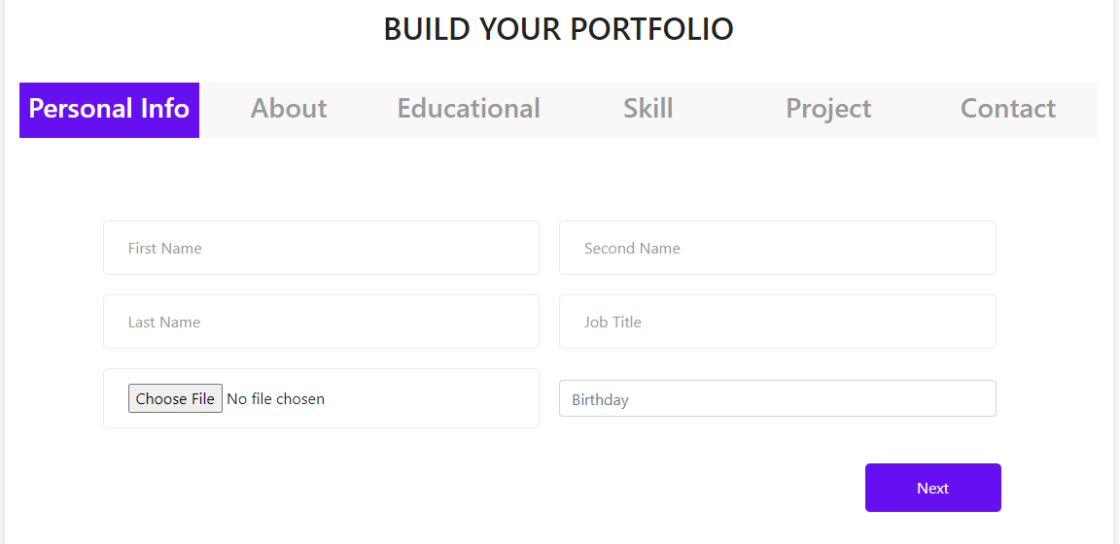

Login Page:

This is the login page to the site that contains the password e-mail for the user to be able to log in his profile.

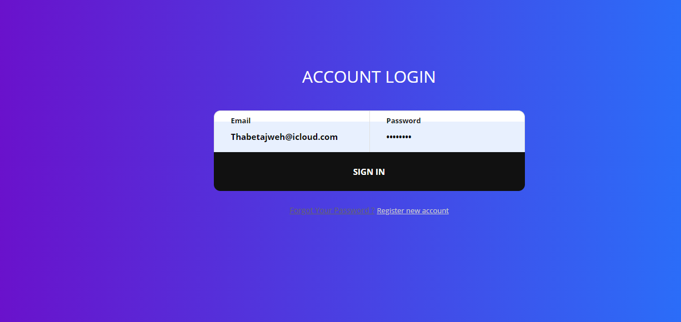

Sign Up Page:

This is the registration page for this site. The user must enter his e-mail and password and retype the password again to verify it.

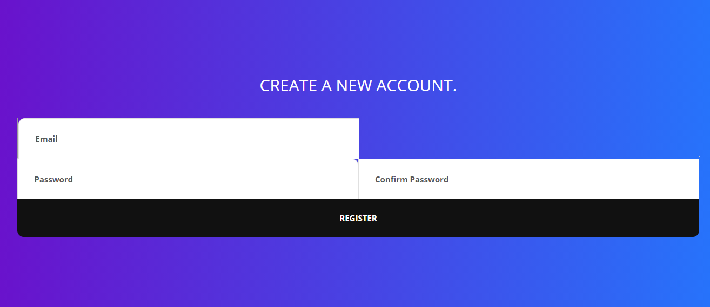

Users for admin:

This is the admin home page that displays all users who use the site and have accounts on this website.

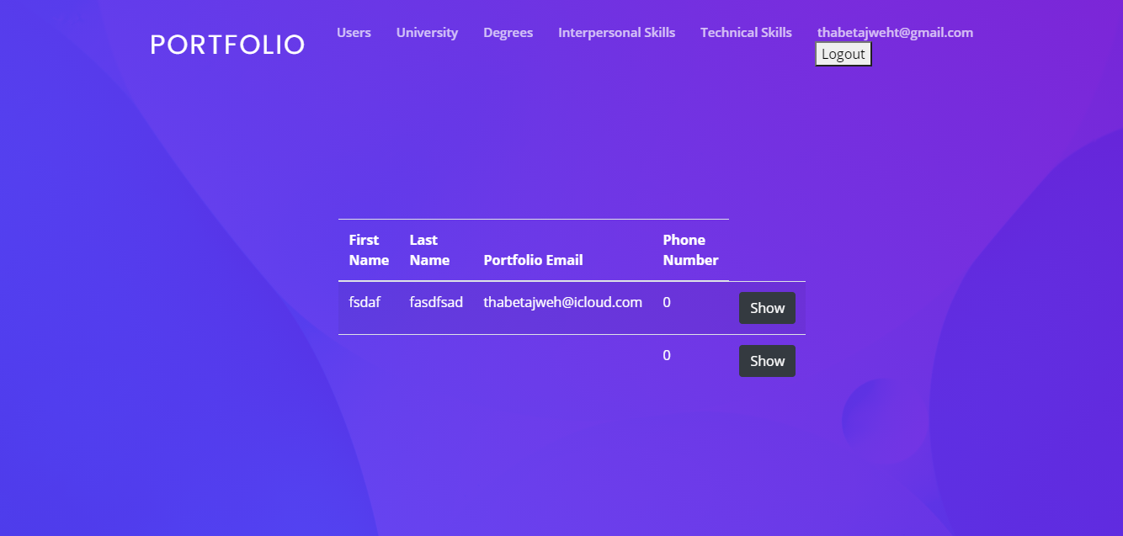

University for admin:

On this page, all the universities in the Data Base are displayed and displayed for the user to choose from it. This page enables the admin to delete, add or modify a university only by pressing the button that indicates the operation he wants to perform.

صورة تحتوي على لقطة شاشة, شاشة, شاشة عرض, تشبث

تم إنشاء الوصف تلقائياً

Technical skills for admin:

On this page, all the Technical skill in the Data Base are displayed and displayed for the user to choose from it. This page enables the admin to delete, add or modify a Technical skill only by pressing the button that indicates the operation he wants to perform.

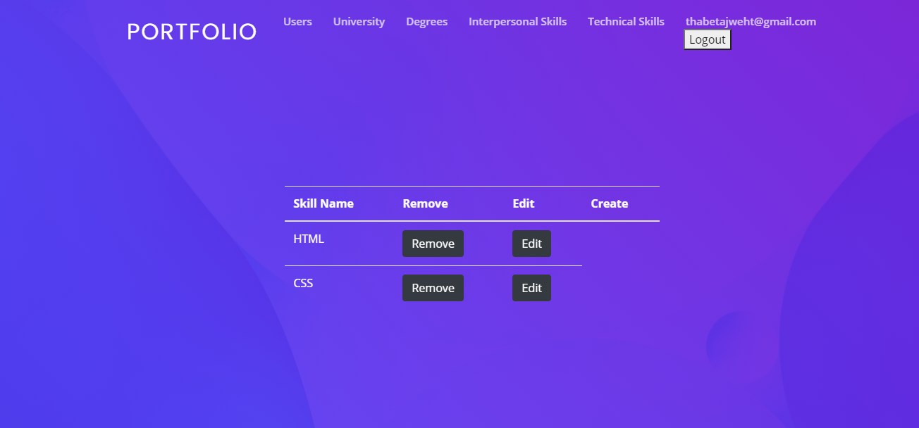

Interpersonal skill for admin

On this page, all the Interpersonal skills in the Data Base are displayed and displayed for the user to choose from it. This page enables the admin to delete, add or modify a Interpersonal skill only by pressing the button that indicates the operation he wants to perform.

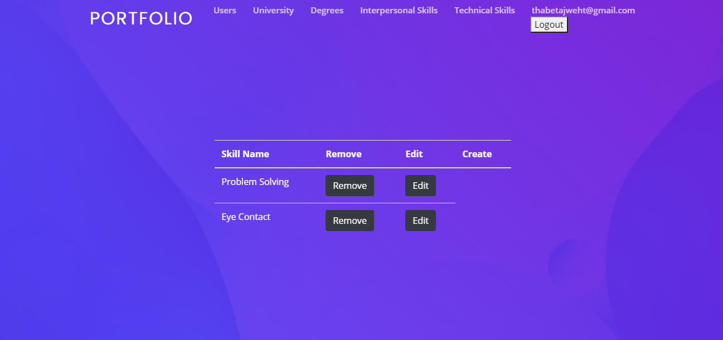

Edit screen for admin:

On this page, only the administrator can edit any site-related information in the database.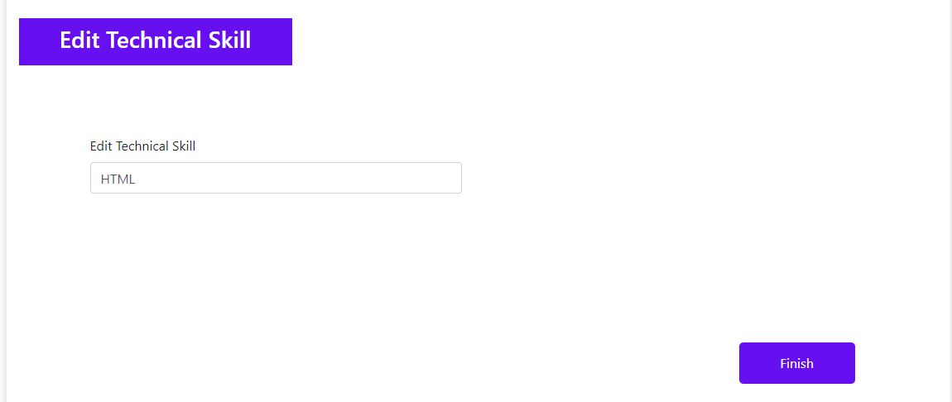

Create screen for admin:

On this page, the admin can add new information about website to the database.

