

**CS251 – Software Engineering I**

|  |  |
| --- | --- |
| **Staff Memebers** | **Email** |
| **Dr Mohamed El Ramly** | **m.elramly@fci-cu.edu.eg** |
| Eng Catherine Bedrossian | c.bedrossian@fci-cu.edu.eg |
| Eng Sara Tarek Ali Othman | s.tarek@fci-cu.edu.eg |
| Eng Mohamed Samir | m.samir@fci-cu.edu.eg |
| Eng Marwa Nabil | m.nabil@fci-cu.edu.eg |
| Eng Yomna Magdy Mohamed | yomna@fci-cu.edu.eg |
| Eng Desoky Abd El-qawy | d.abdelqawy@fci-cu.edu.eg |
| Eng Omar Khaled Ali Ragab | o.khaled@fci-cu.edu.eg |
| Eng Mohamed Elarnaoty | m.elarnaoty@fci-cu.edu.eg |
| Eng Mostafa Saad | m.saad@fci-cu.edu.eg |

Contents

Instructions [To be removed] 3

Team 3

Document Purpose and Audience 3

System Models 3

System Decomposition 3

Class diagrams 6

Important Algorithm 7

Sequence diagrams 7

Class - Sequence Usage 9

Physical Entity-Relationship Diagram 10

User Interface Design 10

Screen 1 – XXX 11

Screen 2 – YYY 11

Screen 3 – Login Screen (example) 11

Screen 4 – Main Interface (example) 11

Ownership Report 12

Policy Regarding Plagiarism: 13

References 13

Authors 13

# Instructions [To be removed]

# Team

|  |  |  |  |
| --- | --- | --- | --- |
| **ID** | **Name** | **Email** | **Mobi** |
| 20120467 | Thabit Ali Abdulla | thabit.abdulla@yahoo.com | 01119229568 |
| 20100092 | Kayira Romin | [rominkayira@yahoo.com](mailto:rominkayira@yahoo.com) | 01288079313 |
| 20110507 | Rouamba Idrissa | Roumba1@gmail.com | 01012692489 |
| 20090479 | Mohamed Vall |  |  |
|  |  |  |  |
|  |  |  |  |

# Document Purpose and Audience

**This document describes the software requirements and specifications for an events social Network. The document will be used in the design, implementation and management of the site.**

**The intended audience of this document are the project owner and the developers.**

# System Models

## System Decomposition

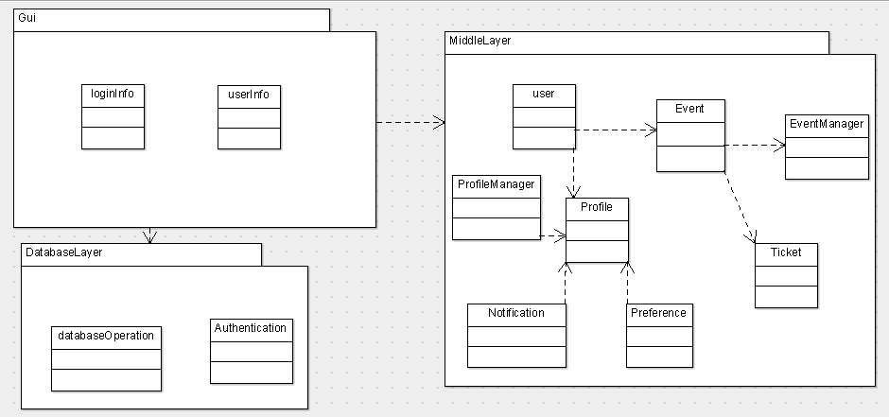

## Class diagrams

**We have attached the argoUML diagram for clarity.**

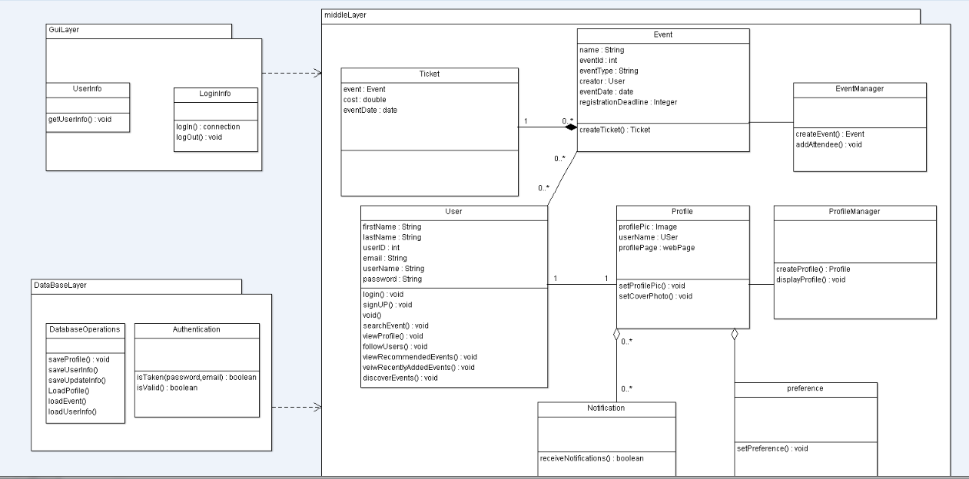

| **Class ID** | **Class Name** | **Subsystem ID** | **Description** |
| --- | --- | --- | --- |
| Class#1 | User | MiddleLayer | This represents the user of the event site who could be a visitor, an event creator or an event attendee. |
| Class#2 | Event | MiddleLayer | This is used to create events and manipulate them. |
| Class#3 | Ticket | MiddleLayer | This creates a ticket for events that require buying of tickets . |
| Class#5 | EventManager | MiddleLayer |  |
| Class#6 | ProfileManager | MiddleLayer |  |
| Class#7 | Preferences | MiddleLayer |  |
| Class#8 | Notifications | MiddleLayer |  |
| Class#9 | DatabaseOperations | DatabaseLayer |  |
| Class#10 | Authentications | DatabaseLayer |  |
| Class#11 | UserInfo | Gui |  |
| Class#12 | LoginInfo | Gui |  |

### Important Algorithm

## 

## Sequence diagrams

**SignUP**

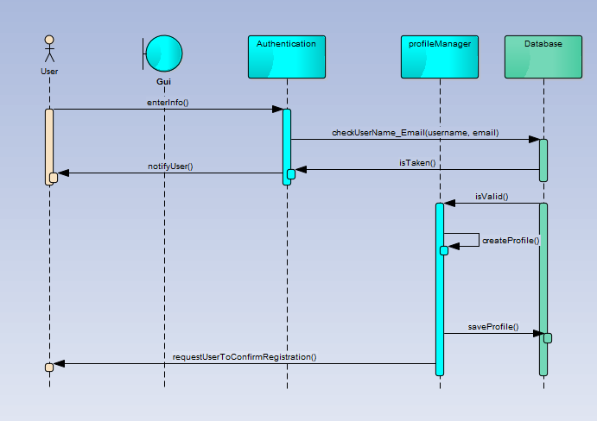

### 

### Login

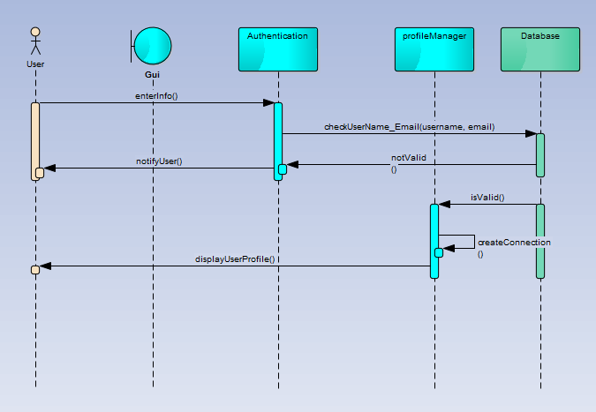

### joinEvent

### 

**Discover Event**

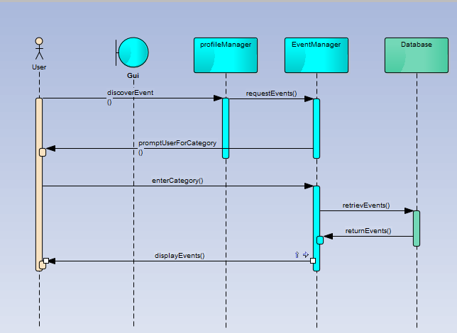

**Create Event**

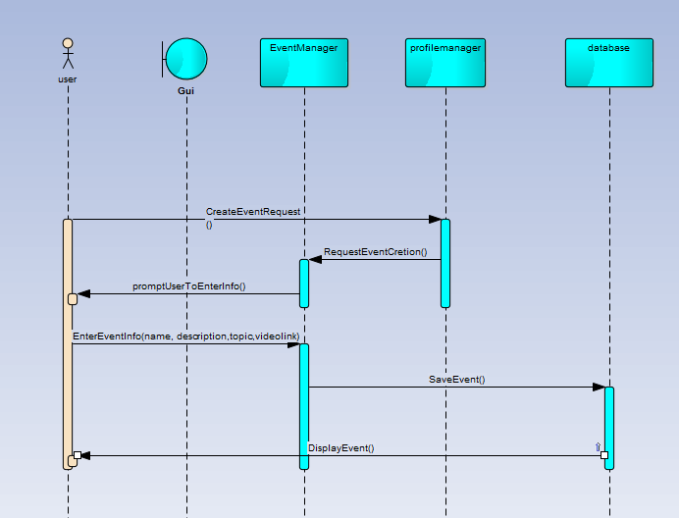

**Manage Event**

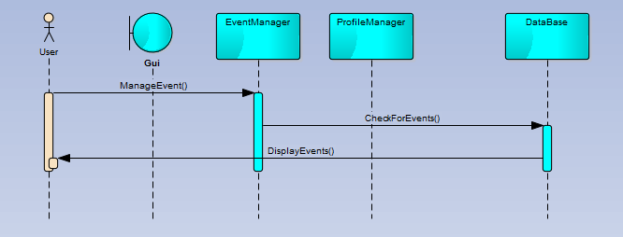

### Class - Sequence Usage

| **Class Name** | **Sequence Diagrams** | **Overall used methods** |
| --- | --- | --- |
| E.g. Employee | 1, 3, 5 (means Seq Ids 1, 3, 5 used Employee class) | Save, GetData |
|  |  |  |
|  |  |  |

## Physical Entity-Relationship Diagram

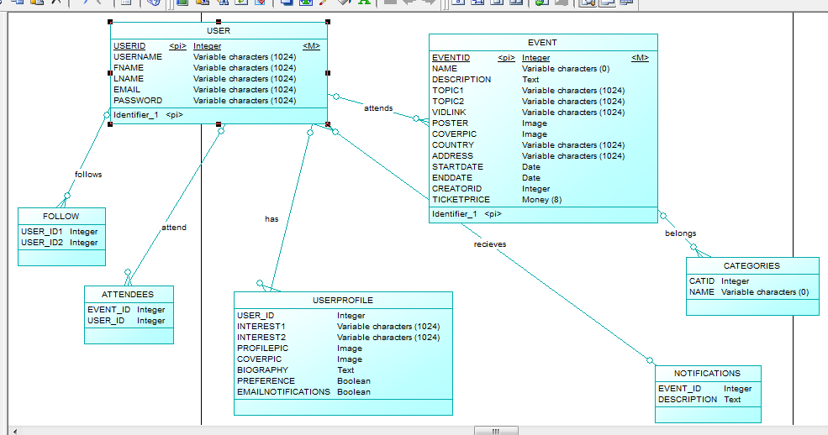

## 

## User Interface Design

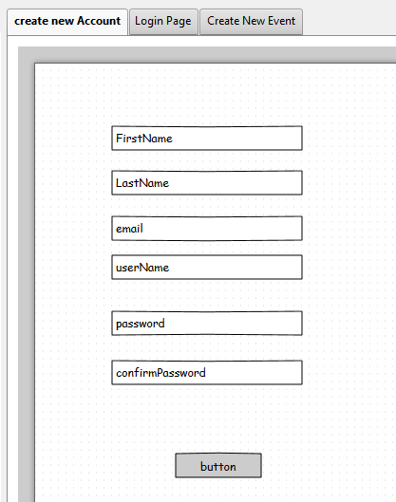

**Login**

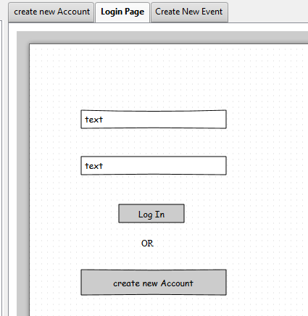

**New Event**

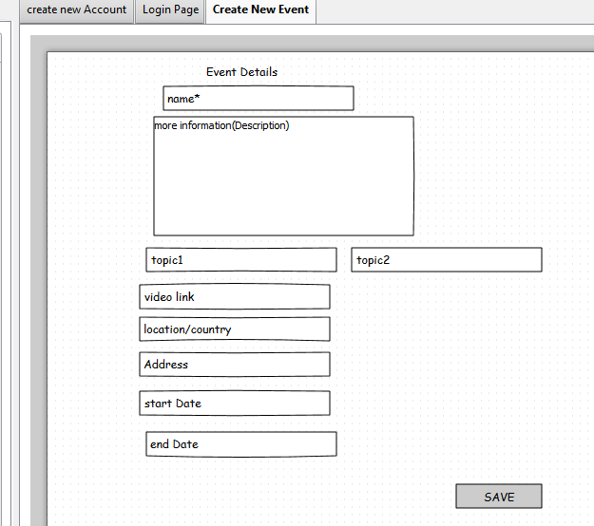

# 

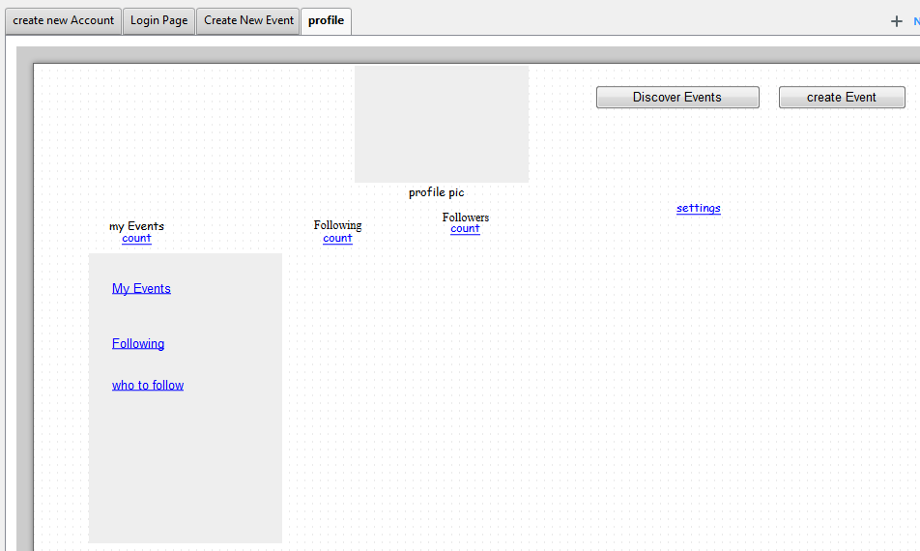

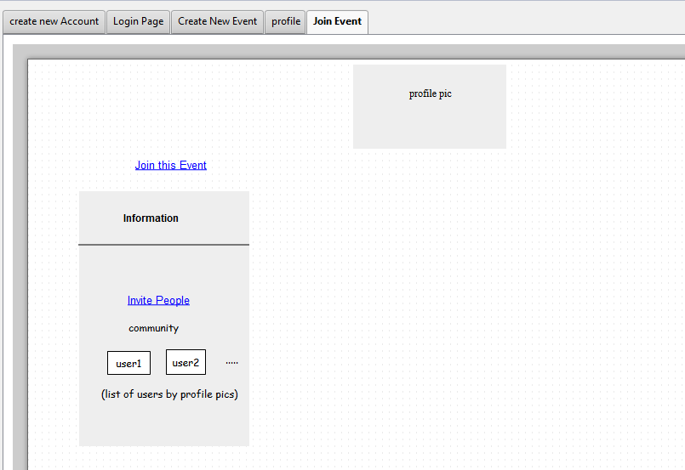

# 

# 

# 

# Ownership Report

|  |  |
| --- | --- |
| **Item** | **Owners** |
|  |  |
|  |  |

# Policy Regarding Plagiarism:

**Students have collective ownership and responsibility of their project. Any violation of academic honesty will have severe consequences and punishment for ALL team members.**

1. تشجع الكلية على مناقشة الأفكار و تبادل المعلومات و مناقشات الطلاب حيث يعتبر هذا جوهريا لعملية تعليمية سليمة
2. ساعد زملاءك على قدر ما تستطيع و حل لهم مشاكلهم فى الكود و لكن تبادل الحلول غير مقبول و يعتبر غشا.
3. أى حل يتشابه مع أى حل آخر بدرجة تقطع بأنهما منقولان من نفس المصدر سيعتبر أن صاحبيهما قد قاما بالغش.
4. قد توجد على النت برامج مشابهة لما نكتبه هنا أى نسخ من على النت يعتبر غشا يحاسب عليه صاحبه.
5. إذا لم تكن متأكدا أن فعلا ما يعد غشا فلتسأل المعيد أو أستاذ المادة.
6. فى حالة ثبوت الغش سيأخذ الطالب سالب درجة المسألة ، و فى حالة تكرار الغش سيرسب الطالب فى المقرر.

# References

* http://www.mhhe.com/engcs/compsci/pressman/graphics/Pressman5sepa/common/cs1/design.pdf

# Authors

* Eng Mostafa Saad