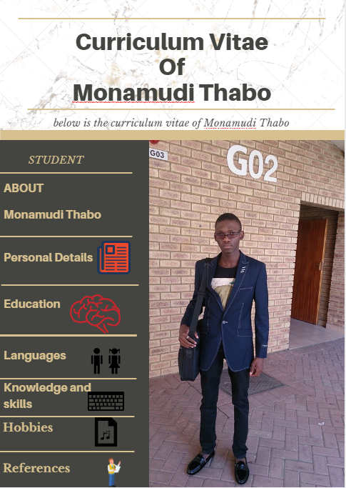

**Personal details**

Title : Mr

First names : Thabo

Surname : Monamudi

Postal address :1257 Mangope Street

Zone13

Sebokeng

1983

Date of birth : 1996/06/12

Identity number : 9606125235080

Gender : Male

Marital status : Single

Contacts : 062 029 8725

E-mail address : thabomonamodi0@gmail.com

Nationality : South African

Home language : South Sotho

Health : Good

Criminal offence : None

**Education**

High school attended : Thuto Tiro Comprehensive School

Highest grade passed : Grade12

Year : 2014

Subjects : Sesotho, English, Electrical technology,

Engineering Graphics and Design, Mathematics,

Physical Science, Life Orientation

**Languages**

Speak : South Sotho (Good), English (Fair)

Read : English (Excellent), South Sotho (Good)

Write : English (Good), South Sotho (Good)

**Skills**

Computer skilled : Microsoft visual studio C# (Good)

: Java bluej (Good)

: MySql workbench(Good)

: CLIPS (Good)

: Linux commands(Good)

: PHP & HTML(Fair)

Good with people

Self-motivated

Photo editing

**Hobbies**

Dancing

Drawing

Reading

Programming

Beat making/instrumentals

Helping others

**References**

Name : Ayanda Piyo

Relationship : Bodybuilding captain

Contacts : 074 235 7329

Name : Raphael Ntumba

Relationship : Bodybuilding couch

Contacts : 081 517 1705

Name : Lerato Mohlaloka

Relationship : High School Teacher

Contacts : 073 612 8828

Name : Tjhatjhobane Johnny Sehanka

Relationship : High School Teacher

Contacts : 073 306 6069