>> INSERT PROJECT LOGO HERE <<
MomBaby Healthcare AI
SOFTWARE DESIGN SPECIFICATION
(SDS)
Ho Chi Minh City, 2026

Record of Changes
Date | A* / M, D | In charge | Change Description
30/06/2026 | A | Team | Initialize the Software Design Specification document.
03/07/2026 | M | Team | Add System Architecture, Package, State and Detailed Class Design sections; presentation fixes.
* A – Added M – Modified D – Deleted

Table of Contents

Record of Changes 2
I. Overview 4
1. Purpose 4
2. Scope 4
3. Overall Description 4
4. Definitions, Acronyms, and Abbreviations 4
5. References 4
II. System Architecture 5
1. Deployment / Container Architecture 5
2. Package Diagram 5
III. System Models 6
1. Use Case Diagram 6
2. Activity Diagrams 6
2.1 Manage Allergy & Weaning Log 6
2.2 View Baby Menu & Exclude Allergens 6
2.3 Postpartum Mood Tracking & Alert (EPDS) 6
2.4 Create & Approve Recipe 7
2.5 Import & Update USDA Data 7
2.6 Create & Update Baby's Profile 7
2.7 Monitor & Consult Assigned Mother 7
2.8 Receive Avoidance Warning (Myth Debunking) 7
2.9 Manage Mom & Staff Accounts 8
2.10 Manage Business Rules 8
3. State Machine Diagrams 8
3.1 Recipe Review Lifecycle (RecipeStatus) 8
3.2 Maternal Journey Stage (JourneyStage) 8
3.3 Notification Alert Lifecycle (NotificationStatus) 8
3.4 Medication Adherence (AdherenceStatus) 9
3.5 Subscription Tier (SubscriptionTier) 9
3.6 Lifestyle / Daily-Monitoring Alert (AlertStatus) 9
4. Data Conceptual Model 9
4.1 Entity Descriptions 9
IV. Code Designs 11
Design Conventions 11
1. User Registration 11
1.a Class Diagram 11
1.b Sequence Diagram 11
2. User Login 11
2.a Class Diagram 12
2.b Sequence Diagram 12
3. View Daily Baby Menu 12
3.a Class Diagram 12
3.b Sequence Diagram 12
4. Record Symptom & Generate Alert 12
4.a Class Diagram 12
4.b Sequence Diagram 13
V. Notes 14

I. Overview

1. Purpose
This Software Design Specification (SDS) describes the software design of the MomBaby Healthcare AI system. It translates the requirements captured in the SRS into design artifacts — the system architecture, package structure, use case, activity, sequence, state machine, class and conceptual data models — that guide implementation and serve as a reference for the development, testing and maintenance teams.

2. Scope
MomBaby Healthcare AI is an AI-assisted platform that supports mothers throughout the pre-pregnancy, pregnancy and postpartum journeys. Its main capabilities include maternal and baby nutrition planning, weaning and allergy logging, symptom tracking with AI analysis, medication reminders, postpartum mental-health screening (EPDS), expert recipe review and real-time health alerts. The system is composed of a React single-page application, an ASP.NET Core backend, a Python FastAPI nutrition microservice, a shared PostgreSQL database and several external services.

3. Overall Description
The backend follows a layered architecture: Controllers expose REST endpoints, Domain Services contain the business logic, a Data Access layer (Entity Framework Core with the Repository pattern) persists data to PostgreSQL, and Integration Clients communicate with external services. Cross-cutting concerns include JWT authentication, a subscription-tier middleware, a global rate limiter, background workers for reminders, and a SignalR hub that pushes real-time alerts to the client. The Python microservice provides USDA-based nutrition analysis and WHO-compliant meal recommendations.

4. Definitions, Acronyms, and Abbreviations
Term | Description
SDS | Software Design Specification.
SRS | Software Requirements Specification.
EPDS | Edinburgh Postnatal Depression Scale — postpartum depression screening questionnaire.
USDA API | United States Department of Agriculture FoodData Central service.
RBAC | Role-Based Access Control (Mom, Expert, Staff, Admin).
SPA | Single-Page Application (React front-end).

5. References
- Software Requirements Specification (SRS) — MomBaby Healthcare AI.
- Source code repositories: MomOi.API (ASP.NET Core), MomOi.NutritionAPI (FastAPI), Front-end (React).

II. System Architecture
Note: every figure below is a placeholder. Export the corresponding diagram and replace the dashed box with the exported image.

1. Deployment / Container Architecture
The deployment diagram shows the overall (high-level) architecture of the system: the React SPA, the momoi-api container (ASP.NET Core 8), the nutrition-api container (Python FastAPI), the shared PostgreSQL database and the external services (Google Gemini, USDA FoodData Central, SMTP, Twilio, Firebase). It establishes the components used as lifelines in the sequence diagrams.
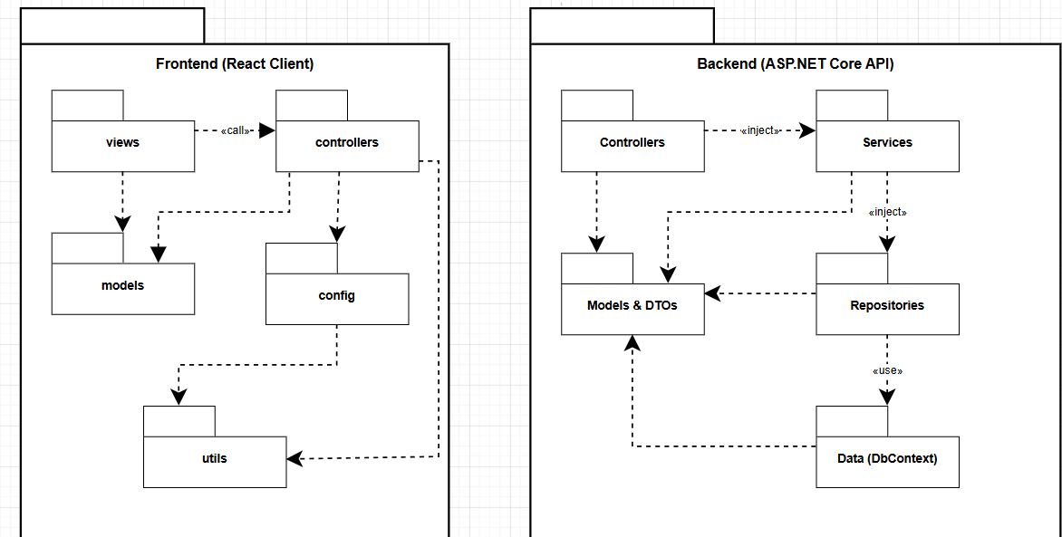Figure 1. Deployment / Container Architecture Diagram

2. Package Diagram
The package diagram presents the code organization of the backend: Controllers, Services (domain packages), Repositories/Data, DTOs, Models, Hubs, Middleware, BackgroundServices and Integration. It clarifies the dependencies between packages.
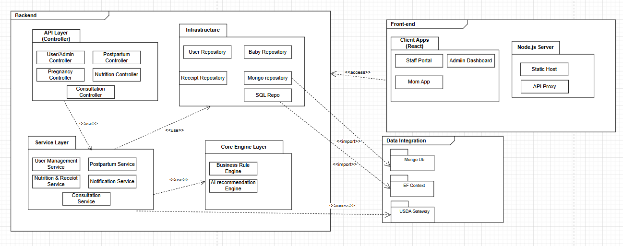Figure 2. Package Diagram

III. System Models

1. Use Case Diagram
The use case diagram captures the main actors — Mom, Staff (Expert/Nutritionist), Caregiver and Admin — together with the primary functions of the system. Association lines connect actors to their use cases; include/extend relationships use the correct notation.
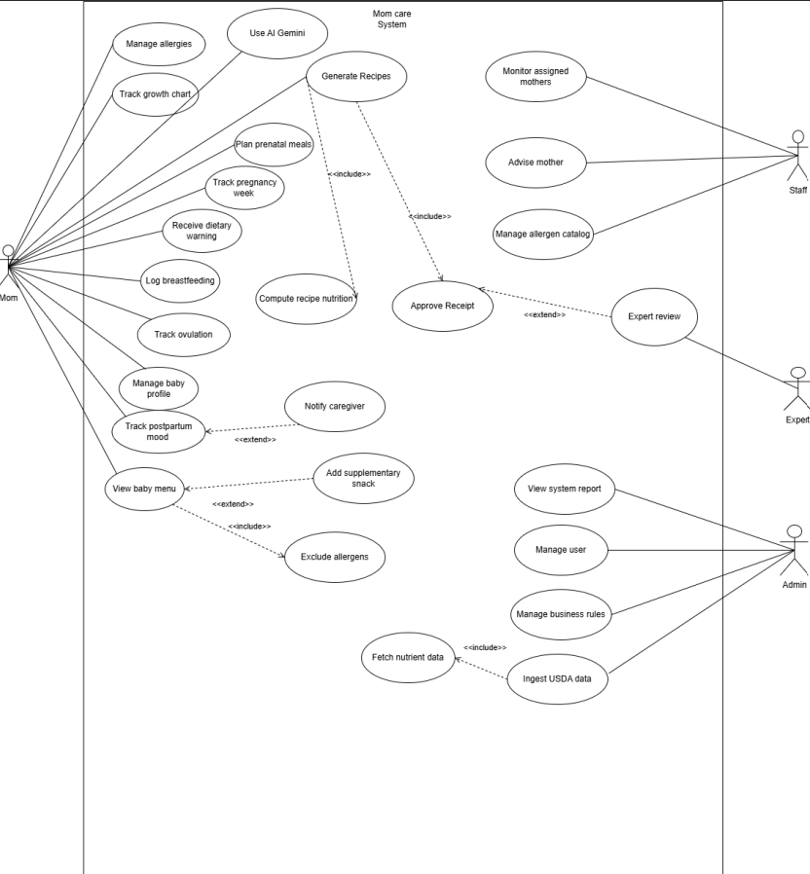Figure 3. Use Case Diagram

2. Activity Diagrams
The following activity diagrams describe the control flow of each major use case, including decision points and swimlane responsibilities. Each diagram is presented as a full, un-cropped figure.

2.1 Manage Allergy & Weaning Log
Mom logs the food consumed by the baby; the System checks the ingredient catalog. If an allergic reaction is reported, the System updates the allergy data and adds the ingredient to the baby's banned list; otherwise it saves a normal weaning log. New foods are forwarded to Staff for review.
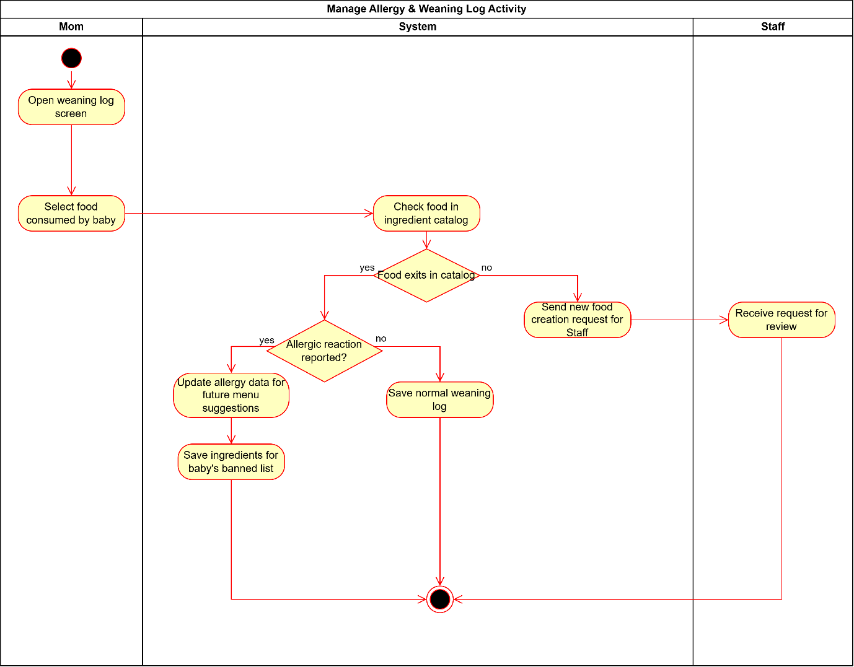Figure 2.1. Manage Allergy & Weaning Log (Activity Diagram)

2.2 View Baby Menu & Exclude Allergens
Mom opens the baby menu; the System retrieves the baby profile and filters dishes by the baby's age and nutrition goals. If the baby has an allergy history, dishes containing allergic ingredients are removed before a personalized safe menu is displayed.
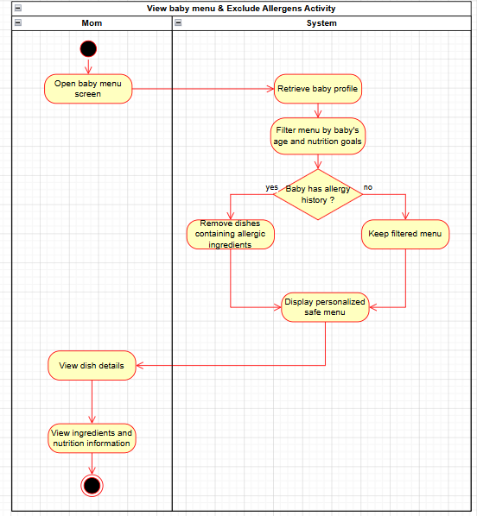
Figure 2.2. View Baby Menu & Exclude Allergens (Activity Diagram)

2.3 Postpartum Mood Tracking & Alert (EPDS)
Mom answers the EPDS questionnaire; the System calculates the total score. If the score exceeds the safe threshold, a high-risk depression alert is activated, the Caregiver is notified and an urgent report is sent to Staff; otherwise the result is marked normal.
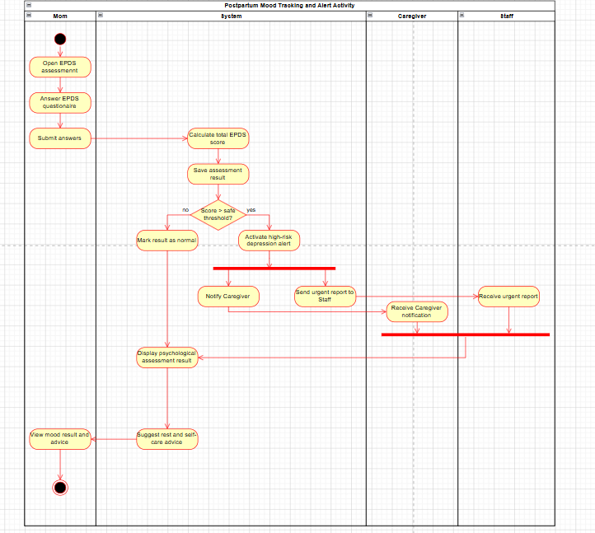Figure 2.3. Postpartum Mood Tracking & Alert (EPDS) (Activity Diagram)

2.4 Create & Approve Recipe
Staff (Expert/Nutritionist) enters recipe details and ingredients and requests a nutrition calculation from the USDA API. Missing micronutrients can be added manually. After review and approval, the recipe and its nutrition data are updated in the library.
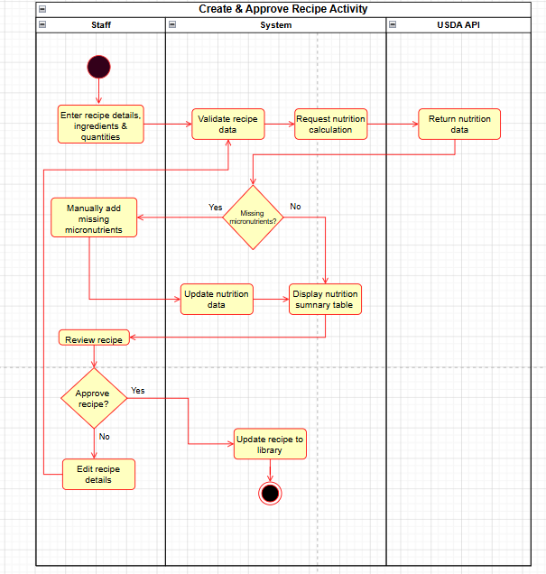
Figure 2.4. Create & Approve Recipe (Activity Diagram)

2.5 Import & Update USDA Data
Admin triggers a USDA sync; the System checks the connection and requests data from the USDA API. On timeout it logs the error and schedules an automatic retry after 30 minutes; otherwise nutrient data is validated, normalized, matched with system ingredients and upserted, then a sync log is written.
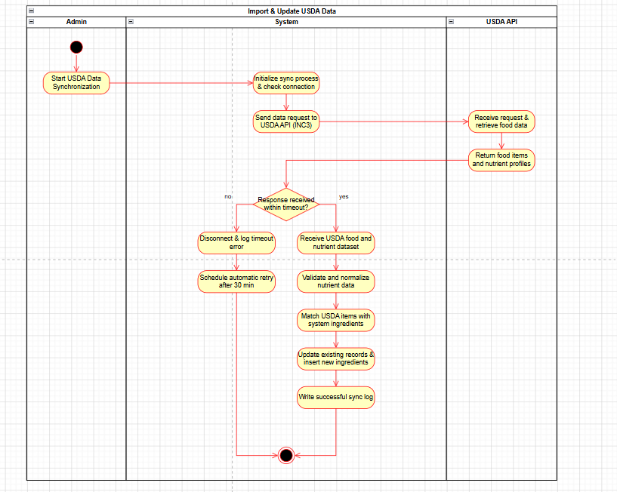Figure 2.5. Import & Update USDA Data (Activity Diagram)

2.6 Create & Update Baby's Profile
Mom adds or edits the baby's information; the System validates the input. If required fields are missing, an error is displayed; otherwise the profile is saved and the baby's growth-chart baseline is updated.
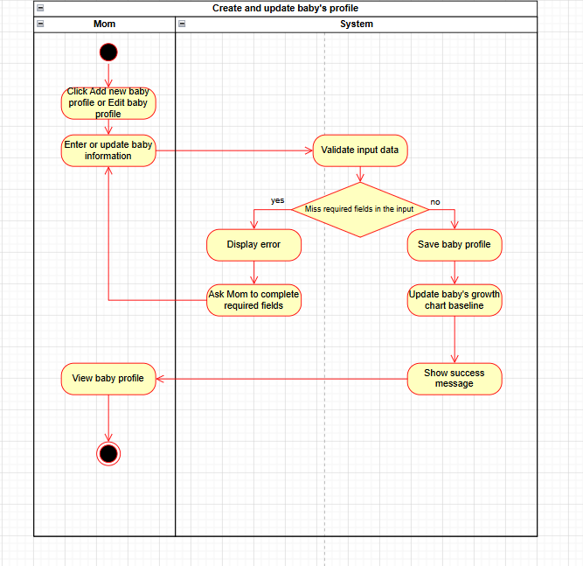Figure 2.6. Create & Update Baby's Profile (Activity Diagram)

2.7 Monitor & Consult Assigned Mother
Staff receives an alert or message on the dashboard, reviews the Mom's detailed health profile and activity log, and writes medical notes. The System checks the Mom's online status and either delivers the message in real time or saves it and sends a push notification.
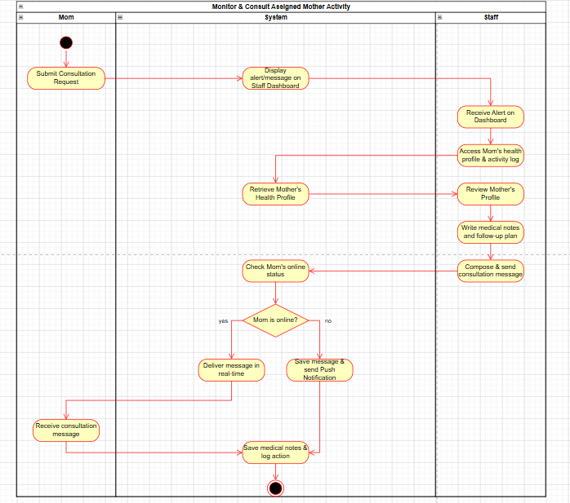
Figure 2.7. Monitor & Consult Assigned Mother (Activity Diagram)

2.8 Receive Avoidance Warning (Myth Debunking)
Mom searches an avoidance keyword; the System cross-analyzes it with a scientific medical database. If the myth exists, evidence-based information is retrieved and a warning is displayed; otherwise the missing keyword is logged for research.
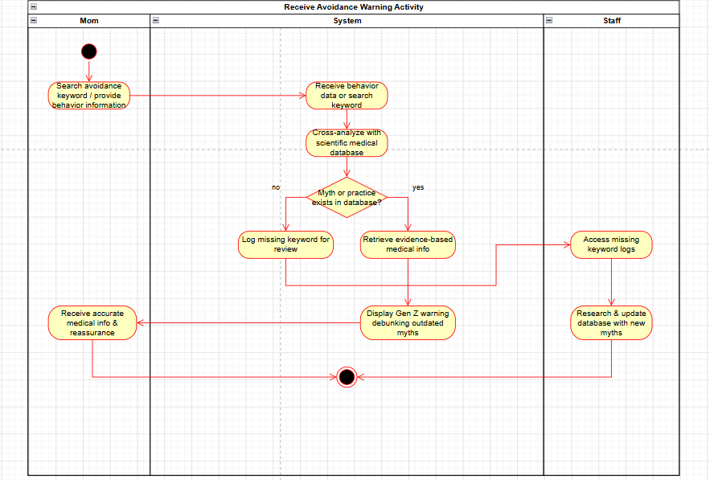Figure 2.8. Receive Avoidance Warning (Myth Debunking) (Activity Diagram)

2.9 Manage Mom & Staff Accounts
Admin searches an account, updates its role or status, and saves the changes. The System validates and applies the access changes, then displays the updated account information.
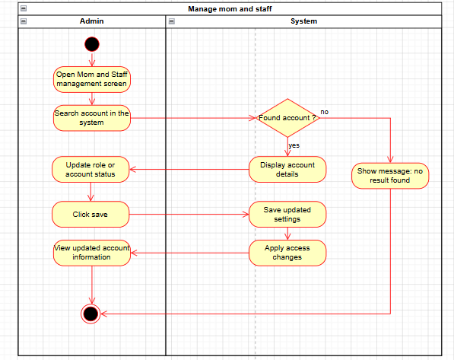
Figure 2.9. Manage Mom & Staff Accounts (Activity Diagram)

2.10 Manage Business Rules
Admin adjusts parameters (EPDS, Z-score, BMI). The System validates the data format; invalid data blocks saving and raises a validation error, while valid rules are saved and applied system-wide immediately.
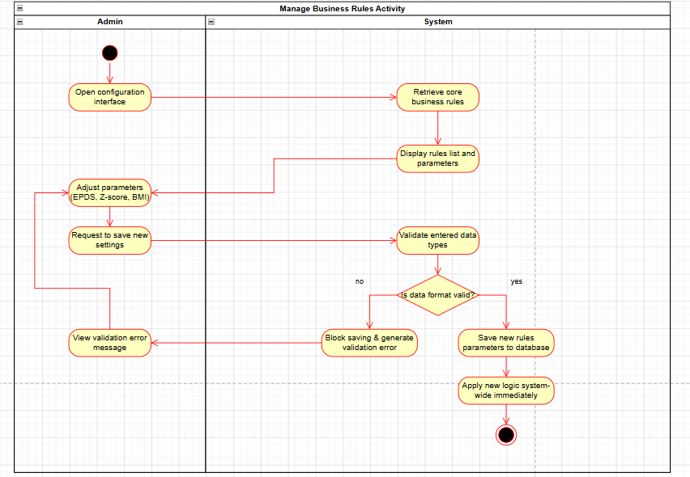Figure 2.10. Manage Business Rules (Activity Diagram)

3. State Machine Diagrams
The state machine diagrams model the lifecycle of the domain objects that carry an explicit status. Each transition is labeled as event [guard] / action, with an initial pseudostate and a final state where the lifecycle terminates.

3.1 Recipe Review Lifecycle (RecipeStatus)
PendingReview -> Approved / Rejected. A recipe generated by AI starts as PendingReview; an Expert approves it (visible to Moms) or rejects it with a note(hidden). Source: ExpertService.ReviewRecipeAsync.
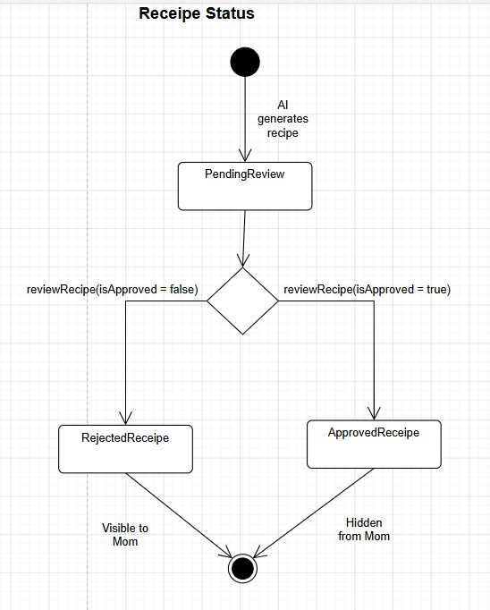
Figure 4.1. State Diagram — Recipe Review Lifecycle (RecipeStatus)

3.2 Maternal Journey Stage (JourneyStage)
PrePregnancy -> Pregnant -> Postpartum, with a cycle Postpartum -> Pregnant for a next pregnancy. Open lifecycle (no terminal state). Source: Auth / Pregnancy / Postpartum services.
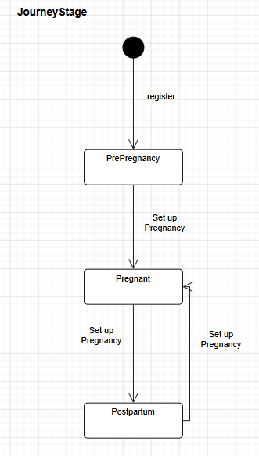
Figure 4.2. State Diagram — Maternal Journey Stage (JourneyStage)

3.3 Medication Adherence (AdherenceStatus)
Reminded -> Taken / Skipped. A reminder log is created by MedicationReminderWorker; the Mom confirms Taken or Skipped through UpdateAdherenceAsync.
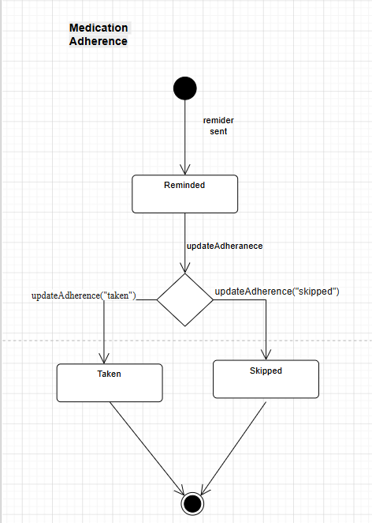
Figure 4.3. State Diagram — Medication Adherence (AdherenceStatus)

3.4 Lifestyle / Daily-Monitoring Alert (AlertStatus)
Pending -> Resolved. Raised by the BusinessRuleEngine when a threshold is breached.
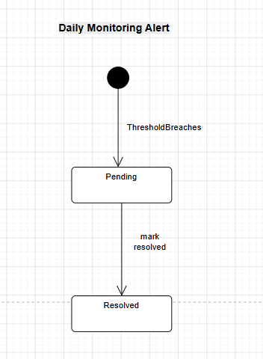
Figure 4.4. State Diagram — Lifestyle / Daily-Monitoring Alert (AlertStatus)

4. Data Conceptual Model
The conceptual data model represents ALL core domain entities and their relationships at a conceptual level (no foreign keys; relationships use multiplicities, composition, aggregation and generalization), with getter/setter operations shown for each entity. The system uses a single User entity with a role attribute (RBAC); the Expert actor is related only to the Recipe it reviews, and the baby NutritionPlan is related to the BabyProfile.
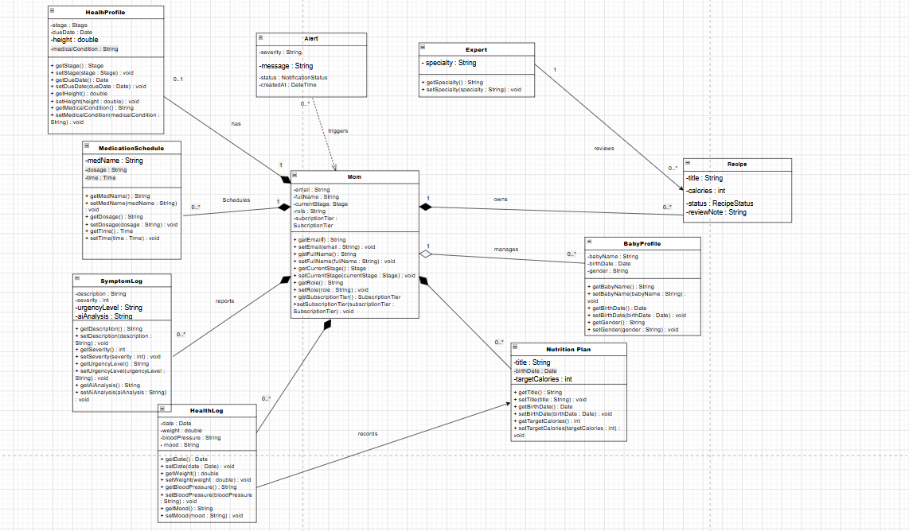Figure 5. Conceptual Data Model

4.1 Entity Descriptions
Entity | Description
User | The single account entity (AppUser). A role attribute distinguishes Mom, Expert, Admin and Staff (Role-Based Access Control).
HealthProfile | The mother's health profile (journey stage, due date, height, medical conditions). Composition of User.
BabyProfile | A baby managed by the mother (name, birth date, gender). Composition of User.
HealthLog | Daily health-monitoring entries (weight, blood pressure, mood). Composition of User.
SymptomLog | A reported symptom with AI analysis and urgency level. May trigger an Alert.
Alert | A health alert/notification (severity, message, status). Received by the User and triggered by a SymptomLog.
NutritionPlan | A personalized nutrition plan. (Baby nutrition plan — related to BabyProfile, not directly to Mom.)
Recipe | An AI-generated recipe with a review Status (PendingReview / Approved / Rejected). Reviewed by a User with the Expert role.
MedicationSchedule | A medication reminder schedule (name, dosage, time). Composition of User.

IV. Code Designs
This section presents the detailed design of each feature. As required, every sequence diagram is accompanied by its own class diagram. For each feature below: (a) the class diagram shows the participating classes, and (b) the sequence diagram shows their interaction over time. The two are kept consistent — every class shown as a lifeline in the sequence also appears in the class diagram, and vice versa.

Design Conventions
- Interface realization (implementation) is drawn as a dashed line with a hollow triangle arrowhead; the word "implements" is not used as a text label.
- A dependency (one class using another) is drawn as a dashed arrow with the «use» stereotype.
- Every lifeline in a sequence diagram also appears as a class in the paired class diagram, and vice versa.
- Repository classes are named after the entity they manage (for example IGenericRepository<SymptomLog>), not left generic.
- Sequence messages use operation names only (language-neutral), so the design can be implemented in any programming language.

1. User Registration
Participating classes: Boundary/Page, Controller, Service (interface + implementation), Repository / Manager, DbContext, the related DTOs and the domain Entity — all of which appear as lifelines in the paired sequence diagram.

1.a Class Diagram
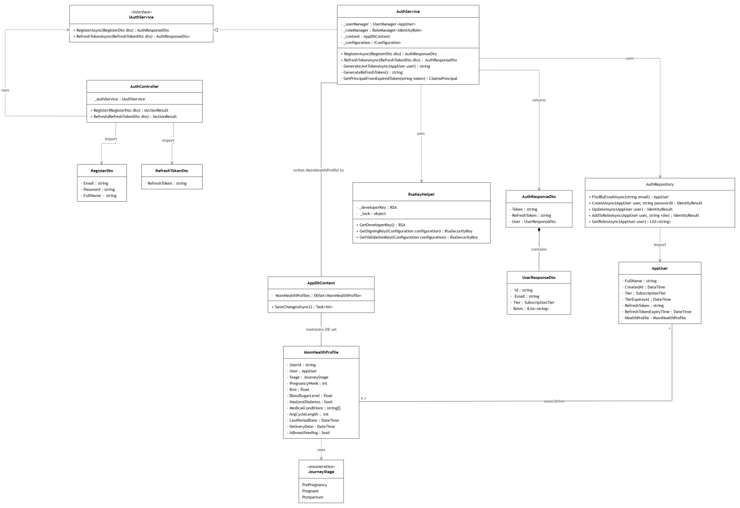Figure 6.1a. Class Diagram — User Registration

1.b Sequence Diagram
The Mom submits the registration form. AuthController calls AuthService.RegisterAsync, which uses UserManager<AppUser> to create the account (CreateAsync), assigns the "Mom" role (AddToRoleAsync), creates the MomHealthProfile, then generates the JWT and refresh token and returns AuthResponseDto. Persistence goes through AppDbContext to the database.
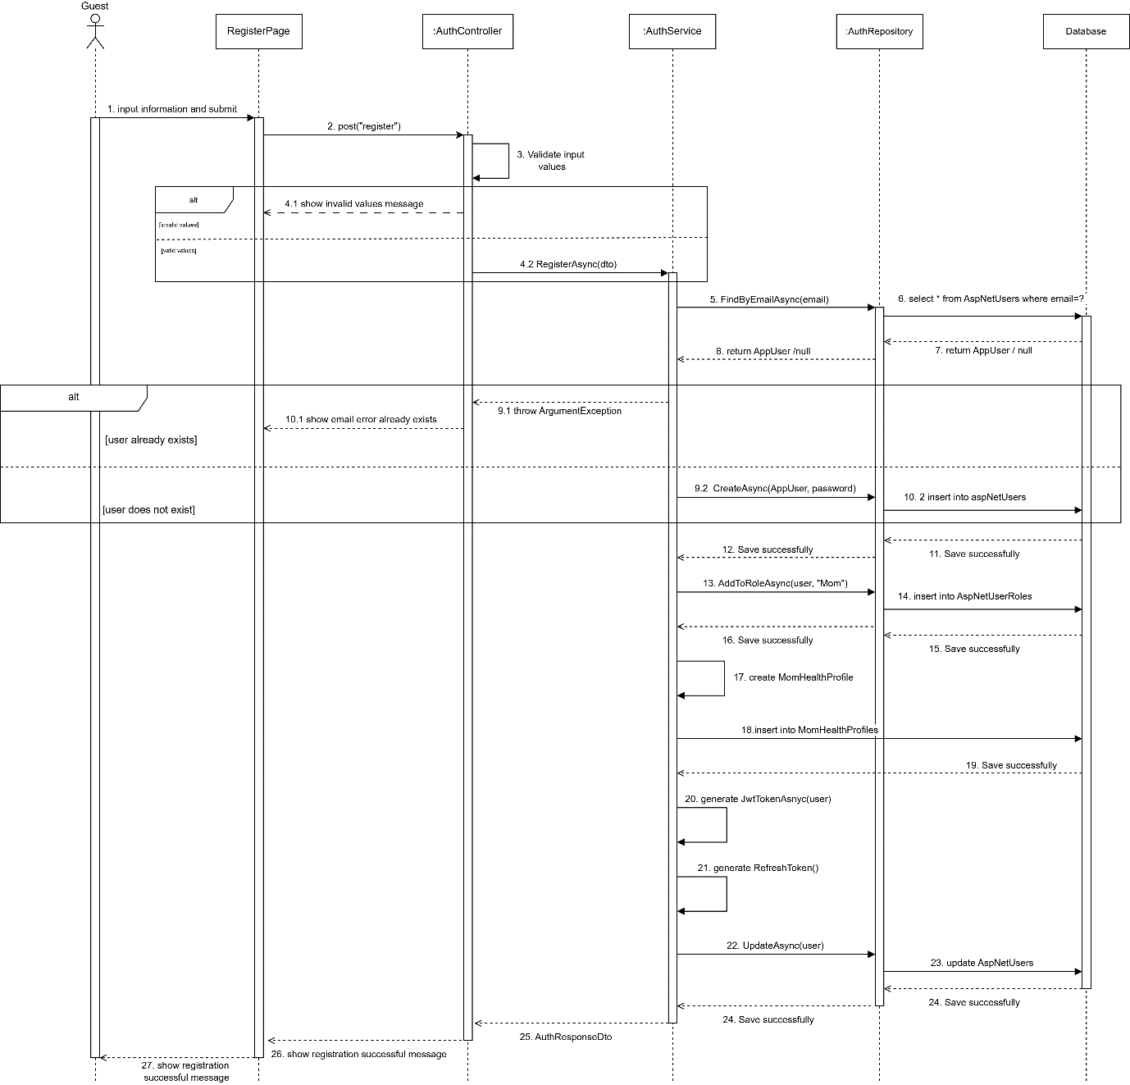
Figure 6.1b. Sequence Diagram — User Registration

2. User Login
Participating classes: Boundary/Page, Controller, Service (interface + implementation), Repository / Manager, DbContext, the related DTOs and the domain Entity — all of which appear as lifelines in the paired sequence diagram.

2.a Class Diagram
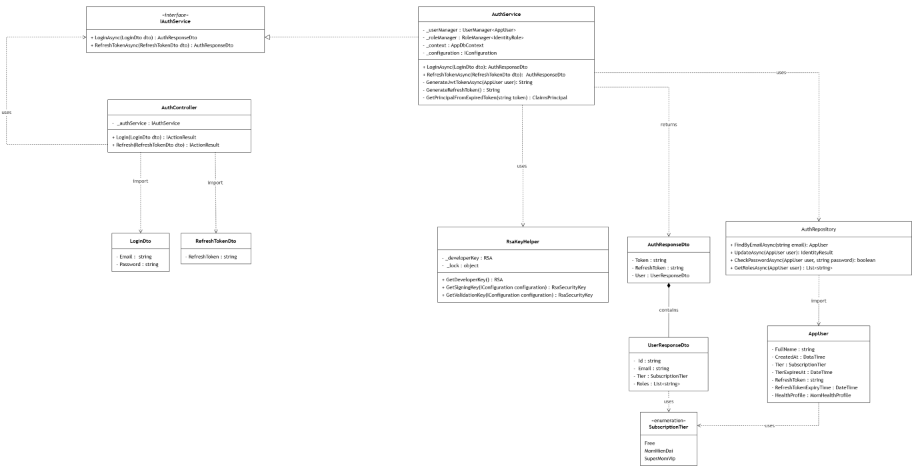Figure 6.2a. Class Diagram — User Login

2.b Sequence Diagram
The Mom submits email and password. AuthController calls AuthService.LoginAsync, which finds the user (FindByEmailAsync), verifies the password, retrieves the roles (GetRolesAsync), generates the JWT and refresh token, updates the user (UpdateAsync) and returns AuthResponseDto. Invalid credentials return a login-failed message.
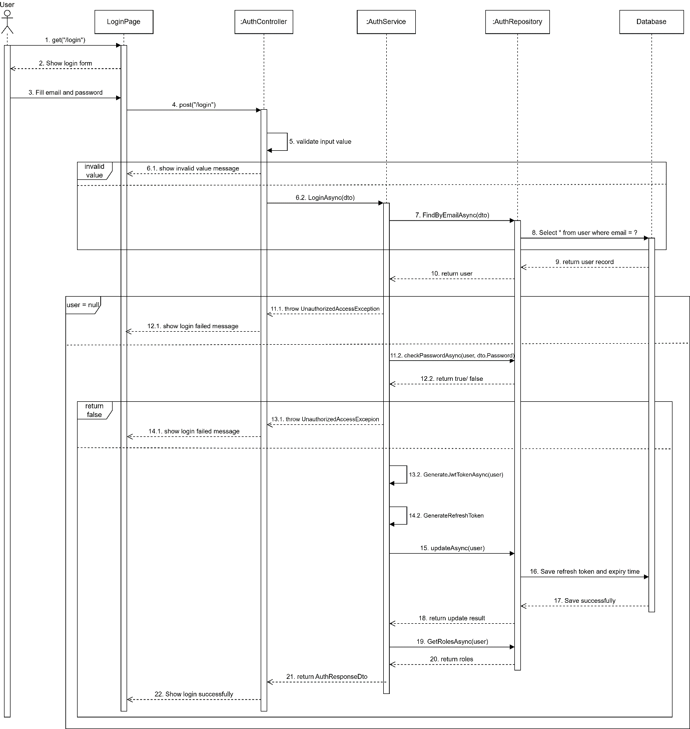Figure 6.2b. Sequence Diagram — User Login

3. AI Generates Meal Plan
Participating classes: the class diagram shows the full meal-plan generation subsystem, spanning both the .NET API and the Python nutrition engine.
- .NET (Boundary/Controller/Service): PregnancyController, IPregnancyService / PregnancyService (prenatal meal plan), DietController, IDietService / DietService (AI-generated diet plan), NutritionProxyService (HTTP client to the Python engine), IGeminiService / GeminiService (Gemini AI recipe generation).
- Repository / Entity: IGenericRepository<T>, DietPlan.
- Python (FastAPI nutrition engine): FastAPI_App, PrenatalMealPlansModule, RecommendationEngineModule, WhoNutritionGoalsModule, and the domain tables Ingredient, Recipe, RecipeIngredient.
The two subsystems communicate over HTTP REST API calls (JSON) — NutritionProxyService on the .NET side calls the Python FastAPI_App endpoints, which delegate to the WHO/USDA-based recommendation modules

a Class Diagram
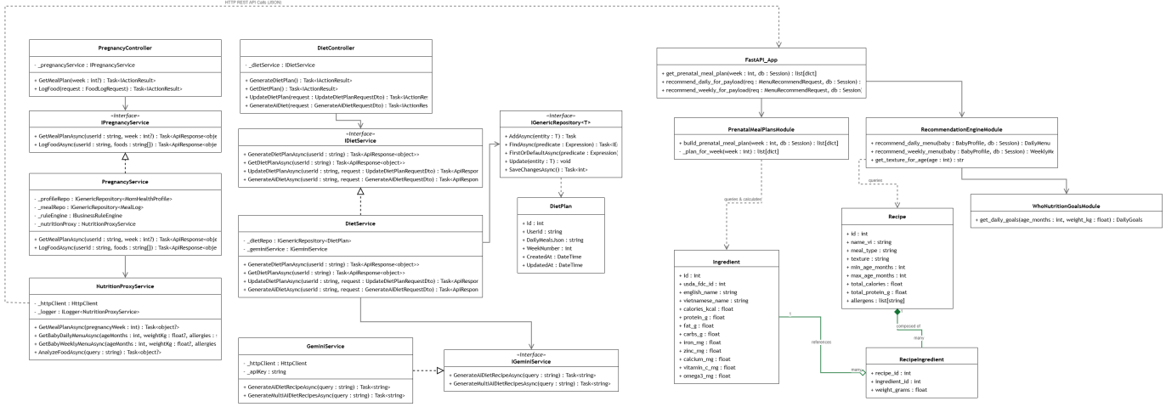
Figure 6.3a. Class Diagram — AI Generates new plan

3.b Sequence Diagram
The Mom requests her prenatal meal plan for a given pregnancy week. PregnancyController.GetMealPlan calls PregnancyService.GetMealPlanAsync(userId, week), which delegates to NutritionProxyService.GetMealPlanAsync(pregnancyWeek) — this issues GET /api/nutrition/meal-plan?week={week} to the Python nutrition engine. The FastAPI endpoint calls PrenatalMealPlansModule.build_prenatal_meal_plan(week, db), which selects the correct trimester's 7-day plan, rotates it deterministically by the pregnancy week, and computes the daily nutrient totals from the Ingredient table (USDA-sourced data). The resulting 7-day plan is returned as JSON up through NutritionProxyService to PregnancyService, which wraps it in an ApiResponse and returns it to the Mom. If the Python service is unreachable, PregnancyService returns an honest failure message instead of showing fabricated data — there is no hardcoded fallback plan.
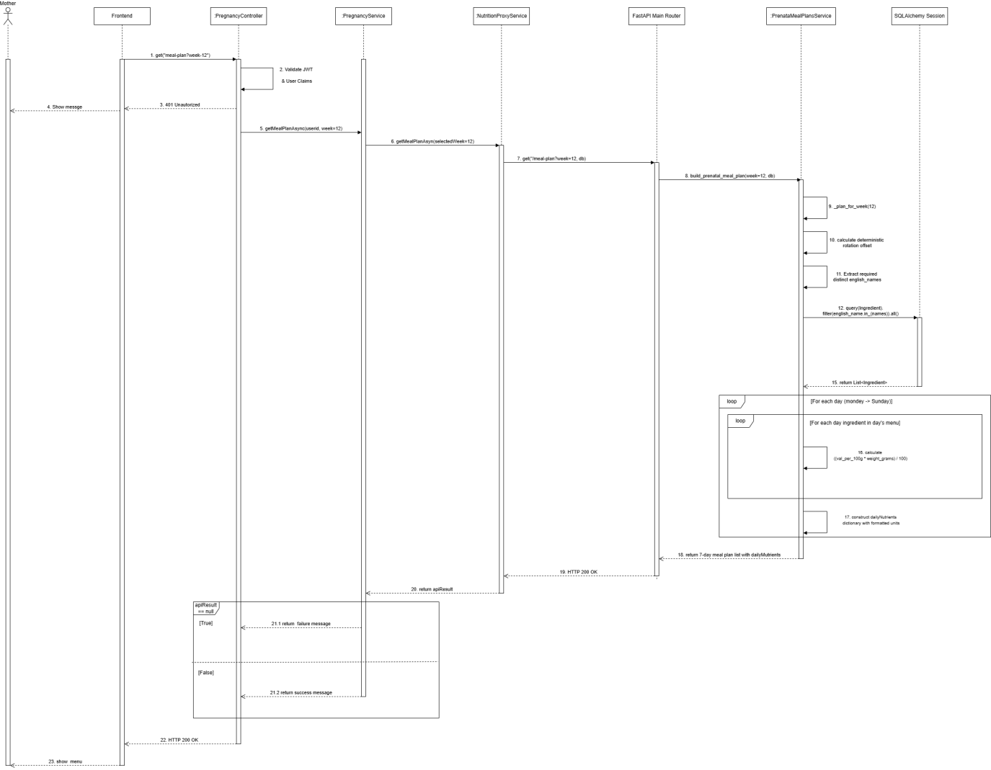

Figure 6.3b. Sequence Diagram — View Daily Baby Menu

4. Record Symptom & Generate Alert
Participating classes: Boundary/Page, Controller, Service (interface + implementation), Repository / Manager, DbContext, the related DTOs and the domain Entity — all of which appear as lifelines in the paired sequence diagram.

4.a Class Diagram
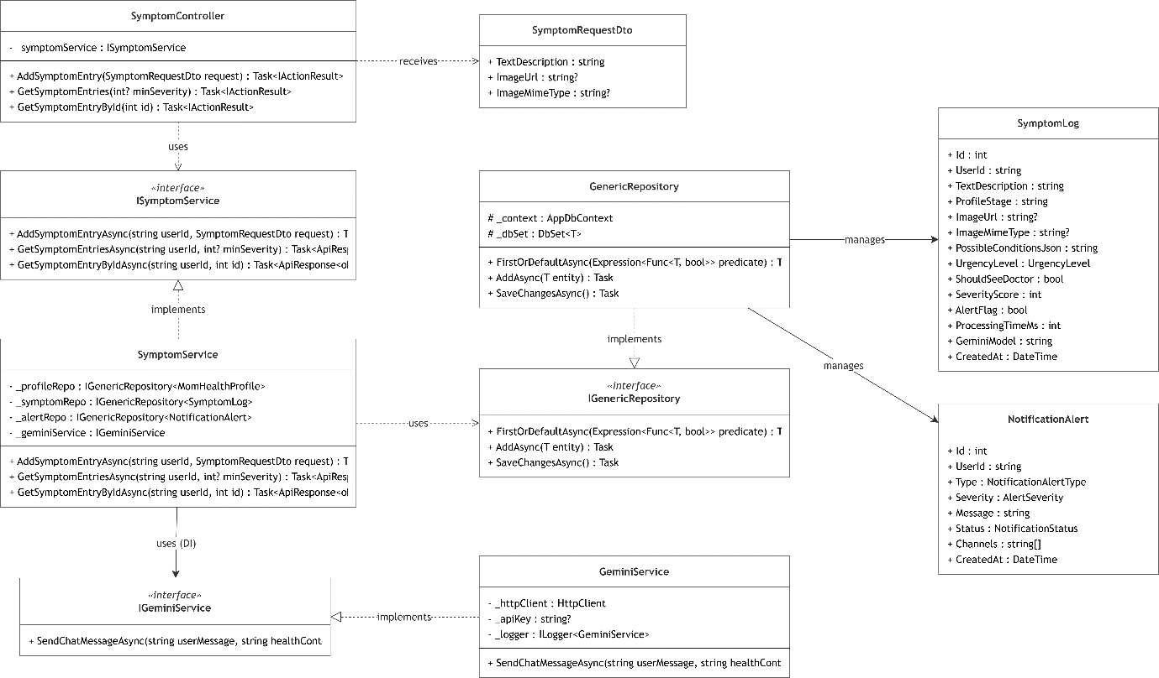Figure 6.4a. Class Diagram — Record Symptom & Generate Alert

4.b Sequence Diagram
The Mom submits a symptom. SymptomController calls SymptomService, which analyzes the symptom (Gemini AI / nutrition), persists it via AppDbContext, and — when the BusinessRuleEngine detects a high-urgency condition — creates a NotificationAlert and pushes it in real time through the AlertHub (SignalR).

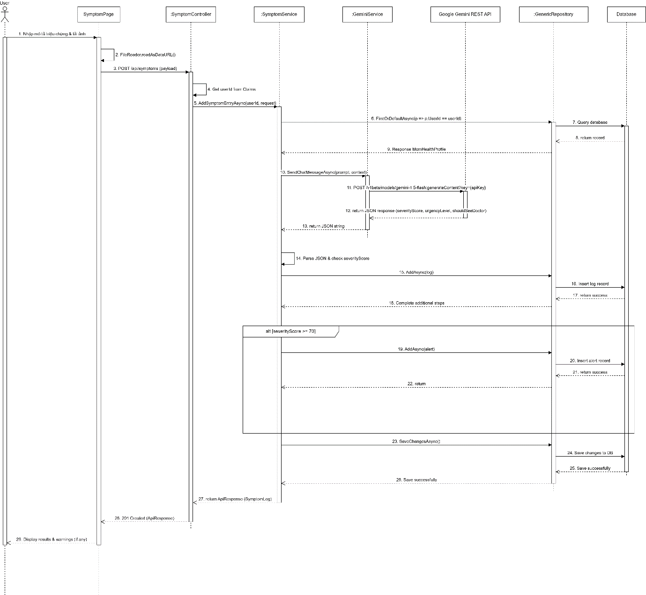Figure 6.4b. Sequence Diagram — Record Symptom & Generate Alert

5. Expert Reviews AI-Generated Recipe
Participating classes: ExpertDashboardPage (Boundary/Page), ExpertController, ExpertService, IUnitOfWork / Repository<Recipe>, AppDbContext, ReviewRecipeDto and the Recipe entity — all of which appear as lifelines in the paired sequence diagram.

5.a Class Diagram
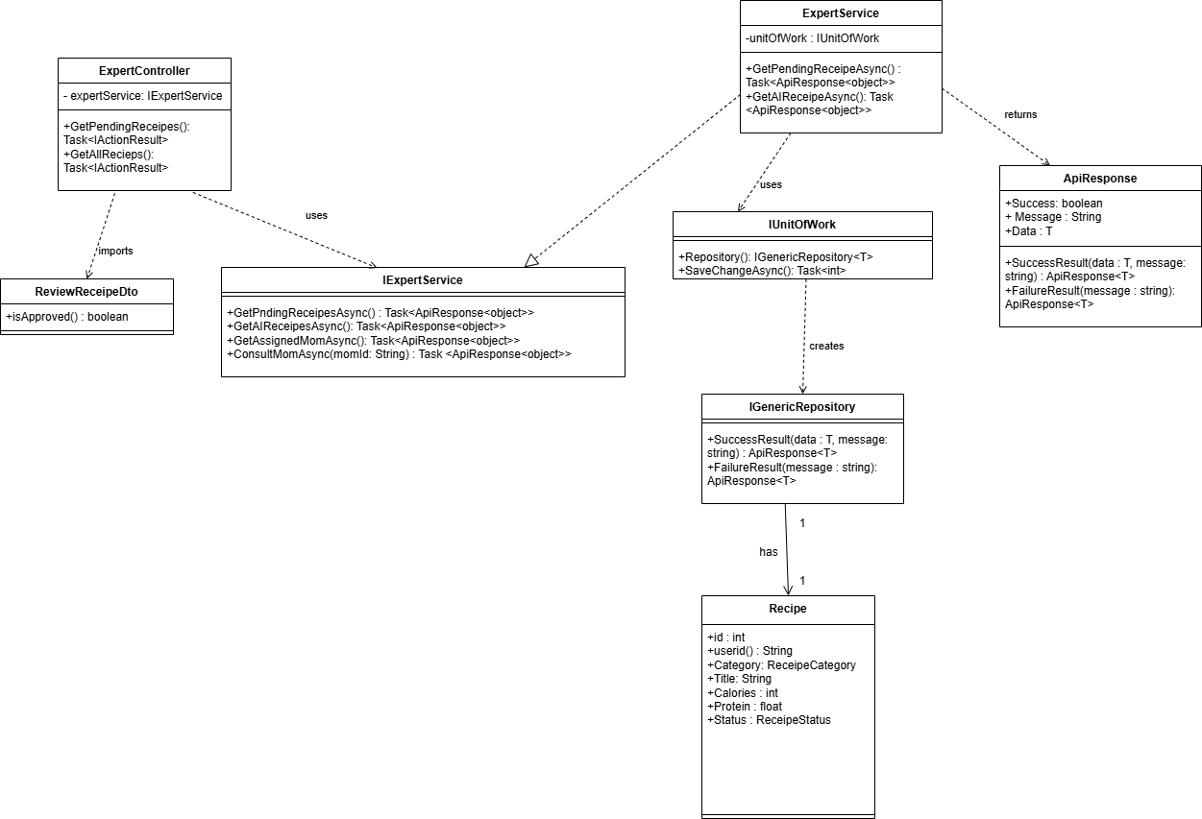Figure 6.5a. Class Diagram — Expert Reviews AI-Generated Recipe

5.b Sequence Diagram
The Expert opens the review dashboard and selects a pending recipe to Approve or Reject (with an optional/required Note). ExpertController resolves the expertId from the JWT claims and calls ExpertService.ReviewRecipeAsync, which loads the recipe via IUnitOfWork / Repository<Recipe>, validates it (the recipe must exist and still be PendingReview; a rejection requires a Note), updates its Status, ExpertNote, ReviewedByExpertId and ReviewedAt, and persists the change through SaveChangesAsync. No exceptions are used for validation failures — every outcome, success or failure, is returned as an ApiResponse object.
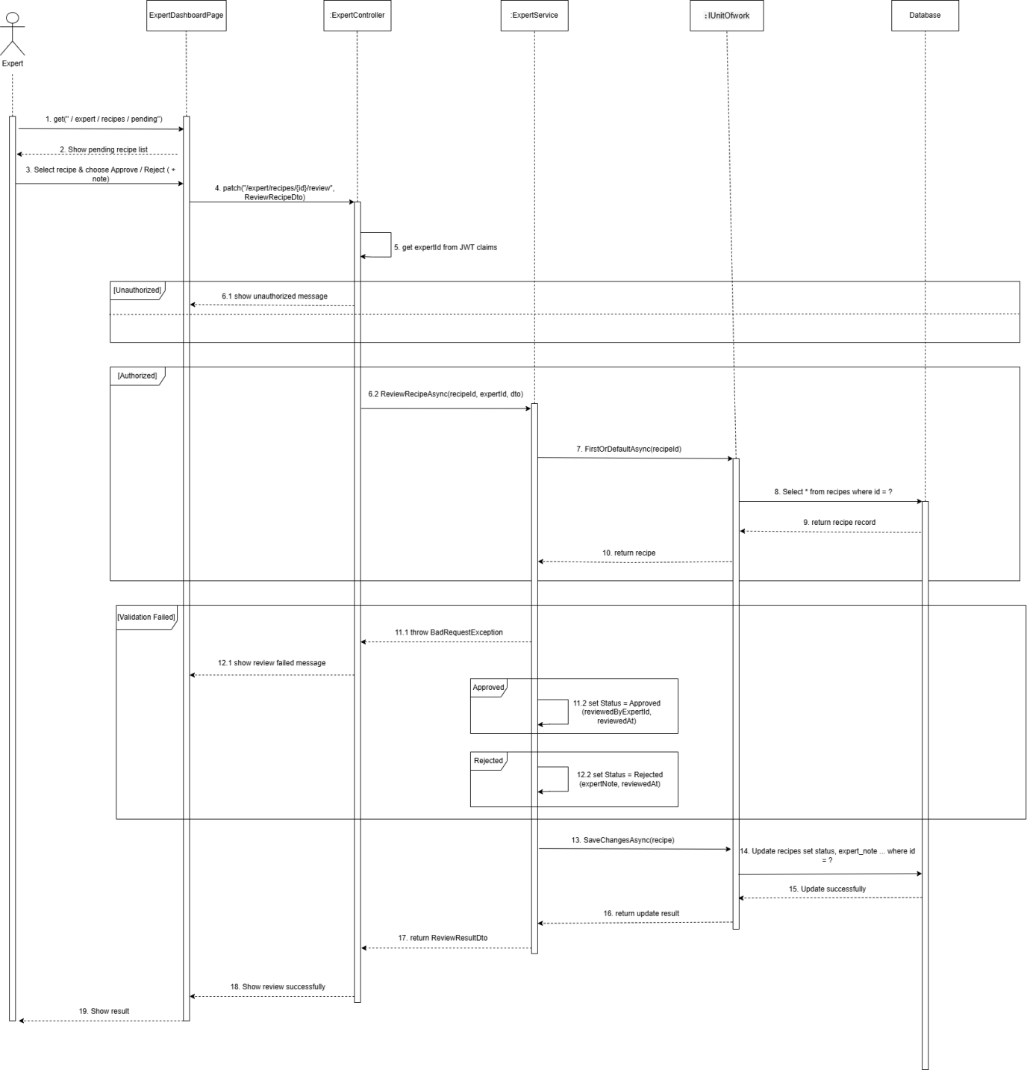Figure 6.5b. Sequence Diagram — Expert Reviews AI-Generated Recipe

