Installation:
Note: For inexperience Linux user our software are tested with current version pipeline. We do not recommend to upgrade the version on Linux Virtual machine. The webserver may crash when new software updated
- Download and install Virtualbox (VB) installation and VirtualBox 6.1.22 Oracle VM VirtualBox Extension Pack from https://www.virtualbox.org/wiki/Downloads
Already tested Virtualbox version 6.1.22 on Ubuntu 18.04 and Window 10.
- Download the webserver.ova image file.

After install VB and its Extension Pack open VB >File> Import Appliance select webserver.ova downloaded file then setup configuration based on your machine configuration.
By default it use 4 cores CPU, 8 GB RAM. We recommend use 8 CPUs, 16 GB RAM, HDD is auto allocated, we recommend to deploy VB image in the partition has at least 100 GB (depend on the number of users and datasize TB volume are recommended).
Configure the network interface on your host site (your primary OS):
Before we start the Virtual machine in Virtual box configuration panel, we configure two network interface as in the figure below. The first network interface to internet (NAT) and the second interface to our host machine.

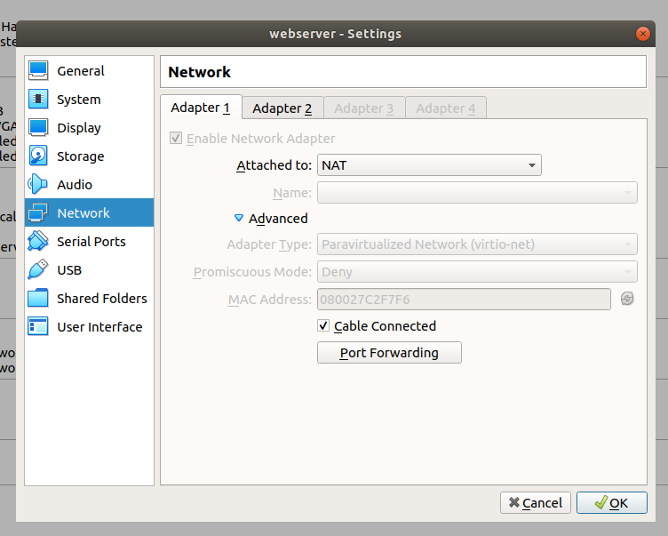
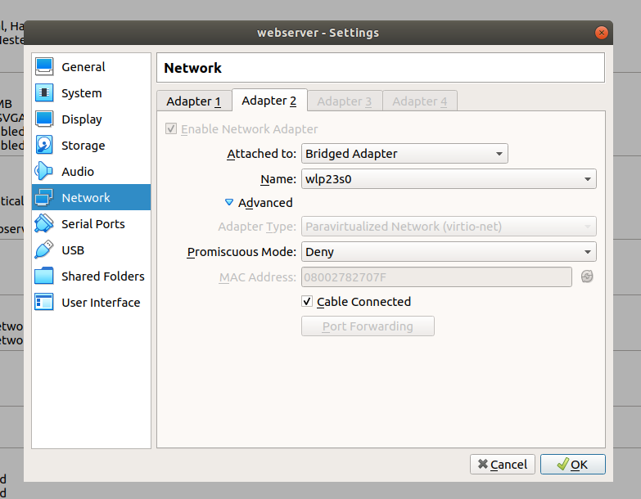

Login and configure webserver
After booting up our guest OS, login your Virtual machine with user name: ag-rossi,password 123456
open the terminal and we can get our webserver IP address by this command on the guest terminal

$ip a

Open the configuration file and add your IP address into to
$gedit NGS_webserver-main/NGS_webserver/NGS_webserver/settings.py

ALLOWED_HOSTS = [‘localhost’, #####ADD YOUR LAN IP HERE######]
Run webserver:
$cd NGS_webserver-main/NGS_webserver
$python manage.py runserver 0.0.0.0:8000

HOW TO USE
Now you can use your webserver on your Local Area Network (LAN) with normal web browser
access the webservice as address
http://{Your IP address}:8000/nanodorf

Normal user can upload fastq files as ONE compressed zip file: each subfolder contain replicas with one experimental condition.
NOTE: files and folders’ name must contain only alphabetic and numeric character.
Below is an example of data separated in two condition ‘treat’ and ‘untreat’
fastq/
├── treat
│ ├── barcode02
│ └── barcode04
└── untreat
├── barcode01
├── barcode03
└── barcode05

We implemented basecaller function on our webserver, however we recommend to use basecaller on the machine which has GPU.

Select one group among your groups as the reference group.
Setting up other parameter of analysis function (optional) : ReadCountMinThreshold, Logfold, adjPValueThreshold

Advance user can customized the RNA.R code to develop a new workflow.

