Online Classs

- Teacher:
- Teacher can create new class:
*Sessions:
- Lessons : + video
+ description
- Teacher can create new test:
*Questions
*Answer
- Teacher can view score of students.
- Teacher can view profile of students.
- Teacher can search class by class name.
- Teacher can update( add, edit, remove, ...) class and test.
- Student:
- Student can join class:
*Learn lessons
*Watching video
- Student can do exercises of once lesson.
- Student can view score.
- Student can search class by class name.
- Student can view progress of class.
- Student can leave from class.
- Student can edit or delete information profile.
- Visitor:
- Visitor can view all class.
- Visitor can view teachers.
- Visitor can registration new user.
- Visitor can login.

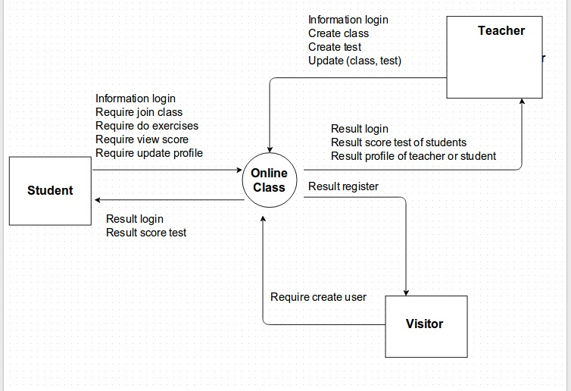

Data flow diagram

List student
List teacher
Teacher
Creat new class
Update(edit,remove)
View
View information

Management login
registration
Result of register and login
Visitor
Management
Test
Creat new test
Update(edit,remove)
List class
List test
Student
Do test
Statistic
List score
View class
Show
information
Show
information
View class
Result information
List question
Do exercises
Save
save
Save
Save
Save
Join Class
Management
Class
Search

