# User Guide

## Introduction

This guide intends to show users how to how to install, create an incident through the Dossa mobile application, and other functions of the Dossier Management System web application. The following system design in Figure 1, show the Dossier Management System as collection of microservices working in addendum with each other’s.

Figure 1. System design of communication flow between users and backend services

## Installation and Using the Application

The Dossier Management System consist of five subsystems: VPN Server using Wireguard, the database system, the backend, web application, and a mobile application.

## Download and install requisite tools:

Download and Install Docker. Installation guide for Docker is available here: <https://docs.docker.com/desktop/>

In the Command Terminal, verify that Docker is installed with the following command:

docker --version

A properly installed docker would display the docker version and build number.

docker version 20.10.10, build b485636

Download and install NodeJs from the official NodeJS download page:

<https://nodejs.org/en/download/>

Download and Install Git. Installation guide for GIT is available here:   
<https://git-scm.com/downloads>

In the Command Terminal, verify that GIT is installed with the following command:

git --version

A properly installed git would display the git version and build number.

git version 2.19.1.windows.1

### Install and run the Wireguard VPN Server (Recommend)

Instructions for installing, configuring, and running of the Wireguard server is available here: <https://www.cyberciti.biz/faq/ubuntu-20-04-set-up-wireguard-vpn-server/>

Verify that your Wireguard VPN Server is running by downloading the Wireguard Mobile App and configuring it to connect to the WireGuard VPN Server.   
  
Wireguard Server is not needed to run the Dossier Management System, but recommended in production to secure data traffic between the API Backend and Mobile App users.

### Install and run the Database System

* 1. Run the following docker command to pull the latest MongoDB Image from Docker Hub

docker pull mongo

* 1. Start a mongo instance using the downloaded MongoDB image with the following command.

docker run --name some-mongo -d mongo:tag

*Some-mongo* is the name you want to assign to your container and *tag* is the tag specifying the MongoDB version you want. By default, the authentication is not required to setup, however in a production environment it is important to setup MongoDB admin authentication with the following docker command.

docker run -d --network some-network --name some-mongo \

-e MONGO_INITDB_ROOT_USERNAME=mongoadmin \

-e MONGO_INITDB_ROOT_PASSWORD=secret mongo

### Launch the API Backend System

1. Clone and download the Dossa project file from Github

git clone git@github.com:thachp/dossa.git

1. In the project root directory, create a file .env.local and fill the following variables with your own string.

APPLICATION_ID=""

MASTER_KEY=""

JAVASCRIPT_KEY=""

FILES_SUBDIRECTORY="../../appdata/incidents"

ENCRYPTIONKEY=""

MONGODB_URL="mongodb://localhost:27017/dossa "

GRAPHQL_SERVERURL="http://localhost:1337/graphql"

SERVER_URL="http://localhost:1337/parse"

VPN_IPS="::ffff:127.0.0.1"

1. Change into the /api folder and run the following commands to start the API backend.

cd /api

yarn install

yarn start:prod

This will launch the API services at the URL <http://localhost:1337/>

### Launch the Web Application

1. From the root directory, change into the /web directory.
2. Create a file .env.local and fill the following variables with your own string. Note, that the APPLICATION_ID must match the APPLICATION_ID in the backend system from the previous instructions. Same with the JAVASCRIPT_KEY variable.

REACT_APP_APPLICATION_ID=""

REACT_APP_JAVASCRIPT_KEY=""

1. Run the following commands to the start web application.

yarn install

yarn start

This will launch the Web services at the URL <http://localhost:3000>

## Launch the Mobile Application (Optional)

1. From the root directory, change into the /mobile directory
2. Edit the file /common/constants/settings.constant.ts to match those in the .env.local file from the Backend configuration.

export const HOSTNAME = "";

export const PARSE_API = "https://example.com/parse";

export const PARSE_GRAPHQL = "http://example.com/graphql";

export const APPLICATION_ID = "";

export const JAVASCRIPT_KEY = "";

1. Run the following commands to the mobile application in Expo environment.

yarn start

For more information about EXPO, visit <https://docs.expo.dev/>

### Setup Nginx for Reverse Proxying (Production)

The following installation and configuration instructions are only necessary if Dossa is to be deployed onto a production environment. The operating system used will be Ubuntu Bionic.

1. Update the APT package cache and install the Nginx web server using the package manager:

sudo apt install

sudo apt install nginx

1. Edit the Nginx.conf file to match the following Nginx configuration.

server {

listen 80;

listen [::]:80;

access_log /var/log/nginx/reverse-access.log;

error_log /var/log/nginx/reverse-error.log;

location / {

proxy_pass http://127.0.0.1:3000;

}

}

For instructions on configuration TLS on Nginx, please visit: <http://nginx.org/en/docs/http/configuring_https_servers.html>

## Submit a corruption incident through DOSSA, the Mobile Application

1. Click the “Report a corruption issue” button to begin. The goal of the application is to allow users to submit corruption issues anonymously, so user registration is not necessary. Figure 2 show the location of the “Report a corruption issue” button located at the bottom of the screen.

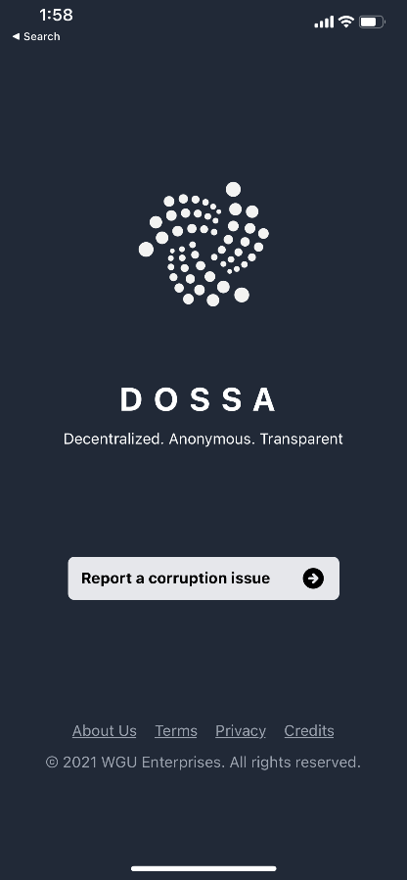

Figure 2 Figure 3 Figure 4

1. Filled in all required fields (Figure 3). The form would throw form validation errors if the user forgot to fill require fields. The Report Corruption form require that the user…
   1. Select the “Type of Corruption”.
   2. Select up to four “Involving institutions”.
   3. Provide a short description of the incident.
   4. Optionally, the user may include hashtags
   5. Optionally, the user may include attachments of the following mime types: images, audio, video, pdf, and plain text.
2. Once all required filed has been filled, press the Submit button located top right corner of the screen to submit the incident. The user will be taken to the Submitting Report screen (Figure 4), with various indicators showing the uploading progress. The user may exist the screen anytime.

## Access the Dashboard as an Analyst

1. Go to the URL <https://dossa.network/#/login>. The user will see the authentication screen. Unlike traditional authentication screen where a user normally enters a username and password to log in, the Dossier Management System uses public key / hash key approach to authentication. This public key and key hash will be provided by administrators of an organization. For demonstration purposes, the demo public key and key hash has between generated:

Public Key: analyst

Key Hash: 1234

1. Enter *analyst* into the public key field and *1234* into the Key Hash field. Press Connect.
2. Upon successful authentication, the user will be taken to the Dashboard for a user with analyst role, where the logged user will have the ability view the followings features:
   1. Number of institutions being report of corruptions
   2. Number of activists currently engage in fighting corruptions
   3. A list of recent institutions associated to corruptions
   4. A list of recent incidents reported by activists.
   5. An incident history chart by months.

## Access the Institutions List as an Analyst

1. *To access the reporting feature, from the Schedule module, click on “Generate Report” near the top right of the page.*

1. *By default, all events are generated and displayed.*

## Access the Reporting as An Analyst