Tank Wars
Introduction to the Design
A design helps us plan a program before we build it. For Tank Wars, we use UML (Unified Modeling Language), a common way of drawing pictures that show how a system works. These pictures link the ideas for the game to the code that makes it run.
Three Views of the Game: The design of Tank Wars is shown in three kinds of diagrams. Each one looks at the game in a different way.
1. Use Case Diagram: Shows what the player can do in the game, such as starting a game, choosing a wave, buying upgrades and using the shield.
2. Activity Diagram: Shows the steps of the game from start to finish, including the choices the game makes and the parts that repeat during play.
3. Sequence Diagram: Shows the order of messages between the parts of the game, such as the game manager, the wave manager, the tower and the enemy.
Use Case Diagram
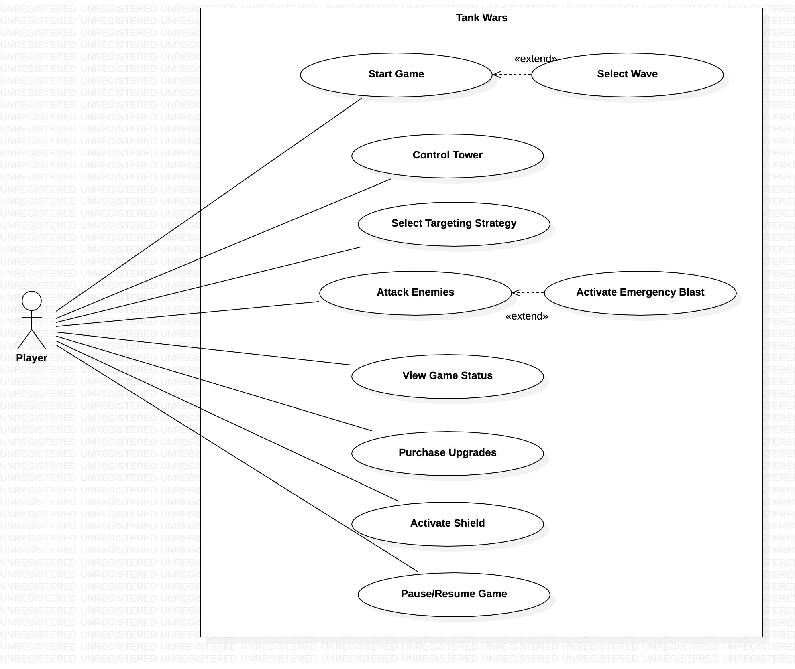
Activity Diagram
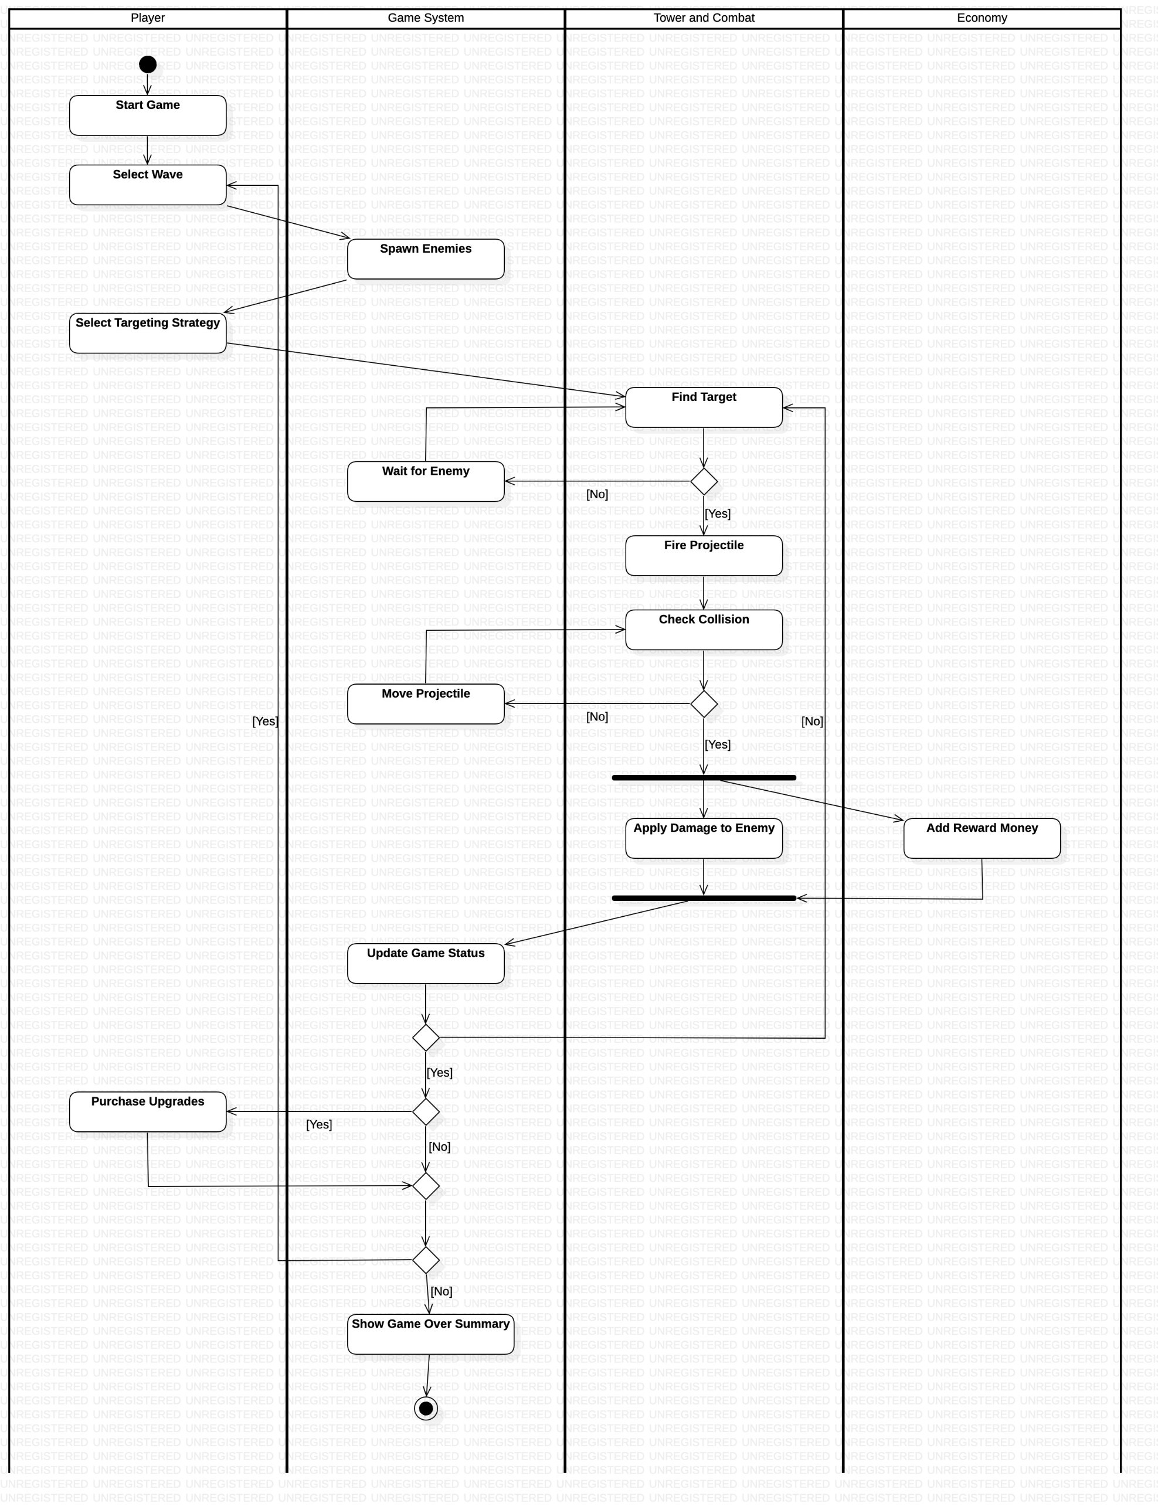
Sequence Diagram


