Detailed Design of the Game
Comprehensive UML Design Specification & Behavioral Architecture for Academic Documentation
A. Title of the Project
Tank Wars
Tank Wars is an arcade-style tactical tower defense game developed using Python and Pygame. The project demonstrates software architecture, real-time physics and collision detection, dynamic economic and upgrade systems, and comparative implementations of fundamental data structures and algorithms (First-In-First-Out Queue, Binary Max-Heap Priority Queue, and Greedy Nearest-Neighbor heuristics). The project title is strictly designated as Tank Wars without modification, subtitles, or alternative aliases.
B. Introduction to the Design
In modern software engineering, the Unified Modeling Language (UML) serves as the industry-standard visual notation for specifying, constructing, visualizing, and documenting the artifacts of software-intensive systems. For an interactive, real-time game application like Tank Wars, software design models bridge the semantic gap between high-level functional requirements and concrete object-oriented implementation details.
Multi-View Architectural Modeling: The design documentation for Tank Wars is structured across three complementary architectural viewpoints:
1. Functional Perspective (Use Case Diagram): Captures the interactive capabilities exposed to human users, defining system boundaries, actor roles, functional goals, and inter-use-case dependencies.
2. Behavioral Process Perspective (Activity Diagram): Models the algorithmic control flow, lifecycle states, decision bifurcations, concurrent processing branches, and iterative gameplay loops executing across continuous 60 FPS cycles.
3. Component Interaction Perspective (Sequence Diagram): Delineates the chronological message exchange, method invocations, parameter transfers, and synchronous/asynchronous data flows between decoupled software subsystems.
Together, these three formal models provide an unambiguous blueprint that validates functional completeness, architectural modularity, algorithmic rigor, and seamless integration between Pygame presentation layers and underlying discrete data structures.
C. Use Case Diagram
The Use Case Diagram captures the complete functional scope of Tank Wars from the perspective of external actors. It defines the system boundary, establishes the primary actor interaction channels, and delineates ten core use cases that encompass menu navigation, stage selection, tactical tank repositioning, algorithmic targeting selection, real-time combat resolution, live diagnostic inspection, capability upgrades, defensive energy management, and flow control.

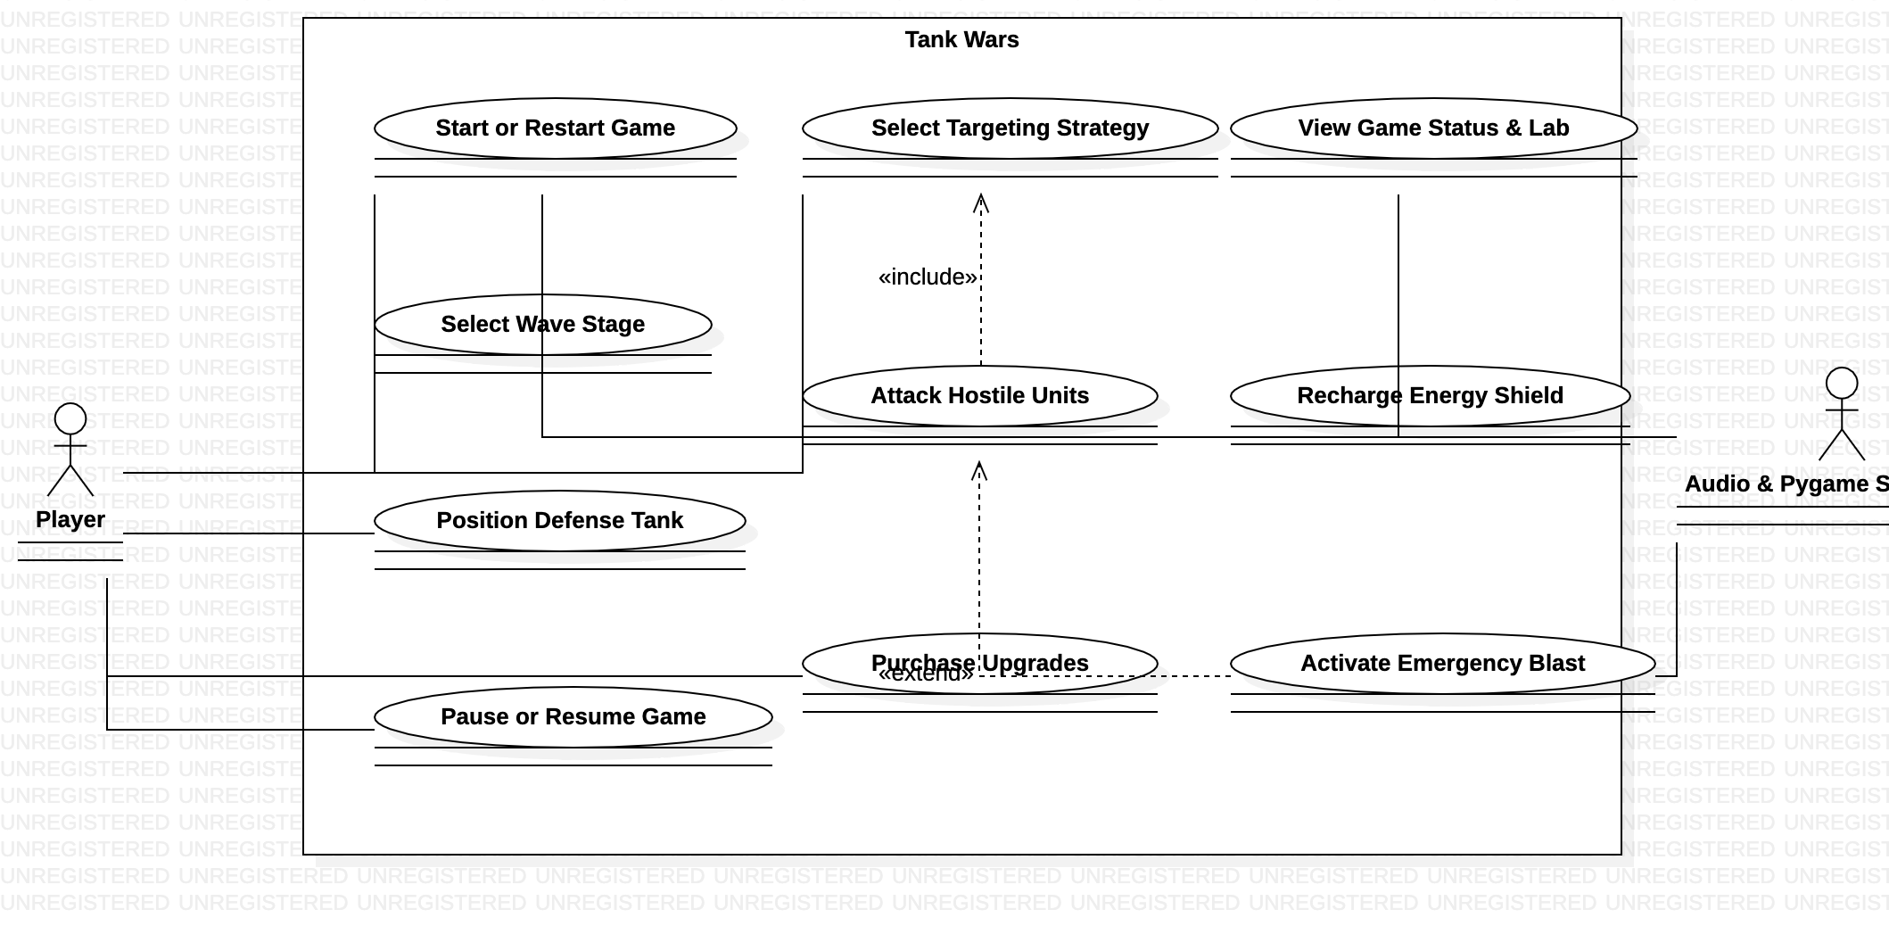
Figure 1: Tank Wars - UML Use Case Diagram (StarUML 5.0.2)
Actor and System Boundary Specification
Primary Actor (Player): The primary actor interacting with Tank Wars is the human Player. The Player represents the end user who provides real-time tactical input through standard hardware interfaces (QWERTY keyboard and precision mouse/trackpad). The Player initiates gameplay, commands tank locomotion, dynamically toggles targeting heuristics, triggers manual defensive measures, reinvests currency, and supervises algorithmic operations. The game architecture is structured around this single actor; no secondary human actors or external networked actors exist in this standalone architectural deployment.
System Boundary (Tank Wars): The system boundary is formally defined as 'Tank Wars', visually represented by an enclosing UML Use Case Subject rectangle. The boundary encapsulates all internal software routines, game states, data structures, combat logic, and UI subsystems. All ten use cases reside strictly inside the Tank Wars boundary, while the Player actor remains external, interacting across the boundary through standardized input association channels.
Detailed Specification of the 10 Use Cases
UC1: Start or Restart Game: Allows the Player to initiate a new gameplay session from the main menu, begin a fresh wave encounter, or reset the current stage following a defeat or tactical retreat. Resetting clears all residual entities, resets combat managers, reinitializes targeting queues, and restores initial tank status.
UC2: Select Wave Stage: Enables the Player to navigate through the 40-stage progression grid within the Wave Select screen. Players can inspect wave clearance status, evaluate escalating difficulty curves, and launch any unlocked wave directly into active combat.
UC3: Position Defense Tank: Provides real-time spatial positioning of the defense tank within the 1280x720 arena. The Player maneuvers the tank using continuous WASD/Arrow directional velocity vectors or precision mouse drag-and-drop mechanics, altering line-of-sight and proximity to approaching hostiles.
UC4: Select Targeting Strategy: Empowers the Player to switch dynamically between three fundamental algorithmic targeting modes: FIFO Queue (arrival vanguard order), Binary Max-Heap Priority Queue (dynamic multi-factor threat sorting), and Greedy Nearest-Neighbor (squared Euclidean distance optimization).
UC5: Attack Hostile Units: The central combat function wherein the automated turret evaluates hostiles within range, calculates aim angles, spawns high-velocity projectiles, resolves circle-circle ballistic collisions, inflicts calculated damage, and eliminates hostile units.
UC6: View Game Status & Lab: Provides comprehensive real-time visual feedback to the Player. This includes the top Heads-Up Display (wave progress, coin balance, current health, shield integrity, speed multiplier) and the interactive Algorithm Lab panel displaying internal heap arrays, queue order, and algorithmic comparison metrics.
UC7: Purchase Upgrades: Allows the Player to reinvest combat coin earnings into permanent combat stat boosts via bottom upgrade cards. Upgrades include Attack Power (+5 damage per level), Shooting Speed (reduced cooldown timer), and Maximum Hearts (additional life buffer up to 10).
UC8: Recharge Energy Shield: Enables the Player to purchase energy shield replenishment using accumulated coins. The defensive energy shield surrounds the tank and absorbs incoming contact damage before heart reserves are depleted, providing critical survival cushioning against boss and runner impacts.
UC9: Activate Emergency Blast: Provides an on-demand screen-clearing defensive ability triggered via Spacebar or UI card selection. Upon activation, an expanding energy shockwave detonates across the arena, inflicting massive damage on all hostile units and resetting immediate breach crises.
UC10: Pause or Resume Game: Allows the Player to halt real-time physics and enemy movement (freezing delta-time updates) to assess battlefield conditions, access configuration toggles, restart the wave, or resume seamless real-time execution without state loss.
Associations and UML Relationship Justification
Relationship Semantics: The Use Case Diagram incorporates precise UML semantic associations and dependency relationships:
• Actor Associations: Solid undirected association lines connect the Player actor to each of the ten use cases, signifying direct user agency and authorization to initiate every primary gameplay feature.
• <<include>> Dependency (UC5 -> UC4): A directed dashed dependency stereotyped with <<include>> connects 'Attack Hostile Units' to 'Select Targeting Strategy'. In the game's architecture, the combat system cannot execute automated turret firing without invoking the active algorithmic targeting strategy to determine candidate validity and acquisition order. Hence, target selection is an indispensable, mandatory inclusion within the attack lifecycle.
• <<extend>> Dependency (UC9 -> UC5): A directed dashed dependency stereotyped with <<extend>> connects 'Activate Emergency Blast' to 'Attack Hostile Units'. The Emergency Blast is an optional, high-cost tactical exception triggered conditionally during extreme emergency scenarios. It extends the standard attack mechanism by unleashing area-of-effect screen-wide destruction rather than single-target ballistic projectile fire.
D. Activity Diagram
The Activity Diagram models the dynamic operational control flow of Tank Wars throughout an end-to-end gameplay session. It visualizes procedural execution from initial framework bootstrapping and menu initialization, through wave configuration, input polling, enemy generation, three-way algorithmic targeting branches, ballistic combat resolution, damage mitigation, resource disbursement, and conditional end-state transitions.

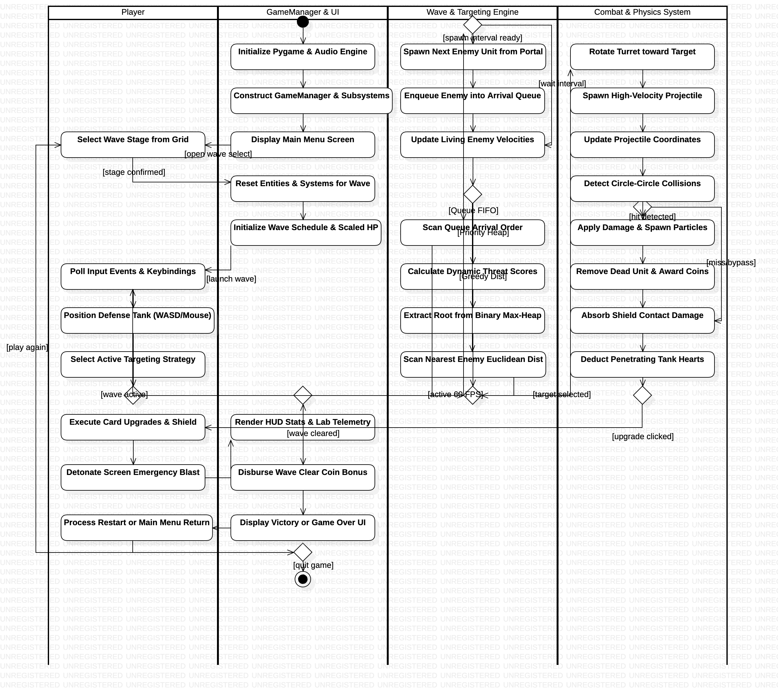
Figure 2: Tank Wars - UML Activity Diagram (StarUML 5.0.2)
Gameplay Workflow and Control Architecture
The workflow originates at a UML Initial Node, initiating Pygame display, sound mixer, and font systems. Control transitions into constructing GameManager and its constituent subsystems (Economy, Tower, Combat, Waves, Targeting, Upgrades, Shield, Blast, Sound, and UI). Once initialized, the main menu is presented, prompting the player to select a wave stage. Selecting a wave triggers a clean state purge via full_reset_for_wave() and computes wave difficulty scaling parameters (enemy count, spawn frequencies, health multipliers, and boss assignments).
During active gameplay, the 60 FPS while-loop executes four synchronized phases: event handling, physics updates, combat resolution, and graphics rendering. Input polling routes WASD locomotion, dragging, and pause triggers. If active, enemy spawn timers schedule portal appearances. Living hostiles update directional velocities towards the tank. Concurrently, the active targeting strategy (FIFO Queue, Max-Heap Priority Queue, or Greedy Nearest-Neighbor) selects the optimal hostile. The turret rotates, shoots projectiles, detects circle-circle collisions, and inflicts damage. Defeated units award currency, while breaching hostiles deplete shield capacity and tank hearts. Wave clearance awards bonus currency, advancing to victory or next-wave states, while zero hearts triggers game over.
Decisions, Guards, Loops, and Alternate Branches
Structural Control Logic: The activity flow incorporates rigorous decision nodes, guards, and loops:
1. Decision [D_PAUSE]: Evaluates user pause triggers. If active, execution proceeds into the frame update; if paused, updates freeze until resumed.
2. Decision [D_SPAWN]: Evaluates wave spawn intervals. When timer <= 0, new enemies emerge from portals; otherwise, existing enemies advance.
3. Decision [D_STRAT]: A three-way algorithmic branch routing target acquisition to (a) FIFO Queue scan [Queue], (b) Floyd's bottom-up heap build and logarithmic root extraction [Priority], or (c) Monotonic squared Euclidean distance scan [Greedy]. All three branches converge at a UML Merge Node [M_TARGET].
4. Decision [D_HIT]: Checks projectile-enemy circle intersections. On hit detection, damage particles and coin rewards trigger; otherwise, projectiles continue flight.
5. Decision [D_BREACH]: Evaluates hostile impact with the tank. Damage is routed first to shield absorption; remaining unabsorbed damage depletes player hearts.
6. Decision [D_WAVE_DONE]: Assesses wave status. When all scheduled enemies are eliminated, wave clearance bonuses disburse; otherwise, control loops back to input polling.
7. Decision [D_TOWER_ALIVE]: Evaluates tank survival. If hearts remain, players proceed to next wave or restart; if depleted, game over screens display before terminating at the Activity Final Node.
Numbered Specification of Exactly 30 Action Nodes
A1: Initialize Pygame & Audio Engine: Initializes the SDL display system, hardware clock, audio mixer, and font cache engines.
A2: Construct GameManager & Subsystems: Instantiates core subsystems including EconomySystem, Tower, WaveManager, CombatManager, and TargetingDispatcher.
A3: Display Main Menu Screen: Renders the title screen providing options for direct play, wave selection, algorithm lab, and sound toggles.
A4: Select Wave Stage from Grid: Processes player wave selection from the 40-stage progression interface, validating unlock status.
A5: Reset Entities & Systems for Wave: Invokes full_reset_for_wave() to clear active projectiles, enemies, effects, and reset subsystem parameters.
A6: Initialize Wave Schedule & Scaled HP: Calculates enemy composition, spawn countdowns, speed multipliers, and health scaling curves.
A7: Poll Input Events & Keybindings: Processes keyboard and mouse events, checking for locomotion keys (WASD), ability triggers, and pause keys.
A8: Position Defense Tank (WASD/Mouse): Updates tank coordinates based on directional velocity input or mouse drag-and-drop dragging mechanics.
A9: Spawn Next Enemy Unit from Portal: Instantiates a new enemy archetype (Scout, Runner, Tank, Boss) at one of four top-boundary portal coordinates.
A10: Enqueue Enemy into Arrival Queue: Enqueues newly spawned enemies into the internal FIFO arrival queue to maintain chronological sequencing.
A11: Update Living Enemy Velocities: Calculates directional vector angles towards the tank, advancing each living hostile by scaled velocity * delta-time.
A12: Select Active Targeting Strategy: Queries the active targeting configuration mode (QUEUE, PRIORITY_QUEUE, or GREEDY).
A13: Scan Queue Arrival Order: Iterates through the arrival queue from head to tail, selecting the oldest active enemy currently within firing range.
A14: Calculate Dynamic Threat Scores: Computes multi-factor threat scores incorporating damage, speed, proximity urgency, archetype bonus, and remaining health.
A15: Extract Root from Binary Max-Heap: Builds a binary max-heap via Floyd's O(n) algorithm and extracts the root enemy exhibiting maximum threat.
A16: Scan Nearest Enemy Euclidean Dist: Performs an O(n) scan over candidate enemies to locate the hostile with minimum squared Euclidean distance.
A17: Rotate Turret toward Target: Computes the angular arc from the tank center to target coordinates, rotating the turret barrel smoothly.
A18: Spawn High-Velocity Projectile: Checks weapon cooldown timers and discharges a ballistic projectile directed towards the acquired hostile.
A19: Update Projectile Coordinates: Updates projectile positions across 2D coordinates according to fixed ballistic speed vectors and elapsed time.
A20: Detect Circle-Circle Collisions: Evaluates Euclidean distances between projectile radii and enemy hitboxes using circle-circle intersection checks.
A21: Apply Damage & Spawn Particles: Reduces enemy hit points by projectile damage, triggering floating numeric damage labels and particle bursts.
A22: Remove Dead Unit & Award Coins: Purges destroyed hostiles, notifies the targeting dispatcher, and credits bounty coins to the EconomySystem.
A23: Absorb Shield Contact Damage: Directs hostile contact damage against the active energy shield buffer, depleting capacity and triggering ripple shaders.
A24: Deduct Penetrating Tank Hearts: Applies residual unabsorbed contact damage directly against player heart reserves, triggering damage flashes.
A25: Execute Card Upgrades & Shield: Processes user clicks on upgrade cards, deducting coin costs and boosting attack damage, fire rate, or shield charge.
A26: Detonate Screen Emergency Blast: Triggers area-of-effect emergency blast detonation via Spacebar, damaging all active enemies and flashing the arena.
A27: Render HUD Stats & Lab Telemetry: Paints the top status HUD (wave, hearts, shield, coins) and live telemetry inside the Algorithm Lab dashboard.
A28: Disburse Wave Clear Coin Bonus: Verifies all wave hostiles are destroyed, plays wave-clear fanfare audio, and awards wave-clear bonus coins.
A29: Display Victory or Game Over UI: Renders the end-of-stage overlay (Victory screen upon clearing Wave 40 or Game Over upon zero hearts).
A30: Process Restart or Main Menu Return: Receives user button input from the end-state overlay to restart the wave or return cleanly to the main menu.
E. Sequence Diagram
The Sequence Diagram titled 'Tank Wars - Gameplay and Combat Sequence' details the chronological message passing and collaborative interactions among ten decoupled software entities during a representative gameplay and combat cycle. It models synchronous procedure calls, asynchronous event rendering, and return responses with high architectural fidelity.

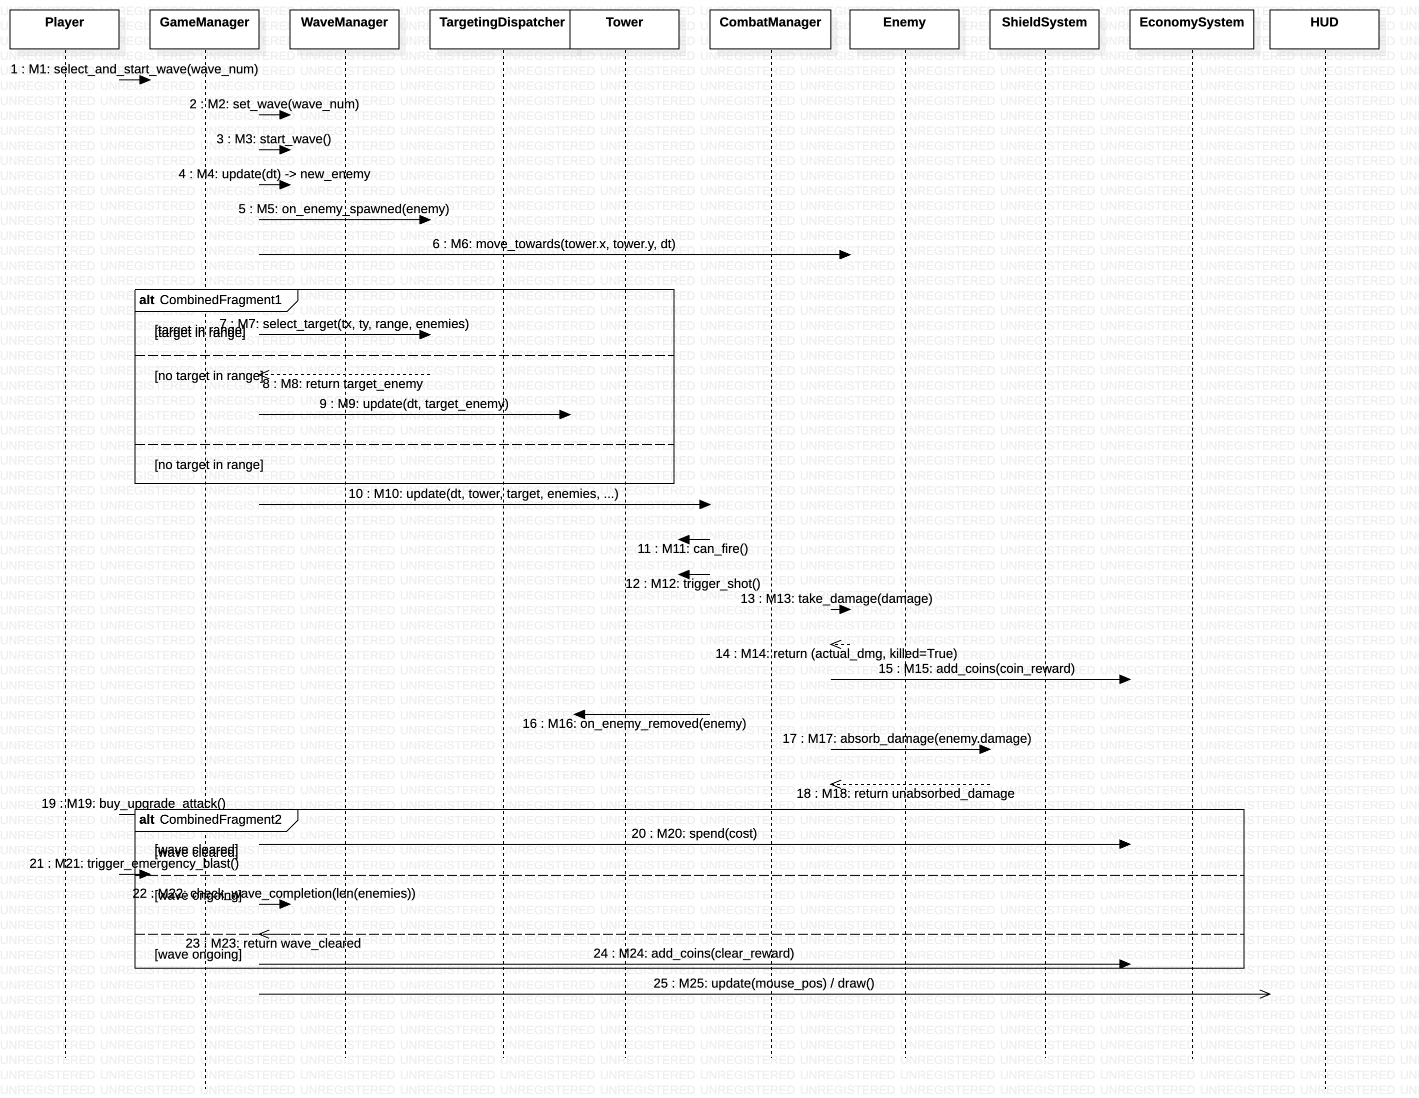
Figure 3: Tank Wars - UML Sequence Diagram (StarUML 5.0.2)
Lifelines and Component Responsibilities
Player: Represents the external human user delivering mouse clicks, drags, key presses, and strategic choices.
GameManager: The central coordinator controlling the state machine, delta-time game loop, subsystem updates, and event routing.
WaveManager: Schedules enemy spawns, manages difficulty scaling, portal coordinates, wave progression, and completion checks.
TargetingDispatcher: Coordinates the algorithmic selection of targets across FIFO Queue, Max-Heap Priority Queue, and Greedy strategies.
Tower: Maintains tank coordinates, orientation angle, damage stats, fire cooldowns, shield levels, and heart counts.
CombatManager: Executes turret auto-fire, projectile trajectory updates, circle-circle collision resolution, and damage dispatch.
Enemy: Encapsulates enemy archetype attributes (Scout, Runner, Tank, Boss), health pools, velocities, and hit reactions.
ShieldSystem: Controls protective energy absorption, shield recharge costs, capacity ceilings, and depletion thresholds.
EconomySystem: Tracks player coin balance, processes currency transactions for upgrades/recharges, and disburses kill rewards.
HUD: Renders graphical interface elements including status bars, buttons, floating text, and the Algorithm Lab panel.
Chronological Message Flow Specification
Lifecycle Phases: The interaction sequence represents a complete combat loop divided into four logical phases:
1. Wave Initialization & Spawning (M1 - M6): The Player triggers stage selection, prompting GameManager to initialize WaveManager, construct the wave schedule, spawn portal hostiles, enqueue them into the targeting arrival queue, and update velocities.
2. Algorithmic Target Acquisition (M7 - M9): GameManager delegates target selection to TargetingDispatcher, evaluating candidates across the active algorithmic strategy. The chosen hostile is returned, enabling Tower to update its turret aim angle.
3. Combat Execution & Damage Resolution (M10 - M18): CombatManager assesses weapon readiness, discharges projectiles, resolves ballistic impacts against enemy hitboxes, deducts health, dispenses coin rewards through EconomySystem upon kill, purges inactive targets, and routes contact damage to ShieldSystem.
4. Upgrades, Blast & Wave Completion (M19 - M25): The Player triggers stat upgrades, deducting coins from EconomySystem, or fires an Emergency Blast. WaveManager checks wave completion status, awards clear bonuses, and updates the HUD.
Numbered Specification of Exactly 25 UML Messages
M1: select_and_start_wave(wave_num): [Player -> GameManager] Synchronous call requesting the launch of a selected wave stage from the UI grid.
M2: set_wave(wave_num): [GameManager -> WaveManager] Synchronous call verifying stage unlock status and configuring current wave parameters.
M3: start_wave(): [GameManager -> WaveManager] Synchronous call initiating the wave countdown and populating the enemy spawn schedule.
M4: update(dt) -> new_enemy: [GameManager -> WaveManager] Synchronous frame update that decrements spawn timers and returns a newly instantiated Enemy unit.
M5: on_enemy_spawned(enemy): [GameManager -> TargetingDispatcher] Synchronous notification enqueuing the newly spawned enemy into the FIFO arrival queue.
M6: move_towards(tower.x, tower.y, dt): [GameManager -> Enemy] Synchronous invocation commanding the living enemy to recalculate its trajectory toward the defense tank.
M7: select_target(tx, ty, range, enemies): [GameManager -> TargetingDispatcher] Synchronous query requesting candidate evaluation and target acquisition using the active algorithm.
M8: return target_enemy: [TargetingDispatcher -> GameManager] Reply message returning the acquired target Enemy reference (or None if no hostile is in range).
M9: update(dt, target_enemy): [GameManager -> Tower] Synchronous update orienting the tank turret barrel toward the acquired target coordinates.
M10: update(dt, tower, target, enemies, ...): [GameManager -> CombatManager] Synchronous frame execution delegating weapon firing, projectile movement, and collision handling.
M11: can_fire(): [CombatManager -> Tower] Synchronous query verifying whether the tower weapon cooldown timer has elapsed.
M12: trigger_shot(): [CombatManager -> Tower] Synchronous invocation resetting the tower fire cooldown timer and triggering muzzle flash effects.
M13: take_damage(damage): [CombatManager -> Enemy] Synchronous damage application reducing the enemy's current health pool by projectile damage.
M14: return (actual_dmg, killed=True): [Enemy -> CombatManager] Reply message returning the actual damage inflicted and confirming unit elimination.
M15: add_coins(coin_reward): [CombatManager -> EconomySystem] Synchronous reward transaction crediting bounty coins to the player's account balance.
M16: on_enemy_removed(enemy): [CombatManager -> TargetingDispatcher] Synchronous notification removing the eliminated enemy from active data structures.
M17: absorb_damage(enemy.damage): [CombatManager -> ShieldSystem] Synchronous call routing enemy contact collision damage against the defensive shield capacity.
M18: return unabsorbed_damage: [ShieldSystem -> CombatManager] Reply message returning residual penetrating damage that bypasses depleted shield capacity.
M19: buy_upgrade_attack(): [Player -> GameManager] Synchronous user interaction selecting an attack power upgrade card from the bottom panel.
M20: spend(cost): [GameManager -> EconomySystem] Synchronous debit transaction verifying and deducting the required coin cost for the upgrade.
M21: trigger_emergency_blast(): [Player -> GameManager] Synchronous emergency command (Spacebar) detonating the screen-wide energy blast ability.
M22: check_wave_completion(len(enemies)): [GameManager -> WaveManager] Synchronous query evaluating whether all scheduled enemies in the wave have been destroyed.
M23: return wave_cleared: [WaveManager -> GameManager] Reply message confirming successful wave clearance and eligibility for clear bonuses.
M24: add_coins(clear_reward): [GameManager -> EconomySystem] Synchronous transaction awarding stage clearance bonus coins to the player's treasury.
M25: update(mouse_pos) / draw(): [GameManager -> HUD] Asynchronous update rendering refreshed coin balances, health bars, wave numbers, and lab telemetry.
F. Conclusion
The UML design documentation for Tank Wars establishes a complete, cohesive, and formally verified architectural specification. By integrating Use Case, Activity, and Sequence models, the documentation captures three vital dimensions of system design:
1. Functional Scope: The Use Case Diagram articulates user requirements across ten rigorously defined use cases, demonstrating how external player actions interface with internal game capabilities, supported by precise <<include>> and <<extend>> relationships.
2. Algorithmic Control Flow: The Activity Diagram illustrates continuous 60 FPS gameplay execution across exactly thirty action nodes, formalizing procedural branching, concurrent updates, three-way targeting comparisons, and lifecycle state loops.
3. Component Interaction Dynamics: The Sequence Diagram documents object-oriented modularity across twenty-five chronological messages, demonstrating clean separation of concerns among managers, entities, data structures, and user interface modules.
All model elements in Tank_Wars_UML_Design.mdj are fully validated against StarUML 5.0.2 schema rules, ensuring seamless opening, editing, and presentation. This documentation demonstrates rigorous software engineering principles, discrete data structure application, and robust computational design suitable for an undergraduate software engineering project.

