 | age | balance | day | duration | campaign | pdays | previous
count | 11162 | 11162 | 11162 | 11162 | 11162 | 11162 | 11162
mean | 41.232 | 1528.539 | 15.658 | 371.994 | 2.508 | 51.33 | 0.833
std | 11.913 | 3225.413 | 8.421 | 347.128 | 2.722 | 108.758 | 2.292
min | 18 | -6847 | 1 | 2 | 1 | -1 | 0
25% | 32 | 122 | 8 | 138 | 1 | -1 | 0
50% | 39 | 550 | 15 | 255 | 2 | -1 | 0
75% | 49 | 1708 | 22 | 496 | 3 | 20.75 | 1
max | 95 | 81204 | 31 | 3881 | 63 | 854 | 58

job | count | percent
management | 2566 | 22.989
blue-collar | 1944 | 17.416
technician | 1823 | 16.332
admin. | 1334 | 11.951
services | 923 | 8.269
retired | 778 | 6.97
self-employed | 405 | 3.628
student | 360 | 3.225
unemployed | 357 | 3.198
entrepreneur | 328 | 2.939
housemaid | 274 | 2.455
unknown | 70 | 0.627
Total | 11162 | 100.0

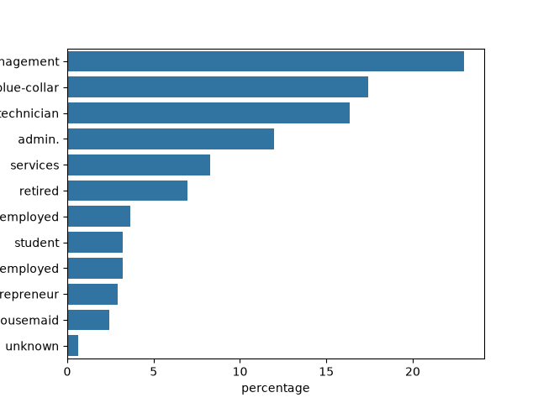

marital | count | percent
married | 6351 | 56.898
single | 3518 | 31.518
divorced | 1293 | 11.584
Total | 11162 | 100.0

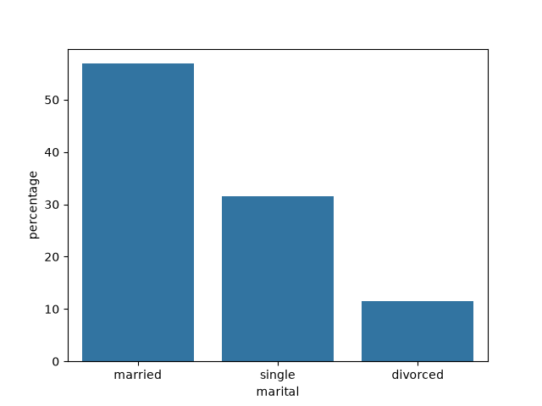

education | count | percent
secondary | 5476 | 49.059
tertiary | 3689 | 33.05
primary | 1500 | 13.438
unknown | 497 | 4.453
Total | 11162 | 100.0
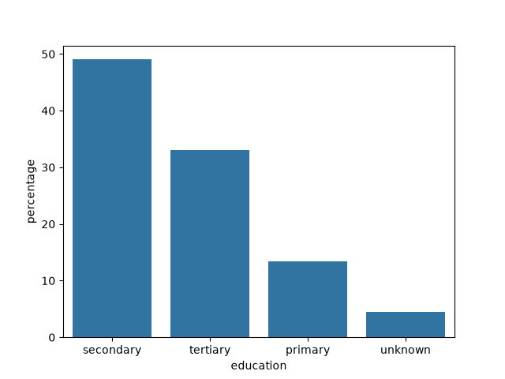

default | count | percent
no | 10994 | 98.495
yes | 168 | 1.505
Total | 11162 | 100.0

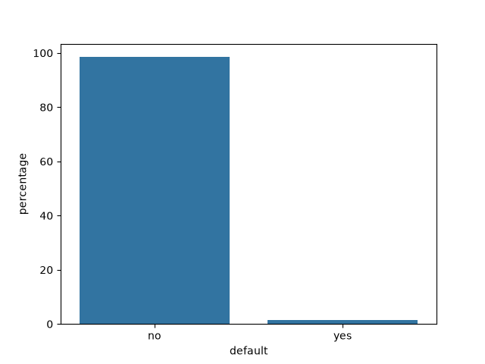

housing | count | percent
no | 5881 | 52.688
yes | 5281 | 47.312
Total | 11162 | 100.0

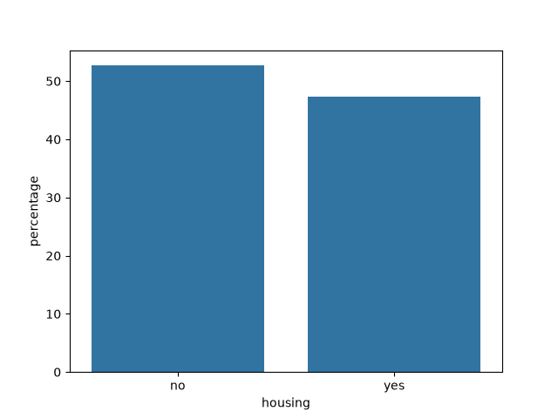

 | count | percent
no | 9702 | 86.92
yes | 1460 | 13.08
Total | 11162 | 100.0

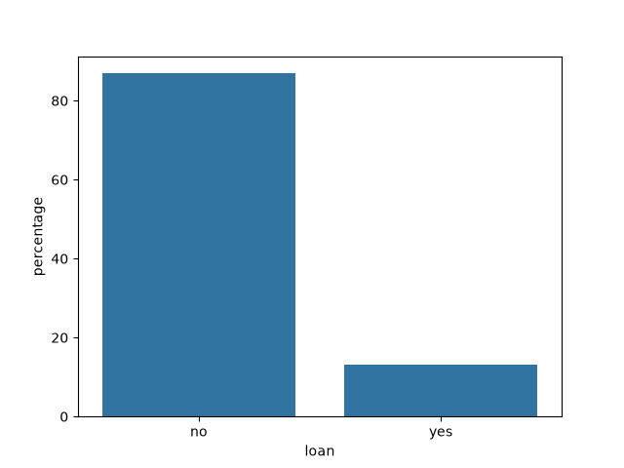

contact | count | percent
cellular | 8042 | 72.048
unknown | 2346 | 21.018
telephone | 774 | 6.934
Total | 11162 | 100.0

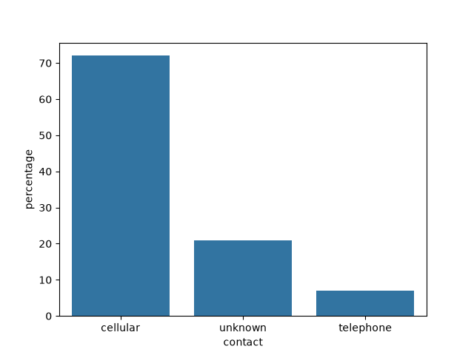

poutcome | count | percent
unknown | 8326 | 74.592
failure | 1228 | 11.002
success | 1071 | 9.595
other | 537 | 4.811
Total | 11162 | 100.0

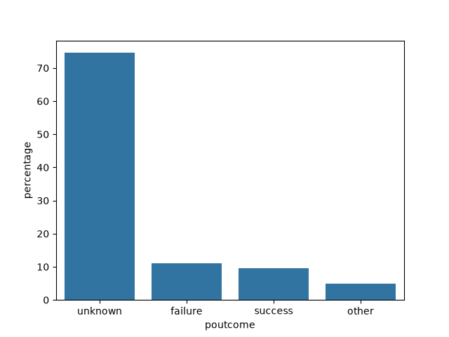

deposit | count | percent
no | 5873 | 52.616
yes | 5289 | 47.384
Total | 11162 | 100.0

