Internal Voltage Model for a Generator in PST V2

pstV2p3

Dan Trudnowski

Aug 2019

Draft 1

# Introduction

This report describes a new method to model a voltage-behind-impedance generator model in PST. I term this an “Internal Voltage Model” (IVM) for a generator. Such a model is used to model a grid-forming inverter-based generator.

The IVM is a voltage behind impedance model. The interface model is in Figure 1 below where *VT* is the terminal voltage. Internal voltage magnitude *E* and angle *δ* are calculated via a user-defined model thru time constants *Tv* and *Td*, respectively. The user-defined model is written in function ivmmod_dyn.m which is called every integration time step and allows for dynamic states to be defined. Any number of model structures can be modeled. Time constants *Tv* and *Td* are defined in mac_con settings.

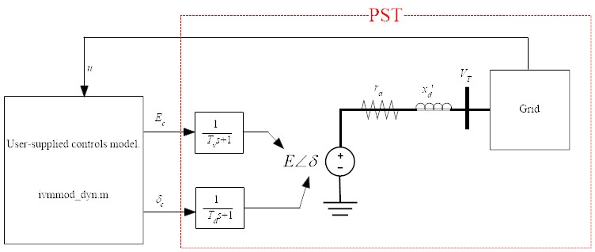

Figure 1: IVM Interface model.

# Declaring IVM Buses

EXPLAIN HOW TO SET UP AN IVM BUS.

# Example 1: a power voltage model

Consider the system in Figure 3. An IVM generator is placed into bus 2. The data file is *d2m_ivmmod1.m*. The IVM generator is set up to output constant power and have a constant internal voltage. At t=5 sec., the reference power is increased by 0.1 pu.

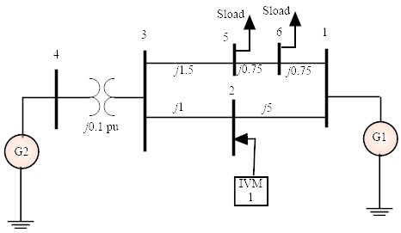

Figure 3: Example one-line.



Figure : Example 1 results. Injected P and Q at each modulation bus.



Figure 5: Example 1 result. Black = nonlinear, red =linear. Note that red is on top of black.

# Example 2: Current Injection Thru a Model

The goal of this example is to simulate the response of the system to current injection for the system in Figure 3. The current injection will be derived as depicted in Figure 6 which is a model of a solar plant. The *Ip* in Figure 6 is the current injection into modulation buses 2 and 3 in Figure 2. The model is in *pwrmod_dyn_Example2.m*. The script to run both the linear and non-linear simulations and plot the results is the file *Example2.m*. The result is shown in Figure 8. The linear and nonlinear responses match exactly as one would expect for such a small input.

In order to run the linear model, the contents of *powrmod_dyn.m* must be linearized outside of PST and then connected to the PST linear model. This is done at lines 26 thru 41 in *Example2.m*.

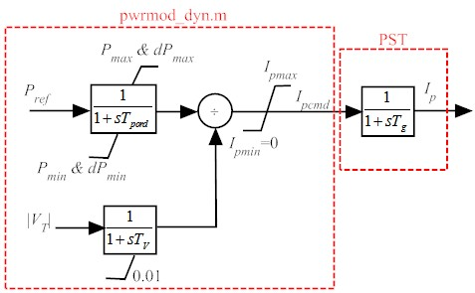

Figure 6: Example 2 current injection model.



Figure : Example 2 results. Injected IP and IQ at each modulation bus



Figure 8: Example 2 result. Black = nonlinear, red =linear. Note that red is on top of black.