**TUTORIAL**  
Author: Thad Haines   
Subject: Configure Raspberry Pi for GUI development  
Date: January 15, 2017

**Purpose**

The purpose of this tutorial is to outline how to configure a Raspberry Pi 3 (rpi) to do GUI development using the Eric IDE, Python 3 and PySide and/or PyQt Qt bindings.  
Note: $ indicates rpi terminal and is not actually typed by user. ↵ indicates pressing enter.

**Requirements**

* rpi
* 8 GB micro SD card and appropriate adapters
* A computer to configure the SD card ( A Windows 7 laptop was used )
* Internet connection for downloads
* A way to enter rpi text commands ( keyboard / VNC )

**Steps**

1. Download and install Win32DiskImager ( Found on Sourceforge.net ).
2. Download the latest Raspbian Jesse image from raspberrypi.org ( the 2017-01-11 image was used ).
3. Extract the .img file from the downloaded Raspbian file to a known location.
4. Insert the microSD card into the computer.
5. Using the Win32DiskImager, select the extracted .img file and the location of the SD card and click write.   
   A screenshot of the application is shown below.

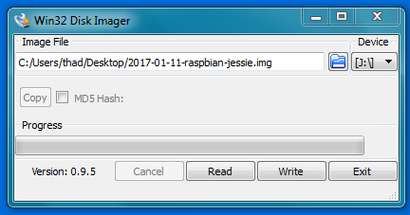

1. When the image write is complete, exit Win32 Disk Imager and remove the SD card from the computer and insert it into the rpi.
2. Boot the rpi and connect to your internet source.
3. Once connected to the internet, open the terminal and enter:

$ sudo apt-get update ↵

$ sudo apt-get upgrade ↵ When asked to upgrade enter: y↵

1. Set the correct keyboard settings by entering:  
     
    $ sudo nano /etc/default/keyboard ↵

Then change the ‘gb’ to ‘us’ and ctrl+x to save and close file.

1. Set the correct time zone by entering:  
      
    $ sudo dpkg-reconfigure tzdata ↵  
     
   Then select the desired country and time zone from the presented prompts.
2. Expand the filesystem by entering:  
     
    $ sudo raspi-config ↵  
     
   Then select ‘Expand Filesystem’ from ‘Advanced Options’ and select ‘ok’. A reboot is required.  
     
    $ sudo reboot ↵ (If not automatically done)
3. Check that python 3 is installed on the rpi:  
     
    $ python3  
     
   This should load the python 3 repl ( read – eval – print loop; it’s the >>> ).  
   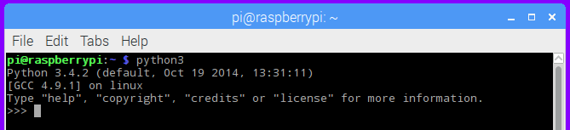   
   This is typically installed by default on the rpi (version 3.4.2). Type exit()↵ to close the repl.
4. Install Eric via terminal (mainly for required dependencies also installed).  
     
    $ sudo apt-get install eric ↵ When asked to install enter: y↵
5. Since repository version of Eric is not the newest, download the newest version from the internet.   
   The official Eric IDE site links to sourceforge.net (eric6-17.01.tar.gz downloaded).
6. Extract the downloaded file by either right clicking and selecting ‘Extract Here’ or, in terminal: navigate to the folder containing the file and enter:  
     
    $ tar xfvz eric6-17.01.tar.gz ↵ (or replace eric6… with the file name you downloaded)
7. Move the extracted folder to the /home/pi folder (or wherever you would like it to live). Open terminal and navigate to inside the moved folder (there should be an install.py file inside as shown below). 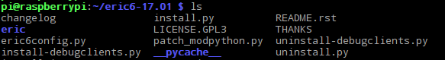
8. To install the newer version of Eric enter the following:  
     
    $ sudo python3 install.py ↵
9. In order for the Qt designer to work in Eric, the packages listed below must be installed. These packages will also enable the use of PyQt development. (NOTE: Each package may be installed individually as shown, or with a space between each new package name after ’install’.)  
     
    $ sudo apt-get install python-qscintilla2 ↵  
    $ sudo apt-get install python3-pyqt4.qsci ↵  
    $ sudo apt-get install python3-pyqt4.qtsql ↵  
    $ sudo apt-get install qt4-designer ↵  
    $ sudo apt-get install qt4-dev-tools ↵  
    $ sudo apt-get install qt4-linguist-tools ↵  
    $ sudo apt-get install pyqt4-dev-tools ↵
10. To install PySide type:  
      
     $ sudo apt-get install python3-pyside ↵  
     $ sudo apt-get install pyside-tools ↵
11. For good measure type:  
      
     $ sudo apt-get update ↵  
     $ sudo reboot ↵
12. If everything went OK, you should be ready to develop GUI applications on your rpi!

**Closing Notes**

This may, or may not, work for you.  
  
**Version History**

00 October 10, 2016 Initial writing/creation of tutorial.  
01 January 15, 2017 Re-Format. Addition of section lines, version history.  
02 March 31, 2017 Slight correction of expanding file system, addition of python3 terminal picture.