Generic ‘Default’ Governor based on PST model and Trudnowski EELE 5550 settings:

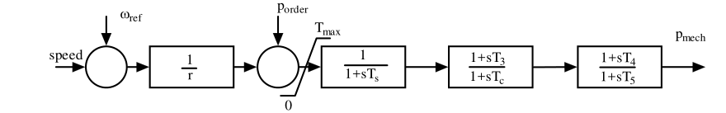

Damping could be added to mimic tgov1 action.

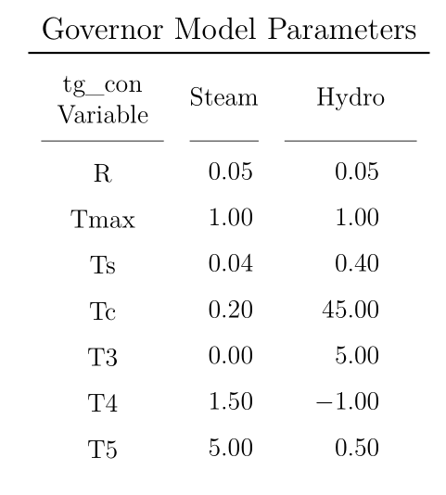

Each gov may be classified as steam or hydro based on machine H, Mbase, and/or MWcap?