**Multiple-Choice Question Generator**

**Thadimudupula Sahith**

**GUVI**

**Multiple-Choice Question Generator**

**Introduction**

This Python program generates multiple-choice questions (MCQs) based on a provided context paragraph. It utilizes the SpaCy library for natural language processing to analyze and manipulate text.

**Installation**

Ensure you have the **spacy** library installed. You can install it using **pip**:

Copy code

pip install spacy

Download the English language model for SpaCy

python -m spacy download en_core_web_sm

**Running the Program**

Execute the Python script.

You will be prompted to enter a paragraph as the context for generating questions.

Next, you will be asked to input the number of questions you want to generate.

**Generated Output**

The program will produce a set of MCQs with correct options and additional options. Each question will be printed to the console.

**Functions**

1. **generate_mcq_with_multiple_correct**
   * *Parameters*:
     + **question** (str): The question text.
     + **correct_answers** (list of str): List of correct answers.
     + **other_options** (list of str): List of incorrect options.
     + **num_options** (int, optional): Total number of options. Default is 4.
   * *Returns*:
     + **mcq** (dict): Dictionary containing the generated MCQ.
2. **generate_variety_question**
   * *Parameters*:
     + **doc** (SpaCy Doc): Processed document.
   * *Returns*:
     + **mcq** (dict): Generated MCQ.
3. **get_mca_questions**
   * *Parameters*:
     + **context** (str): The provided context paragraph.
     + **num_questions** (int): The number of questions to generate.
   * *Returns*:
     + **mca_questions** (list of str): List of formatted MCQs.

**Workflow**

1. **Load English Language Model**:
   * The program loads the SpaCy English language model for natural language processing.
2. **generate_mcq_with_multiple_correct**:
   * This function generates a multiple-choice question with multiple correct answers.
3. **generate_variety_question**:
   * Randomly selects a sentence from the provided context and a word from that sentence to create a fill-in-the-blank question.
4. **get_mca_questions**:
   * Processes the context using SpaCy.
   * Generates a variety of questions using **generate_variety_question**.
   * Formats the questions and options into a list of MCQs.
5. **User Interaction**:
   * Prompts the user to input a context paragraph and the number of questions to generate.
6. **Output**:
   * Prints the generated MCQs to the console.

Code . will open the Visual Studio Code

Create a virtual environment.

**Code: python -m venv myenv**

There we can download all the required libraries for over program

Activate the virtual environment.

**spaCy**: This library is used for natural language processing tasks. It provides pre-trained models and tools for working with text data.

We can install spaCy using the following command:

**Code: pip install spacy**

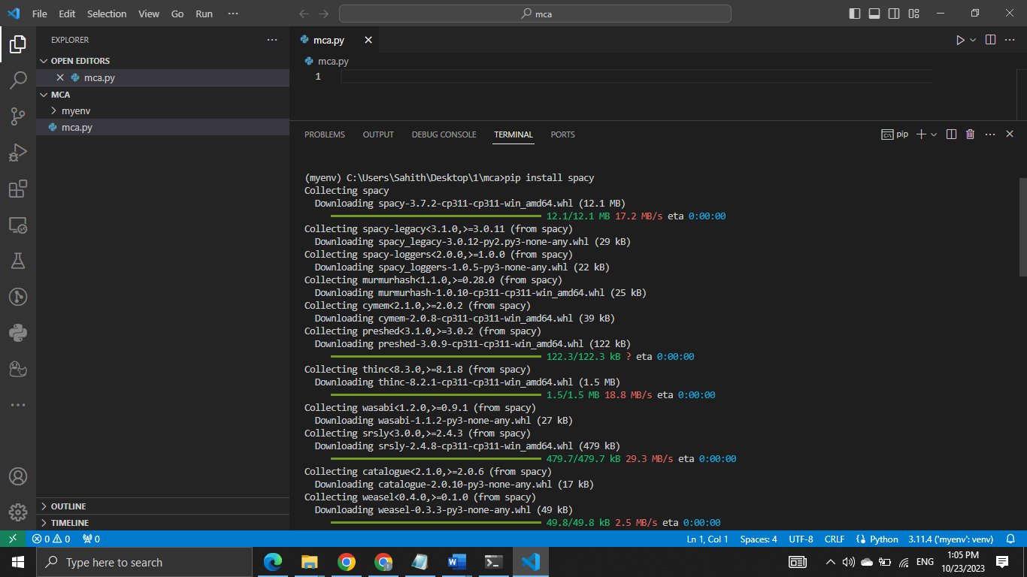

the English language model "en_core_web_sm" downloaded for spaCy.  
**code: python -m spacy download en_core_web_sm**  
Download the file from GitHub  
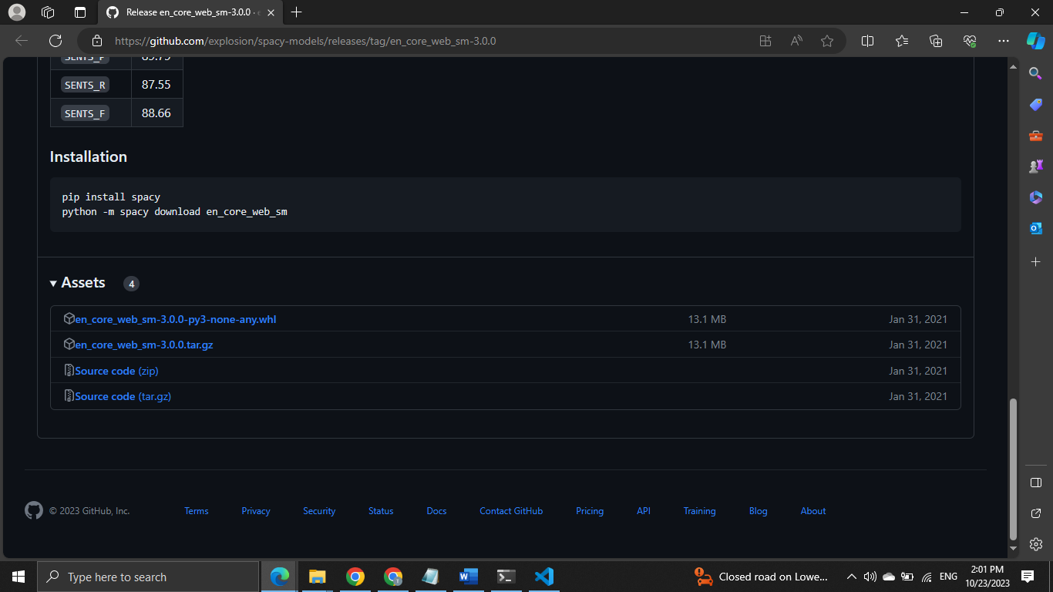

**code: pip install en_core_web_sm-3.0.0.tar.gz**

Download the Microsoft C++ Build Tools is required to install **en_core_web_sm-3.0.0.tar.gz.**



Successfully installed the packages now we are ready to do over project

