Perform Sharpening of Image using unsharp masking
import cv2
import numpy as np
image = cv2.imread(r"C:\Users\kalpa\Downloads\animal.jpg")
kernel = np.array([[0, -1, 0],
[-1, 5, -1],
[0, -1, 0]], dtype=np.float32)
sharpened_image = cv2.filter2D(image, -1, kernel)
cv2.imshow('Original Image', image)
cv2.imshow('Sharpened Image', sharpened_image)
cv2.imwrite('sharpened_image.jpg', sharpened_image)
cv2.waitKey(0)
cv2.destroyAllWindows()
INPUT:
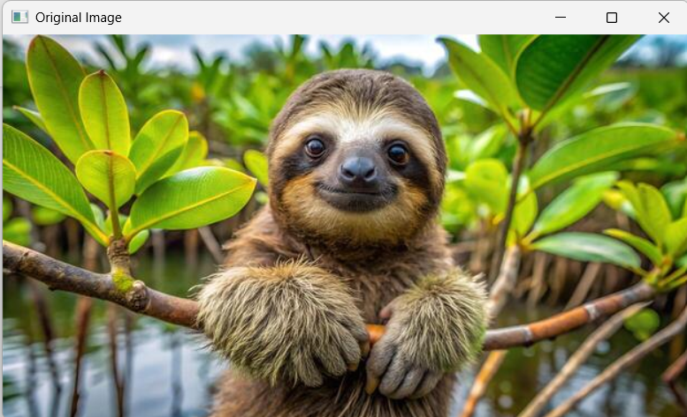

OUTPUT:
