Perform Sharpening of Image using High-Boost Masks.
import cv2
import numpy as np
image = cv2.imread(r"C:\Users\kalpa\Downloads\cat.jpg")
image_float = np.float32(image)
blur = cv2.GaussianBlur(image_float, (0, 0), sigmaX=5)
unsharp_mask = cv2.addWeighted(image_float, 2.5, blur, -1.5, 0)
sharpened_image = cv2.convertScaleAbs(unsharp_mask)
cv2.imshow('Original Image', image)
cv2.imshow('Sharpened Image (Unsharp Masking)', sharpened_image)
cv2.imwrite('unsharp_masked_image.jpg', sharpened_image)
cv2.waitKey(0)
cv2.destroyAllWindows()
INPUT:
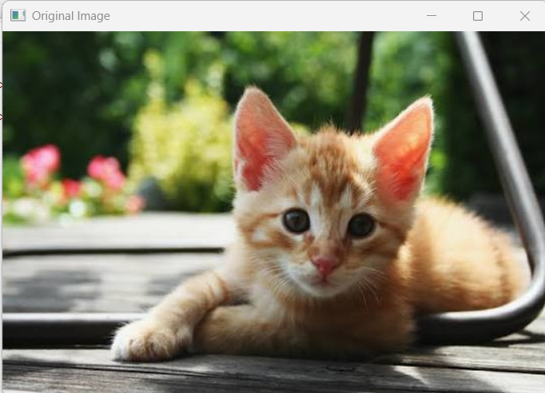

OUTPUT:
