Perform Sharpening of Image using Gradient masking
import cv2
import numpy as np
image = cv2.imread(r"C:\Users\kalpa\Downloads\animal.jpg")
if image is None:
print("Error: Could not load image.")
exit()
gray = cv2.cvtColor(image, cv2.COLOR_BGR2GRAY)
blurred = cv2.GaussianBlur(gray, (5, 5), 0)
grad_x = cv2.Scharr(blurred, cv2.CV_64F, 1, 0)
grad_y = cv2.Scharr(blurred, cv2.CV_64F, 0, 1)
gradient_magnitude = np.sqrt(grad_x**2 + grad_y**2)
gradient_magnitude = cv2.normalize(
gradient_magnitude, None, 0, 255, cv2.NORM_MINMAX
)
gradient_magnitude = np.uint8(gradient_magnitude)
sharpened = cv2.addWeighted(gray, 1.5, gradient_magnitude, -0.5, 0)
cv2.imshow("Original Image", gray)
cv2.imshow("Gradient Magnitude", gradient_magnitude)
cv2.imshow("Sharpened Image", sharpened)
cv2.imwrite("scharr_sharpened_image.png", sharpened)
cv2.waitKey(0)
cv2.destroyAllWindows()

INPUT:
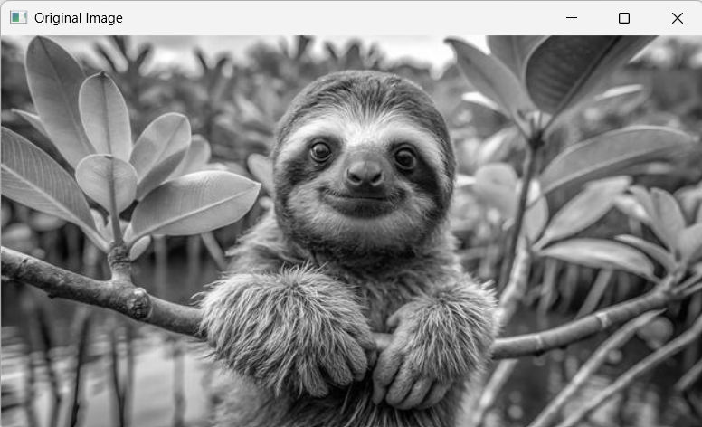
OUTPUT:
