- Convert an Image to Grayscale

import cv2
image = cv2.imread(r"C:\Users\kalpa\Downloads\tiger.jpg")
if image is None:
print("Error: Could not load image.")
else:
gray_image = cv2.cvtColor(image, cv2.COLOR_BGR2GRAY)
cv2.imshow("Original Image", image)
cv2.imshow("Grayscale Image", gray_image)
cv2.waitKey(0)
cv2.destroyAllWindows()

INPUT
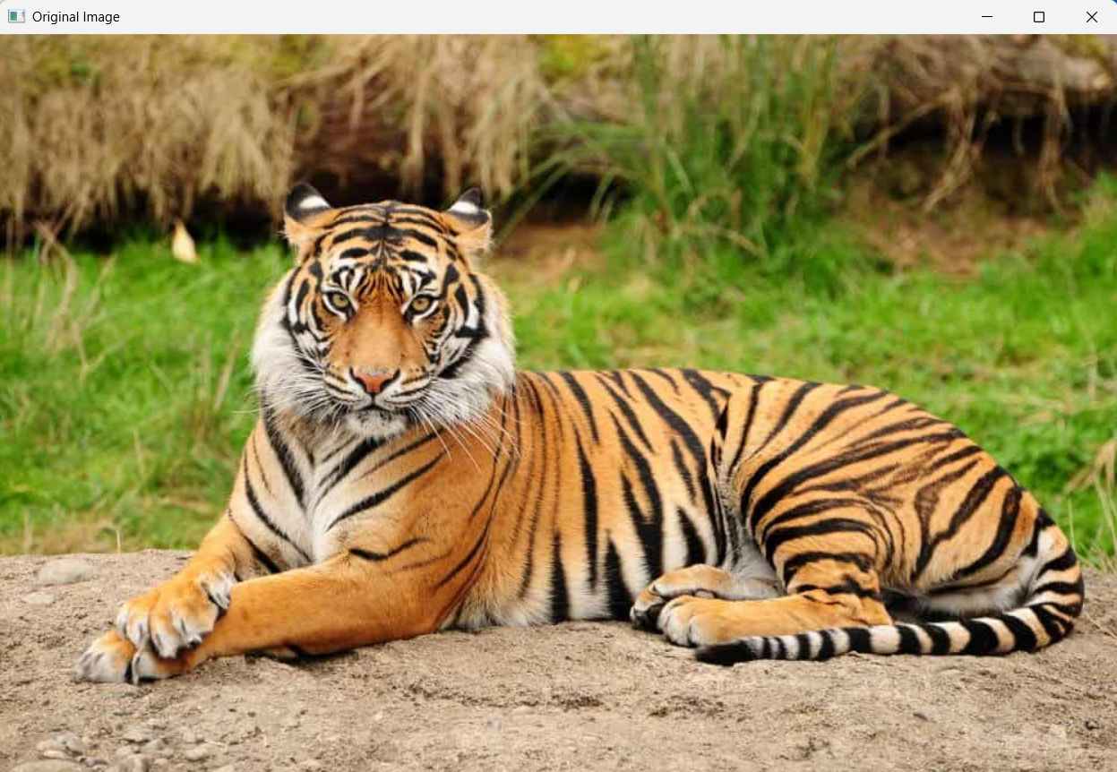

OUTPUT
