Perform Affine Transformation on the image
import cv2
import numpy as np
img = cv2.imread(r"C:\Users\kalpa\Downloads\fishh.jpg")
rows, cols, ch = img.shape
pts1 = np.float32([[50, 50], [200, 50], [50, 200]])
pts2 = np.float32([[10, 100], [200, 50], [100, 250]])
M = cv2.getAffineTransform(pts1, pts2)
dst = cv2.warpAffine(img, M, (cols, rows))
cv2.imshow("Original Image", img)
cv2.imshow("Affine Transformed Image", dst)
cv2.waitKey(0)
cv2.destroyAllWindows()

INPUT:
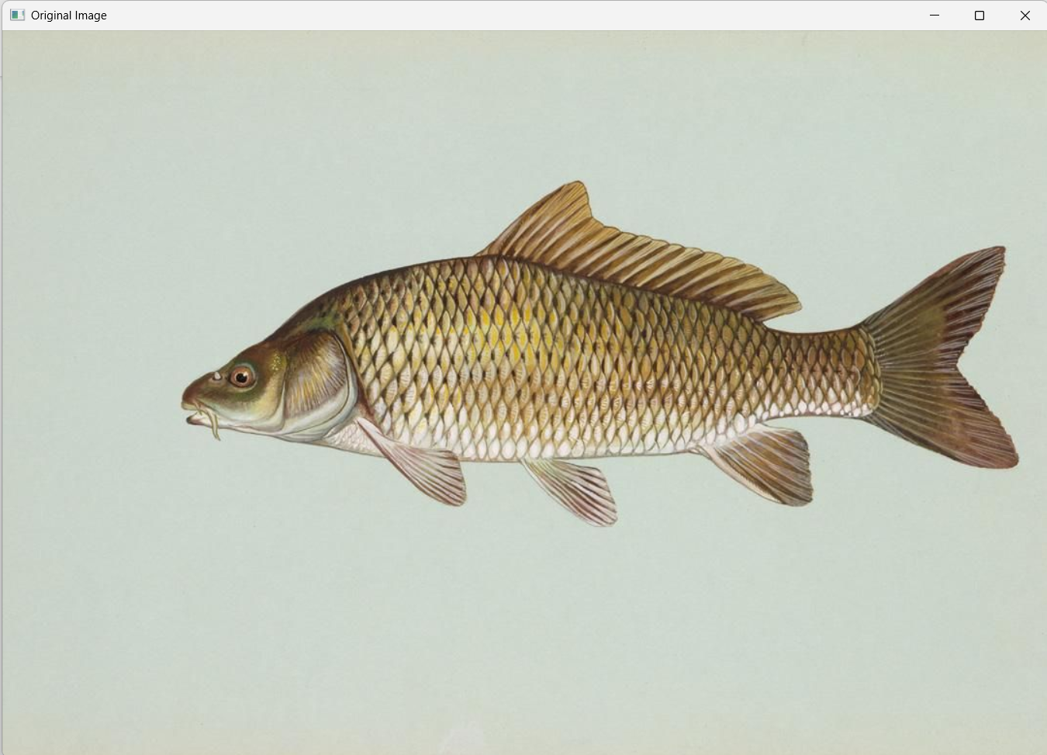
OUTPUT:
