Perform Perspective Transformation on the image.
import cv2
import numpy as np
img = cv2.imread(r"C:\Users\kalpa\Downloads\butterflyy.jpg")
rows, cols, ch = img.shape
pts1 = np.float32([[50, 50],
[300, 50],
[50, 300],
[300, 300]])
pts2 = np.float32([[0, 0],
[300, 0],
[0, 300],
[300, 300]])
M = cv2.getPerspectiveTransform(pts1, pts2)
dst = cv2.warpPerspective(img, M, (cols, rows))
cv2.imshow("Original Image", img)
cv2.imshow("Perspective Transformed Image", dst)
cv2.waitKey(0)
cv2.destroyAllWindows()

INPUT:
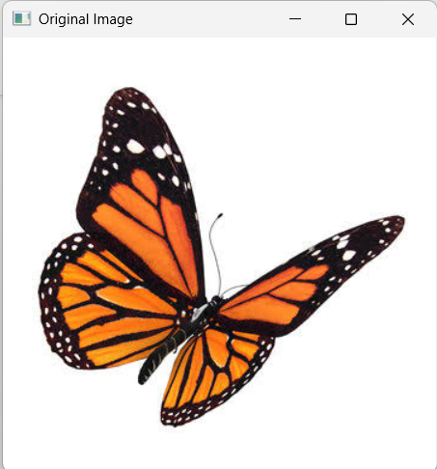
OUTPUT:
