Perform Perspective Transformation on the Video.
import cv2
import numpy as np
cap = cv2.VideoCapture(r"C:\Users\kalpa\Downloads\27260-362770008_medium.mp4")
while True:
ret, frame = cap.read()
if not ret:
break
h, w = frame.shape[:2]
pts1 = np.float32([
[0, 0],
[w, 0],
[0, h],
[w, h]
])
pts2 = np.float32([
[150, 0],
[w - 150, 0],
[0, h],
[w, h]
])
M = cv2.getPerspectiveTransform(pts1, pts2)
transformed = cv2.warpPerspective(frame, M, (w, h))
cv2.imshow("Original Video", frame)
cv2.imshow("Perspective Video", transformed)
if cv2.waitKey(30) & 0xFF == 27:
break
cap.release()
cv2.destroyAllWindows()

INPUT:
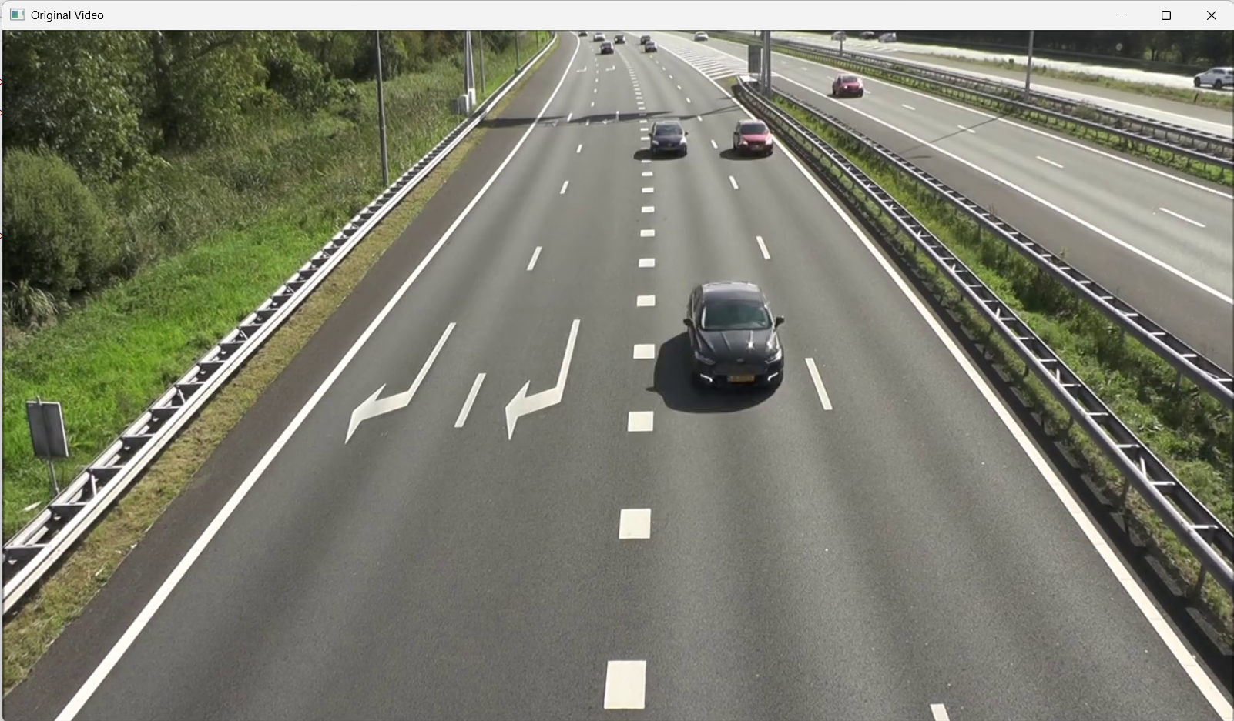
OUTPUT:
