2. CONVERT AN IMAGE TO BLUR
import cv2
img = cv2.imread(r"C:\Users\kalpa\Downloads\tiger.jpg")
img = cv2.resize(img, (600, 400))
blur = cv2.GaussianBlur(img, (25, 25), 0)
cv2.imshow("Original Image", img)
cv2.imshow("Blur Image", blur)
cv2.waitKey(0)
cv2.destroyAllWindows()

INPUT
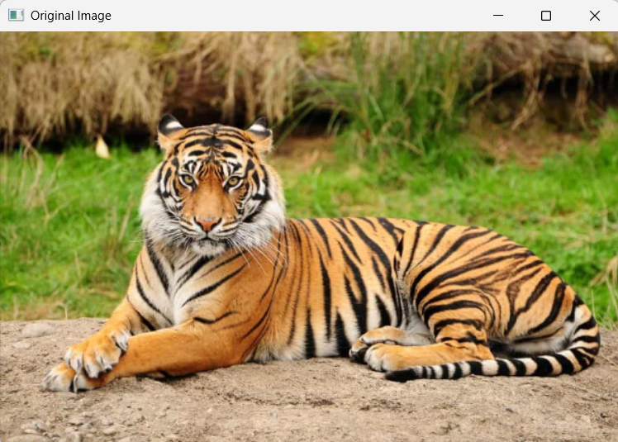

OUTPUT
