Scaling an image to its Bigger and Smaller sizes.
import cv2
img = cv2.imread(r"C:\Users\kalpa\Downloads\animal.jpg")
# Bigger Size Scaling
bigger = cv2.resize(img, (1000, 700))
# Smaller Size Scaling
smaller = cv2.resize(img, (300, 200))
cv2.imshow("Original Image", img)
cv2.imshow("Bigger Image", bigger)
cv2.imshow("Smaller Image", smaller)
cv2.waitKey(0)
cv2.destroyAllWindows()

INPUT:
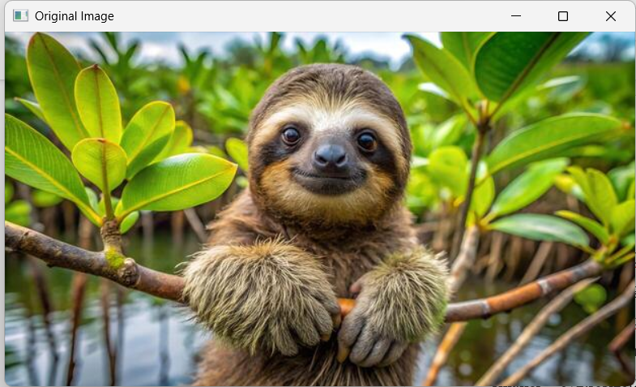

OUTPUT:
