Perform Rotation of an image to clockwise and counter clockwise direction.
import cv2
image = cv2.imread(r"C:\Users\kalpa\Downloads\snake.jpg")
image = cv2.resize(image, (600, 400))
rotated = cv2.rotate(image, cv2.ROTATE_90_CLOCKWISE)
cv2.imshow("Original Image", image)
cv2.imshow("Rotated Image", rotated)
cv2.waitKey(0)
cv2.destroyAllWindows()

INPUT:
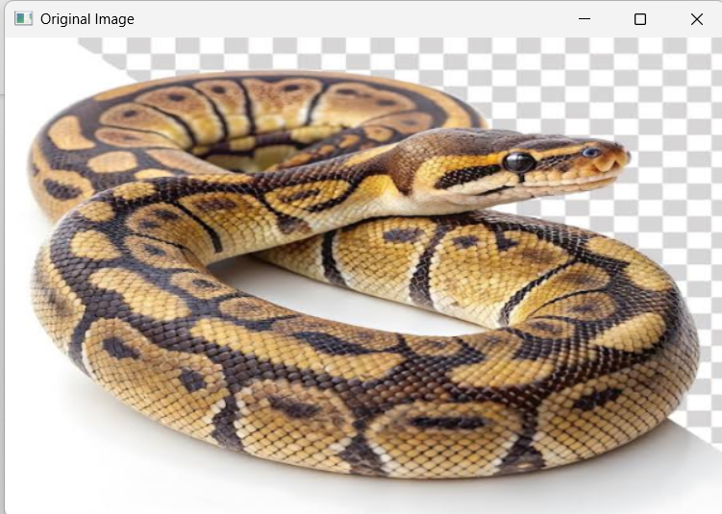

OUTPUT:
